You can send your answers to stoyanov@futuresoft.bg . Please don't hesitate to contact us for any question.

**Problem #1:**

Contacts system

* We need to develop a contacts application
* This application user should be able to store / edit / delete contacts records.
* Each contact should have the following:
  + Personal details like first, last name, company etc.
  + Image (one or more)
  + Phone numbers – different types of phones like mobile, work, home, fax, etc.
  + Emails
  + Addresses (home, work etc.)
  + IM (skype, google etc.)
  + Social networks
  + Comments

1. What is the DB schema you would use; describe the tables and relations for this kind of application.
2. Write a pseudo of “UpdateContact” function  
   what arguments it will get?  
   What will it return?  
   Describe in high level the steps this function will do.

**Problem #2: OOP**

Please write classes structure (in the language of your choosing, such as: C#, JAVA, JavaScript, PHP) that describes the following objects and their properties/functions.

1. Dolphin
   1. Age (property)
   2. Sleep (function that print ‘zzzzzz’)
   3. Swim (function that print ‘splah’)
   4. Eat (function that print ‘yummy’)
2. Lion
   1. Age (property)
   2. Sleep (function that print ‘zzzzzz’)
   3. Roar (function that print ‘wrrrrr ’)
   4. Eat (function that print ‘yummy’)
3. Eagle
   1. Age (property)
   2. Sleep (function that print ‘zzzzzz’)
   3. Fly (function that print ‘whoohooo’)
   4. Eat (function that print ‘yummy’)
4. Bee
   1. Age (property)
   2. Sleep (function that print ‘zzzzzz’)
   3. Fly (function that print ‘whoohooo’)
   4. Eat (function that print ‘yummy’)

**Problem #3: Responsive Design**

Create a web page using the attached file - “games.json” - and the following mockup:

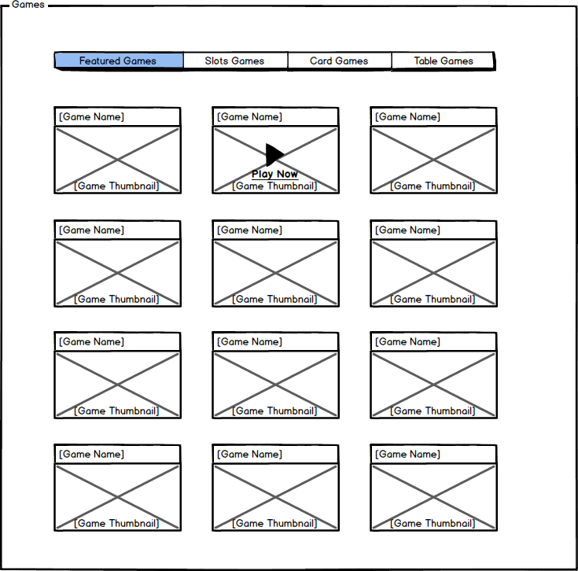

**Functionality**

1. Each category should display the game items belong to it from the JSON.
2. Each game item should display the game name and game thumbnail
3. Game thumbnail URL should be build from the game name as follow:
   1. Convert the game name to lower case
   2. Remove any non-alphanumeric characters from the name (spaces, commas, quotes, etc.)
   3. Append “-minipod.jpg” at the end of the name.
   4. Append the resulting name to the following URL:   
      <http://cacheimg.casinomidas.com/images/www/games/minipods/>

**Example:** For the game “Football Frenzy!” the final URL should be  
<http://cacheimg.casinomidas.com/images/www/games/minipods/footballfrenzy-minipod.jpg>

1. When hovering over a game, there should be a “Play Now” button with “Play” icon over the game thumbnail.
2. Clicking on a game should call the following JavaScript:  
   openGame([game_name], [game_code], [machine_id], [denominations], [hands]);  
   The values should be taken from the JSON file for each game.

You can use either JavaScript or PHP (or other language you like) to render the above.

**Design**

1. Feel free to implement any style or look of your choice. (Use of frameworks is also allowed.)
2. The design should be responsive and adapt to common devices and screen sizes. (PC, Tablet and Phone, are a must!)
3. Choose whichever devices and resolutions to design for, and how to show the content.
4. In mobile, the menu should always be visible, and should scroll horizontally, if needed.
5. In mobile, swiping left or right over the games area should change categories accordingly.