Name: YANG ZISHUO

Matriculation No: G2101493E

Code is available on:

1. **Bayes Decision Rule**

**code:**

**prediction results：**

[1 1 1 1 1 1 1 1 1 1 3 2 2 2 2 2 2 2 2 2 2 3 3 3 3 3 3 3 3 3]

1. **Fisher Discriminant Analysis**

**code:**

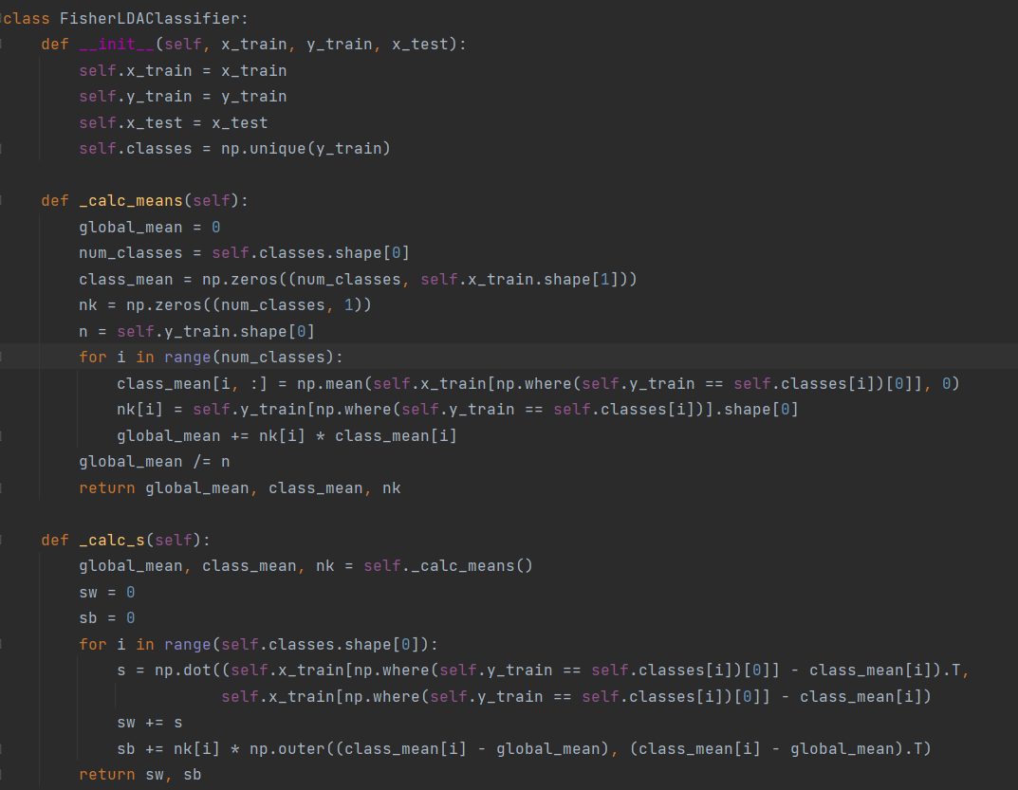

**prediction results：**

[1 1 1 1 1 1 1 1 1 1 2 2 2 2 2 2 2 2 2 2 2 3 3 3 3 3 3 3 3 3]

1. **Decision Tree**

**code:**

**tree plot:**

|--- feature_2 <= 2.45

| |--- class: 1

|--- feature_2 > 2.45

| |--- feature_3 <= 1.75

| | |--- feature_2 <= 5.05

| | | |--- feature_3 <= 1.65

| | | | |--- class: 3

| | | |--- feature_3 > 1.65

| | | | |--- feature_2 <= 4.75

| | | | | |--- class: 2

| | | | |--- feature_2 > 4.75

| | | | | |--- class: 3

| | |--- feature_2 > 5.05

| | | |--- feature_0 <= 6.05

| | | | |--- class: 3

| | | |--- feature_0 > 6.05

| | | | |--- class: 2

| |--- feature_3 > 1.75

| | |--- feature_2 <= 4.85

| | | |--- feature_1 <= 3.10

| | | | |--- class: 2

| | | |--- feature_1 > 3.10

| | | | |--- class: 3

| | |--- feature_2 > 4.85

| | | |--- class: 2

**prediction results：**

[1 1 1 1 1 1 1 1 1 1 3 2 2 2 2 2 2 2 2 2 2 3 3 3 3 3 3 3 3 3]