Student name: Thu Si Nguyen Mai
Student number: s4278836

Modeling self-organization using a partial-differential equation based model.

In this chapter, we are going to program the model of self-organized pattern formation in young mussel beds by Van de Koppel et al 2005, which proposes that the interplay between facilitation and competition between mussels at different scales can explain the formation of spatial patterns in mussel beds. Facilitation results from the mussel attaching to each other by means of byssus threads, which prevents the mussels from being dislodged by waves and predated by birds such as gulls and oystercatchers. This attachment acts from mussel to neighboring mussel, and hence the effect is very local. Competition between mussels works by means of the depletion of algae, their main food source, in the lowest water layer (called the boundary layer). As algae flow with the tidal water over a mussel bed, depletion of algae acts over a larger distance, as consumption by a mussel can influence the potential uptake of another mussel at meters distance.
Find the following publication and take a good look at equations 1 and 2 and at table 1:
Van de Koppel, J., Rietkerk, M., Dankers, M. & Herman, P.M.J. 2005 Scale-dependent feedback and regular spatial patterns in young mussel beds. The American Naturalist 165:E66-E77.
Below, I will explain how to implement this model in R. R is designed for statistical purposes, and hence it is not extensively optimized as for instance Matlab is for operating on big matrixes. Yet it does a reasonably good job if you want to do modeling, especially given that it is free software, and Matlab is very expensive. A very good book that explains you how to implement models in R is the book by Soetaert and Herman (2009), called “A Practical Guide to Ecological Modeling, using R as a Simulation Platform”. You could try to find this in the online ebook library that the University of Groningen (hopefully) has. In this and the following chapter, I will explain how to make spatial models in R.

Modelling partial differential equations
Models based on partial differential equations differ from models of ordinary differential equation in that they do not only involve derivative with respect to time (e.g., ∂A/∂t) but also with respect to some other variable, in our case space (e.g., ∂A/∂x or ∂A/∂y). So to simulate a model based on partial differential equations, we also need to include a numerical description of the partial derivatives with respect to space. This makes it a little more complex.
Lets look at the mussel model presented in Van de Koppel et al 2005:

$\frac{∂A}{∂t}=\left(A_{\text{up}}−A\right)f−\frac{c}{h}\text{AM}−V∇_{y}A$
$$\frac{∂M}{∂t}=e\text{cAM}−d_{M}\frac{k_{M}}{k_{M}+M}M−DΔM$$
Here we see two spatial components: the water gradient operator ∇A and the Laplacian operator ΔM., which are used to model advection (flow) and diffusion (or dispersal) of a (biological or chemical) species in space, respectively. The gradient operator equals to ∂A/∂x (A is the concentration of algae), and the Laplacian operator is given by ∂²M/∂x² (M is the density of mussels), both of course in only a single dimension x.
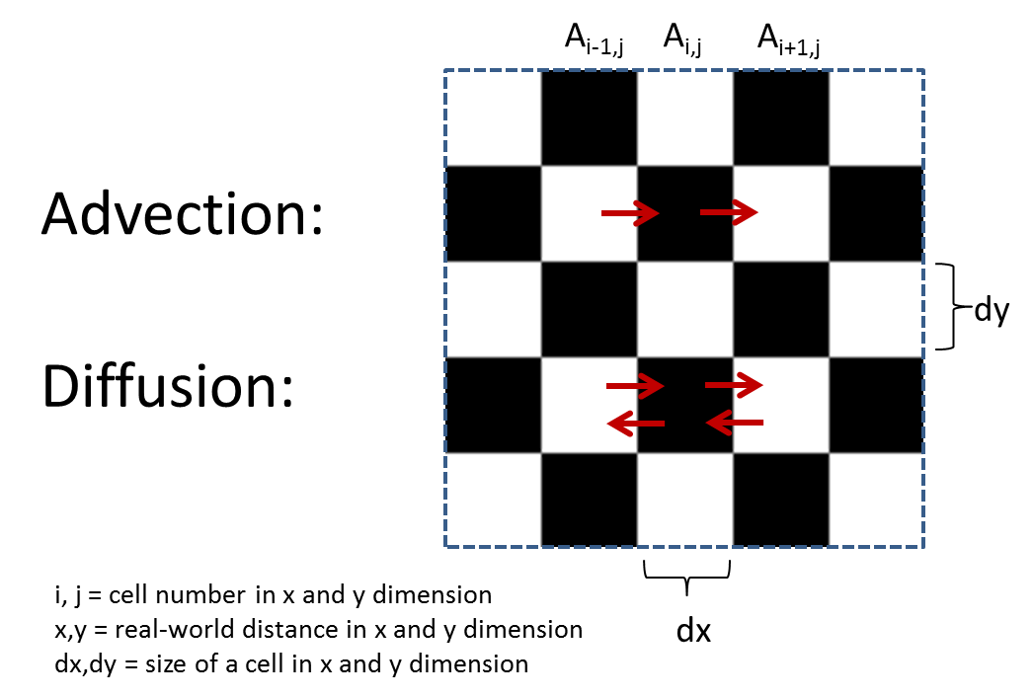
Spatial models are often solved numerically on a grid. For each grid cell, both the local (e.g., non-spatial) and the spatial processes are calculated, and determine how local concentrations and densities change. Spatial processes should be seen in this context as fluxes that move over the edges of each grid cell (the squares of the chess board in the above figure).
Lets take a look at the process of advection (move with the flow) of algae over the simulation grid. If we assume that V is the flow rate of the water that moves algae from cell to cell in the x dimension, and the grid cell has size $Δ$x⋅$Δ$y⋅$Δ$z, then the fraction of the algae in each cell that is transported from one cell to the other equals V⋅$Δ$y⋅$Δ$z/($Δ$x⋅$Δ$y⋅$Δ$z) = V/$Δ$x . The net change of algae at local A_{x,y} equals to what flows in minus what flows out = +VA_{x-1,y} /$Δ$x - VA_{x,y}/$Δ$x .
$$Advection=−V\frac{A_{i,j}−A_{i−1,j}}{Δx}≈−V\frac{∂A}{∂x}$$
This numerical equation we can use in the simulation.
Dispersal of mussels can be approximated in a similar way, using what is called a diffusion approximation. We then implicitly assume that mussels move randomly, like molecules in a fluid. This is of course a simplification, but it serves us well in models where the precise nature of movement is not the focus of the study. The numerical scheme can be derived from the equation above where we consider the dispersal of mussel M in a single dimension x:
$$Diffusion=+D\frac{∂^{2}M}{∂x^{2}}=+D\frac{∂\left(\frac{∂M}{∂x}\right)}{∂x}≈+D\frac{\frac{M_{i+1,j}−M_{i,j}}{Δx}−\frac{M_{i,j}−M_{i−1,j}}{Δx}}{Δx}$$

Implementation of a spatial model in R.
With the numerical approximations for ∂A/∂x and ∂²M/∂x², we can now build our model. This we do in a programming language. In this course, we use R for this.
First, we need to provide the program with the values of the parameters that make up the model:

# Spatially explitic model for regular pattern formation in mussel beds
# The model follows the paper :
#
# Van de Koppel, J., M. Rietkerk, N. Dankers and P. M. J. Herman (2005).
# Scale-dependent feedback and regular spatial patterns in young mussel
# beds. American Naturalist 165(3): E66-E77.

remove(list=ls()) # Remove all variables from memory
require("fields") # Loading a package for the visualization of the model

# --- Parameters values of the model ------------------------------------------

# Algal Exchange parameters
Aup = 1.1 # g/m3 Algal concentration in upper layer (Oosterschelde data)
h = 0.10 # m Height of the lower layer defined
f = 100 # m3/m3/h Change rate with upper layer (Guestimated)

# Mussel update, growth & mortality parameters
c = 0.1 # g/g/h Maximal consumption rate of the mussels (Riisgard 2001)
e = 0.2 # g/g Trophic efficiency of mussels (Lamie)
d_M = 0.02 # g/g/h Density dependent mortality rate of the mussels Calibrated
k_M = 150 # g/m2 Effect of density on mortality (Guestimated)

# Spatial movement parameters
D = 0.0005 # m2/h The diffusion constant describing the movement of mussels
V = 0.1*60*60 # m/h Tidal advection constant (0.1 m/s * 60 sec * 60 min)

# The speeding constant Phi
Phi = 1000 # Speeding constant, accelerates mussel growth

A surprising parameter might be the speeding constant Phi that appears at line 10 in the script. This parameter multiplies a certain set of parameters in such a way that the entire simulation produces patterns within a much shorter simulation time without quantitatively changing the predicted outcome. The reason for this is that because of the large timescale different in the movement of water (seconds) and the growth of the mussels (days), the model has to use a very short time step dT (see below) to accurately describe how depletion of algae is transported from cell to cell. By accelerating both the rates of growth, mortality, and movement of the mussels, mussel life acts at a much faster pace, while similar predictions are obtained. If you don’t trust this procedure, you are welcome to try to reduce EX to lower values.
We now have to define the simulation settings, e.g.: how long are we going to simulate, how large the simulated space will be, are we going to use a very course simulation grid or a very fine one:

# --- Simulation parameters ---------------------------------------------------

Length = 25 # m The length of the simulated landscape, in meters
m = 50 # # gridcells

dx = Length/m # The size of a grid cell in X direction
dy = Length/m # The size of a grid cell in Y direction

dT = 0.0002 # timestep (per hour)
EndTime = 180*24/Phi # end time (days x hours)
NoFrames= 360 # Number of frames displayed during the entire simulation

frac = 0.05 # Initial settings: fraction of area filled with mussels

Now all the parameters needed for the model are defined. We also need to define some parameters that determine how things are displayed later:
# --- Graphic settings --------------------------------------------------------

WinWidth=12 # - Width of the simulation window
WinHeight=5 # - Height of the simulation window

# Color pallette for the algae and the mussels
algae.palette = colorRampPalette(c("lightblue", "green"))
mussel.palette = colorRampPalette(c(’#b2aa9e','#f4e8ed','#a3a3b5','#707a8e','#334447','#000000'))

# --- A "Open window" function that works both on Mac and on Windows ----------
OpenWindow <- function(width, height,...)
{
if (Sys.info()["sysname"]=="Darwin"){
quartz(width=width, height=height,...)
} else {
win.graph(width=width, height=height,...)
}
}

Note the function “OpenWindow” that should open a new window irrespectively whether you run a Mac or a Windows computer.
For the model to run smoothly, we need to predefine the matrixes that are used in the model, so that they don’t need to be created on the run:
# --- Initialization of matrices containing the state variables ---------------

A = M = dA = dM = matrix(nrow=m,ncol=m) # The state and rate variables

To calculate the spatial components of the model (i.e., the dA/dx and d²M/dx²) we will predefine functions for the gradient operator (dA/dx) and the laplacian (2D diffusive) operator (d²M/dx² + d²M/dy²). These are given by the functions below:

# --- advective (Gradient) and diffusive (Laplacian) operators ----------------

# The gradient operator
d_dy = function (w) { # fluxes in y-direction, backwards difference scheme
# Flux = (middle cell - left side cell) / cell size in y dimension
fy = (w[c(1:m),] - w[c(m,1:(m-1)),]) / dy
return(fy)
}

# The laplacian operator
d2_dxy2 = function (w) { # Diffusion terms in x and y dimensions
# Flux = Right + Left - 2*middle cells +
fxy = (w[1:m,c(2:m,1)] + w[1:m,c(m,1:m-1)] - 2*w[1:m,1:m])/dy/dy +
# Above + Below - 2*middle cells
(w[c(2:m,1),1:m] + w[c(m,1:m-1),1:m] - 2*w[1:m,1:m])/dx/dx;
return(fxy)
}

Before we can run the simulation, we need to set the starting conditions in our simulations. We have put the algal concentration in the benthic boundary layer to half of Aup to avoid a mussel explosion, and seed around mussels everywhere, as the initial distribution of mussels when they fall from the water column is homogeneous.
#------ Initial setup and calculation -----------------------------------------

set.seed(20) # Making sure the random number generator gives the same values

# Initial values for the algae and the musels
A[,]=0.5
M=100+(matrix(ncol=m,nrow=m,data=runif(m*m))<=frac)*10

# Some counters used in the loop below
Time = 0 # Begin time
ii = 1e6 # Setting the plot counter to max, so that drawing start immediately

We need to set up a graph window in which the results are displayed.

# --- Setting up the figure ---------------------------------------------------

## Open a graphics window (Darwin stands for a Mac computer)
OpenWindow(width=WinWidth, height=WinHeight, title=”Self-organization in mussel beds”)
par(mfrow=c(1,2), mar=c(3, 4, 2, 6) + 0.1) # sets up the margins

Now we have to provide the simulation loop. Within this loop we repeat for each time step the basic calculations that make up the simulation. The loop consists of a while statement that keeps on running until the condition between the brackets fails:

# --- The simulation loop -----------------------------------------------------

while(Time<=EndTime){ # Here the time loop starts

We can now specify the rates of change, making use of the gradient and Laplacian operators that we defined above. The step after that is to update the state variables.

# Calculating local input, uptake, growth, mortality, and fluxes
drA = (Aup - A)*f - c/h*A*M - V*d_dy(A)
drM = e*c*A*M - d_M*k_M/(M + k_M)*M + D*d2_dxy2(M)

# Summing up local processes and lateral flow to calculate new A and M
A = A + drA*dT
M = M + drM*Phi*dT

Now all calculations are finished. We now have to plot (R) the graphs that present the domains. This we don’t do for every calculation cycle, because then plotting would significantly slow down the model. Rather, we update the graphs NoFrames times during the entire simulation:

# Graphic representation of the model every now and then
if (ii>=EndTime/NoFrames/dT)
{
image.plot(A, zlim=c(0,Aup), xaxt="n", yaxt="n",
col = algae.palette(255),asp=1, bty="n",
legend.shrink = 0.99, legend.width = 1.8)
title("Algal concentration")

image.plot(M, zlim=c(0,2000), xaxt="n", yaxt="n",
col = mussel.palette(255),asp=1, bty="n",
legend.shrink = 0.99, legend.width = 1.8)
title("Mussel biomass")

mtext(text=paste("Time : ",sprintf("%1.0f",Time*Phi/24),
"of" ,sprintf("%1.0f",EndTime*Phi/24), "days"),
side=1, adj=-0.7, line=1.5)

# The following two lines prevent flickering of the screen
dev.flush() # Force the model to update the graphs
dev.hold() # Put all updating on hold

ii=0 # Resetting the plot counter

}

Then, to wrap up our program, we have to update the Time variable with one dT, increase the plot counter, and then finish the loop.

Time=Time+dT # Incrementing time with one
ii=ii+1 # Incrementing the plot counter with one

} # Here the time loop ends

The code specification would not be principally different in Matlab, Fortran, or C++. Actually, you can copy the above program to many other languages such as C++ and Fortran with only minor changes, where Matlab is very close to (and based on) Fortran, and R is more close to C++. The only difference is that variable management, in particular the arrays, is more complex in compiled languages such as C++ or Fortran.

Assignment 1: A first exercise, to learn using the model
Obtain the “Mussels.R” script fromt the Nestor, and run it. As this is a spatial model, you have to be patence. Things should start to happen at about Time = 70 days.

The simulation now just shows the 2D development of the patterns. But what if we would like to see the temporal development of the average mussel biomass in a graph. First, we need to make 2 variables that will contain the values of average mussel biomass and of time. We could record these every loop cycle, but with a dT of 0.0002, the variable will get very large. So we will record every time the graph is updated. The variables to store the data are declared in the “Initialization” section:

TimeRec=MusselRec=vector(length=NoFrames); # Mean mussel biomass

We should now add a counter jj to the program that remembers at which position of the MusselRec and TimeRec variables we are. Put these just underneat the declaration of the ii variable, that is just before the start of the loop.

jj = 0 ; # The counter needed for recording data during the run

Then, within the section that updates the graphs with the patterns (just below “ii=0”), we enter:

jj=jj+1 # Increasing the Recorder counter

TimeRec[jj]=Time*Phi/24 # The time in days
MusselRec[jj]=mean(M) # Mean mussel biomass

Now you should plot the recorded data. You should have had some experience with that from the last exercises.

Assignment 1: Provide a plot of mussel biomass versus time
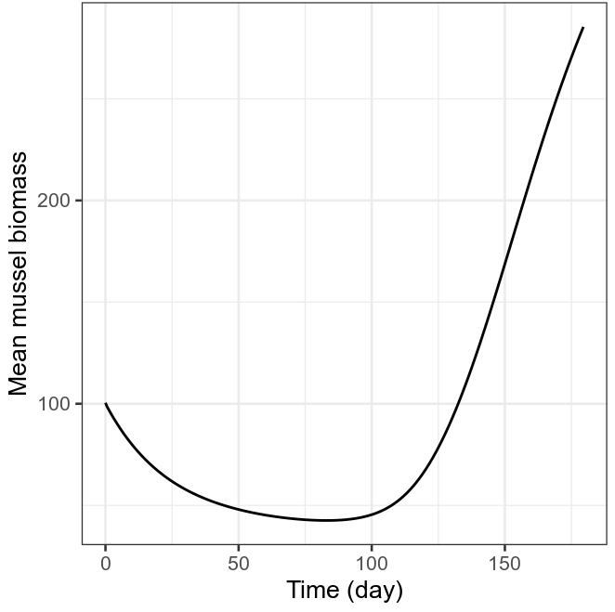

Question 1.1: Why does the mean biomass decrease at first, but then increase?
Initially, the distribution of the mussels across space is still relatively homogeneous. Per square meter, the number of mussels is small, therefore, the mortality is high. High mortality then leads to further decrease in the mussel density. The result of this feedback loop is a drop in the mean biomass across the entire surface. Note that we are able to observe this also because the diffusion here is a very slow process (small D) such that it takes quite a long time for mussels in one grid cell to move to the other cell.

However, once there are certain diffusions across grid cells, there are some area where the numbers of mussels become sufficiently high to trigger a different positive feedback loop. In this loop, high number of mussels concentrated in an area leads to reduction in per capita mortality, which then in turn increases the number of mussels in that area further. As a consequence, dense clumps are gradually formed where the biomass accumulates over time, leading to an increase in the average biomass across the entire surface.

Assignment 2

By now, I have given you some handles of how to make a Partial Differential Equation-based model in R, and how to do some simple analyses with it. It is now time to use the model for some serious work. Below are two questions, which have been stated in very general terms. Please give the questions some very, very good thought, and then use the model to try to answer the question.

Question: Why do mussels only occur in dense aggregations?

Use the model to investigate how the model works differently when it develops patterns, compared to when the mussels would stay homogeneous. You can force the mussels to stay homogeneous by increasing they movement (e.g. diffusion constant D) with for instance a factor of 10.

How does the development of patterns affect the average biomass in equilibrium. (Maybe simulate somewhat longer until the average biomass does not increase anymore). To determine this, add the following line at the end of the script:

print(paste("Mean biomass :", mean(M)))

Use both arguments and figures and the computed numbers to solidify your results. Enter the results in the box below.

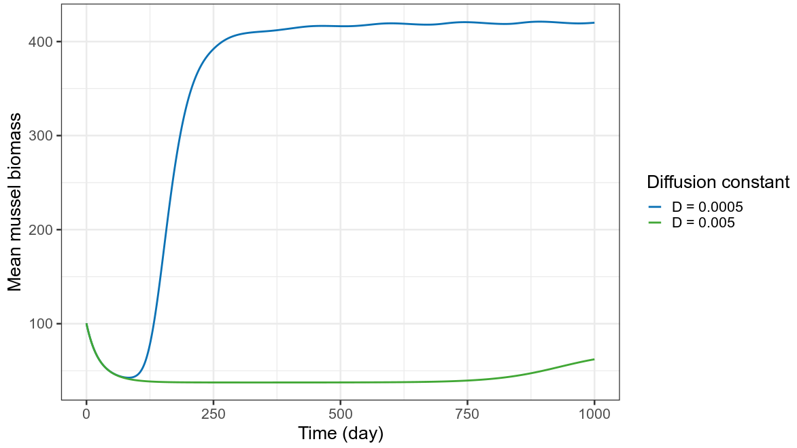
When dense aggregations can be formed (low diffusion constant D=0.0005), mean biomass at t=1000 days is 420.050853799225.
When mussels are forced to stay homogeneous (high diffusion constant D=0.005), mean biomass at t=1000 days is 62.1435826232487.
In general, the development of patterns significantly increases the average biomass at equilibrium.

How does this difference in biomass come about? How do the patterns affect the population processes, such as the average food intake per mussel, or the average mortality of the mussels.

At the end of the script, add the following lines:
Consumption = c/h*A*M
Mortality = d_M*k_M/(M + k_M)*M
print(paste("Mean biomass :", mean(M)))
print(paste("Consumption :", mean(Consumption)/mean(M)))
print(paste("Mortality :", mean(Mortality)/mean(M)))
Again, use both arguments and the computed numbers to solidify your results. Enter the results in the box below.
When there are dense aggregations (low diffusion constant D=0.0005):
- Mean biomass : 446.66917450762
- Consumption : 0.179046535899072
- Mortality : 0.00358046044921176

When there is homogenous distribution of mussels (high diffusion constant D=0.005):
- Mean biomass : 47.952858487256
- Consumption : 0.72639683631155
- Mortality : 0.014432933712961

When the diffusion rate is low, aggregations can persist and grow once they appear (by random diffusion) at a sufficiently high density. This is because of the combination of three factors:

1. The reduced per capita mortality in sufficiently dense clumps. (Mean per capita mortality is higher in homogenous distribution than when there are dense aggregations).

2. The low diffusion rate itself (if the mussels disperse so fast, small aggregations are quickly destructed just by random movements)

3. Although per capita algae consumption is reduced in denser area (mean per capita consumption is higher in homogenous distribution than when there are dense aggregations), it is still sufficient for reproduction and can still be compensated by the decreased mortality.

The persistence and growth of the aggregations results in the increases in their biomasses and thus, the average biomass across the surface. The average biomass can only increase to a certain limit and reach an equilibrium because the available resource in the environment is limited (defined by A_{up}).

Assignment 3: Do patterns matter in a changing world?

Climate change is likely to increase the wave exposure of the mussels, as they will experience more storms. This is likely going to increase the mortality rate (d_{M}) that they will experience. To investigate this, we are going to increase the d_{M} values that range from 0.02 to 0.04.

The way to do this exercise is to gradually increase the mortality rate and then automatically store the data in R. To automatically analyse for the presence of patterns and the resulting biomass along the entire gradient, you could go through the following steps to program it as script that runs it in one go.

First, we are going to store a going output of a single simulation, for use later.

- First, run a simulate for a somewhat longer time, for a year (e.g. put the EndTime to 360*24/Phi).

- After the simulation, type into the console window:
save(file = "Mussels.RData", A, M)

Also, save the script itself, and that “save as” the script under a new file name.

- Now we are going to load this datafile at the initialization of A and M, so that we don’t have to go through the musselbed development each time. For this, type after the line “M=100+(matrix …” (approximately at line 92) the line:
load(file = "Mussels.RData")

- Just after the beginning of the loop (i.e. after the line “while (Time<=EndTime){“ at +/- line number 111), type:
d_M = 0.02 + Time/EndTime*(0.02)

- Now, the simulation will run with a gradually increasing d_M. We of course need to record the d_M values for later to make a graph. We have to add a new vector definition at +/- line 69 (addition in red):
TimeRec = MusselRec = d_M_Rec = vector(length=NoFrames)
And add in a new line after “MusselREc[jj]=mean(M)”:
d_M_Rec[jj] = d_M
- Finally, at the of the script, add (or replace) the plot command to show the result:
plot(d_M_Rec, MusselRec, ylim=c(0,500))
It is better to run the simulation for a much longer time, so that the mortality is increased gradually. Run the simulation this time for 10 years.

Plot the resulting graph here:
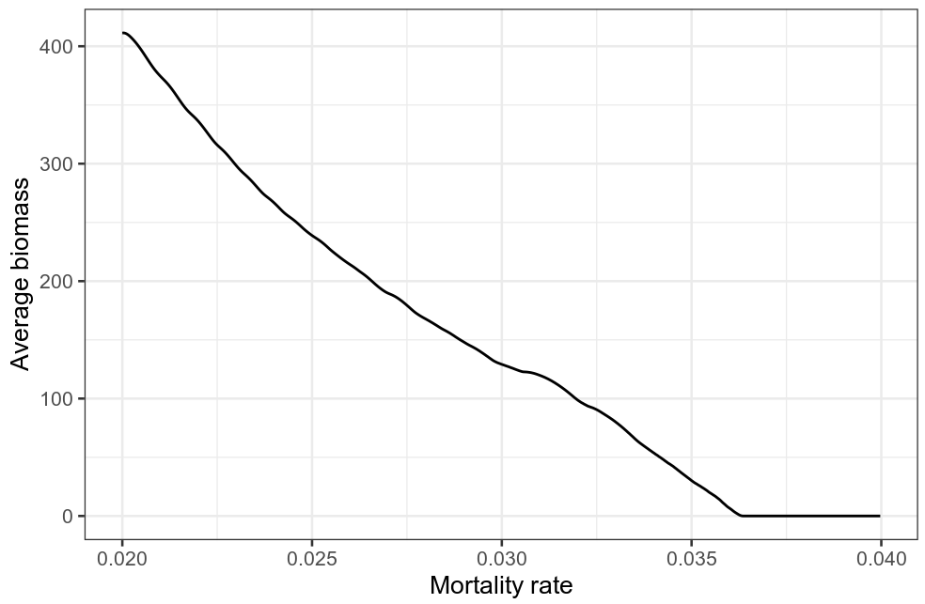

This figure depicts how a patterned mussel bed will respond to increase mortality because of increased wave action (or actually any increase of mortality).
To study how a mussel bed without any patterns will respond to increased mortality, we are going to repeat the above simulation. For this, do the following:
- Open the script saved earlier (at point 2). Increase the D to a value of 0.05, and then run the simulation to equilibrium. Save the values as at point 2.

- Now go back to the script with the changing d_M. Also, change the D to a value of 0.05, and run again.
Plot the resulting graph here:
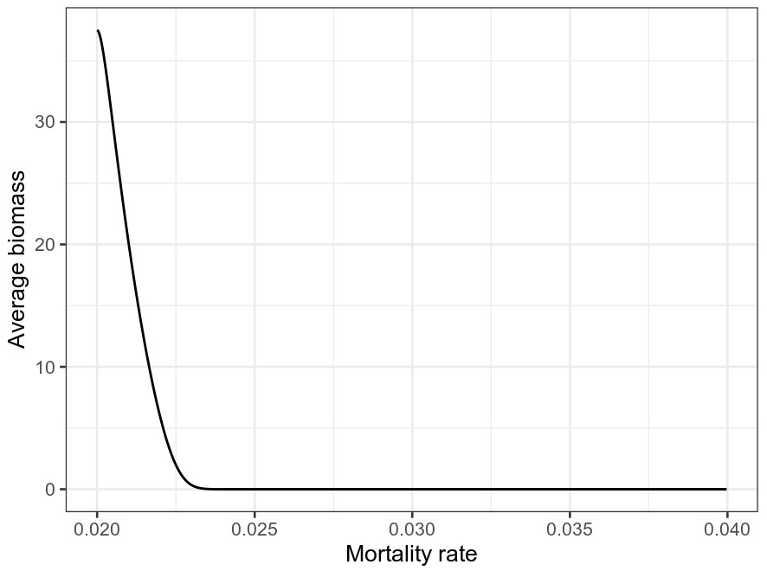

Can you explain the difference, and explain what this means for the ability of mussel beds to resist the climate-change induced increase of mortality?
The drop in the average biomass as the mortality rate constant d_{M} increases are more rapid when the mussels are homogeneously distributed than when they exist in patterns of dense clumps.

At the equilibrium with dense aggregations, because the biomasses of the clumps are very high, their mortality rates are scaled by a very small number (<1) (scaled down) and thus, an increase in the mortality rate constant d_{M} does not affect the system heavily unless the increase is very large and/or the system has been pushed to where the average biomass across space is significantly reduced.

On the contrary, at the equilibrium with homogeneous distribution of mussels, the average biomass is already low and the average mortality is already high. Therefore, an increase in d_{M} has a larger detrimental effect.

An biological interpretation here is that patterned mussel beds with dense clumps could be more resistant to climate-change induced increase of mortality than beds of homogeneously distributed mussels.

