Touchstone 4 Template
Interactivity and Client-Side Data
Name: | Shenghua Luo
Course: | Introduction to Web Development
Date: | 11/10/2026
Selected Client: | Client A: North Star Bakery

Important: Continue using the same client and website from Touchstone Task 2 and Touchstone 3. Submit this completed template as your single Touchstone file. Your linked project must contain the updated HTML, CSS, and JavaScript files.

Section 1: Project Link
Paste the URL to your public GitHub repository for this project. The repository should include all updated HTML, CSS, and JavaScript files required for this Touchstone.
Working Project Link:
Repository Link (if different):

Section 2: Implementation Explanation
Respond to every prompt below. Each response should be 2–4 sentences, refer to a specific element or behavior from your project, and explain how the implementation works. Reference your screenshots where requested.
Feature Purpose
Explain what your interactive feature helps users do and how it supports your client’s goals or audience. Identify the page where the feature appears and describe the user need it addresses.
Response:
My interactive feature is a "Quick Pre-Order" cart on the homepage (index.html). It helps users calculate the total price of the pastries they want to buy before they come to the store. This addresses a user need for price transparency and supports the bakery's goal of encouraging pre-orders. As shown in Screenshot 1, the user can easily see the items and the total price update instantly.

User Interaction
Describe how a user interacts with the feature step by step. Explain what JavaScript changes on the page after the user clicks, selects, or enters information.
Response:
When a user clicks the "Add Sourdough" button, it triggers the addToOrder() function. This function takes the item name and price, adds them to a JavaScript array, and then uses document.getElementById to find the order list and total price elements. The JavaScript dynamically updates the page by adding a new list item and recalculating the total text, so the user immediately sees their cart update without the page refreshing.

Form Validation
Identify at least two JavaScript validation checks you added to your form. Explain how invalid submission is prevented and how feedback appears near the relevant fields so users can correct their entries.
Response:
I added two JavaScript validation checks to the form on contact.html. First, it checks if the Name field is empty; if so, it stops submission and shows an error message. Second, it checks if the Email field contains an "@" symbol. These error messages appear in a red div right above the submit button, allowing users to easily correct their mistakes. Screenshot 2 shows the exact error message "Error: Name cannot be empty." when a user tries to submit an empty form.

Data Storage
State whether you used localStorage or sessionStorage. Explain what data is stored, when it is saved, and when it is loaded again. Describe how this improves the user experience.
Response:
I used localStorage to save the user's cart. When an item is added, the orderItems array is converted into a string using JSON.stringify() and saved. When the page is reloaded, the loadOrder() function retrieves this string, parses it back into an array using JSON.parse(), and rebuilds the HTML list. This improves the user experience by ensuring they don't lose their pre-order items if they accidentally refresh or close the browser. As you can see in Screenshot 3, the cart still remembers the items after I refreshed the page.

Technical Design
Explain how functions organize your JavaScript and how arrays or objects manage data. Name at least one function and one array or object, then describe what each does in your implementation.
Response:
I organized my JavaScript into separate functions like addToOrder(), loadOrder(), and validateForm() to keep the logic clean and easy to debug. For data management, I used an array called orderItems to hold multiple objects. Each object represents a food item, storing its name and price. This makes it easy to loop through the array and calculate the total price.

Challenges Encountered
Describe one specific problem you encountered while building or testing the feature, validation, or storage. Explain what was not working, how you identified the cause, and what change fixed it.
Response:
A specific challenge I faced was getting localStorage to work properly. At first, I tried to save the orderItems array directly. However, when I refreshed the page, the browser displayed [object Object] instead of the actual items. I realized that localStorage only stores strings. To fix this, I used JSON.stringify() before saving the array, and JSON.parse() after loading it. This successfully saved and restored the cart data.

Section 3: Technical and Submission Checklist
Check each item after testing your project.
☑ One meaningful JavaScript feature responds to a click, selection, or user input.
☑ The feature updates the page dynamically and clearly supports the client's goals.
☑ JavaScript is organized into multiple functions rather than one large block.
☑ At least one array or object is used to manage data.
☑ For Advanced performance, at least two arrays or at least two objects are used.
☑ At least two JavaScript validation checks are implemented.
☑ Invalid form submission is prevented.
☑ Clear validation feedback appears near the relevant fields.
☑ Users can correct errors without losing the information they already entered.
☑ localStorage or sessionStorage saves at least one meaningful piece of data.
☑ Stored data is loaded when the relevant page opens or reloads.
☑ All previous HTML, CSS, navigation, media, and form functionality still works.
☑ The working project link is included and opens without requiring sign-in.
☑ All six explanation sections are complete and use project-specific examples.
☑ At least three screenshots and captions are included below.

Section 4: Screenshots
Insert at least three clear screenshots. Crop each image so the relevant feature is easy to see, and add a short caption that explains what the screenshot proves.
Screenshot 1: Interactive Feature in Use
Show the feature after a user action and the resulting dynamic update on the page.
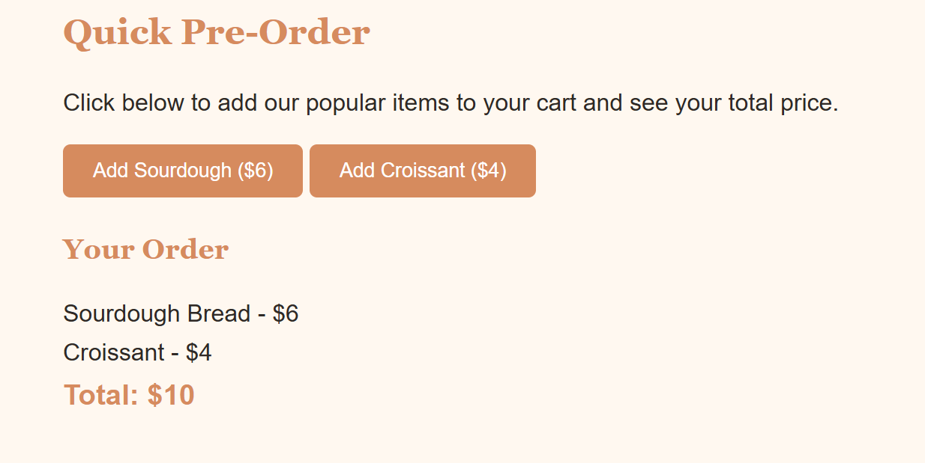
Caption: ___This screenshot shows the cart list updating with two items and the total price changing to $10 after clicking the buttons._________________________________________________________
Screenshot 2: Form Validation Feedback
Show at least two validation messages displayed near the relevant fields while submission is prevented.
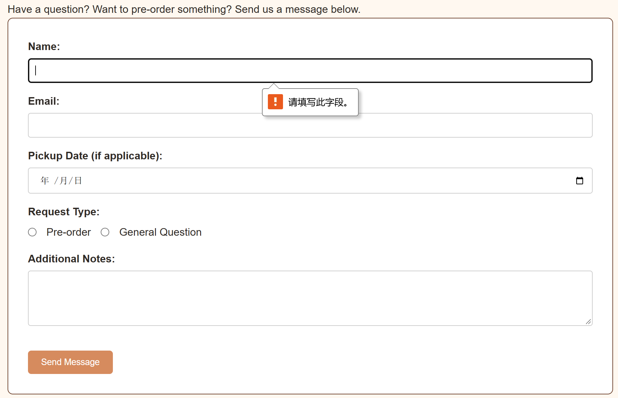
Caption: __This shows the custom error message appearing near the submit button when the Name field is left empty.__________________________________________________________
Screenshot 3: Browser Storage Working
Show data restored after a refresh or return visit, such as a remembered selection, saved favorite, or pre-filled field.
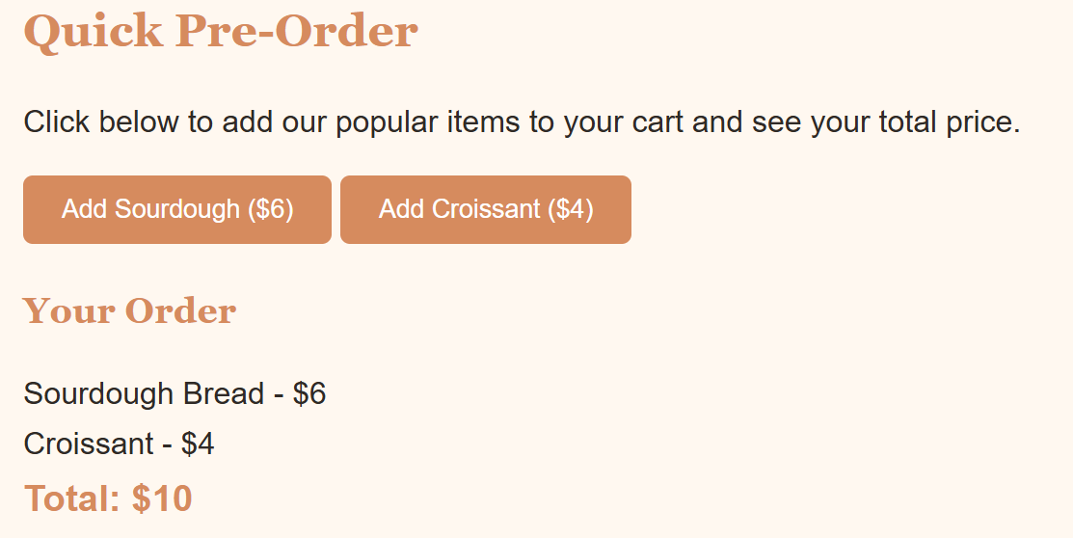
Caption: _This shows the order items and total price ($10) still intact after pressing F5 to refresh the browser, proving localStorage works.___________________________________________________________

Section 5: Final Review
☐ The interactive feature works as expected after repeated testing.
☐ The page updates dynamically when the user takes the intended action.
☐ Validation prevents invalid submission and messages appear near fields.
☐ Valid form entries can proceed without unnecessary errors.
☐ Stored data saves and reloads correctly after refreshing or reopening the page.
☐ No JavaScript errors appear in the browser console during normal use.
☐ Navigation and relative file paths work across all pages.
☐ The project remains readable and usable at mobile and desktop widths.
☐ The submitted link and all screenshots match the final version of the project.

Section 1: GitHub Repository
Paste the URL to your public GitHub repository for this project. The repository should include all updated HTML, CSS, and JavaScript files required for this Touchstone.
Repository URL:
______________________________________

Updated Final Review Items
- ☐ Public GitHub repository link included
- ☐ Repository opens without requiring login
- ☐ Repository contains all updated HTML, CSS, and JavaScript files
- ☐ Interactive feature works as expected
- ☐ Form validation prevents invalid submission
- ☐ Feedback appears near the relevant fields
- ☐ Stored data persists correctly
- ☐ Previous HTML and CSS functionality remains intact

