Touchstone 3: Visual Design and Responsive Layout
STUDENT EXEMPLAR
Name | Shenghua Luo
Course | Introduction to Web Development
Date: | 11/9/2026
Selected Client | Client A: North Star Bakery

Section 1: Preview Link and GitHub Link
Paste the GitHub Repository Link: https://github.com/singvis/Sophia-Courses/blob/main/web/Touchstone_3_Student_Template.pdf
Working Project/Preview Link:

Section 2: Design Explanation

Respond to each prompt below. Focus on explaining your design decisions.

Your responses should reference specific elements from your website. General descriptions without examples may receive reduced credit.

Note: Your design should use 2 to 4 colors and no more than 2 font families, applied consistently across all pages.

Client Alignment

Explain how your design choices support your selected client’s goals and audience. Include at least one specific example from your website.

I chose North Star Bakery because their goal is to feel warm and welcoming. I didn't want the site to look like a big corporate chain. To match their audience, I used a very simple navigation bar so people can find the menu and location quickly. For example, on the homepage, I put the welcome message right in the center with a big, cozy picture of the bakery behind it. I also kept the text very simple because a lot of their older customers might not be good with complicated websites.

Color Palette
The main colors are cream (#FFF8F0), brown (#6B3E26), peach (#D88C5A), and charcoal (#2F2A26). you used (you may include hex codes). Explain how these colors support your client’s tone and ensure readability. Include one example of where you applied these colors.

I used four main colors for this site. The background is a soft cream color (#FFF8F0), which is easier on the eyes than plain white. For the navigation bar and footer, I used a dark brown (#6B3E26). I also used a peach color (#D88C5A) for the main headings to make them pop out. The text is dark charcoal (#2F2A26) so it is easy to read. I picked these because brown and peach remind me of baking bread. I applied the brown color to the main header on the index.html page to give it a strong, warm anchor.

Typography

Identify the font or font pair you used. Explain how your choices support readability and create visual hierarchy. Include one example of how you used font size, weight, or style.

I used two font families: Georgia for the headings and Arial for the normal text. I chose Georgia because it looks a bit traditional and handwritten, which fits a bakery. Arial is standard and safe for phones. To make a visual hierarchy, I used different font sizes. For example, on the products.html page, I made the product names very bold and slightly larger so people can scan them quickly. The price and description are smaller in normal weight.

Responsive Design

Describe how your layout adapts across screen sizes. Include at least one specific example of a layout, spacing, or content change.

I used Flexbox to build the layout. On a big desktop screen, the product cards sit next to each other in a row. But I knew people would look at this on their phones, so I added a media query. When the screen gets smaller than 768px, it changes the flex direction to column, so the cards stack on top of each other. I also made the main images width 100% so they shrink automatically. It's a mobile-first approach.

Design Challenge

Describe one design challenge you encountered. Explain how you addressed it and what change you made.

My biggest challenge was trying to put text on top of a background image on the homepage. At first, I just put an <img> tag in HTML and tried to put text below it, but it looked really messy and pushed the text down. I realized I needed to use CSS. So, I deleted the image tag from HTML and used background-image in my CSS file instead. Then I used Flexbox to center the text. It took me a while to figure out that I needed background-size: cover so the image wouldn't stretch weirdly. That was a big learning moment for me.

Section 3: Submission Checklist
☑ Updated HTML files
☑ External CSS file
☑ Working preview link
☑ Consistent color palette (2–4 colors)
☑ Consistent typography (1–2 fonts)
☑ Styles applied across all pages
☑ Flexbox used in layout
☑ At least one media query
☑ Readable text with sufficient contrast
☑ Completed design explanation

Section 4: Screenshot
Include one screenshot of your website that demonstrates a design decision you described above.
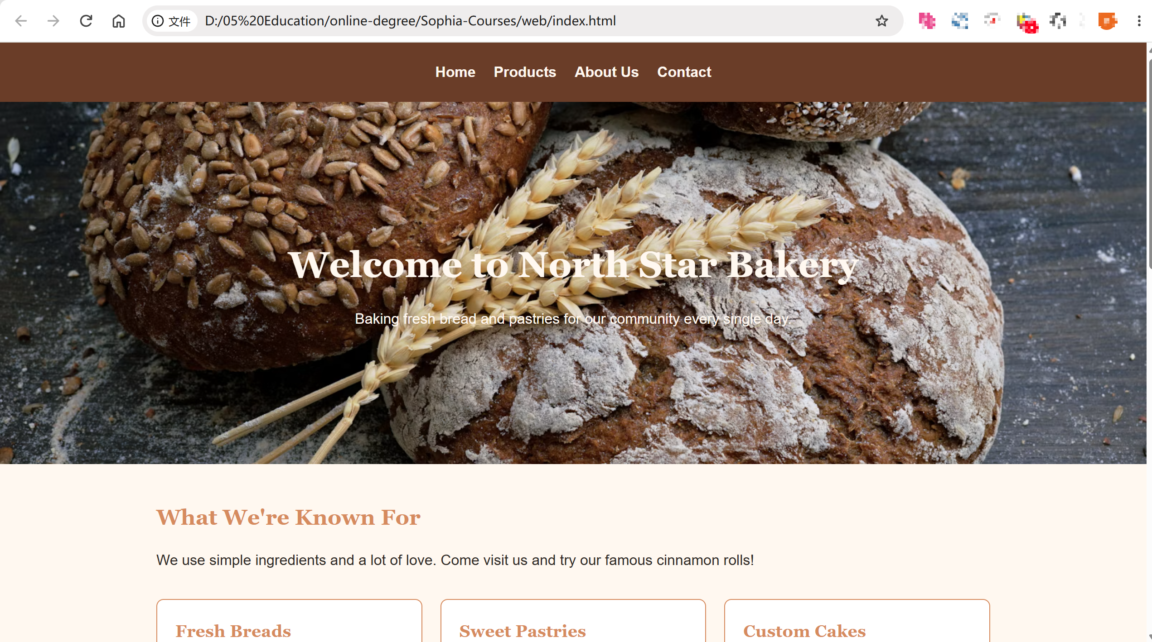

Section 5: Final Review
I tested all the navigation links to make sure they go to the right pages. I also checked the layout on a narrow browser window and the text did not overlap. The colors look consistent across all the pages.

