**Machine Learning Assignment - 3 :**

Here we are applying linear regression on a data set , but we are considering only 20 data points out of 100 points present.

Scatter Plot of the data Distribution :

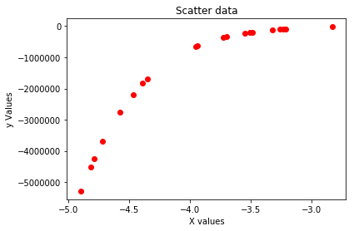

The data is widely distributed as mentioned below:

Y ranges from : -5286527.14 to -21730.98

X ranges from : -4.9 to -2.83

We use the below libraries :

1. *sklearn.model_selection.KFold* : To do train-validation split of the data
2. *sklearn.linear_model.LinearRegression* : To create the Linear Regression
3. *sklearn.preprocessing.PolynomialFeatures*: To create the polynomial features

We are using the below error function for estimating the models behaviour and the plots to identify the region of Overfit, Underfit and Goodfit.

1. *mean_squared_error*
2. *mean_absolute_error*
3. *median_absolute_error*

**For Goodness of Fit we use the r2-Value :**

The goodness of fit of a statistical model describes how well it fits a set of observations.

Measures of goodness of fit typically summarize the discrepancy between observed values

and the values expected under the model in question.

total ss = regression ss +residual ss

r-square = regress sum of square/ total sum of square

r2 is always 0-1

0 : poor fitting

1 : good fitting

if R2 value is : 0.4745

The regression model can explain about 47.45 % variation in the y values.

Now on the data what we do is :

1. We loop over the different degree polynomial and
2. For each of them we calculate each of the error metrics

2.1. During error metric calculation we use the KFold library and take an average

Over the errors calculated for different folds.

1. We put it in a matrix form.
2. We calculate the r2 value as Goodness of fit measure and according we select the degree(variable name : deg) for which we have the best goodness of fit (r2-value) measure.

**The error metric values calculated are as below :**

Column 0 : Train Error and Column 1 : Test Error

Row No’s : degree of the polynomial .

**Mean Squared Error :**

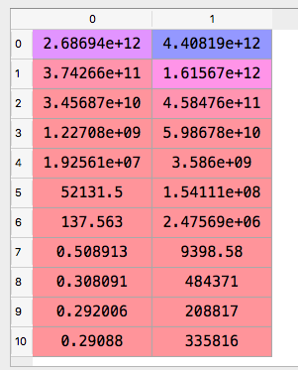

**Mean Absolute Error : Median Absolute Error :**

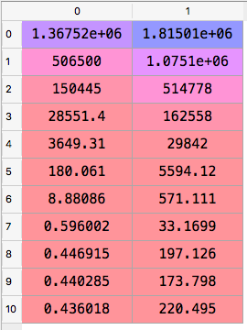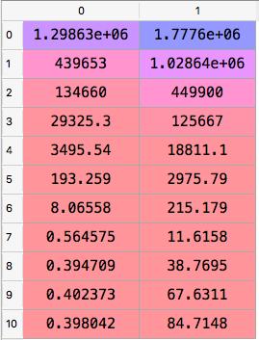

**The goodness of fit measure Values are r2_values:**

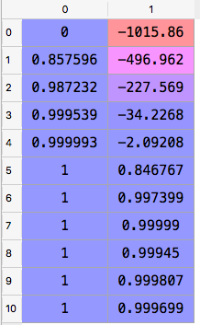

As Clearly Visible that for Order 7 the r2 Values is maximum we choose the deg 7 as the degree of the model .

**Optimal_degree = 7**

**Identification of UnderFit Overfit and Best fit :**

Red : Test Error

Blue line : Train error

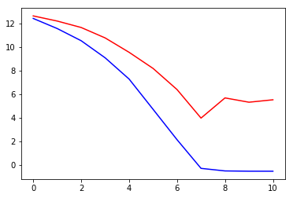

At degree 0 : Train and Test error both are very high : **UNDERFIT**

At degree 8 to 10 : Train Error :Low and Test Error : high : **OVERFIT**

At around degree 7 : both are stable and minimum : **BEST-FIT**

Same has been Indicated by the goodness fit measure .

Now that we have got the best fit at degree = 7 we use the same to create our final model and apply train test split to visualize as well .

**Polynomial Coefficients:**

0.00000000e+00,1.83751104e+07,1.60463200e+07,7.91590331e+06 , 2.39956074e+06, 4.52254571e+05, 5.01250001e+04, 2.62356468e+03

**Intercept** : 9127378.06773753

**Variance** : 1335.8439318633496

**The training Set fit with optimal degree of 7 :**

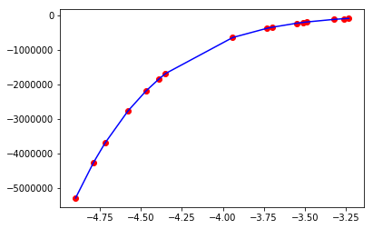

**The testing Set fit with optimal degree of 7 :**

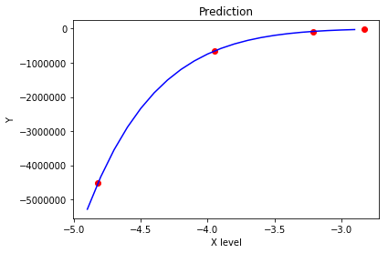

**Repeating the same experiments with now the whole data set :**

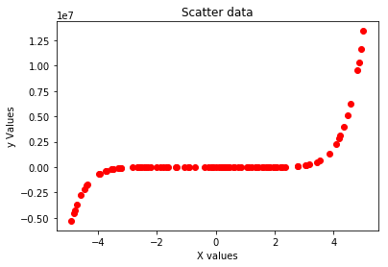

**Mean Squared Error : Mean Absolute Error :**

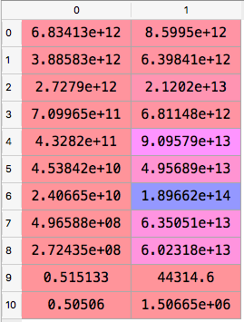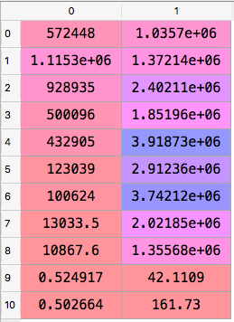

**Median Absolute Error :**

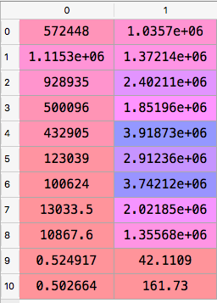

**Goodness of Fit measure :**

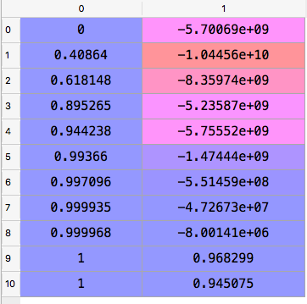

**The Optimal Degree Obtained is : 9** .

**Observation:**

For 20 data points the degree was 7 and now for 100 data points we get a optimal degree of 9 . So basically as we increase the data points the chances of learning better increase.

**Now for 100 data points we have the below error function :**

Red : Test Error

Blue line : Train error

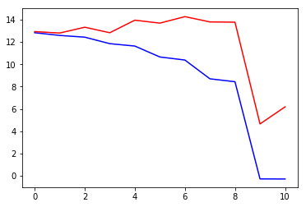

At degree 0 : Train and Test error both are very high : **UNDERFIT**

At degree 10 : Train Error :Low and Test Error : high : **OVERFIT**

At around degree 9 : both are stable and minimum : **BEST-FIT**

Same has been Indicated by the goodness fit measure .

Now that we have got the best fit at degree = 9 we use the same to create our final model and apply train test split to visualize as well .

**Polynomial Coefficients:**

0, 5.97605199, 2.93962589, 5.66787466, 7.94284174, 8.40782067, 8.59773922, 1.49942007 8.60003644 5.00001346

**Intercept** : 5.62820036

**Variance** : 0.5530508254255564

**The training Set fit with optimal degree of 9 :**

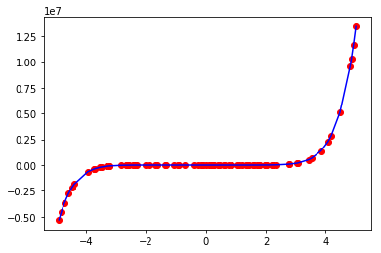

**The test Set fit with optimal degree of 9 :**

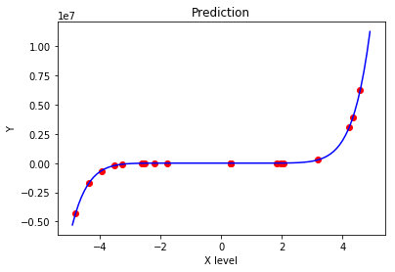

**Ridge Regularizer on data set of 100 points :**

Now we input regularization into the model which will help in smoothing the model curve.

We first of all apply the regularizer to the data set of 20 points and see its prediction :

1. We vary the value of the alpha parameter as below possible values :

alpha_range = [1e-2,1e-1,1,10,1e2]

2. For each one of them we iterate at each degree from 0 to 10 .

3. We are using KFOLD and all the errors and goodness of fit measure values are an average of the folds.

Ten we select the alpha and degree combination which gives us the best goodness of fit measure.

**The goodness of fit values for different alpha values are as depicted below:**

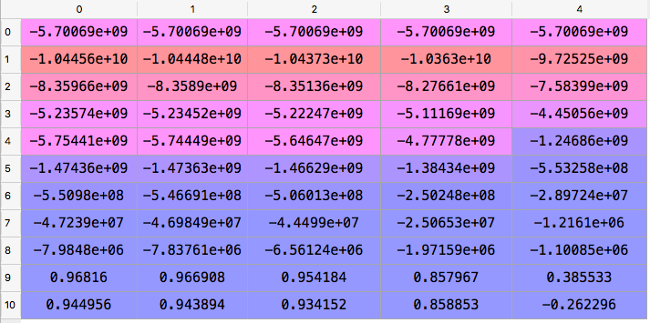

And the optimal values of :

**Degree = 9**

**Alpha = 0.01**

The value of degree is same as the data set without the regularizer . The difference might be noticed in the obtained coefficients and the intercept .

**Now for 100 data points we have the below error function :**

Red : Test Error

Blue line : Train error

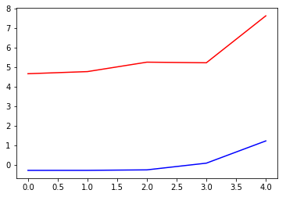

At C = 100 : Train and Test error both are very high : **UNDERFIT**

At C = 0.01 : both are stable and minimum : **BEST-FIT after this test error starts increasing**

Same has been Indicated by the goodness fit measure .

Now that we have got the best fit at alpha = 0.01 and degree = 9 we use the same to create our final model and apply train test split to visualize as well .

**Polynomial Coefficients:**

0, 6.03943865, 3.42768939, 5.71569535, 7.73592179, 8.35476811, 8.61729302, 1.5077892 8.60080755, 5.00001039

**Intercept** : 5.41377067

**Variance** : 32338.743972342894

**Ridge Regularizer on data set of 20 points :**

Same process as done with 100 data points .

**The goodness of fit values for different alpha values are as depicted below:**

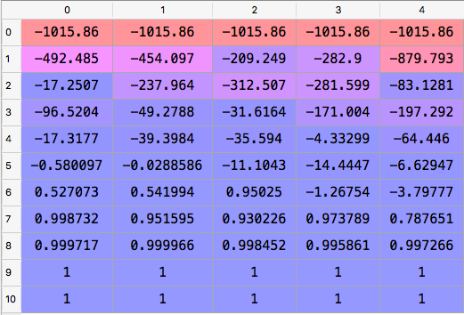

And the optimal values of :

**Degree = 10**

**Alpha = 0.01**

The value of degree has changed earlier it was 7 now its 9 , as because the data points are very very less the effect of the regularizer is evident .

**Now for 20 data points we have the below error function :**

Red : Test Error

Blue line : Train error

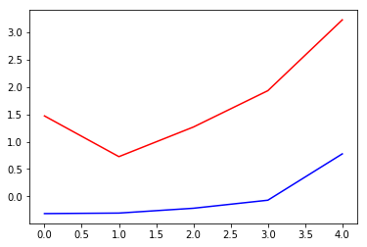

At C = 100 : Train and Test error both are very high : **UNDERFIT**

At C = 0.001 : Train and Test error both are very high : **OVERFIT**

At C = 0.01 : both are stable and minimum : **BEST-FIT after this test error starts increasing**

Same has been Indicated by the goodness fit measure .

Now that we have got the best fit at alpha = 0.01 and degree = 9 we use the same to create our final model and apply train test split to visualize as well .

**Polynomial Coefficients:**

0, 0.02071802, -0.07201634, 0.15407658, -0.20120288, 0.0214545, 0.69594328, -2.674471 7.46970985, 4.84972232, -0.00782562

**Intercept** : 40.38255382

**Variance** : 1.2404

**The SVM :**

Here we first load the data set, in-order to analyze the data.

No of Train Records = 2000

No of Test Records = 1001

We are supposed to divide the train data itself in 50 percent train and 50 percent validation data.

**The data is distributed as below if you use PCA with no of components as = 2.**

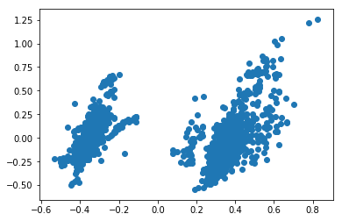

It seems that data is linearly separable , but let us use the t-SNE(**t**-distributed stochastic neighbor embedding) to project the data in 2 dimensional space.

**The data is distributed as below if you use t-SNE with no of components as = 2.**

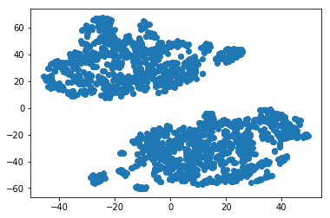

Although the data seems separable clearly when projected to 2-D space but its not what we want we would like to project the data class wise we have 2 classes present in the data.

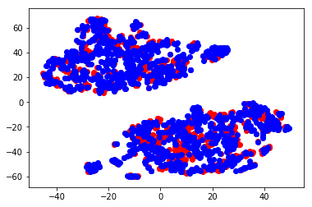

Now it gives us a better picture as we can now clearly see that that the data is mixed up when projected in the 2 dimensional space.

**Kernel used : Linear**

Now as part of the main code we will run through different values of the C parameter to find the best possible C with the highest degree of accuracy . During accuracy calculation we use the KFold library and take an average over the errors calculated for different folds.

C_2d_range = [1e-3,1e-2,1e-1,1,10,1e2]

And we create the accuracy array to log the accuracy corresponding to each value of C .

**Opt_C = 0.1**

**Max_Accuracy = 94.8**

Accuracy_array = 94.8

[68.1,93.3, 94.8, 94.8, 94.6, 94.8]

**classification accuracy as a function of the parameter *C:***

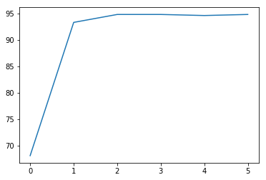

**Polynomial Coefficients:**

3.0090448, -1.48837243, 0.59240381, 0.38472849, 0.07690939, 0.55007765, 0.45035059 0.16824594

**Intercept** :

-0.9360495

**Kernel used : RBF**

Now as part of the main code we will run through different combinations of the C and gamma parameters to find the best possible combination with the highest degree of accuracy . During accuracy calculation we use the KFold library and take an average over the errors calculated for different folds.

Now as part of the main code we will run through different values of the C parameter to find the best possible C with the highest degree of accuracy .

C_2d_range = [1e-3,1e-2,1e-1,1,10,1e2]

gamma_2d_range = [1e-1, 1, 1e1]

Accuracy Matrix where the entry *(i, j*) of the matrix corresponds to the classification accuracy on the cross validation set with *i*th value of *C* and *j* th value of *gamma:*

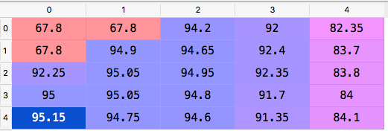

And we create the accuracy array to log the accuracy corresponding to each value of C .

**Maximum Accuracy : 95.15**

**Optimal Value of C is : 150**

**Optimal Value of Gamma : 0.01**

**Optimal Value of Sigma : 7.0710678**

**Corresponding Optimal Intercept : 6.42736528**

**classification accuracy as a function of the parameter *C (For Optimal gamma):***

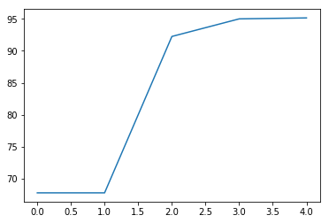

Now we use these set of parameters obtained to predict the values for the test set and save them .