**Target SQL Case Study**

**Q1 :- Import the dataset and do usual exploratory analysis steps like checking the structure & characteristics of the dataset:**

**Q1.1 Data type of all columns in the "customers" table.**

**Query:-**   
SELECT column_name, data_type  
FROM `target.INFORMATION_SCHEMA.COLUMNS`  
WHERE table_name = 'customers';

**Screenshot:-**

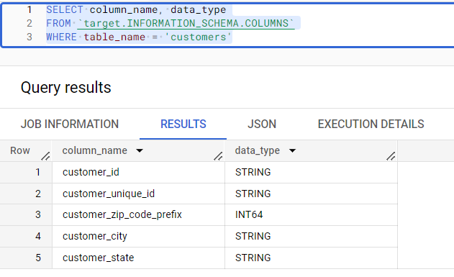

**Q1.2 Get the time range between which the orders were placed**

**Query:-**

SELECT   
MIN(order_purchase_timestamp) AS first_purchase_timestamp,

MAX(order_purchase_timestamp) AS last_purchase_timestamp

FROM `target.orders`;

**Screenshot:-**

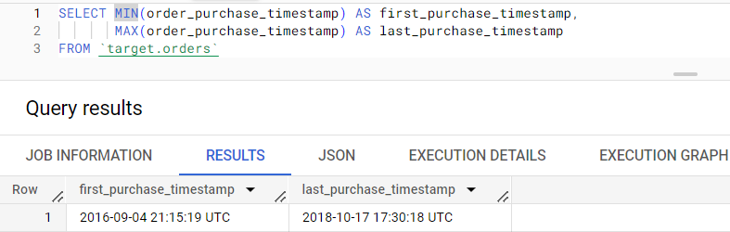

**Q1.3 Count the number of Cities and States in our dataset**

**Query:-**   
SELECT   
COUNT(DISTINCT customer_city) AS num_cities,  
COUNT(DISTINCT customer_state) AS num_states  
FROM `target.customers`;  
Screenshot:-

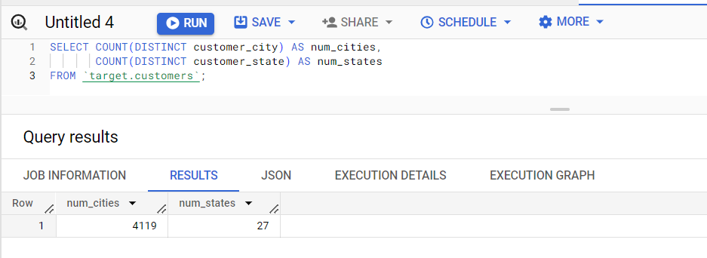

**Q2:-** **In-depth Exploration:  
Q2.1 :- Is there a growing trend in the no. of orders placed over the past years?**

**Query:-**  
SELECT   
EXTRACT(YEAR FROM order_purchase_timestamp) AS year,  
EXTRACT(MONTH FROM order_purchase_timestamp) AS month,  
COUNT(*) AS order_count  
FROM `target.orders`  
GROUP BY year, month  
ORDER BY year, month  
**Screenshot:-**   
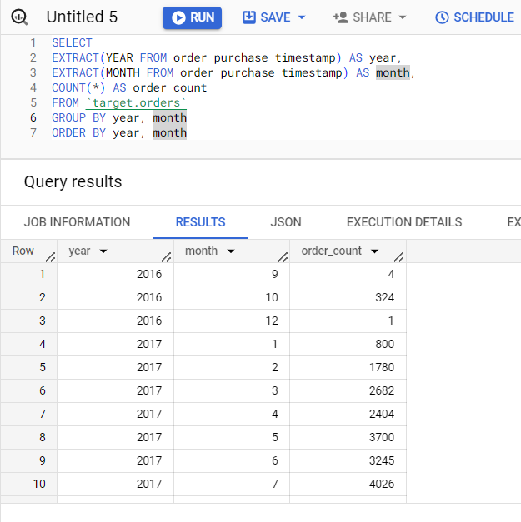

**Analysis:-**

1. Max order placed in November 2017 i.e., 7544 orders.
2. Total order in   
   2016 = 329 , 2017 = 45101 , 2018 = 54011
3. We can conclude from the above data that no. of orders is increasing year over year

**Q2.2 Can we see some kind of monthly seasonality in terms of the no. of orders being placed?  
Query :-**  
SELECT EXTRACT(MONTH FROM order_purchase_timestamp) AS month,  
COUNT(*) AS order_count  
FROM `target.orders`  
GROUP BY month  
ORDER BY month

Screenshot:-   
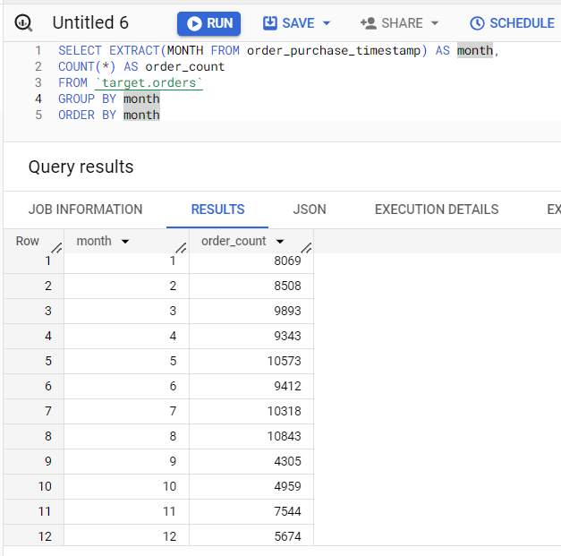

**Analysis :-**

1. Max order placed in August
2. From the above data we can conclude that the number of orders increases as we reach near the year mid (May, June, July, August), then we can see a decline in the orders during the year end.
3. The above data forms a bell curve having peak in mid year

**Q2.3 During what time of the day, do the Brazilian customers mostly place their orders? (Dawn, Morning, Afternoon or Night)**

* + **0-6 hrs : Dawn**
  + **7-12 hrs : Mornings**
  + **13-18 hrs : Afternoon**
  + **19-23 hrs : Night**

**Query :-**

SELECT CASE

WHEN EXTRACT(HOUR FROM order_purchase_timestamp) BETWEEN 0 AND 6 THEN 'Dawn'

WHEN EXTRACT(HOUR FROM order_purchase_timestamp) BETWEEN 7 AND 12 THEN 'Morning'

WHEN EXTRACT(HOUR FROM order_purchase_timestamp) BETWEEN 13 AND 18 THEN 'Afternoon'

WHEN EXTRACT(HOUR FROM order_purchase_timestamp) BETWEEN 19 AND 23 THEN 'Night'

END AS time_of_day,

COUNT(*) AS order_count

FROM `target.orders`

GROUP BY time_of_day

ORDER BY order_count DESC

**Screenshot :-**  
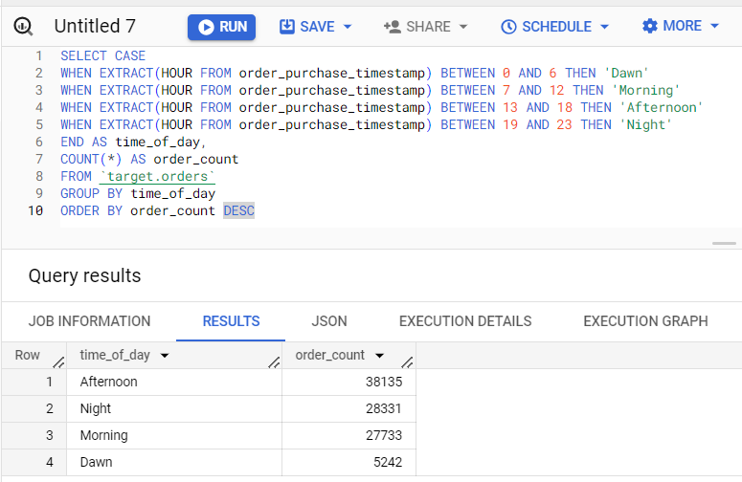

**Analysis :-**

1. From the above results we can conclude the Maximum orders are places in Afternoon
2. Followed by Night and Morning with a marginal difference of 1k orders
3. Least orders are placed in Dawn

**Note:-** Time zone of the given data set is not converted and used as it is. Incase we have to convert the time zone result may differ.

**Q3. Evolution of E-commerce orders in the Brazil region:**

**Q3.1 Get the month on month no. of orders placed in each state.**

**Query :-**

SELECT EXTRACT(YEAR FROM o.order_purchase_timestamp) AS year,

EXTRACT(MONTH FROM o.order_purchase_timestamp) AS month,

c.customer_state,

COUNT(DISTINCT o.order_id) AS order_count

FROM `target.orders` AS o

JOIN `target.customers` AS c

ON o.customer_id = c.customer_id

GROUP BY year, month, c.customer_state

ORDER BY year, month, c.customer_state

**Screenshot:-**

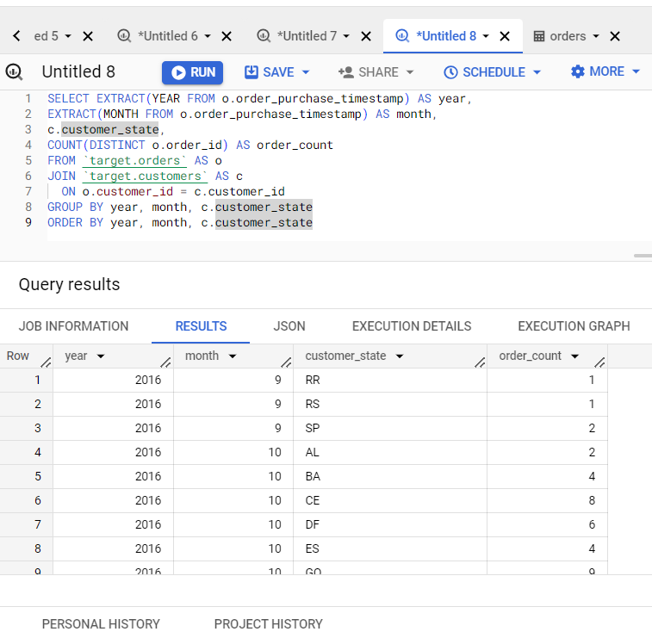

**Q3.2 How are the customers distributed across all the states?**

**Query:-**

SELECT customer_state, COUNT(DISTINCT customer_id) AS unique_customers

FROM `target.customers`

GROUP BY customer_state

ORDER BY unique_customers DESC

Screenshot:-

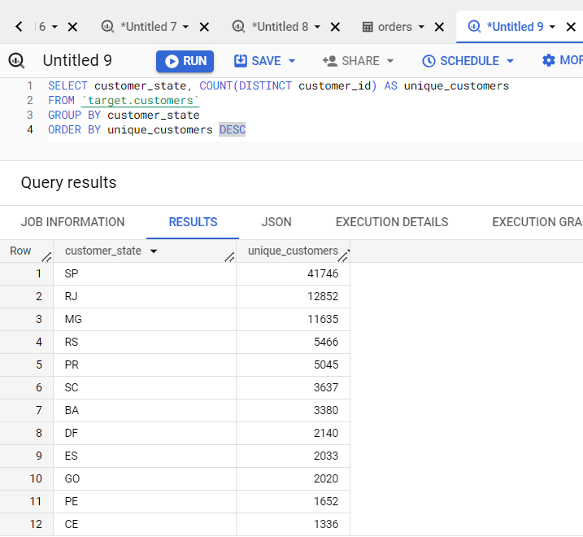

**Analysis:-**

1. Top three state in terms of customers SP, RJ and MG
2. Bottom three state in terms of customers are RR, AP and AC

**Q4.** **Impact on Economy: Analyze the money movement by e-commerce by looking at order prices, freight and others.**

**Q4.1 Get the % increase in the cost of orders from year 2017 to 2018 (include months between Jan to Aug only).**

**Query :-**

WITH orders_2017 AS (  
SELECT  
    o.order_id,  
    o.order_purchase_timestamp,    p.payment_value  
FROM `target.orders` o  
JOIN `target.payments` p ON o.order_id = p.order_id  
WHERE  
EXTRACT(YEAR FROM o.order_purchase_timestamp) = 2017  
AND EXTRACT(MONTH FROM o.order_purchase_timestamp) BETWEEN 1 AND 8),

orders_2018 AS (

SELECT

    o.order_id,

    o.order_purchase_timestamp,

    p.payment_value

FROM `target.orders` o

JOIN `target.payments` p ON o.order_id = p.order_id

WHERE

EXTRACT(YEAR FROM o.order_purchase_timestamp) = 2018

AND EXTRACT(MONTH FROM o.order_purchase_timestamp) BETWEEN 1 AND 8 )

SELECT

  (SUM(orders_2018.payment_value) - SUM(orders_2017.payment_value)) / SUM(orders_2017.payment_value) * 100 AS percentage_increase

FROM orders_2017

FULL OUTER JOIN

orders_2018 ON orders_2017.order_id = orders_2018.order_id;

**screenshot**

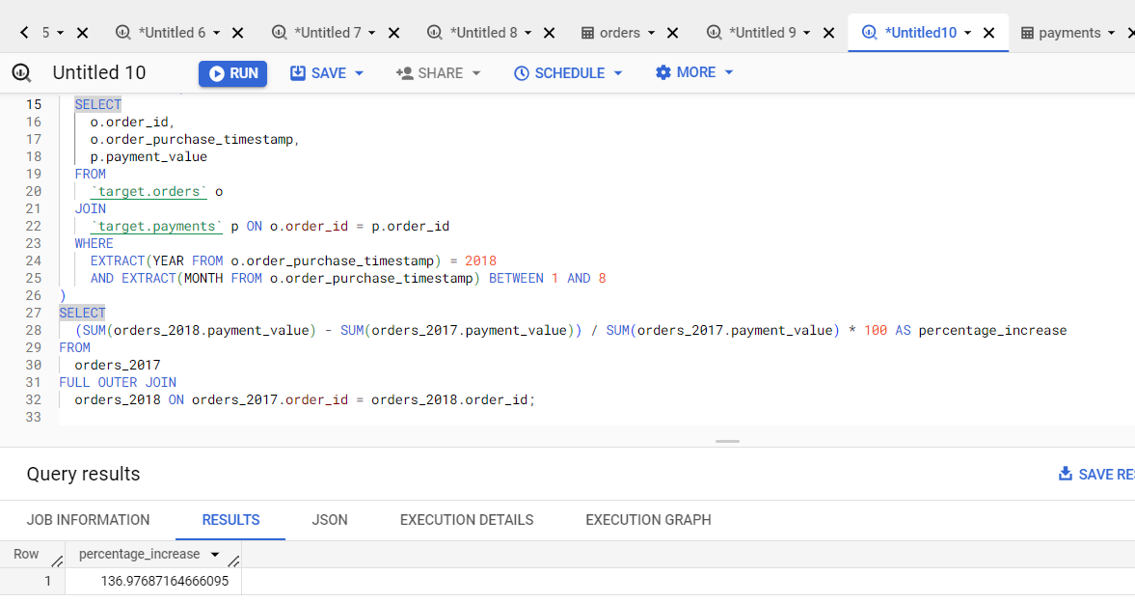

**Q4.2. Calculate the Total & Average value of order price for each state.**

**Query:-**

SELECT

  c.customer_state,

  ROUND(SUM(oi.price),2) AS total_order_price,

  ROUND(AVG(oi.price),2) AS average_order_price

FROM `target.orders` o

JOIN `target.customers` c ON o.customer_id = c.customer_id

JOIN `target.order_items` oi ON o.order_id = oi.order_id

GROUP BY c.customer_state

ORDER BY total_order_price desc , average_order_price desc

Screenshot:-

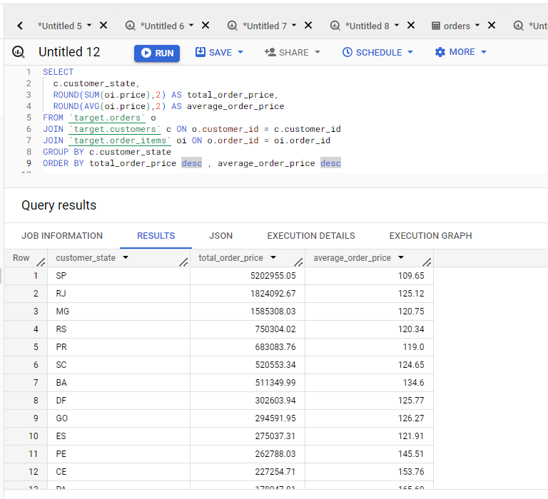

**Analysis :-**

1. Top three state in terms of max total order price are SP, RJ, MG
2. Top three state in terms of avg order price are PB, AL, AC
3. Bottom three state in terms of total order price are RR, AP, AC
4. Bottom three state in terms of avg order price are SP, PR, RS

**Q4.3 Calculate the Total & Average value of order freight for each state**

**Query :-**

SELECT  
  c.customer_state,  
  ROUND(SUM(oi.freight_value),2) AS total_freight_value,  
  ROUND(AVG(oi.freight_value),2) AS average_freight_value  
FROM `target.orders` o  
JOIN `target.customers` c ON o.customer_id = c.customer_id  
JOIN `target.order_items` oi ON o.order_id = oi.order_id  
GROUP BY c.customer_state  
ORDER BY total_freight_value desc, average_freight_value desc

**Screenshot:-**   
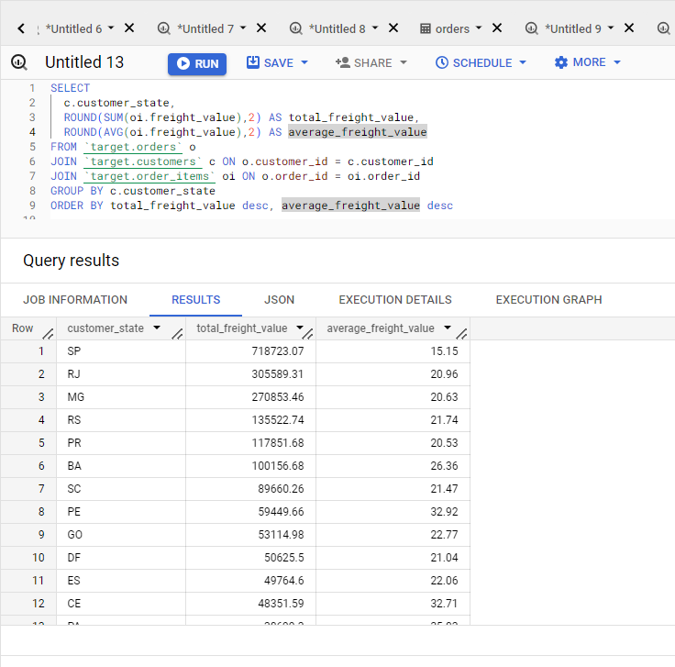

**Analysis :-**

1. Top three state in terms of max total freight value are SP, RJ, MG
2. Top three state in terms of avg freight value are RR, PB, RO
3. Bottom three state in terms of total freight value are RR, AP, AC
4. Bottom three state in terms of avg freight value are SP, PR, MG

**Q5**. **Analysis based on sales, freight and delivery time.**

**Q5.1 Find the no. of days taken to deliver each order from the order’s purchase date as delivery time.  
Also, calculate the difference (in days) between the estimated & actual delivery date of an order.**

**Query :-**

SELECT order_id,

DATE_DIFF(order_delivered_customer_date, order_purchase_timestamp, DAY) AS delivery_time,

DATE_DIFF(order_estimated_delivery_date, order_delivered_customer_date, DAY) AS diff_estimated_delivery

FROM `target.orders`

WHERE order_status = 'delivered'

ORDER BY delivery_time desc, diff_estimated_delivery desc;

**Screenshot :-**  
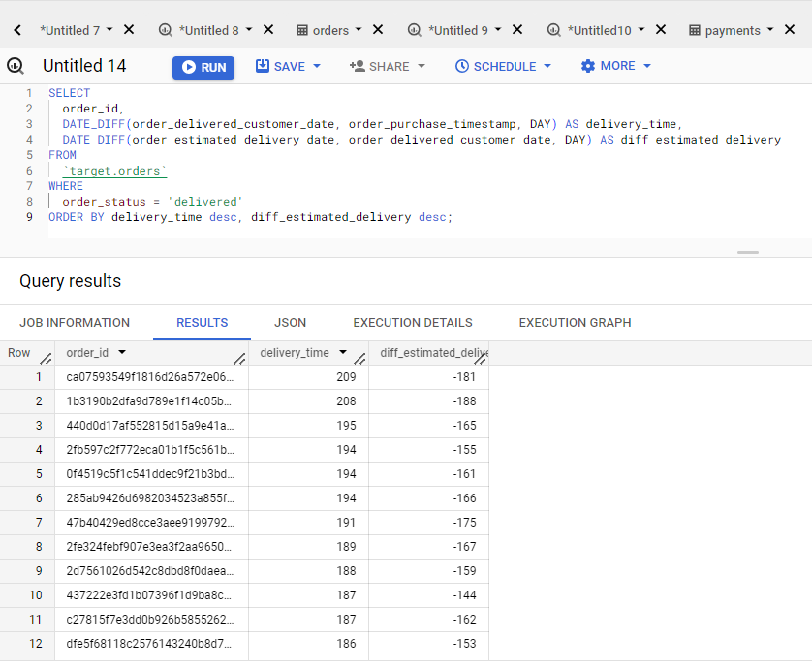

**Analysis :-**

1. Maximum delivery time = 209 days
2. Minimum delivery time = 0 days
3. Maximum diff estimated delivery = 146 days
4. Minimum diff estimated delivery = -188 days (delivered before time)

**Q5.2 Find out the top 5 states with the highest & lowest average freight value.**

1. **Highest**

**Query**

SELECT

  customer_state,

  AVG(freight_value) AS average_freight

FROM

  `target.orders` o

JOIN

  `target.customers` c ON o.customer_id = c.customer_id

JOIN

  `target.order_items` oi ON o.order_id = oi.order_id

GROUP BY

  customer_state

ORDER BY

  average_freight DESC

LIMIT

  5;

**Screenshot**

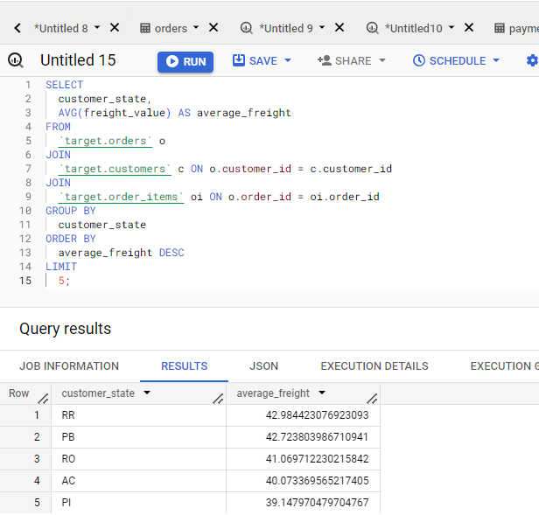

1. **Lowest**

**Query :-**

SELECT

  customer_state,

  AVG(freight_value) AS average_freight

FROM

  `target.orders` o

JOIN

  `target.customers` c ON o.customer_id = c.customer_id

JOIN

  `target.order_items` oi ON o.order_id = oi.order_id

GROUP BY

  customer_state

ORDER BY

  average_freight ASC

LIMIT

  5;

**Screenshot:-**

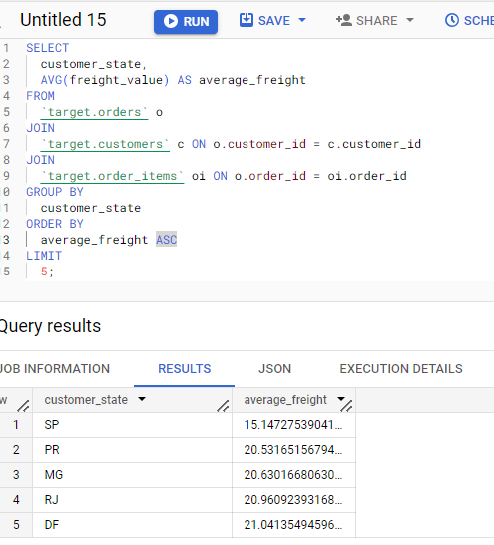

**Q 5.3 Find out the top 5 states with the highest & lowest average delivery time.**

**A. highest**

**Query :-**

SELECT

  customer_state,

  AVG(DATE_DIFF(order_delivered_customer_date, order_purchase_timestamp, DAY)) AS average_delivery_time

FROM

  `target.orders` o

JOIN

  `target.customers` c ON o.customer_id = c.customer_id

WHERE

  order_status = 'delivered'

GROUP BY

  customer_state

ORDER BY

  average_delivery_time DESC

LIMIT

  5;

**Screenshot:-**

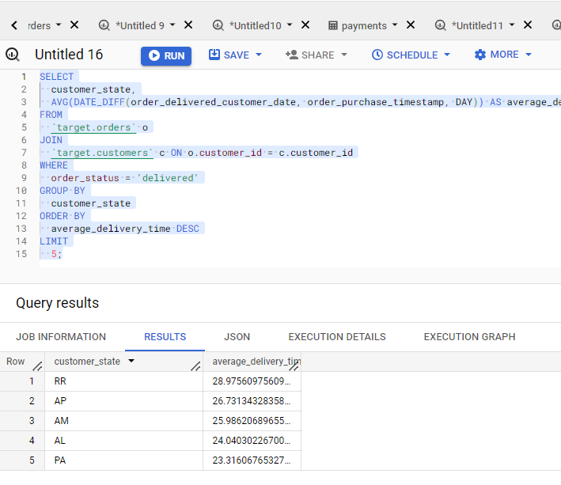

**B. Lowest**

**Query :-**

SELECT

  customer_state,

  AVG(DATE_DIFF(order_delivered_customer_date, order_purchase_timestamp, DAY)) AS average_delivery_time

FROM

  `target.orders` o

JOIN

  `target.customers` c ON o.customer_id = c.customer_id

WHERE

  order_status = 'delivered'

GROUP BY

  customer_state

ORDER BY

  average_delivery_time ASC

LIMIT

  5;

**Screenshot:-**

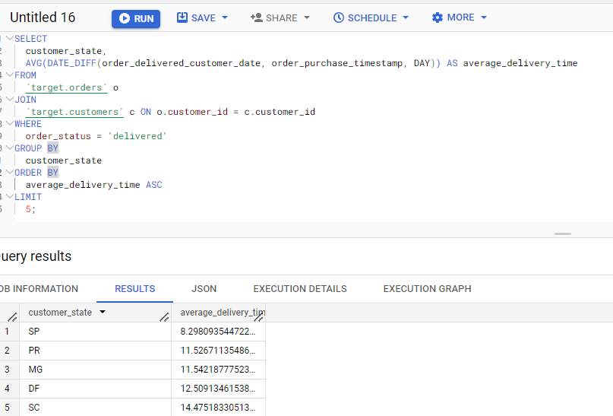

**Q 5.4. Find out the top 5 states where the order delivery is really fast as compared to the estimated date of delivery.**

**Query :-**

SELECT

  customer_state,

  AVG(DATE_DIFF(order_estimated_delivery_date, order_delivered_customer_date, DAY)) AS diff_average_delivery

FROM

  `target.orders` o

JOIN

  `target.customers` c ON o.customer_id = c.customer_id

WHERE

  order_status = 'delivered'

GROUP BY

  customer_state

HAVING

  diff_average_delivery > 0

ORDER BY

  diff_average_delivery ASC

LIMIT

  5;

**Screenshot:-**

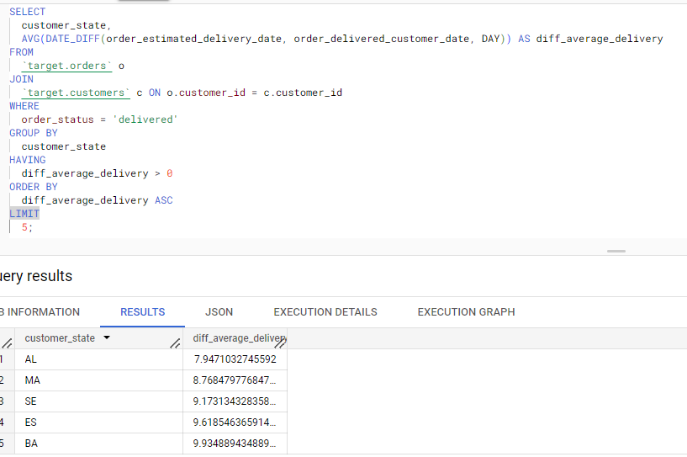

**Q6.** **Analysis based on the payments:**

**Q6.1 Find the month on month no. of orders placed using different payment types.**

**Query:-**

SELECT

  EXTRACT(MONTH FROM o.order_purchase_timestamp) AS month,

  p.payment_type,

  COUNT(DISTINCT o.order_id) AS num_orders

FROM

  `target.orders` o

JOIN

  `target.payments` p ON o.order_id = p.order_id

GROUP BY

  month,

  p.payment_type

ORDER BY

  month;

**Screenshot:-**

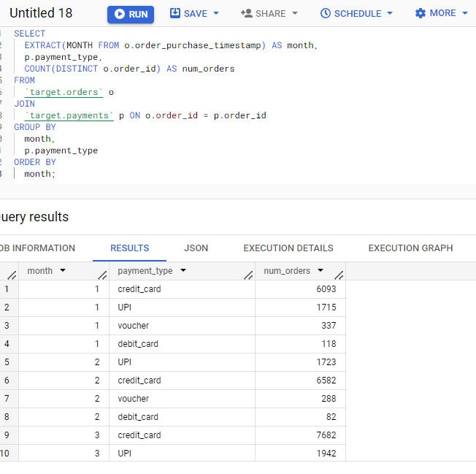

**Q6.2 Find the no. of orders placed on the basis of the payment installments that have been paid.**

**Query**:-

SELECT

  payment_installments,

  COUNT(DISTINCT order_id) AS num_orders

FROM

  `target.payments`

WHERE

  payment_installments > 0

GROUP BY

  payment_installments;

**Screenshot** :-

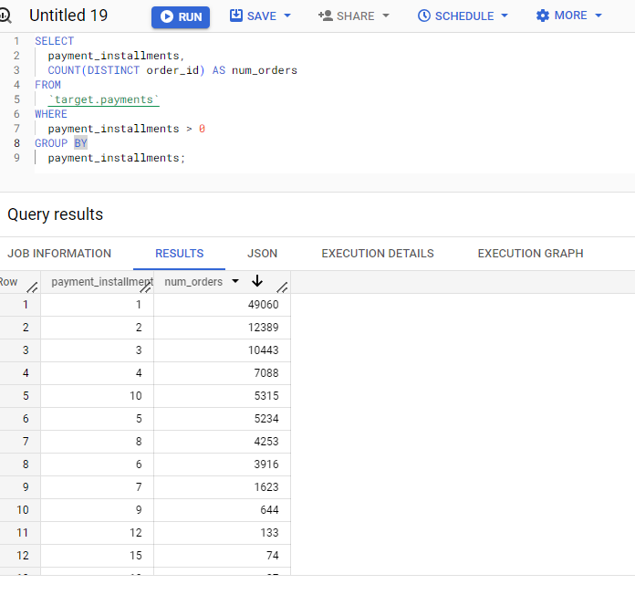

**Analysis :-**

1. Maximum order places with single instalment i.e., full payment
2. Minimum orders are placed with 22 and 23 instalments (single order each)