Finance Analytics Dashboard using Power BI
A comprehensive financial performance dashboard built in Power BI to analyze key financial metrics such as sales, profit, cost, discounts, and product-wise performance across countries and time periods.
Contents
Finance Analytics Dashboard using Power BI 1
Overview 1
Problem Statement 1
Build Dashboard using Power BI 1
Key Insights 2
Tools & Technologies 3
Results & Conclusion 3

Overview
The Finance Analytics Dashboard provides a data-driven understanding of a company’s financial health by visualizing performance across multiple dimensions — including sales, profit, cost, COGS, COGS_to_Sales %, Profit_Margin %, Discount, Product, product category, country, segment, and discount bands. It enables stakeholders to identify revenue drivers, profitability trends, and underperforming areas, helping make strategic business decisions.

Problem Statement
The finance department needed a consolidated, visual representation of the company’s financial performance to replace static and time-consuming manual reporting.
Challenges included:
- Lack of centralized visibility into key KPIs (Sales, Profit, Units Sold, COGS, COGS to Sales %, Profit Margin %, Discounts)
- Inability to quickly analyze financial performance by region, product, segment, discount band, or time
- Difficulty in identifying profitability patterns and discount impacts
This dashboard solves these problems by integrating all critical KPIs and financial visuals in one interactive report.

Build Dashboard using Power BI
Data Preparation Steps:
1. Imported CSV dataset (financial_data.csv) into Power BI.
2. Cleaned and transformed data using Power Query (renaming fields, removing duplicates, correcting data types).
3. Created calculated columns and measures using DAX for KPIs like Total Sales, Total Gross Sales, Avg Sales, Total Profit, Total Unit Sold, Total Discount, Total COGS, Profit Margin %, COGS-to-Sales ratio, and Total Cost.
Dashboard Design & Explanation:
Top Filters Panel:
- Year, Month, Segment, Country, and Product slicers for dynamic filtering.
- Enables performance comparison across different time periods and dimensions.
KPI Cards (Top Row):

Total Sales & Profit by Country:
- Line & Stacked column Chart showing country-wise Total Sales and Total Profit.
- USA and Canada lead in sales; Mexico shows lower profitability.
Total Sales & Profit by Year and Month:
- Line chart displaying monthly and yearly sales and profit trends.
- Profit peaks in Dec 2014 ($2M profit with $11.7M sales).
Gross Sales vs Discount by Product and Country:
- Bubble Chart showing Gross Sales vs Total Discount and Units Sold.
- Identifies high-performing products with minimal discount dependency.
Sales by Product & Discount Band:
- Matrix table summarizing performance by product and discount category (High, Medium, Low, None).
- Paseo generates highest revenue ($32.42M); low/medium discount products yield better profitability.
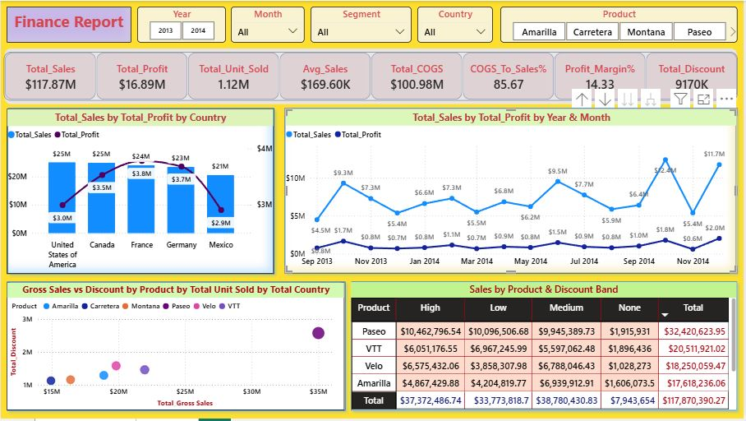
Dashboard

Key Insights
1. Total Revenue: $117.87M and Total Profit: $16.89M.
2. Profit Margin: 14.33%; COGS accounts for 85.67% of total sales.
3. USA and Canada lead in Revenue, France and Germany lead in profit.
4. Sales peak in October 2014.
5. High discounts reduce profit margins.
6. Paseo is the top-selling product ($32.4M revenue).
7. Mexico has low profit despite moderate sales.
8. Products with low/medium discounts show better profitability.

Tools & Technologies
Database: CSV File (financial_data.csv)
Data Cleaning: Power Query
Data Analysis: DAX (Data Analysis Expressions)
Visualization: Microsoft Power BI
Data Modeling: Star Schema
Reporting: Interactive Power BI Dashboard

Results & Conclusion
The Finance Analytics Dashboard provides a clear and dynamic view of financial KPIs, enabling faster and smarter decision-making.
Benefits:
- Replaced static Excel reports with interactive visuals.
- Provided real-time financial insights.
- Allowed comparison by product, region, and time.
Outcomes:
- Improved discount and pricing strategies.
- Focus on high-margin markets.
- Better operational cost management.
Final Result: A fully interactive and data-driven financial monitoring system supporting strategic business decisions.

