Pizza Sales Analysis using PostgreSQL and Power BI
End-to-end analytics pipeline using PostgreSQL for data cleaning & analysis and Power BI for interactive dashboards to uncover sales trends and performance drivers from pizza sales performance data

Contents
Overview 1
Problem Statement 2
KPI’s REQUIREMENT 2
CHARTS REQUIREMENT 2
Data Cleaning in PostgreSQL 3
Data Analysis using PostgreSQL 3
ANALYSIS OF DIFFERENT SQL STATEMENT ON DATA BASE 3
Build Dashboard or a Report using Power BI 11
KPI’S 11
KEY INSIGHTS 11
12
Tools and Technologies 13
Results & Conclusion 13

Overview
This project explores historical pizza-sales data to:
- Identify top-performing products, categories & sizes
- Detect weekly / daily / hourly demand patterns
- Build KPI-driven dashboards for management decisions
The workflow covers data extraction, transformation, and loading (ETL) in PostgreSQL, SQL-based analytics, followed by the creation of an interactive dashboard in Power BI that provides actionable insights into sales performance, popular products, and category contributions.

Problem Statement

KPI’s REQUIREMENT

We need to analyze key indicators for our pizza sales data to gain insights into our business performance. Specifically, we want to calculate the following metrics:
- Total Revenue: The sum of the total price of all pizza orders.
- Average Order Value: The average amount spent per order, calculated by dividing the total revenue by the total number of orders.
- Total Pizzas Sold: The sum of the quantities of all pizzas sold.
- Total Orders: The total number of orders placed.
- Average Pizzas Per Order: The average number of pizzas sold per order, calculated by dividing the total number of pizzas sold by the total number of orders.

CHARTS REQUIREMENT
We would like to visualize various aspects of our pizza sales data to gain insights and understand key trends. We have identified the following requirements for creating charts:

1. Hourly Trend for Total Pizzas Sold: Create a stacked column chart that displays the hourly trend of total pizza sold over a specific time period. This chart will help us identify any patterns or fluctuations in quantity sold on a hourly basis.

2. Weekly Trend for Total Orders: Create a line chart that illustrates the weekly trend of total orders throughout the year. This chart will allow us to identify peak weeks or periods of high order activity.

3. Daily Trend for Total Orders: Create a stacked column chart that displays the daily trend of total orders throughout the year. This chart will help us identify any patterns or fluctuations in total orders on a daily basis.
4. Percentage of Sales by Pizza Category: Create a donut chart that shows the distribution of sales across different pizza categories. This chart will provide insights into the popularity of various pizza categories and their contribution to overall sales.

5. Percentage of Sales by Pizza Size: Generate a donut chart that represents the percentage of sales attributed to different pizza sizes. This chart will help us understand customer preferences for pizza sizes and their impact on sales.

6. Total orders & Pizzas Sold by Pizza Category: Create a stacked bar chart that presents the total orders & total number of pizzas sold for each pizza category. This chart will allow us to compare the sales performance of different pizza categories.

7. Top 5 Best Sellers by Revenue, Total Quantity and Total Orders: Create a funnel chart and stacked bar charts, highlighting the top 5 best-selling pizzas based on the Revenue, Total Quantity, Total Orders. This chart will help us identify the most popular pizza options.

8. Bottom 5 Best Sellers by Revenue, Total Quantity and Total Orders: Create a funnel chart and stacked bar charts, showcasing the bottom 5 worst-selling pizzas based on the Revenue, Total Quantity, Total Orders. This chart will enable us to identify underperforming or less popular pizza options.

Data Cleaning in PostgreSQL
1️⃣ Trim & Normalize Text
```sql
UPDATE Pizza_Sales_Data
SET pizza_name = INITCAP(TRIM(pizza_name)),
pizza_category = INITCAP(TRIM(pizza_category)),
pizza_size = UPPER(TRIM(pizza_size));
```
2️⃣ Map Abbreviations to Full Size Names
```sql
UPDATE Pizza_Sales_Data
SET pizza_size = CASE
WHEN pizza_size IN ('L','LG') THEN 'Large'
WHEN pizza_size = 'M' THEN 'Medium'
WHEN pizza_size = 'S' THEN 'Small'
WHEN pizza_size = 'XL' THEN 'Upper_Large'
WHEN pizza_size = 'XXL' THEN 'Very_Large'
ELSE pizza_size
END;
```

Data Analysis using PostgreSQL

ANALYSIS OF DIFFERENT SQL STATEMENT ON DATA BASE
- KPI’s
- Total Revenue:
SELECT ROUND(SUM(total_price),2)AS Total_Revenue FROM Pizza_Sales_Data;
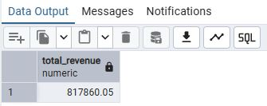
- Average Order Value:
SELECT ROUND(SUM(total_price)/COUNT(DISTINCT order_id),2)AS Avg_Order_Value
FROM Pizza_Sales_Data;
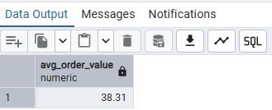
- Total Pizza Sold:
SELECT SUM(quantity)AS Total_Pizza_Sold FROM Pizza_Sales_Data;
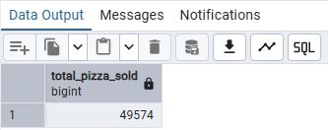
- Total Orders:
SELECT COUNT(DISTINCT order_id)AS Total_Orders FROM Pizza_Sales_Data;
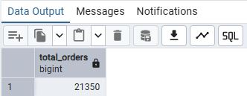
- Average Pizzas Per Order:
SELECT ROUND(CAST(SUM(quantity)AS DECIMAL(10,2))/CAST(COUNT(DISTINCT order_id)
AS DECIMAL(10,2)),2)AS Average_Pizzas_Per_Order
FROM Pizza_Sales_Data;
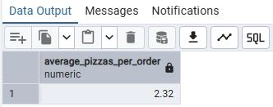

- Daily Trend for Total Orders(stacked by category)
SELECT TO_CHAR(order_date,'DAY')AS Order_Day, pizza_category,
COUNT(DISTINCT order_id)AS Total_Orders
FROM Pizza_Sales_Data
GROUP BY Order_Day, pizza_category ORDER BY Order_Day, pizza_category;
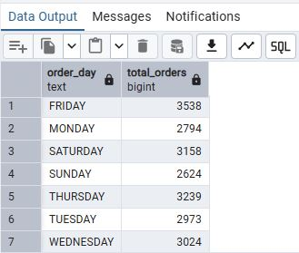
- Hourly Trend for Total Pizzas Sold(stacked by category)
SELECT EXTRACT(HOUR FROM order_time) AS order_time_hours,pizza_category,
SUM(quantity) AS total_quantity
FROM Pizza_Sales_Data
GROUP BY EXTRACT(HOUR FROM order_time), pizza_category
ORDER BY order_time_hours,pizza_category;
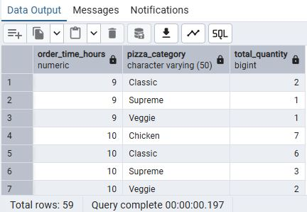
- Monthly and Weekly Trend for Orders(stacked by category)
SELECT DATE_PART('YEAR',order_date)AS Year_Extracted,
DATE_PART('MONTH',order_date)AS Month_Extracted,
DATE_TRUNC('WEEK',order_date)AS Start_of_Week,
pizza_category,
COUNT(DISTINCT order_id)AS Orders_Placed
FROM Pizza_Sales_Data
GROUP BY Year_Extracted, Month_Extracted, Start_of_Week, pizza_category
ORDER BY Month_Extracted,Start_of_Week, Orders_Placed DESC;
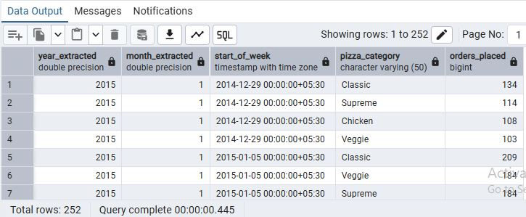
--D. Monthly Trend for Orders
SELECT TO_CHAR(order_date,'Month')AS Month_Extracted,
COUNT(DISTINCT order_id)AS Total_Orders
FROM Pizza_Sales_Data
GROUP BY Month_Extracted ORDER BY Total_Orders DESC;
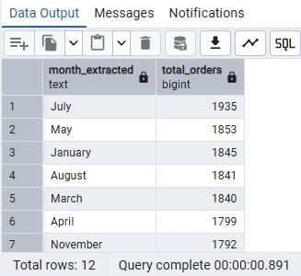
--D. Weekly Trend for Orders
SELECT DATE_TRUNC('WEEK',order_date)AS Start_Of_Week,
COUNT(DISTINCT order_id)AS Total_Orders
FROM Pizza_Sales_Data
GROUP BY Start_Of_Week ORDER BY Start_Of_Week;
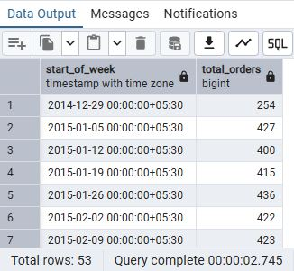
- % of Sales by Pizza Category
SELECT pizza_category, SUM(total_price)AS Total_Revenue,
ROUND(SUM(total_price)*100/(SELECT SUM(total_price) FROM Pizza_Sales_Data),2)
AS Perc_of_Total_Sales
FROM Pizza_Sales_Data
GROUP BY pizza_category ORDER BY Perc_of_Total_Sales DESC;
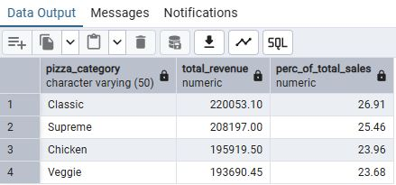
--E. % of Sales by Pizza Category(for Janauary month only)
SELECT pizza_category, SUM(total_price)AS Total_Sales,
ROUND(SUM(total_price)/(SELECT SUM(total_price) FROM Pizza_Sales_Data
WHERE DATE_PART('MONTH',order_date)=1)*100,2) AS Perc_of_Total_Sales
FROM Pizza_Sales_Data
WHERE DATE_PART('MONTH',order_date)=1
GROUP BY pizza_category ORDER BY Perc_of_Total_Sales DESC;
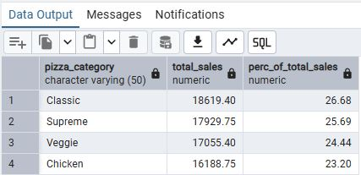
- % of Sales by Pizza Size
SELECT pizza_size, SUM(total_price) AS Total_Revenue,
ROUND(SUM(total_price)/(SELECT SUM(total_price) FROM Pizza_Sales_Data)*100,2) AS Perc_of_Total_Sales
FROM Pizza_Sales_Data
GROUP BY pizza_size ORDER BY Perc_of_Total_Sales DESC;
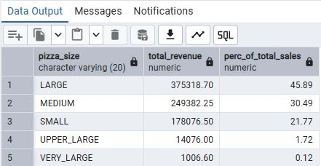
- % of Sales by Pizza Size(for 1st quarter only)
SELECT pizza_size, ROUND(SUM(total_price),2) AS Total_Revenue,
ROUND(SUM(total_price)/(SELECT SUM(total_price) FROM Pizza_Sales_Data
WHERE DATE_PART('QUARTER',order_date)=1)*100,2) AS Perc_of_Total_Sales
FROM Pizza_Sales_Data WHERE DATE_PART('QUARTER',order_date)=1
GROUP BY pizza_size ORDER BY Perc_of_Total_Sales DESC;
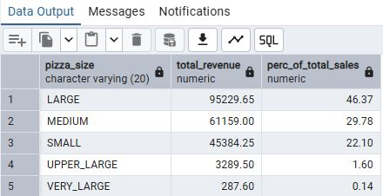
- Total Pizzas Sold by Pizza Category
SELECT pizza_category, SUM(quantity)AS Pizzas_Sold
FROM Pizza_Sales_Data
GROUP BY pizza_category ORDER BY Pizzas_Sold DESC;
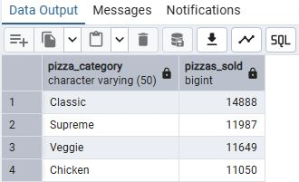
- Top 5 Pizzas by Revenue
SELECT pizza_name, SUM(total_price)AS Total_Revenue
FROM Pizza_Sales_Data
GROUP BY pizza_name ORDER BY Total_Revenue DESC
LIMIT 5;
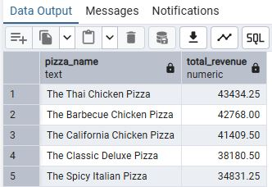
- Bottom 5 Pizzas by Revenue
SELECT pizza_name, SUM(total_price)AS Total_Revenue
FROM Pizza_Sales_Data
GROUP BY pizza_name ORDER BY Total_Revenue ASC
LIMIT 5;
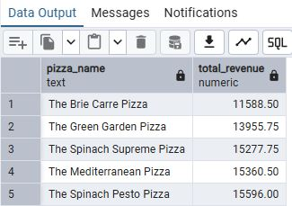
- Top 5 Pizzas by Quantity
SELECT pizza_name, SUM(quantity)AS quantity_sold
FROM Pizza_Sales_Data
GROUP BY pizza_name ORDER BY quantity_sold DESC
LIMIT 5;
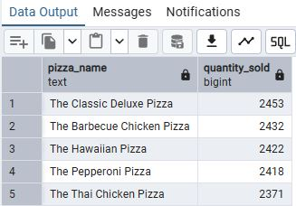
- Bottom 5 Pizzas by Quantity
SELECT pizza_name, SUM(quantity)AS quantity_sold
FROM Pizza_Sales_Data
GROUP BY pizza_name ORDER BY quantity_sold ASC
LIMIT 5;
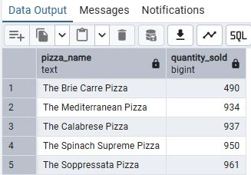
- Top 5 Pizzas by Total Orders
SELECT pizza_name, COUNT(DISTINCT order_id)AS Total_Orders
FROM Pizza_Sales_Data
GROUP BY pizza_name ORDER BY Total_Orders DESC
LIMIT 5;
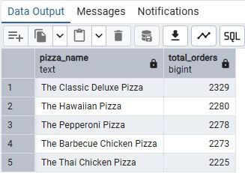
- Bottom 5 Pizzas by Total Orders
SELECT pizza_name, COUNT(DISTINCT order_id)AS Total_Orders
FROM Pizza_Sales_Data
GROUP BY pizza_name ORDER BY Total_Orders ASC
LIMIT 5;
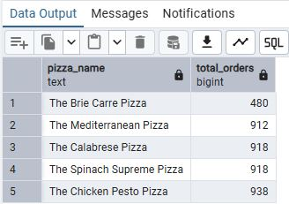

Build Dashboard or a Report using Power BI
Created comprehensive dashboard in Power BI featuring key metrics and charts, including Hourly Trend, Weekly Trend, Sales by Category, Sales by Size, Total Orders & Pizzas Sold by Category, Top 5 Best Sellers, and Bottom 5 Worst Sellers.

KPI’S
- Total Revenue = SUM('Data Model - Pizza Sales xlsx - pizza_sales'[total_price])
- Total Orders = DISTINCTCOUNT('Data Model - Pizza Sales xlsx - pizza_sales'[order_id])
- Avg Order Value = [Total Revenue]/[Total Orders]
- Total Pizzas Sold = SUM('Data Model - Pizza Sales xlsx - pizza_sales'[quantity])
- Avg Pizzas Per Order = [Total Pizzas Sold]/[Total Orders]
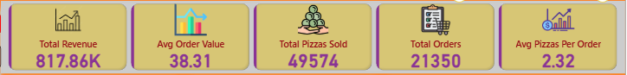

KEY INSIGHTS
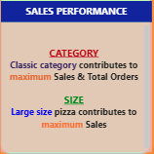
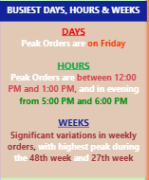
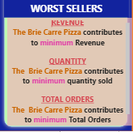
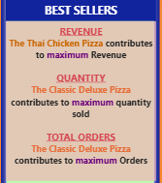

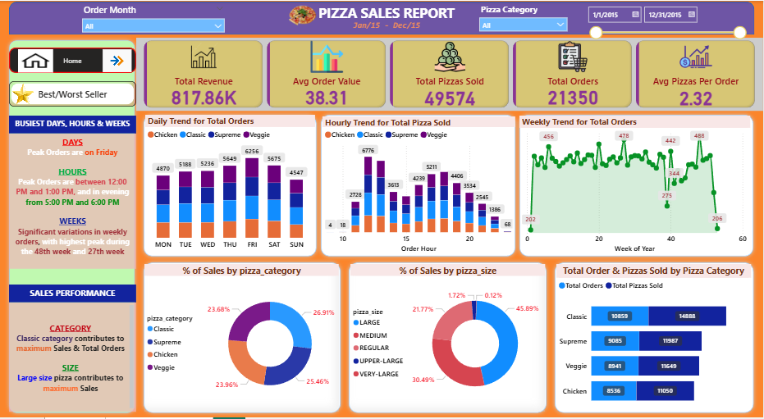
DASHBOARD

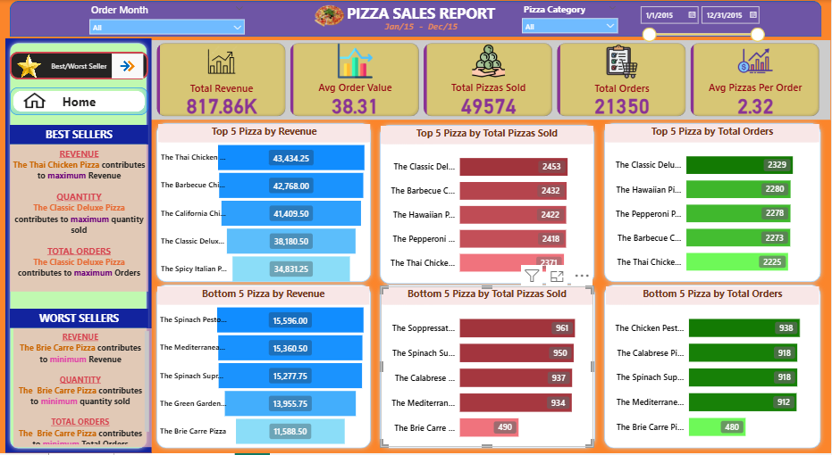

Tools and Technologies
Task | Tool
Database & Cleaning | PostgreSQL
Query Language | SQL
Visualization | Power BI Desktop
Data Transformation | Power Query
Presentation | Interactive Dashboards

Results & Conclusion
- The analysis provided a complete picture of pizza sales performance across time, categories, and products.
- Using PostgreSQL ensured efficient and scalable data processing, while Power BI enabled dynamic visualization of insights.
- The management team can now make data-driven decisions, such as:
  - Promoting high-margin pizza categories and sizes.
  - Offering discounts during low-sales hours.
  - Discontinuing underperforming pizzas.
In conclusion, this project demonstrates how combining SQL-based analytics with interactive Power BI dashboards can transform raw sales data into meaningful business intelligence.

