Stock Market Analysis Dashboard using Power BI
An interactive Power BI dashboard analyzing stock performance metrics — including closing prices, returns, volatility, and trading volumes — for major tech companies like Apple, Google, Microsoft, and Netflix.
Contents
Stock Market Analysis Dashboard using Power BI 1
Overview 1
Problem Statement 1
Build Dashboard using Power BI 1
Key Insights 3
Tools & Technologies 3
Results & Conclusion 3

Overview
This project focuses on understanding stock market behavior and investment performance using historical price and trading data of major companies.
The dashboard provides a comprehensive view of price movements, daily price change, cumulative returns, daily returns, trading volume, and volatility trends across different companies, enabling investors and analysts to make data-driven financial decisions.

Problem Statement
Investors often struggle to:
- Monitor stock price trends and volatility efficiently
- Compare performance between multiple companies
- Understand the risk-return relationship
- Identify daily trading patterns and cumulative performance
This project aims to solve these challenges by designing an interactive Power BI dashboard that visually presents all important stock metrics in one place, helping users easily analyze stock movements and risk factors.

Build Dashboard using Power BI
Step-by-Step Process:
1. Data Import & Cleaning:
- Imported the stocks.csv dataset into Power BI.
- Verified date formats, null values, and ensured data consistency.
- Created calculated columns and measures using DAX for Average Daily Return %, Cumulative Return %, Average Daily Volume, Average Volatility %, Daily Return %, Daily Return Value, Latest Close, Volatility 21-day, 21-Day MA, 7-Day MA.
2. Dashboard Layout:
The dashboard was built using two report pages, each focusing on specific financial aspects.
Page 1: Stock Performance Overview
KPI Cards:
Stock Closing Price Trend Over Time:
- Visualizes daily closing prices of Apple, Google, Microsoft, and Netflix.
- Compares performance over the selected date range (Feb–May 2023).
Cumulative Return % by Company:
- Microsoft (16.10%) and Apple (12.23%) lead in performance; Google: (-1.69%), Netflix shows (-11.07%).
Daily Price Change Analysis:
- Shows average daily price change for each company.
- Apple (+0.29%) and Google (+0.26%) have stable gains.
Company Volatility & Volume Summary:
- Table showing average volatility, return, and volume.
- Apple and Microsoft maintain low volatility with high trading activity.
Average Trading Volume by Stock:
- Clustered Bar chart comparing Average trading volumes.
- Microsoft and Apple dominate trading activity.
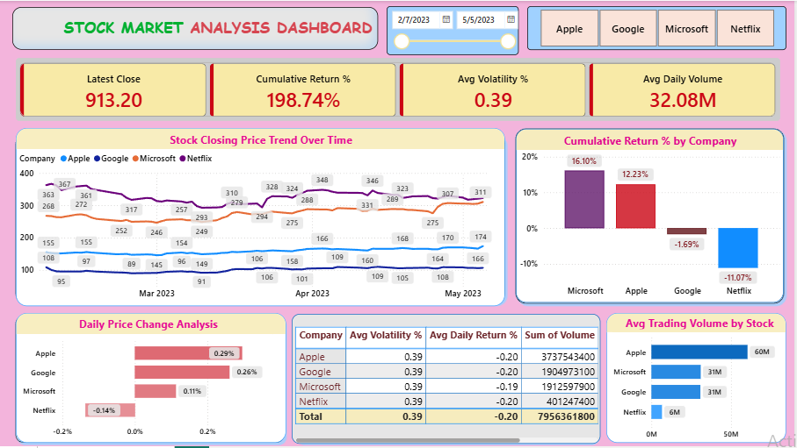

Page 2: Advanced Visualization Dashboard
KPI Cards:
Stock Closing Price Trend (with Moving Averages):
- Shows Sum of Close, 7-Day MA, and 21-Day MA.
- Indicates trend strength and direction.
Daily Trading Volume by Date & Company:
- Displays trading volume variation.
- Peaks indicate market volatility or news impact.
Daily Return % Over Time:
- Shows daily return swings.
- Microsoft shows consistent returns, Netflix fluctuates more.
Risk vs. Return Relationship:
- Scatter plot comparing average daily return vs volatility.
- Microsoft delivers higher return with low risk, making it ideal.
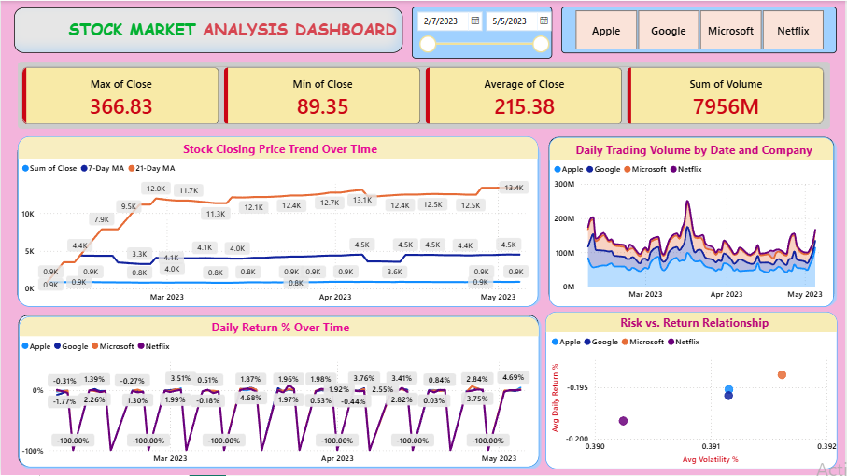

Key Insights
1. Microsoft shows the highest cumulative return (16.10%) and strong stability.
2. Apple maintains consistent growth with moderate volatility (0.39%).
3. Netflix records negative returns (-11.07%), indicating high risk.
4. Google displays mild returns with steady performance.
5. Apple dominate in Avg trading volume (~60M ).
6. Moving averages confirm bullish trends in early April 2023.
7. Risk-return scatter plot positions Microsoft as the most balanced performer.
8. Dashboard effectively tracks volatility and performance trends.

Tools & Technologies
Data Source: CSV File (stocks.csv)
Data Preparation: Power Query
Data Analysis: DAX (Data Analysis Expressions)
Visualization: Power BI Desktop
Chart Types: Line, Bar, Column, Area, Scatter Plot, KPI Cards, Tables
Reporting Style: Two Interactive Pages

Results & Conclusion
The Stock Market Analysis Dashboard provides a complete visual analysis of stock performance, helping investors monitor key indicators like returns, volatility, and trading volume.
Results:
- Real-time filtering by date and company.
- Detailed comparison of risk vs. return.
- Easy visualization of short- and long-term price trends.
Conclusion:
Power BI transforms raw stock data into actionable insights for investors.
The dashboard enables users to track stock behavior dynamically and supports better investment decisions.

