LAB ASSIGNMENT V : HUERISTIC EVALUATION
SYSTEM EVALUATED : Sinha Properties Real-Estate Website
Groups members NAME : ASHIT AMIT SINHA
**Evaluation to be done by other Group
PART I : HUERISTIC EVALUATION BASED ON NIELSEN'S 10 GENERAL PRINCIPLES FOR INTERACTION DESIGN. (0 is lowest and 10 is highest)
S.No. | Heuristic Evaluation Parameter | Mention Violation if any | Severity 0-10 (0- minimum and 10 is maximium) | Ways to improve
1 | User Control: Interface will allow the user to perceive that they are in control | Some actions may not clearly show the next step; users may need clearer feedback after selecting an option. | 8 | Use clear success messages after enquiry submission, brochure download, or visit scheduling; make closing pop-ups and returning to the project list easy.
2 | Human Limitations: Interface will not overload the users cognitive, auditory and motor skills | The homepage and project cards contain several details at once; users may need filters to narrow choices quickly. | 7 | Add filters for budget, city, configuration, and possession status; keep the most important property details prominent.
3 | Accommodation: The interface will fit the way each user group works and thinks (personas) | The layout suits homebuyers and families, with project details and contact options presented clearly. | 9 | -
4 | Linguistic Clarity: Interface will communicate as efficiently as possible | Most labels are understandable, but terms such as “Configuration” and “Possession” may be unfamiliar to first-time buyers. | 8 | Use plain-language labels or short explanations for “Configuration” and “Possession”; keep button wording action-oriented.
5 | Aesthetic Integrity :The interface will have an attractive and appropriate design | No major visual-design violation observed; the clean layout, navy/green palette, imagery, and spacing create a polished look. | 10 | Maintain the current visual hierarchy and contrast; check text readability and image quality on smaller screens.
6 | Simplicity: The interface will have a simple design | The page is generally simple, though the long homepage requires scrolling to reach testimonials and footer contact details. | 9 | Keep the main navigation accessible and consider a quick project-search/filter area so users do not need to scroll through every card.
7 | Predictability :The interface will behave in such a manner that the user can accurately predict what will happen next | Buttons such as “View Details,” “Download Brochure,” and “Schedule a Visit” make their purpose fairly predictable. | 8 | Keep action labels consistent and show what happens after each click; ensure Compare clearly indicates selected projects.
8 | Accuracy: Interface will be free from errors | The screenshots do not establish whether all links, forms, comparison controls, and downloads work correctly; functionality needs testing. | 7 | Test all navigation links, compare controls, enquiry forms, brochure download, and schedule-visit flow; provide helpful error messages.
9 | Technical Clarity: Interface will have the highest possible fidelity. | The high-fidelity layout is visually detailed, but responsive behaviour and real interaction states should be tested on different devices. | 7 | Test mobile/tablet layouts, keyboard navigation, focus states, and loading behaviour to ensure the prototype works beyond the desktop view.
10 | Fulfillment : The interface will provide a satisfying user experience | The website supports browsing projects and contacting the company, though buyers may need more details such as amenities and floor plans. | 9 | Include floor plans, amenities, maintenance/extra charges where applicable, and more project-specific information.
11 | Consistency: Interface will be consistent | Navigation, colours, typography, and button styling appear consistent across the shown sections. | 9 | Preserve consistent spacing, typography, colours, and button styles across all pages and pop-ups.
12 | User Support: Interface will provide additional assistance as needed or requested | Phone and email are available in the footer, but an FAQ or guided help option could answer common buyer questions. | 7 | Add FAQs and a simple enquiry form; clearly display office hours and what to expect after contacting the company.
13 | Precision: The interface will allow the users to perform a task exactly | Project cards show key facts, but filters for budget, location, and configuration would help users find an exact match. | 9 | Add practical filters and a side-by-side comparison view for price, location, configuration, possession, and amenities.
14 | Forgiveness: Interface will make action recoverable | The project details pop-up has a close control; confirm that forms provide clear validation and allow users to correct mistakes. | 9 | Ensure pop-ups can be closed with a clear close button and that forms retain valid entries when errors occur.
15 | Responsiveness: The interface will inform users about the results of their actions and their interface status | The interface communicates information through labels and visible buttons, but actions should show clear confirmation or status feedback. | 8 | Show loading, success, and error states for interactive actions; confirm enquiry receipt and visit-request submission.
 | Total Score |  | 124 / 150

**Attach Screenshots
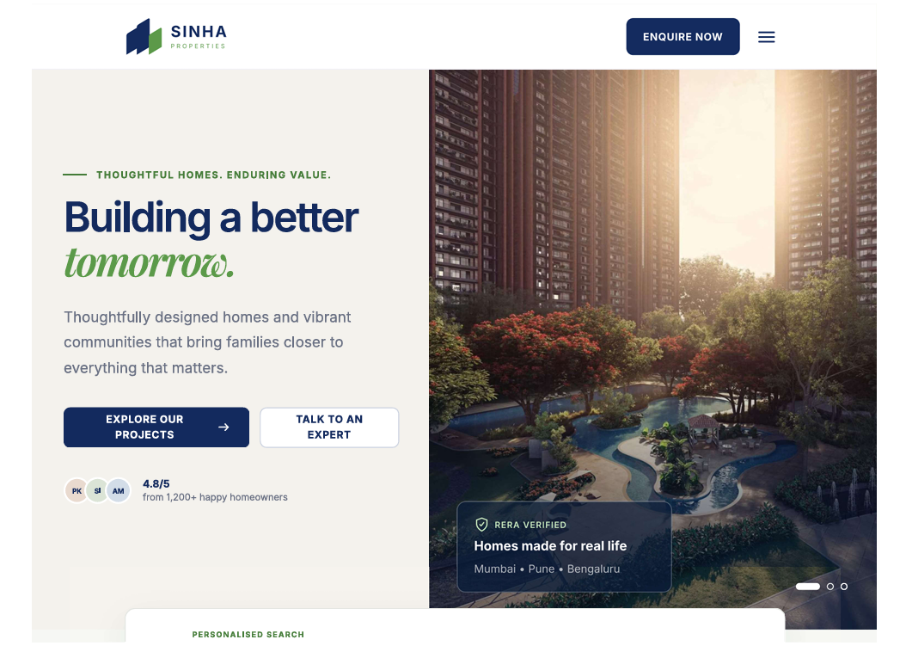
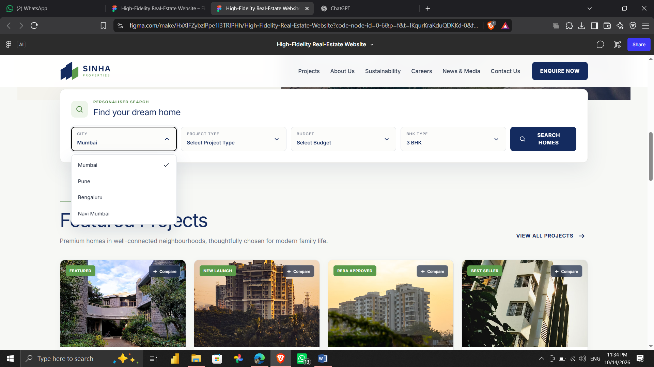

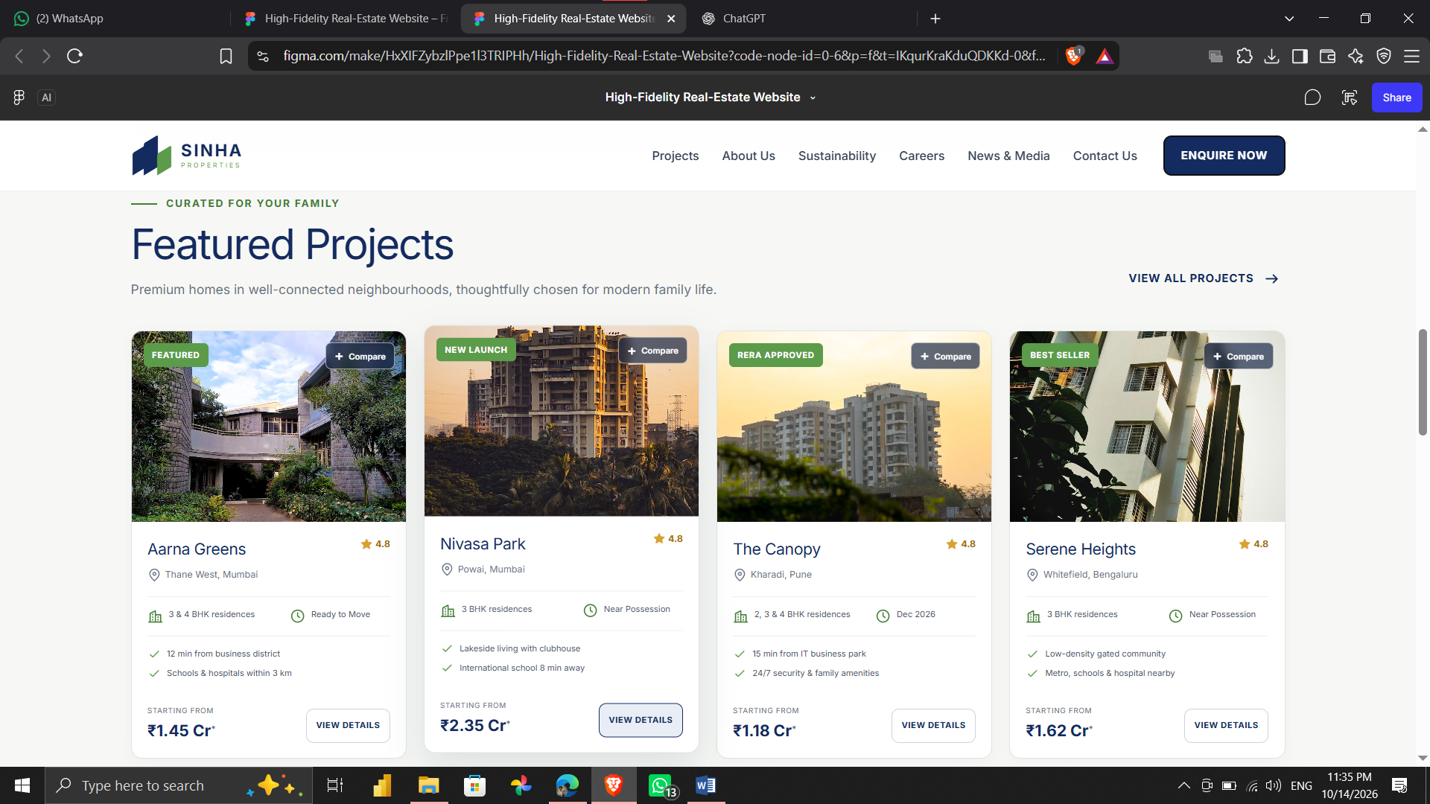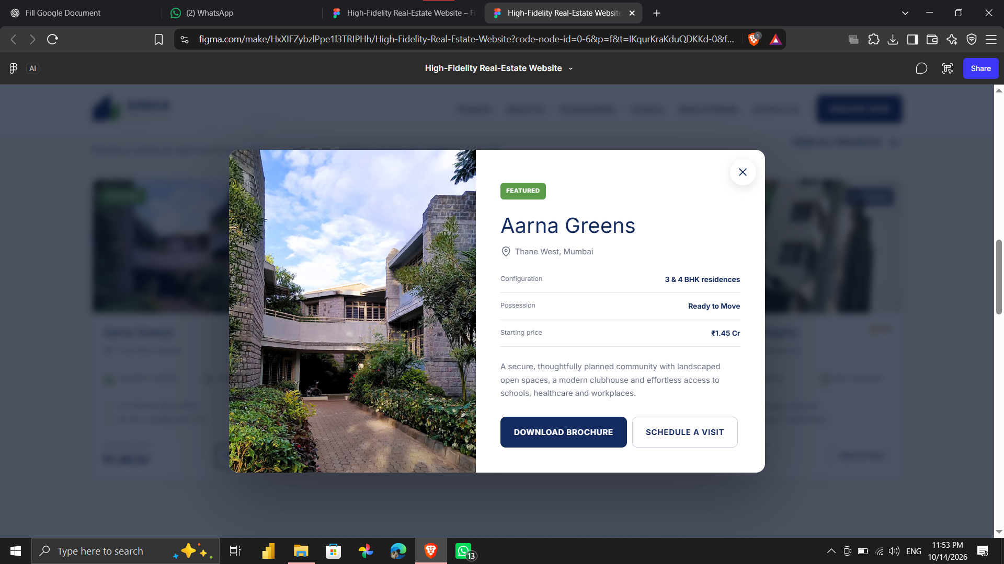

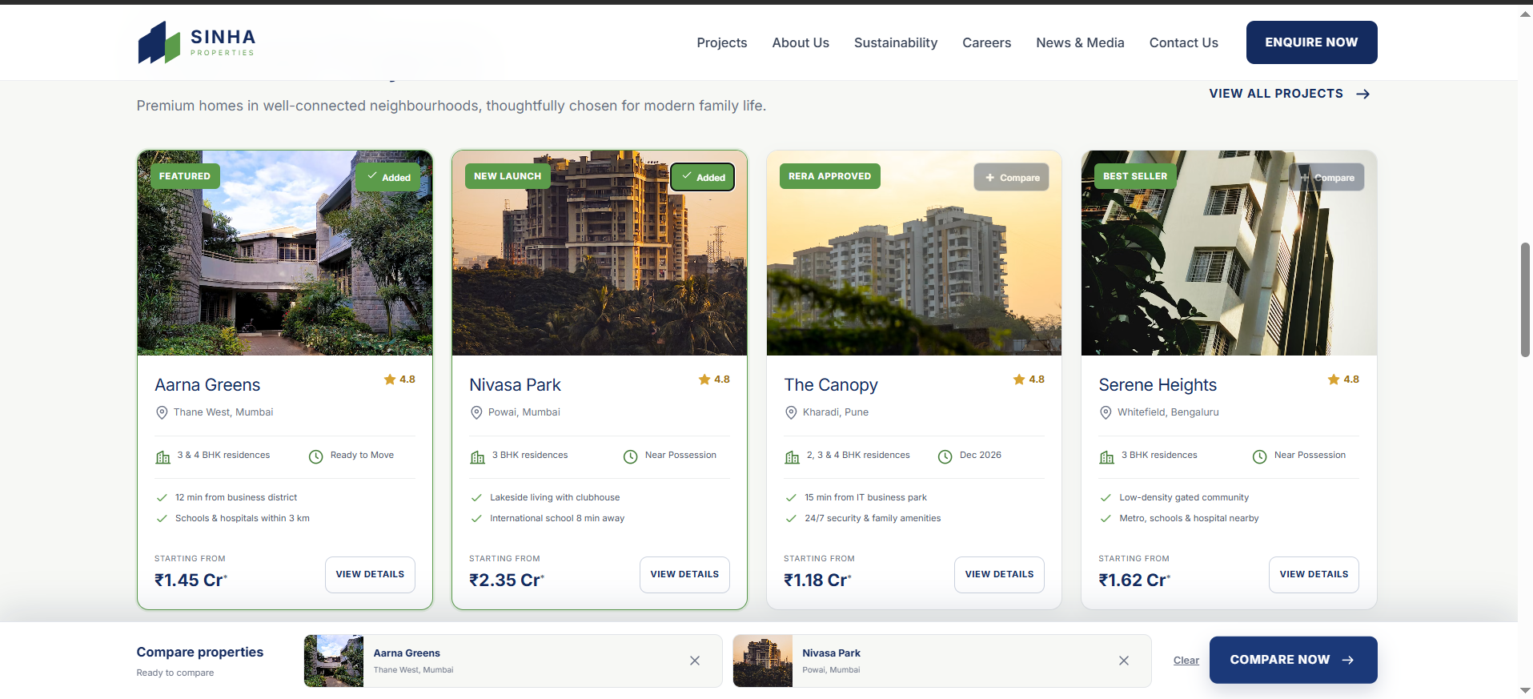
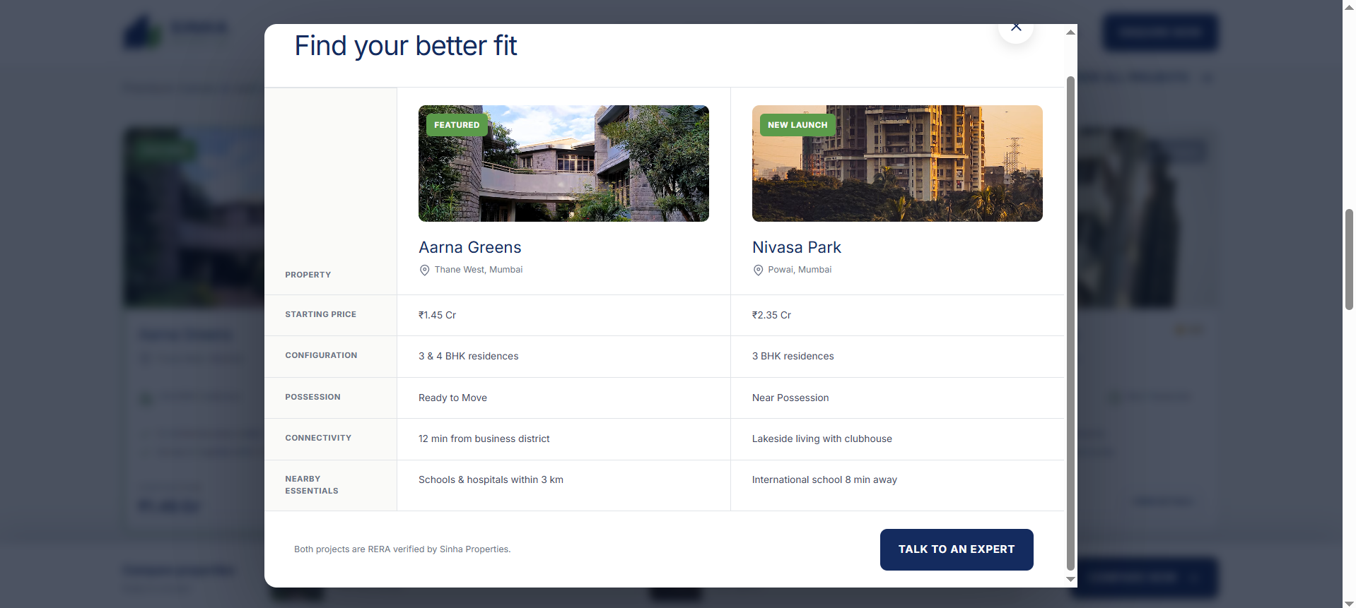
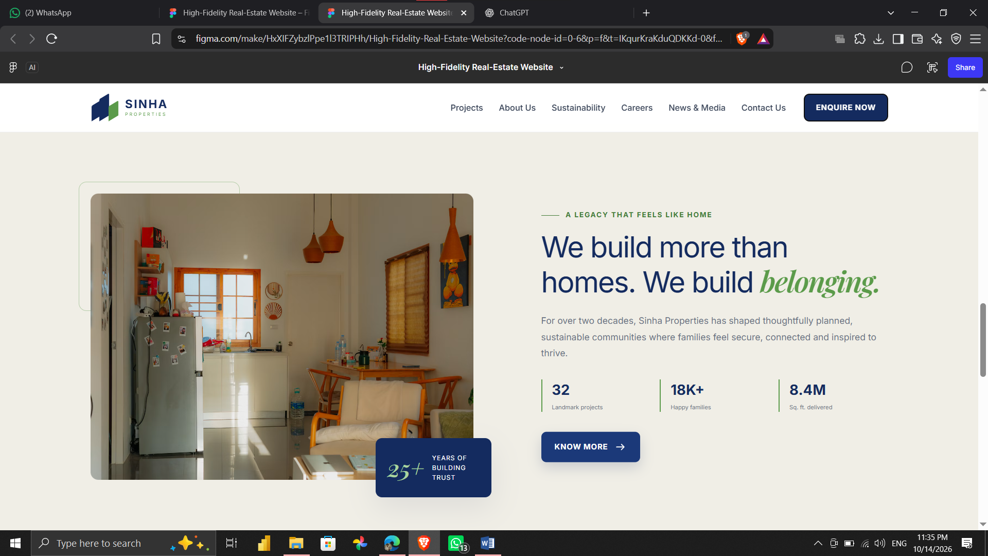
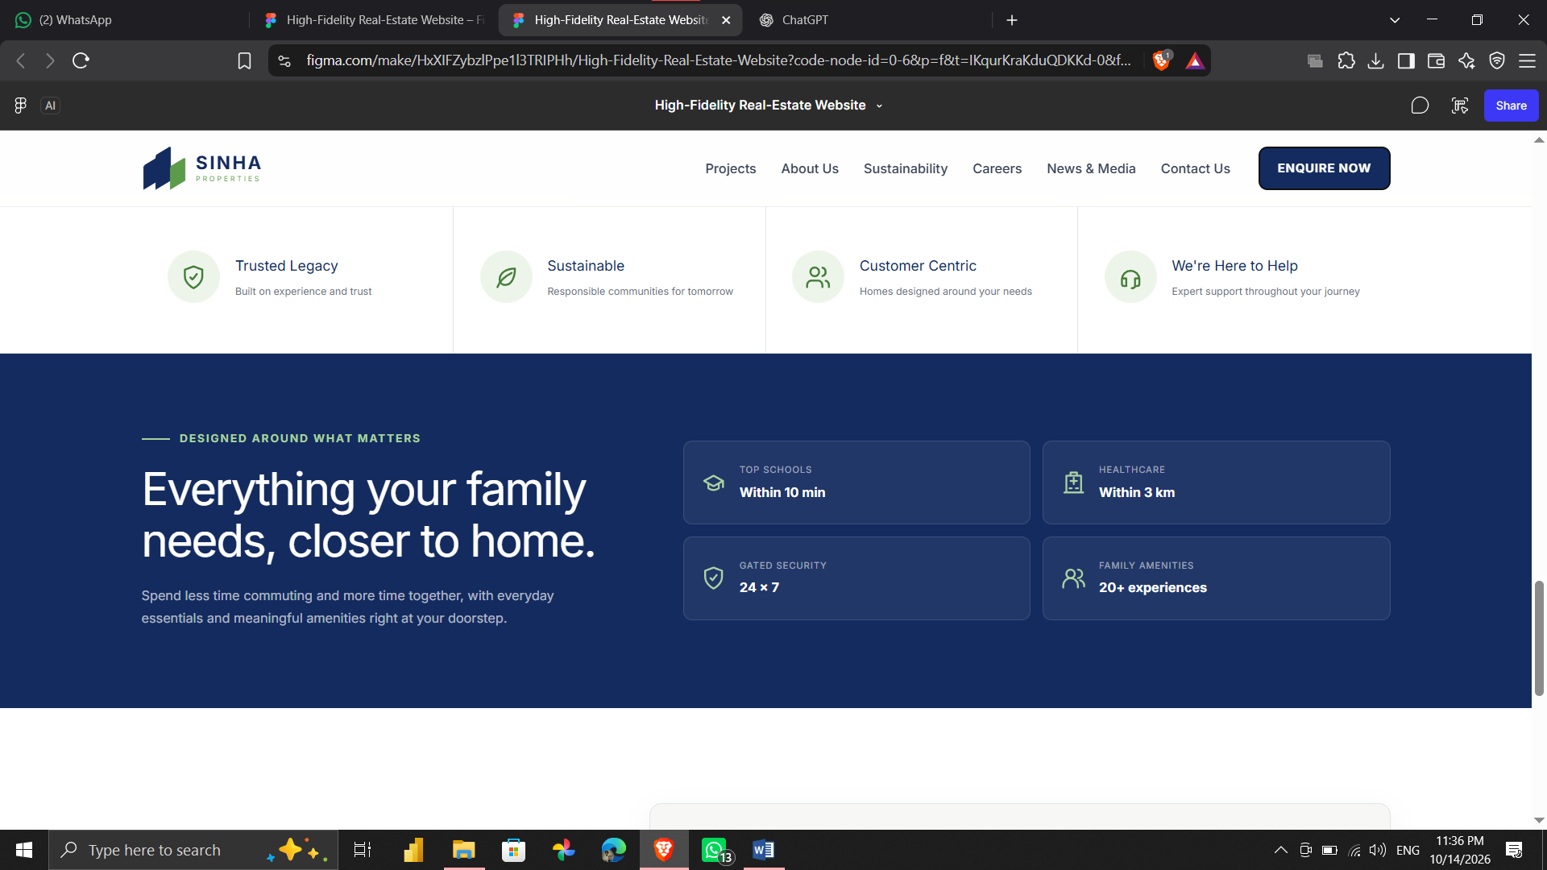

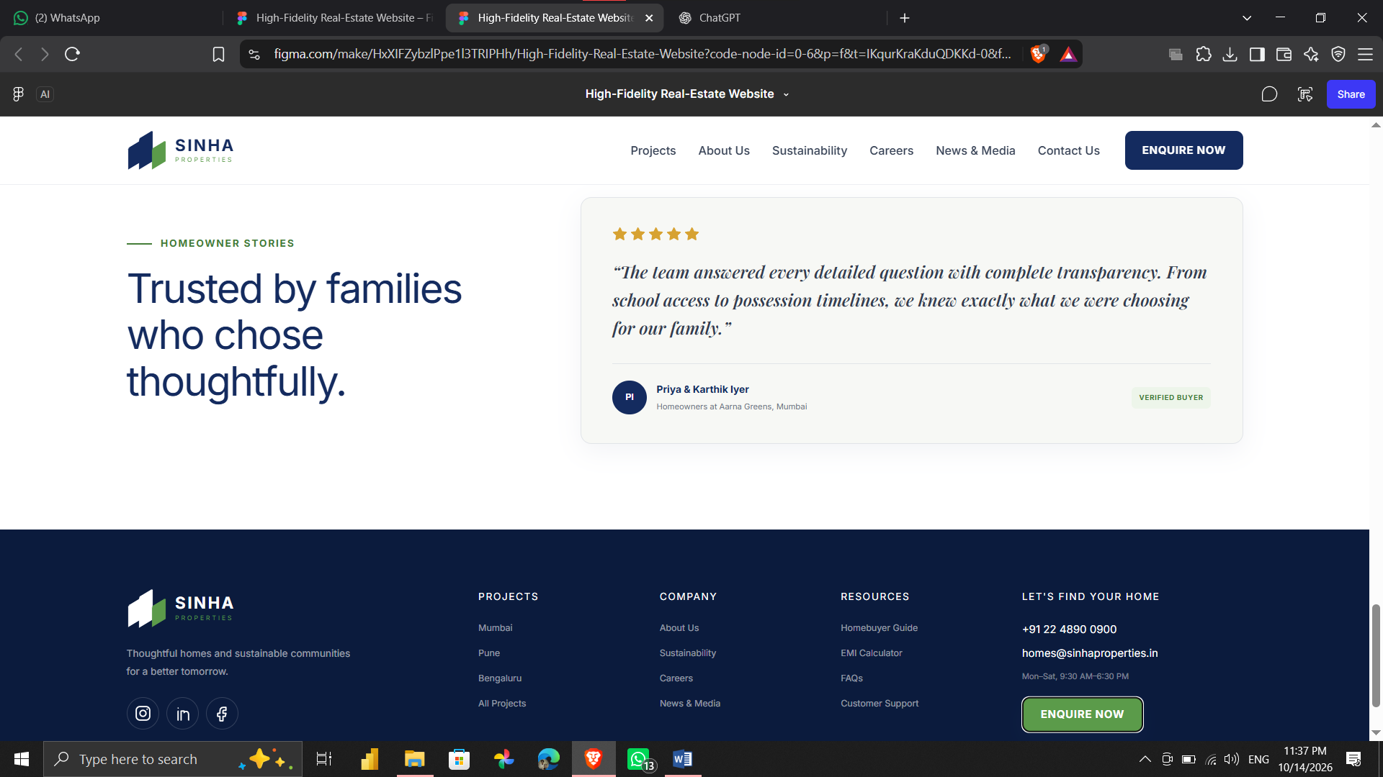

PART II : List out any other points that you may have missed out . (Other than Nielsen’s Principles)

S.NO | OBSERVATIONS | COMMENTS
1 | Property comparison support | Compare buttons are visible on project cards; a clear side-by-side comparison would help buyers judge options faster.
2 | Property information completeness | Cards show price, location, configuration and possession status; amenities, floor plans and additional charges could be easier to find.
3 | Mobile accessibility | The screenshots mainly show desktop layouts; test responsive behaviour, readable text and touch-friendly controls on mobile.
4 | Trust and transparency | Company statistics and a testimonial are shown; verified reviews, project documents and clear RERA details could strengthen confidence.

