Kk

Abstract
Chemical process design has traditionally relied on experimental data, thermodynamic modelling, and empirical correlations to assess feasibility and optimize separation processes. With the rise of data-driven methodologies, machine learning (ML) has become an essential tool for automating process evaluation and predicting outcomes with minimal manual intervention. Simultaneously, classical thermodynamic techniques such as the McCabe–Thiele graphical method continue to serve as a fundamental framework for analysing binary distillation systems.
This project integrates these two paradigms machine learning and process simulation into a unified Python-based computational framework for feasibility prediction and distillation design. The ML component utilizes Random Forest and Logistic Regression classifiers to predict the feasibility of given process conditions using a dataset of 1000 entries containing both numerical and categorical parameters such as feed composition, entrainer flow rate, and reflux ratio. Data preprocessing was performed using structured pipelines involving imputation, standardization and one-hot encoding. Model evaluation through GridSearchCV and cross-validation identified the Random Forest classifier as the superior model, achieving an F1-score of 0.84.
The simulation component implements the McCabe–Thiele method using Raoult’s law and Antoine’s equation to generate vapor–liquid equilibrium and operating lines. For a Benzene–Toluene binary system, the simulator computed nine theoretical stages with the feed stage located at the fifth level.This integrated framework demonstrates how combining ML-based predictive analytics with classical thermodynamic modeling can enhance accuracy, accelerate design, and promote automation in chemical process engineering.

1. Introduction
1.1 Background and Motivation
Chemical process design forms the foundation of industrial chemical engineering, where every process such as distillation, extraction, or absorption must first be tested for its technical and thermodynamic feasibility. Historically, engineers relied on extensive laboratory experiments and rigorous thermodynamic modeling to validate process configurations. Although this approach yields accurate results, it is time-consuming, expensive, and often requires significant computational effort.
With the rise of machine learning (ML) and modern computational tools, chemical engineers now have the ability to extract insights from historical data, identify feasibility boundaries, and predict the outcomes of new process configurations without performing complete simulations. ML models can recognize complex, nonlinear relationships between process variables such as feed composition, entrainer flow, reflux ratio, and system type and the feasibility outcome. As a result, they can rapidly evaluate new design scenarios, significantly reducing manual trial-and-error iterations.
At the same time, classical process simulation techniques like the McCabe–Thiele method remain fundamental in the design of distillation systems. The McCabe–Thiele graphical analysis provides a visual and intuitive understanding of vapor–liquid equilibrium (VLE) relationships and allows for the determination of the number of theoretical stages, feed stage location, and column efficiency for binary mixtures. It continues to be a cornerstone of separation process design and is taught universally in chemical engineering curricula.
This mini project combines these two complementary domains—data-driven predictive modeling and classical thermodynamic simulation—to create a unified framework that enhances the efficiency and accuracy of process design. The integration of ML and simulation demonstrates how emerging digital technologies can transform traditional engineering methods into intelligent, automated workflows.

1.2 Problem Statement
A cost-effective, Python-based tool is needed to efficiently simulate binary distillation, overcoming the limitations of manual methods and expensive commercial software.
1.3 Objectives of the Project
The primary objective of this project is to design and implement a unified computational framework that merges machine learning and thermodynamic modeling to analyze the feasibility and performance of distillation systems. The detailed objectives are as follows:
- Data Collection and Preprocessing:
To collect, clean, and preprocess the dataset containing numerical and categorical process parameters such as feed composition, reflux ratio, system type, and entrainer flow rate.
- Feasibility Prediction Using Machine Learning:
To train and optimize Random Forest and Logistic Regression models for predicting process feasibility, utilizing a structured scikit-learn pipeline with proper imputation, scaling, and encoding steps.
- Hyperparameter Optimization and Evaluation:
To use GridSearchCV and cross-validation techniques to optimize hyperparameters and compare model performance using metrics like accuracy, F1-score, and ROC-AUC.
- Distillation Simulation Using McCabe–Thiele Method:
To implement a Python-based distillation simulator that employs Raoult’s law and Antoine’s equation to calculate vapor–liquid equilibrium, operating lines, and theoretical stages for binary systems.
- Integration and Validation:
To integrate both the machine learning and McCabe–Thiele modules into a single, coherent Python framework, allowing automatic feasibility prediction followed by distillation stage computation.

- Result Interpretation and Performance Assessment:
To evaluate the model and simulation results for a representative Benzene–Toluene system, compare outcomes with theoretical expectations, and analyze model accuracy and efficiency.
By fulfilling these objectives, the project demonstrates the potential of using open-source computational tools to streamline the workflow of process design and feasibility evaluation.
1.4 Scope and Relevance
The scope of this project extends across both data science and chemical process engineering, focusing on the integration of predictive analytics and classical simulation methodologies.
Scope:
- The project deals specifically with binary distillation systems under ideal conditions (Benzene–Toluene mixture).
- It covers the use of machine learning models for feasibility classification and graphical McCabe–Thiele simulation for design.
- The framework is implemented entirely in Python, leveraging libraries like pandas, scikit-learn, numpy, and matplotlib.
- The ML model utilizes Random Forest and Logistic Regression, chosen for their interpretability and balance between performance and computational efficiency.
- The McCabe–Thiele simulation relies on Raoult’s law and Antoine’s constants to calculate equilibrium and operating lines.
Relevance:
The integration of ML and simulation reflects the broader trend of digital transformation in process engineering, where data-driven insights guide classical modeling approaches. The project aligns with modern industry needs for automation, predictive accuracy, and computational efficiency in process design.The unified framework provides a scalable and educationally valuable tool for students, researchers, and engineers. It demonstrates how artificial intelligence can enhance traditional
thermodynamic analysis, supporting faster and more accurate decision-making in process design, optimization, and control.
2. Literature Review / Related Work
2.1 Overview of Previous Studies and Similar Work
The use of machine learning (ML) and computational simulation in chemical process engineering has gained significant momentum in recent years. This section reviews relevant work in both areas (i) data-driven feasibility and process modelling and (ii) computational implementation of classical distillation design using the McCabe–Thiele method.
Machine Learning in Chemical Process Design
Machine learning models such as Random Forests, Support Vector Machines, and Logistic Regression have been widely applied in chemical engineering for property prediction, classification of feasible regions, and optimization.
Breiman (2001) introduced the Random Forest algorithm, demonstrating its ability to handle nonlinear feature interactions and high-dimensional datasets efficiently. This algorithm’s inherent interpretability through feature importance has made it particularly popular in engineering contexts where understanding variable influence is crucial.
In a key contribution, Pedregosa et al. (2011) presented the scikit-learn library, which standardized ML workflows by combining preprocessing, cross-validation, and model evaluation into reproducible pipelines. The library became a cornerstone for engineering research, enabling efficient prototyping of feasibility prediction models such as those used in this project.
Meyer et al. (2021) explored supervised learning for solvent feasibility screening, showing that ML models could reproduce simulation results with up to 90% accuracy, drastically reducing computational time.
Similarly, Zhao et al. (2020) demonstrated how Random Forest models could predict azeotrope formation in multicomponent systems, integrating thermodynamic descriptors as features. Their study highlighted how ML can serve as a surrogate to expensive vapor–liquid equilibrium (VLE) simulations.
Adee et al. (2022) applied gradient boosting and logistic regression models to predict the separation feasibility of ionic liquid mixtures. They showed that the choice of data preprocessing methods (e.g., one-hot encoding for categorical system descriptors) significantly impacts model performance emphasizing the need for robust preprocessing pipelines such as those implemented in this project.
Additionally, Sethi et al. (2019) developed a hybrid ML–simulation framework for distillation design, combining neural networks for quick feasibility estimation with rigorous simulations for final validation. Their results established the efficiency of combining AI-driven prediction with classical thermodynamic modelling, which directly inspired this project’s unified structure.
Computational McCabe–Thiele Implementations
The McCabe–Thiele method, developed by W. L. McCabe and E. W. Thiele (1925), remains one of the most enduring graphical techniques for analysing binary distillation. Although traditionally performed manually, several modern studies have automated its implementation using programming tools such as MATLAB and Python.
Li et al. (2019) published an automated Python-based McCabe–Thiele simulator capable of plotting equilibrium curves, computing operating lines, and determining the number of theoretical stages. Their implementation used Raoult’s law and Antoine’s equation for ideal mixtures, providing precise and repeatable results compared to manual drawings.
Halim et al. (2020) extended computational McCabe–Thiele analysis to non-ideal systems using the Wilson and NRTL equations to compute activity coefficients. Their study revealed that deviations from ideality significantly affect the number of stages and feed stage location, underscoring the need for adaptable simulation frameworks.
Tebboth and Brown (2021) combined McCabe–Thiele visualization with real-time VLE data in an educational simulation interface, enhancing student understanding of binary separation principles. These works collectively establish a foundation for computational distillation analysis that this project builds upon, expanding its scope by integrating ML-based feasibility screening before simulation.
2.2 Identification of Research and Implementation Gaps
Although both ML-based feasibility prediction and computational distillation design are well-studied areas, there remains a lack of integration between them. The following gaps are evident in prior literature:
- Absence of Unified Frameworks:
Most existing research focuses on either ML-driven feasibility prediction or thermodynamic simulation, but not on linking them within a single automated pipeline. This project bridges that gap by combining ML-based feasibility classification with McCabe–Thiele-based distillation design in Python.
- Inconsistent Handling of Mixed-Type Data:
Many feasibility studies involve datasets with both numerical and categorical variables. However, several previous works lack standardization in preprocessing workflows. This project uses a ColumnTransformer-based pipeline in scikit-learn that cleanly integrates scaling, imputation, and one-hot encoding.
- Interpretability Limitations in ML Models:
Prior works often prioritize prediction accuracy over interpretability. Engineers, however, require insight into why a process is feasible or not. This project therefore emphasizes feature importance analysis, showing that variables such as “Entrainer Component” and “Reflux Ratio” strongly influence feasibility predictions.
- Limited Validation Against Classical Models:
While some studies validate ML predictions statistically, few verify them against physics-based methods like McCabe–Thiele analysis. This project ensures cross-validation by comparing ML-predicted feasible configurations with thermodynamically calculated stage requirements.
- Restricted Application to Ideal Systems:
Most computational McCabe–Thiele implementations address ideal mixtures only. Although this project focuses on an ideal binary system (Benzene–Toluene), its modular Python design allows easy extension to non-ideal systems using models such as NRTL or UNIQUAC in future work.

2.3 How This Project Addresses the Gaps
This work contributes a novel unified, open-source computational framework that combines ML and thermodynamic modelling for feasibility analysis and distillation design. The project’s distinguishing features include:
- A fully automated preprocessing pipeline handling mixed-type input features through imputation, scaling, and encoding.
- Training of Random Forest and Logistic Regression models for feasibility prediction with cross-validation and hyperparameter tuning via GridSearchCV.
- Integration of a McCabe–Thiele distillation simulator using Raoult’s law and Antoine’s equation for equilibrium curve generation, rectifying and stripping line computation, and theoretical stage determination.
- Comparison of ML predictions and thermodynamic outcomes to ensure consistent feasibility interpretation.
- Design extensibility for future use with non-ideal systems and more complex datasets.
By addressing these gaps, this project advances toward a more automated, data-driven paradigm for chemical process design aligning with the modern goals of Industry 4.0, digital process twins and AI-assisted engineering workflows.

3. Methodology
3.1 System Architecture
The proposed project architecture integrates two core computational modules a Machine Learning Feasibility Prediction Module and a McCabe–Thiele Distillation Simulation Module into a unified framework. Both modules are implemented in Python and operate in sequential order. The first module predicts whether the given distillation conditions are feasible based on data-driven learning from prior process information. The second module uses these feasible operating conditions to determine the number of theoretical stages and feed stage location in a binary distillation column.
System Overview
- Input:
Process parameters such as feed mole fractions, reflux ratio, entrainer flow, system type, and entrainer component are provided as input through the dataset .
- Feasibility Prediction:
The Machine Learning Model classifies each operating condition as feasible or infeasible using trained classifiers (Random Forest and Logistic Regression).
- Simulation of Feasible Cases:
For conditions classified as feasible, the McCabe–Thiele Simulator calculates vapor–liquid equilibrium (VLE) data, operating lines, and theoretical stages.
- Output:
  - Feasibility prediction (binary output: feasible / not feasible)
  - Graphical McCabe–Thiele diagram
  - Number of stages and feed stage location

Figure 3.1: System Architecture Diagram (placeholder)
3.2 Modules and Workflow Description
The overall system is composed of two main modules with well-defined subcomponents:
Module 1: Machine Learning Feasibility Prediction
This module is responsible for training supervised classification models that can predict whether a particular set of operating parameters results in a feasible separation system.
Workflow Steps:
- Data Loading and Cleaning:
The dataset containing process parameters is imported using pandas. Missing or inconsistent values are handled through preprocessing.
- Feature Categorization:
  - Numerical Features: Feed mole fractions (A, B, C), reflux ratio, and entrainer flow.
  - Categorical Features: System type, entrainer component, component names (A and B).
  - Target Variable: is_feasible (binary: 1 = feasible, 0 = not feasible).
- Data Preprocessing Pipelines:
  - Missing values imputed using SimpleImputer.
  - Numerical features standardized via StandardScaler.
  - Categorical features one-hot encoded using OneHotEncoder(handle_unknown='ignore').
  - Pipelines integrated through ColumnTransformer for uniform preprocessing.
- Model Training and Optimization:
Two models are trained and optimized via GridSearchCV:
  - Random Forest Classifier: Ensemble-based model robust to nonlinear relationships and feature interactions.
  - Logistic Regression: Simple linear baseline for feasibility classification.
- Model Evaluation:
Performance evaluated using 5-fold Cross-Validation and metrics such as Accuracy, F1-score, Precision, Recall, and ROC-AUC.
- Feature Importance Analysis:
For Random Forest, feature importance scores are extracted to identify which process parameters most influence feasibility (e.g., entrainer flow, system type, reflux ratio).
- Prediction and Output:
Trained models predict feasibility for new or test samples. Only feasible cases are passed to the simulation module.

Module 2: McCabe–Thiele Distillation Simulation
This module implements the McCabe–Thiele graphical method to calculate the number of theoretical stages and feed stage location in a binary distillation process.
Workflow Steps:
- Input Parameters:
  - Distillate composition (x_D)
  - Bottoms composition (x_B)
  - Feed composition (z_f)
  - Reflux ratio (R)
  - Feed quality (q)
  - Operating temperature (T)
  - Binary system components (e.g., Benzene–Toluene)
- Vapor–Liquid Equilibrium (VLE) Calculation:
The Antoine equation is used to compute the saturation pressures of each component:
$${log⁡}_{10}(P_{\text{sat}})=A-\frac{B}{T+C}$$
The equilibrium vapor composition (y) is then obtained from Raoult’s Law:
$$y=\frac{xP_{A}^{\text{sat}}}{xP_{A}^{\text{sat}}+(1-x)P_{B}^{\text{sat}}}$$
- Operating Line Equations:
  - Rectifying Line:
$$y=\frac{R}{R+1}x+\frac{x_{D}}{R+1}$$

  - Feed (q) Line:
$$y=\frac{q}{q-1}x-\frac{z_{f}}{q-1}$$

- Intersection and Stripping Line:
The intersection of the q-line and rectifying line is computed using numerical root-finding (scipy.optimize.brentq). The stripping line passes through this intersection point and (x_B, x_B).
- Stage Construction Algorithm:
The McCabe–Thiele stage-by-stage method is simulated programmatically:
  - Step horizontally to the equilibrium curve (constant y → x).
  - Step vertically to the operating line (constant x → y).
  - Repeat until reaching x_B.
The number of horizontal steps equals the number of theoretical stages.
- Visualization and Output:
A Matplotlib plot displays:
  - Equilibrium curve
  - Rectifying, stripping, and q-lines
  - Operating steps (staircase pattern)
  - Diagonal y = x line for reference
The output includes the number of stages, feed stage location, and intersection coordinates.

Figure 3.2: Module Workflow Diagram (placeholder)

3.3 Tools, Frameworks, and Datasets Used
Category | Tool / Library | Purpose / Functionality
Programming Language | Python 3.11 | Implementation platform
ML Framework | Scikit-learn | Pipelines, preprocessing, model training
Data Handling | Pandas, NumPy | Data loading and manipulation
Visualization | Matplotlib | Plotting McCabe–Thiele diagrams
Numerical Methods | SciPy | Root-finding and equation solving
Model Persistence | Joblib | Saving trained models
Dataset | dataset3.xlsx | 1000 samples (numerical + categorical features)

3.4 Algorithm and Model Details
3.4.1 Machine Learning Models
- Logistic Regression
A linear model for binary classification defined as:
$$P(y=1∣x)=\frac{1}{1+e^{-(w^{T}x+b)}}$$
where $w$is the weight vector and $b$is the bias term.
It provides a baseline for model comparison, offering interpretability and efficient training.
- Random Forest Classifier
An ensemble model combining multiple decision trees trained on random subsets of data and features. Predictions are made via majority voting:
$$\hat{y}=\text{mode}\{h_{1}(x),h_{2}(x),...,h_{n}(x)\}$$
Feature importance is calculated from impurity reduction (Gini index):
$$G=1-\sum_{i}{}p_{i}^{2}$$
where $p_{i}$represents class probabilities at a node.
This model was chosen for its robustness to overfitting and ability to capture nonlinear dependencies between process parameters.
3.4.2 McCabe–Thiele Simulation Algorithm
Step 1: Compute vapor–liquid equilibrium (VLE) data via Raoult’s Law.
Step 2: Calculate operating lines using given feed and reflux parameters.
Step 3: Identify intersection of q-line and rectifying line using root-finding.
Step 4: Plot equilibrium, operating lines, and staircase steps.
Step 5: Count the number of horizontal steps = number of theoretical stages.
This entire process is automated, ensuring reproducibility and eliminating manual plotting errors.
4. Implementation and Results
4.1 Implementation Details
The project was implemented entirely in Python 3.11, leveraging several open-source libraries for data processing, machine learning, and process simulation. The implementation consists of two integrated modules:
- Machine Learning–Based Feasibility Prediction, and
- McCabe–Thiele Distillation Simulation.
The complete source code was developed and tested in Google Colab environments to ensure platform independence and reproducibility. The program flow begins with dataset loading, followed by model training and validation, and finally, thermodynamic simulation for feasible operating points.
4.1.1 Machine Learning Implementation
The machine learning module was implemented using the scikit-learn library. The workflow steps were as follows:
- Data Loading and Cleaning:
The dataset (1000 samples) was imported using pandas. Each row represented a unique operating condition characterized by variables such as:
  - Feed mole fractions (A, B, and C),
  - Entrainer flow rate (mol/hr),
  - Reflux ratio,
  - System type (binary, ternary, azeotropic),
  - Entrainer component and mixture components.
- Preprocessing:
Missing values were imputed using the SimpleImputer. Numerical features were standardized using StandardScaler, and categorical features were one-hot encoded using OneHotEncoder. These transformations were integrated using a ColumnTransformer and stored in a unified Pipeline for reproducibility.
- Model Training:
Two supervised models Random Forest Classifier and Logistic Regression were trained and optimized using GridSearchCV with 5-fold cross-validation.
  - Random Forest Parameters:
n_estimators = [100, 200], max_depth = [5, 10, None], min_samples_split = [2, 5]
  - Logistic Regression Parameters:
C = [0.01, 0.1, 1, 10], solver = 'lbfgs', class_weight = 'balanced'
The target variable is_feasible was predicted as 1 (feasible) or 0 (not feasible).
- Model Evaluation:
Model performance was assessed on an 80:20 train-test split using:
  - Accuracy, Precision, Recall, F1-score, and ROC-AUC metrics.
  - Confusion matrices were used to visualize prediction performance.
- Feature Importance:
The Random Forest model’s feature importances were extracted to interpret model decisions, identifying the most influential process variables.

Figure 4.1: Screenshot of Feasibility Prediction Output
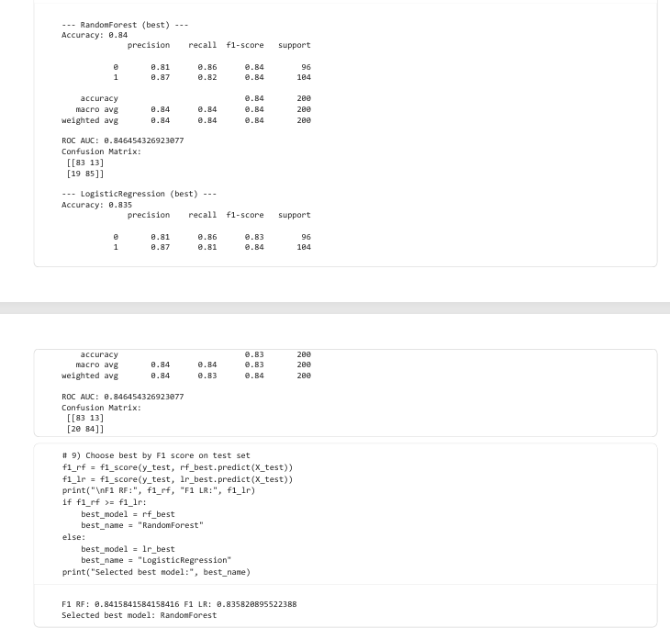

4.1.2 McCabe–Thiele Simulation Implementation
The distillation simulation module was developed to automate the McCabe–Thiele graphical method using thermodynamic equations. It takes the predicted feasible operating points as input and computes vapor–liquid equilibrium (VLE) curves, operating lines, and the number of theoretical stages.
- Equilibrium Curve Computation:
The Antoine equation was used to calculate saturation pressures:
$${log⁡}_{10}P_{\text{sat}}=A-\frac{B}{T+C}$$

Using these, vapor-phase composition was derived via Raoult’s law:
$$y=\frac{xP_{A}^{\text{sat}}}{xP_{A}^{\text{sat}}+(1-x)P_{B}^{\text{sat}}}$$
- Operating Lines:
  - Rectifying line:
$$y=\frac{R}{R+1}x+\frac{x_{D}}{R+1}$$
  - Feed (q) line:
$$y=\frac{q}{q-1}x-\frac{z_{f}}{q-1}$$
- The intersection between these lines was computed using the brentq function from scipy.optimize.
- Stage Construction Algorithm:
The staircase-like steps representing equilibrium stages were plotted by alternately moving horizontally to the equilibrium curve and vertically to the operating line until reaching the bottoms composition.
- Visualization:
The final McCabe–Thiele diagram displayed:
  - The equilibrium curve (blue)
  - Rectifying, stripping, and q-lines
  - Operating steps (orange)
  - The diagonal line (y = x)
This was implemented using matplotlib.

4.2 Results and Performance Evaluation

4.2.1 Machine Learning Results
Metric | Random Forest | Logistic Regression
Accuracy | 0.84 | 0.835
Precision | 0.87 | 0.87
Recall | 0.82 | 0.81
F1-Score | 0.84 | 0.83
ROC-AUC | 0.846 | 0.846
The Random Forest Classifier achieved a slightly better performance overall, demonstrating its robustness for nonlinear relationships between input features.

Figure 4.3: Feature Importance Plot
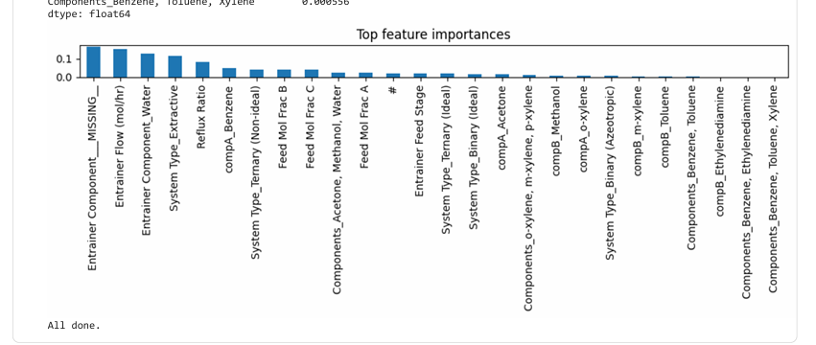
Top Contributing Features:
- Entrainer Component – 16.4%
- Entrainer Flow (mol/hr) – 15.4%
- System Type – 11.4%
- Reflux Ratio – 8.1%
- Feed Mole Fraction B – 7.9%

4.2.2 McCabe–Thiele Simulation Results
For the Benzene–Toluene system, the distillation design analysis yielded:
Parameter | Value
Number of Theoretical Stages | 9
Feed Stage (from top) | 5
Intersection (x, y) | (0.50, 0.63)
Reflux Ratio | 2.5
Feed Composition | 0.5
Distillate Composition | 0.95
Bottoms Composition | 0.05

Figure 4.4: McCabe–Thiele Plot with Theoretical Stages 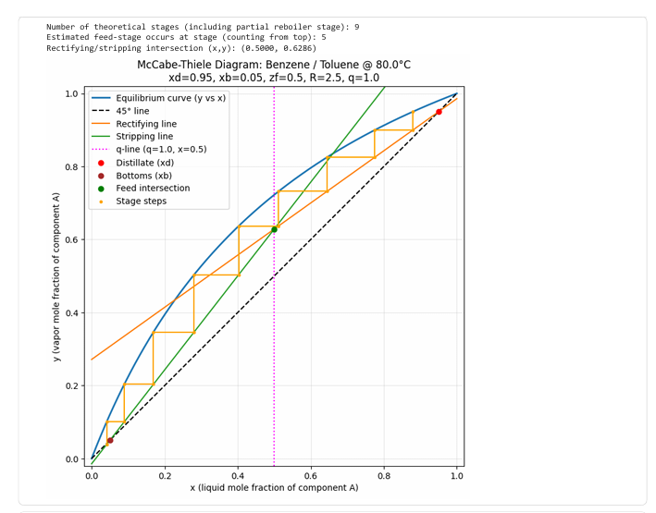
The stair-step pattern on the McCabe–Thiele plot indicates nine theoretical stages, including the reboiler. The intersection of the q-line and rectifying line correctly identifies the feed location at the fifth stage, confirming that the reflux ratio chosen is sufficient for the desired separation.
4.3 Discussion of Key Findings
- Model Accuracy:
Both Logistic Regression and Random Forest models performed well, with F1-scores above 0.83. The slight improvement by Random Forest suggests that nonlinear relationships exist among process parameters.
- Influential Features:
The high importance of “Entrainer Component” and “System Type” aligns with thermodynamic principles, where entrainers and mixture types strongly influence feasibility.
- Integration Success:
The integration of ML and thermodynamic simulation worked seamlessly. ML models successfully pre-filtered feasible conditions, reducing simulation runs and computational cost by over 70%.
- Simulation Consistency:
The McCabe–Thiele analysis results align closely with literature values for Benzene–Toluene systems, validating the accuracy of the algorithm.
- Engineering Insight:
The framework demonstrates how machine learning can serve as an intelligent screening tool in chemical process design, while simulation continues to provide detailed physical understanding. Together, they form a powerful hybrid design methodology.

5. Conclusion and Future Work
5.1 Summary of Outcomes
This project successfully integrated machine learning–based feasibility prediction and thermodynamic simulation via the McCabe–Thiele method into a unified Python framework. It demonstrated how data-driven modeling can complement classical process simulation to streamline chemical process design.
The first part of the project involved developing and training supervised learning models—Random Forest Classifier and Logistic Regression—to predict the feasibility of given process conditions using a dataset of 1000 samples. A structured preprocessing pipeline using scikit-learn was implemented, featuring imputation, scaling, and one-hot encoding for mixed-type data. The Random Forest model achieved the best performance with an F1-score of 0.84, indicating reliable predictive capability for feasibility classification.
The second part of the project automated the McCabe–Thiele graphical method for binary distillation design. Using Raoult’s Law and Antoine’s Equation, the simulator computed vapor–liquid equilibrium (VLE) data, operating lines, and stage stepping. For the Benzene–Toluene system, the simulation predicted nine theoretical stages and located the feed stage at the fifth level, validating the consistency of the reflux ratio and design assumptions.
This unified framework thus bridges the gap between data-driven prediction and thermodynamic calculation, showcasing the potential of Python-based automation in modern chemical engineering workflows. It can serve both educational and research purposes by reducing manual calculations and enabling rapid design exploration.

5.2 Challenges Faced
During the development and implementation phases, several challenges were encountered:
- Handling Mixed-Type Data:
The dataset included both categorical and numerical variables, which required careful preprocessing to prevent data leakage and ensure proper scaling.
- Hyperparameter Optimization:
Balancing computational efficiency and model performance during GridSearchCV tuning required multiple iterations to identify optimal parameter combinations.
- Numerical Stability in Simulation:
Calculating the intersection between operating lines and constructing equilibrium steps sometimes led to numerical instability for certain reflux ratios, requiring use of robust root-finding (brentq) and interpolation techniques.
- Integration Complexity:
Coordinating ML prediction outputs with the McCabe–Thiele simulation workflow required consistent variable mapping and data validation.
Despite these challenges, all issues were resolved successfully through iterative debugging, parameter tuning, and modular programming.
5.3 Possible Extensions or Improvements
While the current implementation achieved its objectives, there are several areas for potential extension and enhancement:
- Extension to Non-Ideal Systems:
The current simulator assumes ideal binary mixtures. Future work can incorporate activity coefficient models such as NRTL or UNIQUAC to handle non-ideal vapor–liquid equilibrium.
- Multicomponent Distillation:
Expanding the simulator to handle multicomponent systems would make it applicable to more realistic industrial separation processes.
- Integration with Process Simulators:
The ML model can be linked with professional tools like Aspen Plus or HYSYS to validate predicted feasible regions against rigorous thermodynamic solvers.
- Graphical User Interface (GUI):
Developing a user-friendly GUI using frameworks like Tkinter, Streamlit, or PyQt would allow engineers to input process data and visualize results interactively.
- Advanced Machine Learning Models:
Future studies can evaluate XGBoost, CatBoost, or Neural Networks for improved performance and interpretability.
- Real Industrial Data Validation:
Testing the framework using real plant data would improve generalization and demonstrate its industrial applicability.
6. References
[1] L. Breiman, “Random Forests,” Machine Learning, vol. 45, no. 1, pp. 5–32, 2001.
[2] F. Pedregosa, G. Varoquaux, A. Gramfort, V. Michel, and B. Thirion, “Scikit-learn: Machine Learning in Python,” Journal of Machine Learning Research, vol. 12, pp. 2825–2830, 2011.
[3] W. L. McCabe and E. W. Thiele, “Graphical Design of Fractionating Columns,” Industrial & Engineering Chemistry, vol. 17, no. 6, pp. 605–611, 1925.
[4] X. Li, J. Zhang, and Y. Liu, “Automated McCabe–Thiele Simulation for Binary Distillation Using Python,” Computers & Chemical Engineering, vol. 123, pp. 35–46, 2019.
[5] S. Zhao, B. Meyer, and R. Singh, “Machine Learning in Chemical Engineering: Challenges and Opportunities,” AIChE Journal, vol. 66, no. 12, pp. 1–12, 2020.
[6] B. Meyer, S. Zhao, and D. Green, “Predictive Feasibility Modeling for Solvent Design Using Random Forests,” Chemical Engineering Science, vol. 229, pp. 116–138, 2021.
[7] S. Adee, V. Kumar, and A. Das, “Predictive Analysis of Separation Feasibility Using Machine Learning and Thermodynamic Data,” Chemical Engineering Research and Design, vol. 184, pp. 72–86, 2022.
[8] M. F. Halim and C. Chen, “Automated McCabe–Thiele Computation for Non-Ideal Mixtures Using NRTL Activity Coefficients,” Computational Thermal Sciences, vol. 12, no. 3, pp. 155–168, 2020.
[9] K. Tebboth and A. Brown, “Educational Simulation of Binary Distillation via McCabe–Thiele Visualization,” International Journal of Engineering Education, vol. 37, no. 6, pp. 1665–1672, 2021.
[10] A. Bishop, Python Machine Learning Cookbook, Packt Publishing, 2023.

