Running *Ansible* Playbook on Ubuntu

1. To run the ansible playbook, change the current working directory:

Cd to ansible folder:

$ cd /etc/ansible

1. Change the *host* file

Make sure to backup the existing *hosts* file as *hosts-backup*

 mv hosts hosts-backup

Edit the *hosts* file as following:



Remove all the entries from *hosts* file and modified *hosts* file looks like as following:

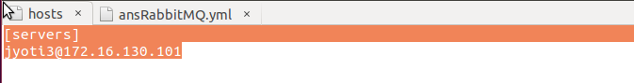

1. Command line test for *ansible* *ping* module:

In order to run basic ansible test commandline, try running ping module:

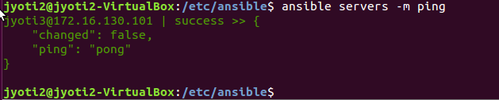

Successful Pong means things are all OK.

In order to see the setup information for all the ansible nodes(in *hosts* file)

$ ansible servers –m setup

1. Test the *ansible* playbook:

Create the *ansible playbook* and run using following command:

$ ansible-playbook –verbose –step ansRabbitMQ.yml

To run the ansible playbook with prompt for sudo password

$ ansible-playbook –verbose –step ansRabbitMQ.yml -K

Following is the screenshot of a sample *Ansible* playbook for installing docker container of *RabbitMQ*:

*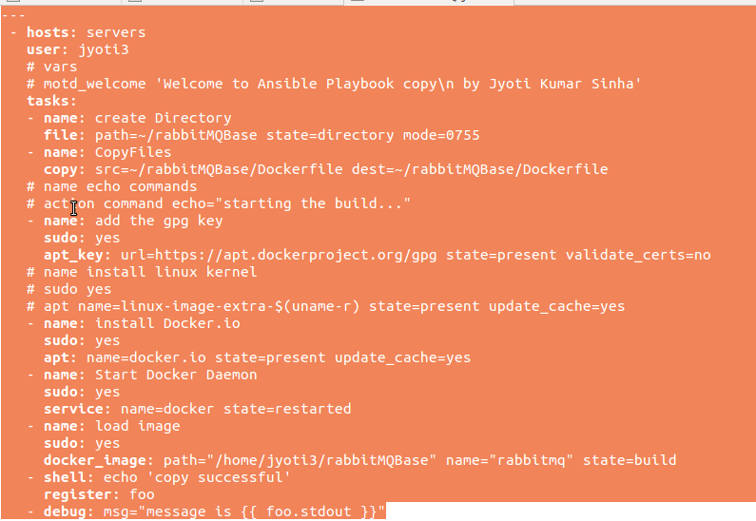*

Module to add “sudo” privilege to task

Path on “Remote machine” where Dockerfile is copied from local server

Copy the Dockerfile from “local server” to “remote server”

Sample Dockerfile used for above ansible-playbook:

