Installing RabbitMQ on Ubuntu Remote Host using Ansible Playbook

1. **Steps to install RabbitMQ on Remote Ubuntu Hosts:**

Step 1: change the PWD to /etc/ansible

$ sudo cd /etc/ansible

Step 2: $ sudo gedit *ansRabbitMQUbuntu.yml*

Step 3: in the text editor, write the text as given in image below:

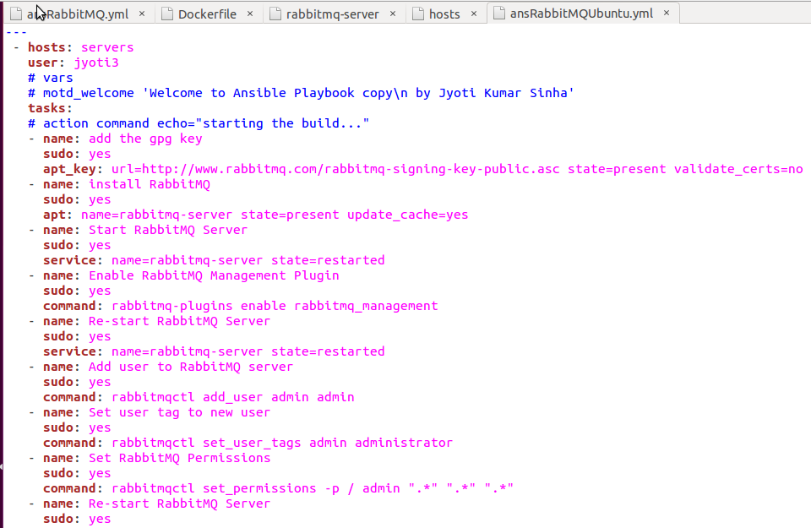

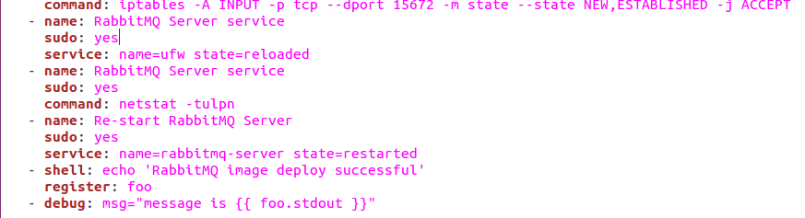

Step 4: Save the file *ansRabbitMQUbuntu.yml*

Step 5: on command prompt, write the following command to execute the playbook just created:



Step 6: now go to Remote Ubuntu server and in firefox browser, type following url:

<http://127.0.0.1:15672>

It shall show you the Management console of RabbitMQ as following:

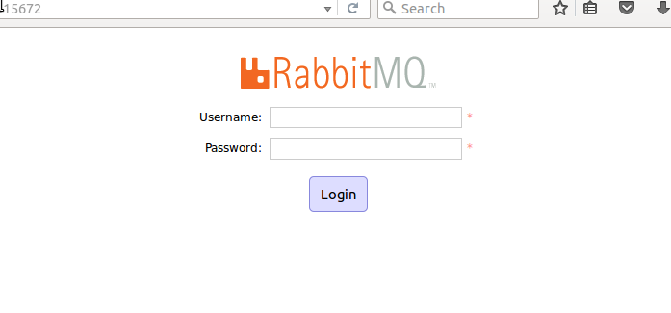

You can login now using default credentials of guest/guest.

Trouble shooting: in case RabbitMQ console does show “Trouble while loading website” when tried to load management console, try following fixes:

1. In file explorer, go to /var/log/rabbitmq directory and see if log says that plugins are started correctly. 1.) If Plugins are not started properly and encountered errors, you might have to try by installing the image manually to verify if image is good or not. 2.) if plugins are started properly then try following:
   * 1. On command prompt restart docker daemon
     2. $ sudo docker stop
     3. $ sudo docker start, refresh the firefox browser now and if management console still not showing then go to step iv
     4. Uninstall docker.io using $ sudo apt-get remove docker.io
     5. Re-install the docker.io using $ sudo apt-get install docker.io

The Management console should work now.

1. **Following are the Steps to install self-contained Docker container of RabbitMQ on Remote Ubuntu Servers:**

**Step 1:** Make sure, PWD is /etc/ansible/

$ sudo cd /etc/ansible

**Step 2:** Create playbook file (.yml) as given below

One that worked finally is here as below (ansRabbitMQssl-V3.yml):

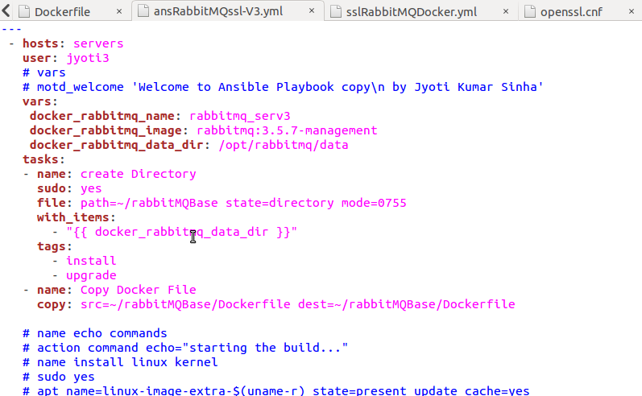

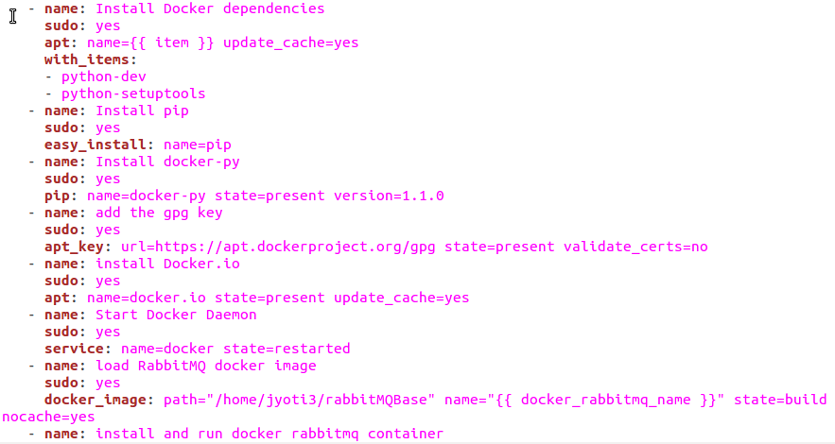

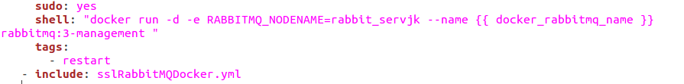

**Step 3: Apply SSL**

Step 3.1: Preparations before creating *sslRabbitMQDocker.yml* file:

1. On the local server, make sure to have some directory created as /etc/rabbitmq/testca
2. Make sure to chdir to testca folder
3. $ sudo gedit *serial* -> type *01* in the file ->save
4. Now change the directory and move a level up

$ sudo cd ..

Now, we are in /etc/rabbitmq directory

1. $ sudo gedit rabbitmq.config

In the text editor paste following text:

{rabbit, [ {tcp_listeners, [5672] },

{ssl_listeners, [5673] },

{ssl_options, [

{cacertfile, "/etc/rabbitmq/testca/cacert.pem" },

{certfile, "/etc/rabbitmq/server/cert.pem" },

{keyfile, "/etc/rabbitmq/server/key.pem" },

{verify, verify_peer},

{fail_if_no_peer_cert, true }]}

]}

].

Save the file.

Step 3.2: create *sslRabbitMQDocker.yml* file:

Following is the text for sslRabbitMQDocker.yml(for implementing SSL). Make sure this file is also located in /etc/ansible folder:

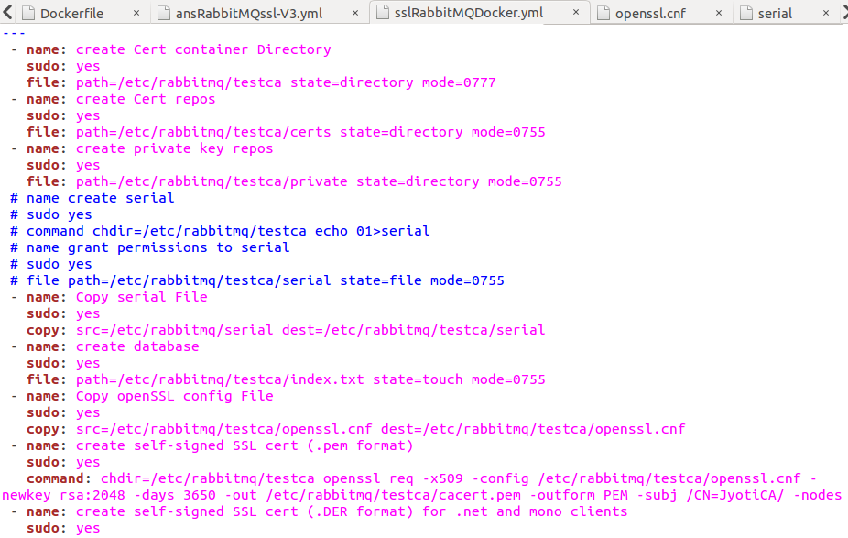

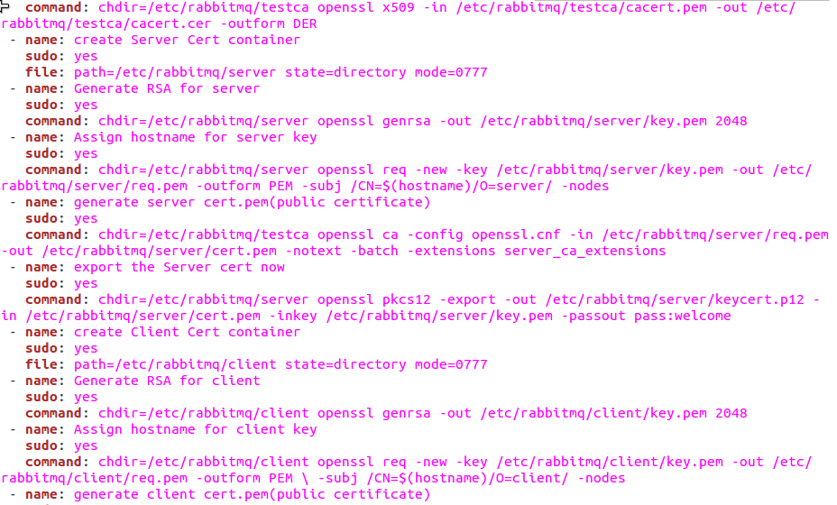

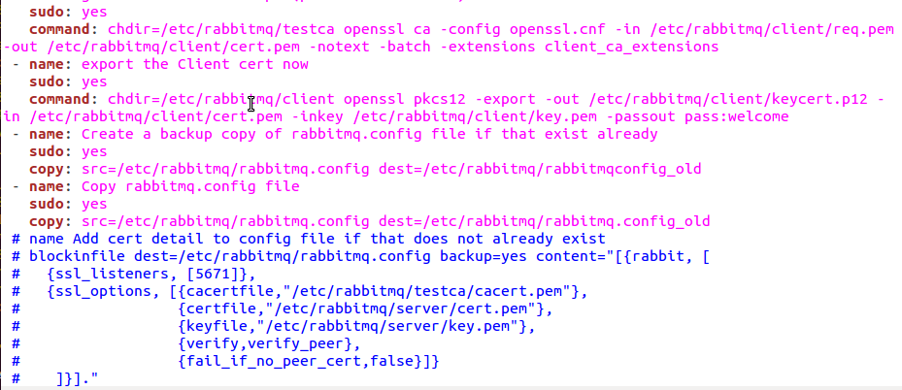

Now go to command prompt and run the playbook using command line as following:



After running this command, it will ask for y(=yes), n(=No) or c(continue without any further user prompt).

Press *y* in wherever applicable (or simply press *c*)… output shall be similar to this:

