Ansible Installation Tutorial

1. Create two VMs with Ubuntu 15.04 or higher
2. install ansible on each of these VMs using following command

$ apt-get install ansible

$ apt-get update

$ apt-get install python-pip

$ apt-get update

Install docker-py



To install docker-py of a certain version say, version 1.1.0, use the following syntax



1. MAke sure Ansible is installed properly

$ ansible --version

1. Need install openSSH on both the VMs

$ apt-get install openssh-server

$ apt-get update

$ apt-get install openssh-client

$ apt-get update

1. Now, set up the internal networking among the VMs.
2. Go to, Parent Windows machine -> Run -> cmd -> ipconfig.

note down the default gateway entry. Assuming it's 172.16.130.1.

1. On the cmd prompt-> type following command:

C:\ "C:\Program Files\Oracle\VirtualBox\VBoxManage.exe" dhcpserver add --netname JyotiNet --ip 10.0.1.1 --netmask 255.255.255.0 --lowerip 172.16.130.100 --upperip 172.16.130.200 --enable

1. in the VM1 – go to network settings

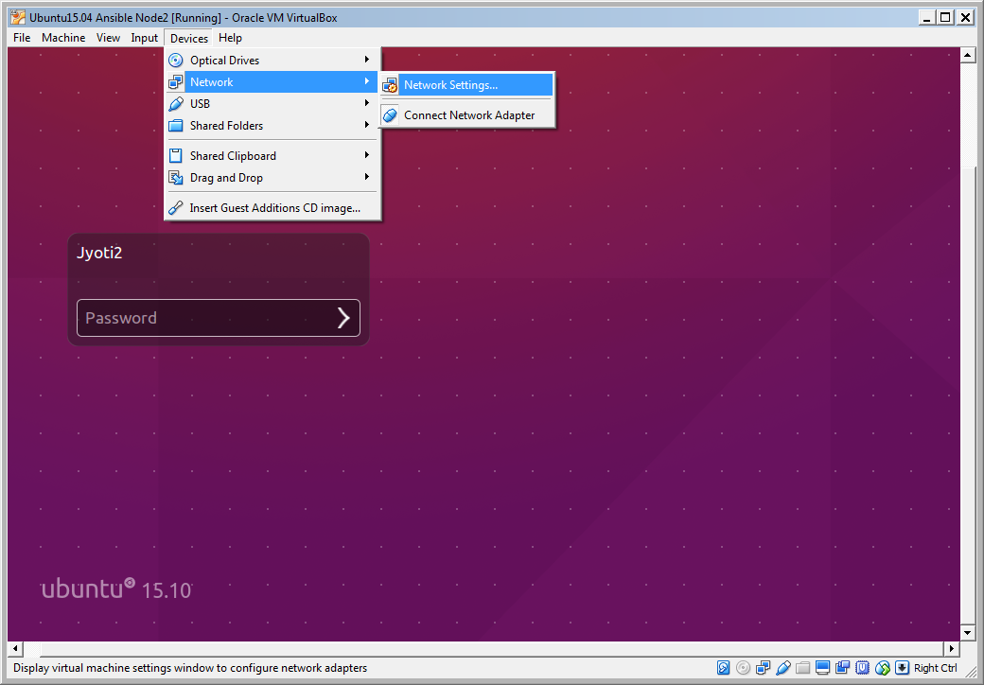

a.) make sure “***Attached to***” field has “Internal Network” selected

b.) If New network name is not available, make the entry with exact name in editable dropdown for “***Name***” in Adapter1 tab.

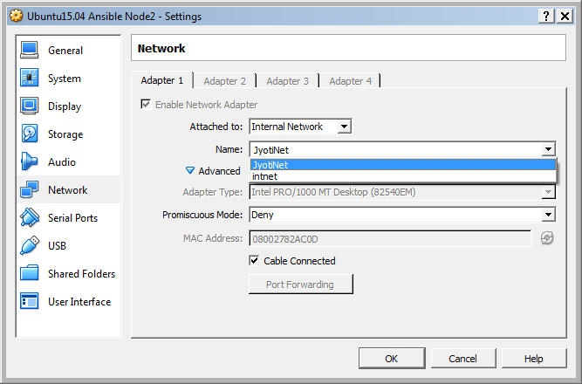

1. in VM1, try following command

$ ifconfig

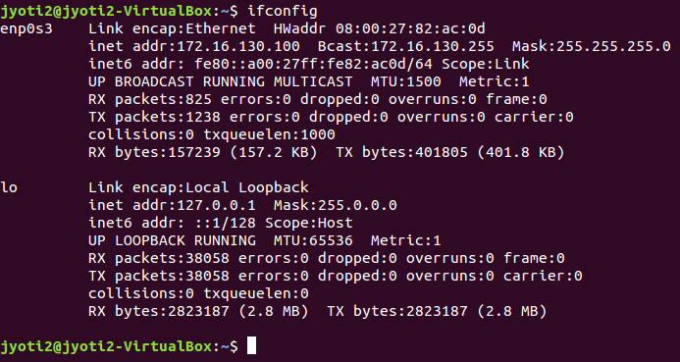

1. Repeat the step 8 and step 9 on VM2 as well. Now, you have the Network IPs for both the boxes
2. Try following command on VM1

$ ping <ipaddress of VM2>

And same from VM2

$ ping <ipaddress of VM1>

You shall be able to do that

1. Configure SSH on VM1:
   1. Prior to configuration VM1, make sure VM2 has following folder:

$ *mkdir ~/.ssh*

* 1. $ ssh-keygen -t rsa -b 2048
  2. $ Enter Passphrase - press enter
  3. $ confirm passphrase – press enter
  4. Output shall be similar to following:

*Your identification has been saved in /Users/username/.ssh/id_rsa.*

*Your public key has been saved in /Users/username/.ssh/id_rsa.pub.*

*The key fingerprint is:*

*60:b5:c1:b7:ee:ab:31:d1:70:d8:03:41:df:0f:08:eb Enter an optional comment about your key*

*The key's randomart image is:*

*+--[ RSA 2048]----+*

*| .=. |*

*| . B o |*

*| X B o |*

*| o X o o |*

*| E S . |*

*| o |*

*| o . |*

*| + |*

*| ..o. |*

*+-----------------+*

* 1. $ chmod 700 ~/.ssh && chmod 600 ~/.ssh/*
  2. $ cat ~/.ssh/id_rsa.pub | ssh username@VM2 'cat - >> ~/.ssh/authorized_keys'

1. Ensure VM1 has all the access granted.
   1. Login to VM2 using credential that was used to create keys on VM1
   2. Grant following file permissions:

$ chmod 600 ~/.ssh/authorized_keys && chmod 700 ~/.ssh/

1. Now on VM1, try to SSH the VM2 using following command:

$ SSH <VM2username>@<VM2 IP> shall login you to VM2 box(in my case 172.16.130.101)

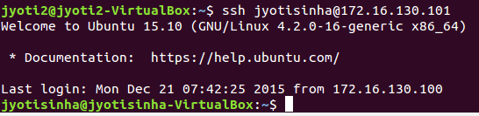

1. Time to test using Ansible:
   1. On VM1, change the current location to /etc/ansible using following command

$ cd /etc/ansible

* 1. Make sure to back-up the original *hosts* file as *hosts-old*
  2. Now, edit the *Hosts* file such that it looks a very basic playbook, something like this:

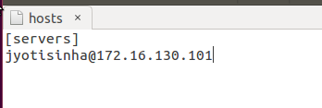

* 1. Save the file changes and now run the ansible ad-hoc command using following command:

$ ansible servers –m ping

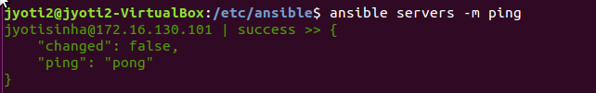

That’s it!

**Troubleshoot**:

SSH Error: ssh: connect to host 172.16.130.100 port 22 – Permission denied (public key….)

Do following thing:

1. On remote box 172.16.130.100(in this example),

$ sudo apt-get remove --purge openssh-server && sudo apt-get install openssh-server

1. **On remote server,**

**$ mkdir ~/.ssh**

1. Go to local server and try

$ **chmod 700 ~/.ssh && chmod 600 ~/.ssh/\***

$ ssh jyotisinha@172.16.130.100

1. **On remote server, make sure permissions are set**

**$ chmod 600 ~/.ssh/authorized_keys && chmod 700 ~/.ssh/**

1. On local server run the following:

$ **cat ~/.ssh/id_rsa.pub | ssh jyotisinha@172.16.130.100 'cat - >> ~/.ssh/authorized_keys'**

**Note:**

* In Ubuntu, You can either change the permission of the directory and enable others to create files inside.

sudo chmod -R 777 /home/sixven/camp_sms/inputs

* To remove ‘*group writable*’ or ‘*world writable*’ permission from a folder

sudo chmod 751 /etc/*

Follow up:

[Steps to install Docker container on Ubuntu](StepsToInstallDockerContainerOnUbuntu.docx)

References:

[*https://youtu.be/nR_cE2xnwEs*](https://youtu.be/nR_cE2xnwEs)

[*https://mediatemple.net/community/products/dv/204644740/using-ssh-keys-on-your-server*](https://mediatemple.net/community/products/dv/204644740/using-ssh-keys-on-your-server)