1. **Create Operation(POST)**:

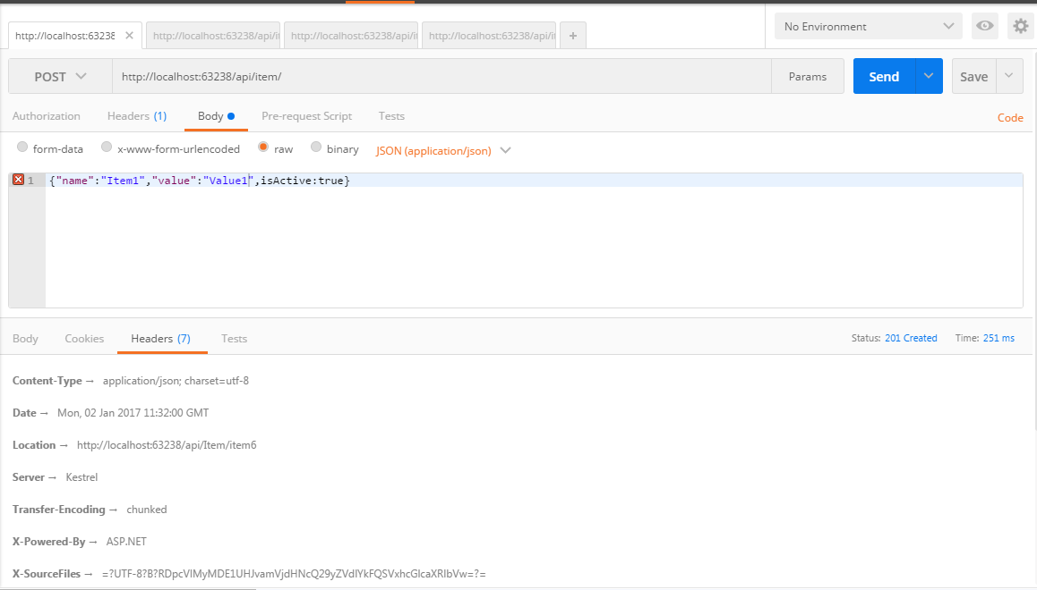

1. **Get Operation:**

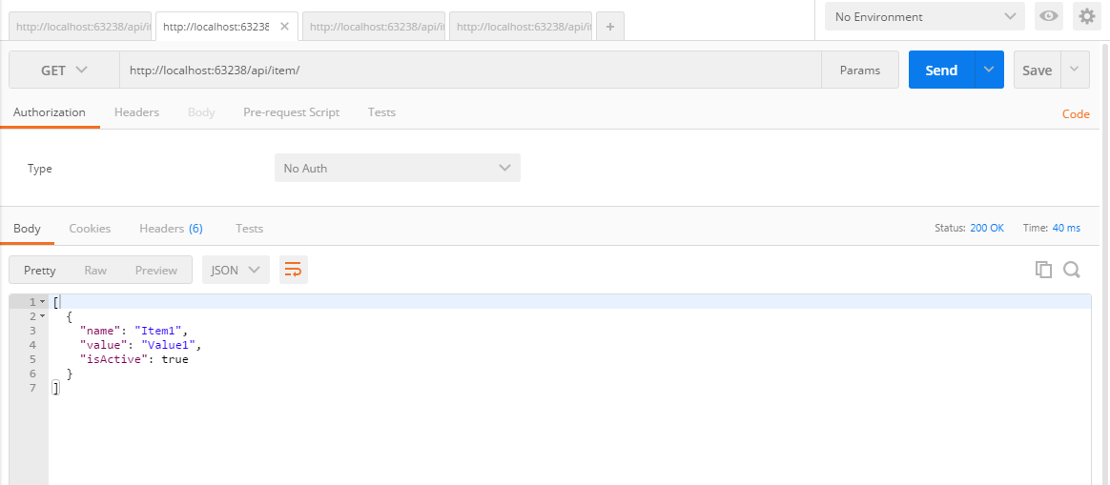

1. **Update Operation(PUT)**:

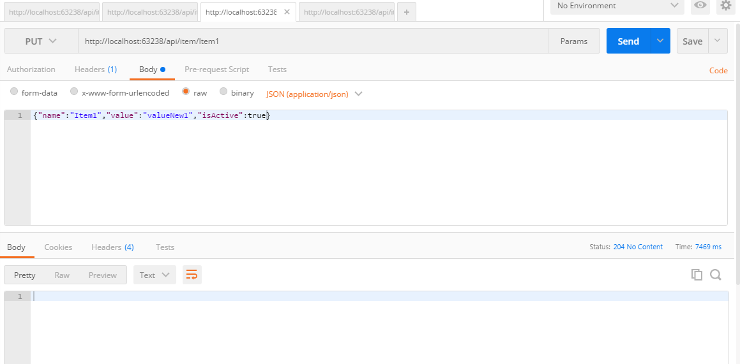

1. **Delete Operation:**

# 

# Publish the API:

Create the Profile:

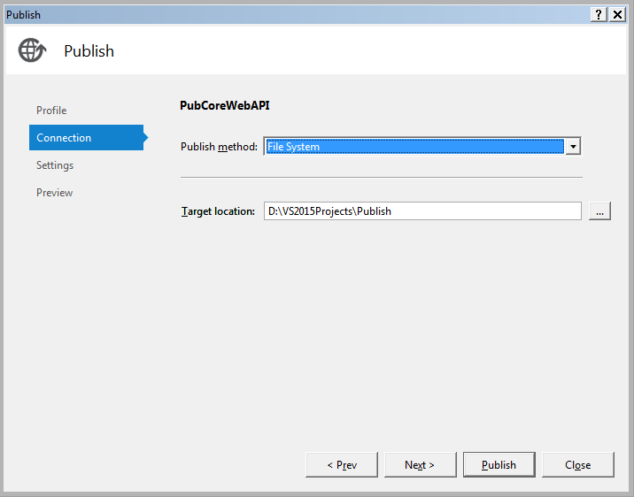

Set the configurations:

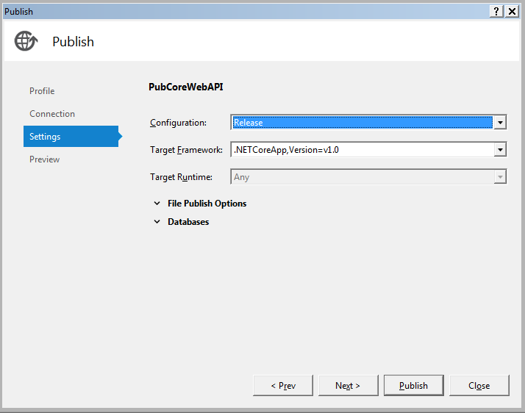

Publish confirmation:

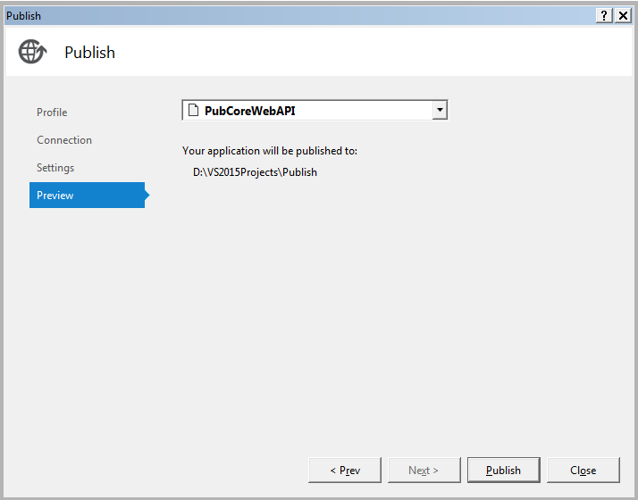

Post-publish activities:

1. Create a new Virtual directory in IIS pointing to Publish folder



1. Since Virtual directory would always require an App pool, create a new app pool as following:

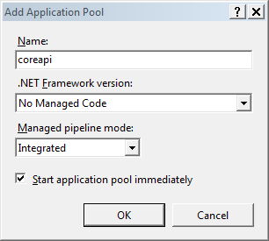

1. Convert the Virtual directory into an application. The settings should look like following:

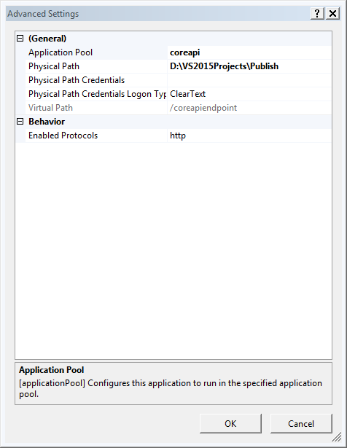

1. Test the *endpoints* in Postman as following:

**Post**:

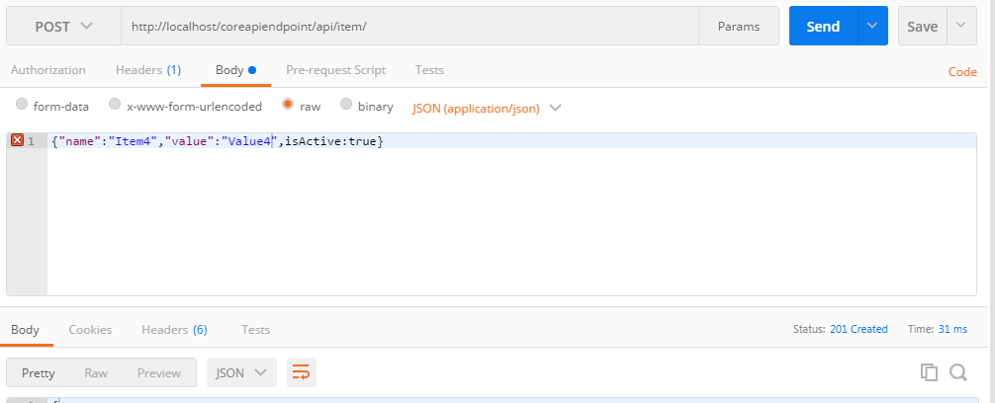

**GET**:

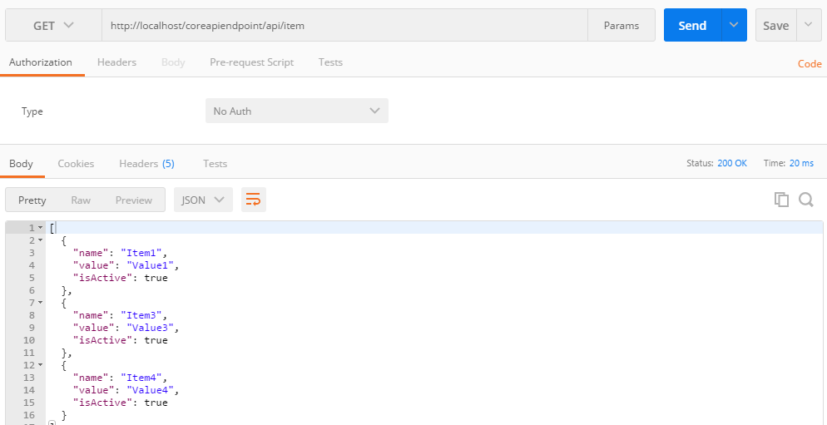

**PUT**:

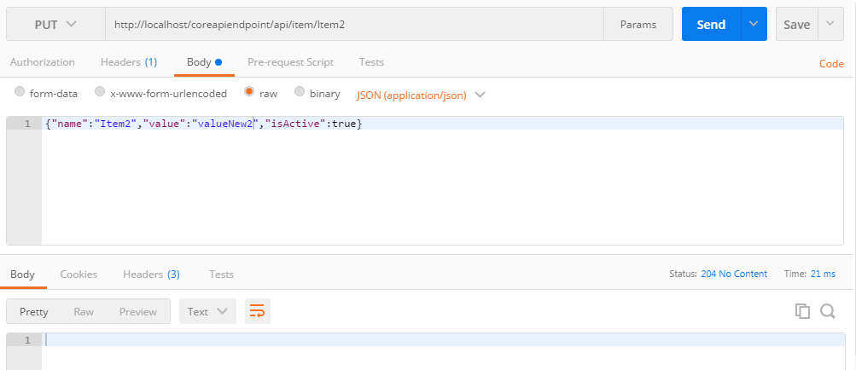

**NOTE: While issuing PUT, if following exception is encountered “405.0 - Method Not Allowed”, then follow the steps below:**

1. **Using IIS**
2. Open IIS
3. Select Modules, find the WebDAV Module and remove it.
4. Select HandlerMapping, find the WebDAVHandler and remove it.

**OR**

**B.) Edit the web.config to look somewhat like following:**

<?xml version="1.0" encoding="utf-8"?>

<configuration>

<!--

Configure your application settings in appsettings.json. Learn more at http://go.microsoft.com/fwlink/?LinkId=786380

-->

<system.webServer>

<handlers>

<remove name="WebDAV" />

<add name="aspNetCore" path="*" verb="*" modules="AspNetCoreModule" resourceType="Unspecified" />

</handlers>

<aspNetCore processPath="dotnet" arguments=".\CoreWebAPI.dll" stdoutLogEnabled="false" stdoutLogFile=".\logs\stdout" forwardWindowsAuthToken="false" />

<modules>

<remove name="WebDAVModule" />

</modules>

</system.webServer>

</configuration>

<!--ProjectGuid: e943e26d-e166-414a-a7e8-1c8200c111d2-->

**DELETE**:

