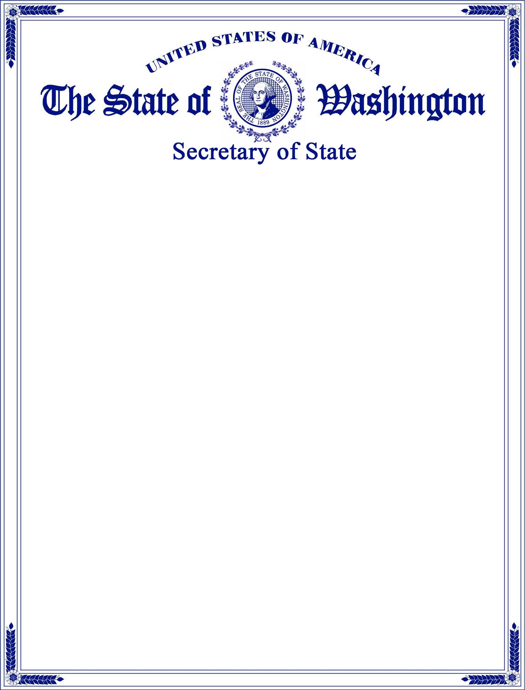
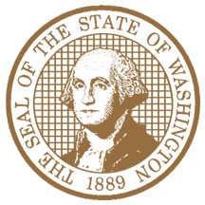
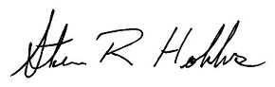
Effective Date:

10/04/2024
UBI Number:

605 624 424
I,

STEVE R. HOBBS
, Secretary of State of the State of Washington and custodian of its seal, hereby
issue this

ARTICLES OF INCORPORATION

to

AUTO BOND BLESSINGS

A
WA NONPROFIT CORPORATION
, effective on the date indicated below.

Given under my hand and the Seal of the State
of Washington at Olympia, the State Capital
Steve R. Hobbs
, Secretary of State
Date Issued:

10/04/2024

