# Assignment – Capstone Project

# Mid submission

Credit Card Fraud Detection System - ScriptsExecution.pdf

By: Shubhra Sinha

# TASK 1 ScreenShots

Creating the required directories:

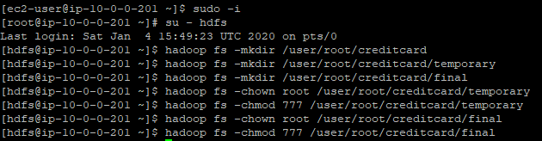

1. Script to create (INTERNAL) card_transactions temporary hive table to load the given CSV



2. Script to load initially card_transactions data from csv

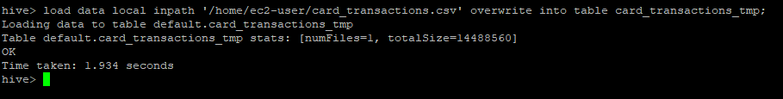

3. Check the data loaded

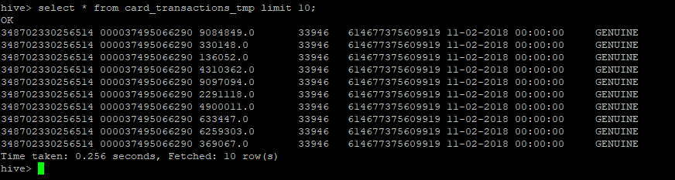

4. Create card_transactions table (HIVE-HABSE integrated table)

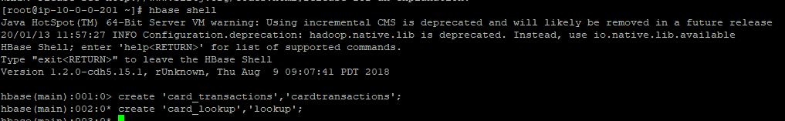

NOTE: For creating HIVE-HBASE integrated table, we need to first create a HBase table and then integrate with hive table, HIVE external creation works only on existing HBase table.

Creating external table in hive:



5. Insert data from card_transactions_tmp table to hive-hbase table

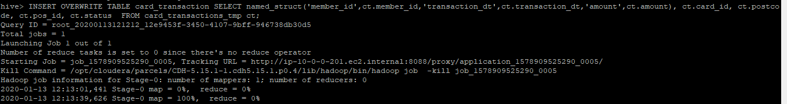

6. Check if the data is inserted in hive

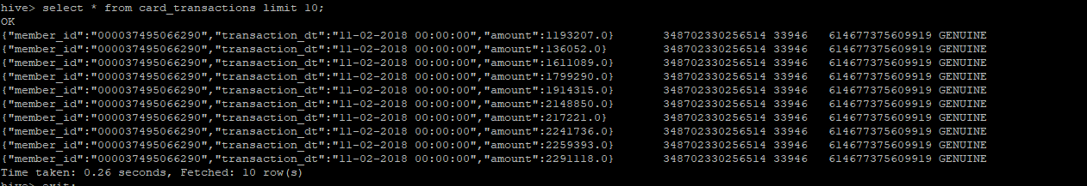

7. Check if the data is inserted in hbase

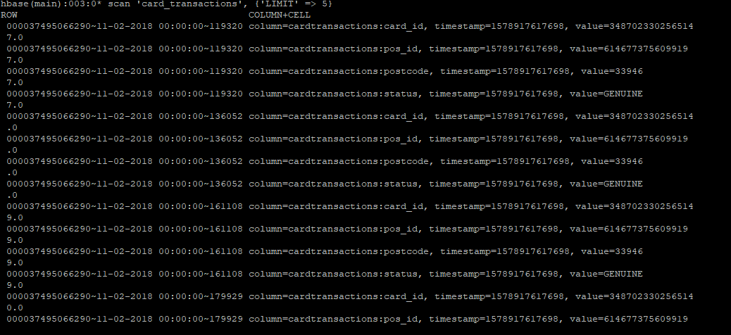

8. Script to create final lookup table (HIVE-HABSE integrated)

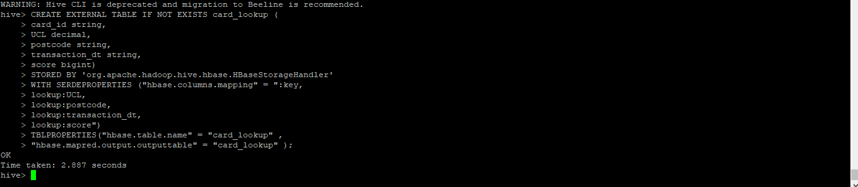

# TASK 2 ScreenShots

1. Switching to hdfs user

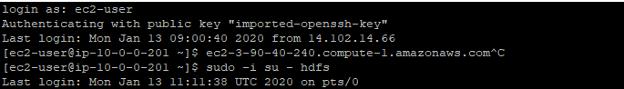

2. Create Sqoop job to import data incrementally from AWS RDS

#> 

3. Look for the listed Sqoop job



4. View the configuration of the job

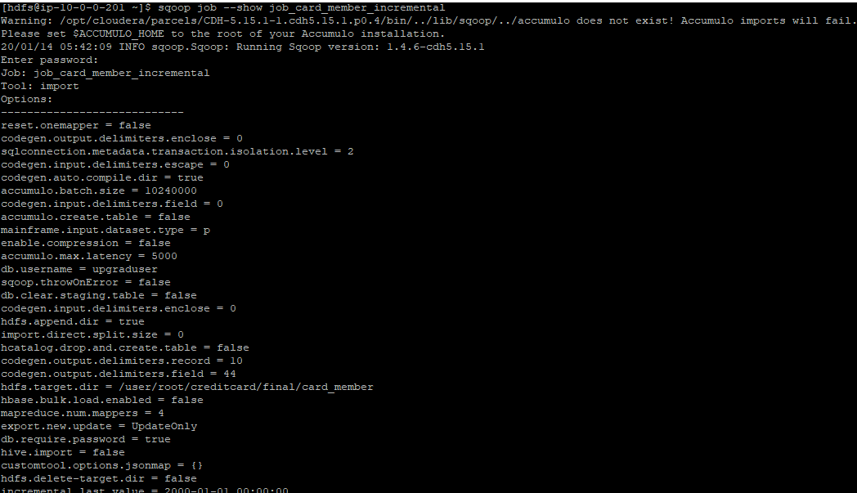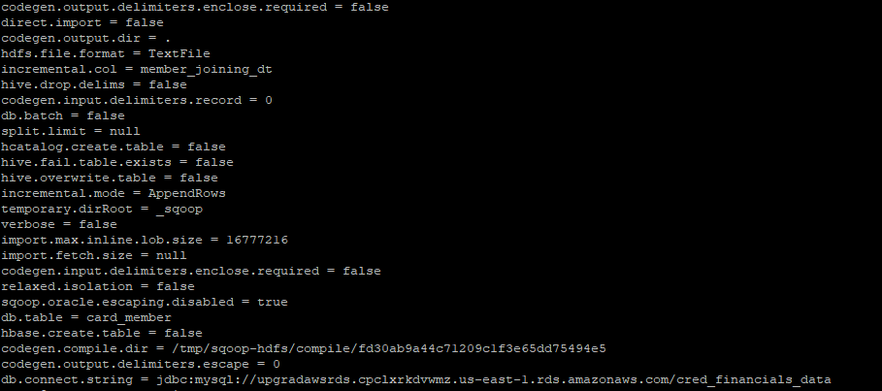

5. Execute the job to load initial data

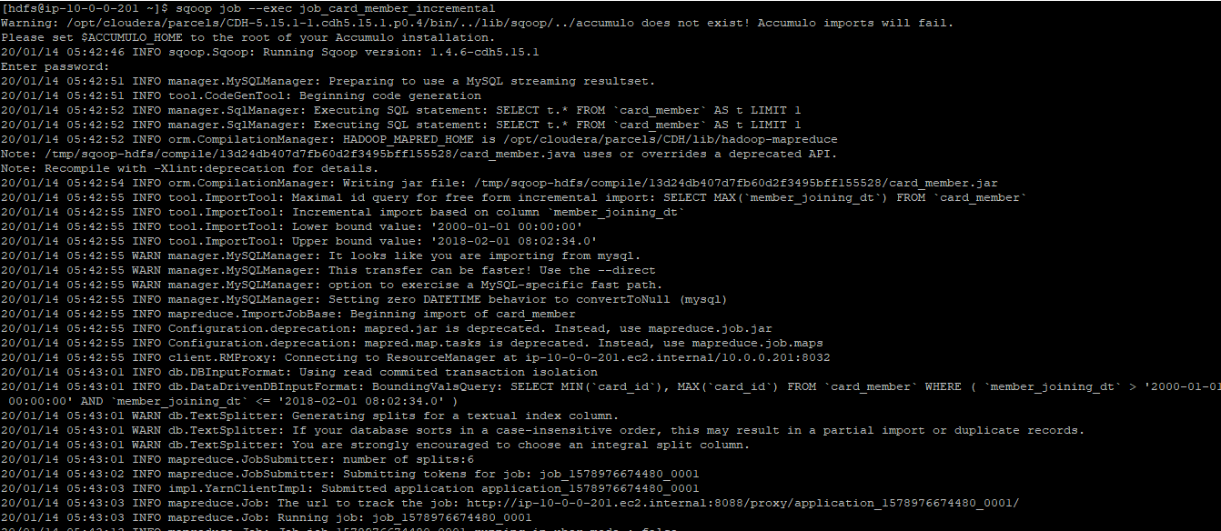

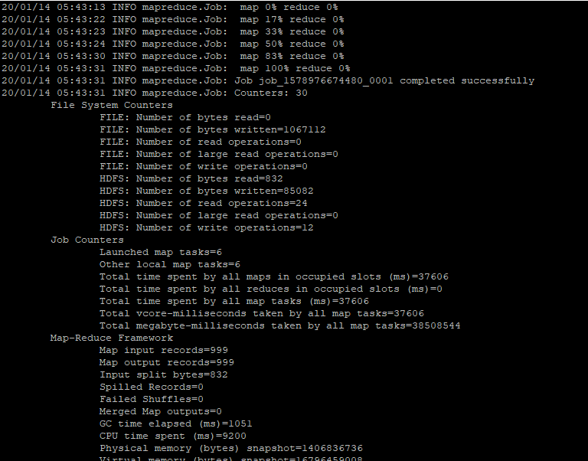

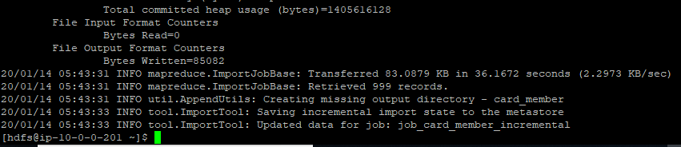

6. List contents of /user/root/creditcard/card_member, to check if the import is working

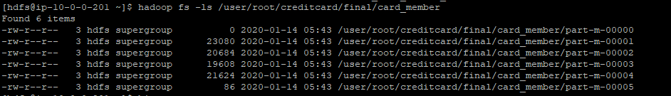

7. Create card_member table



8. Check if the data is inserted (Data automatically loaded into table)

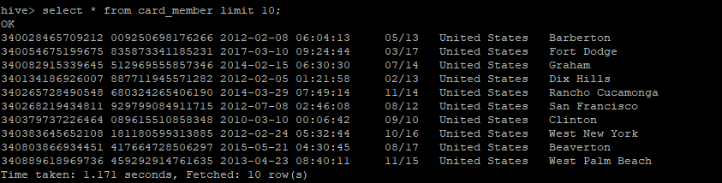

9. Script to insert/load data from hadoop into card_member table (Load data is not required)

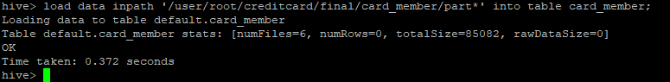

10. Create Sqoop job to import member_score data from AWS RDS ( It need to be refreshed in 4 hours)



11. Execute to load the initial data

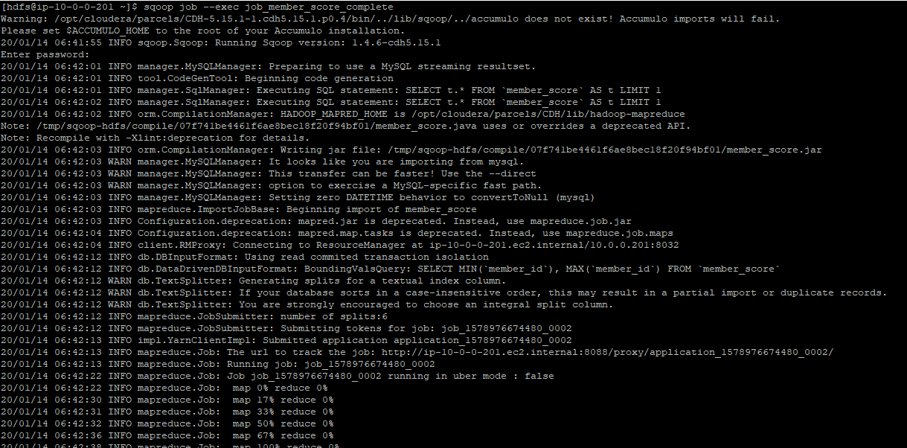 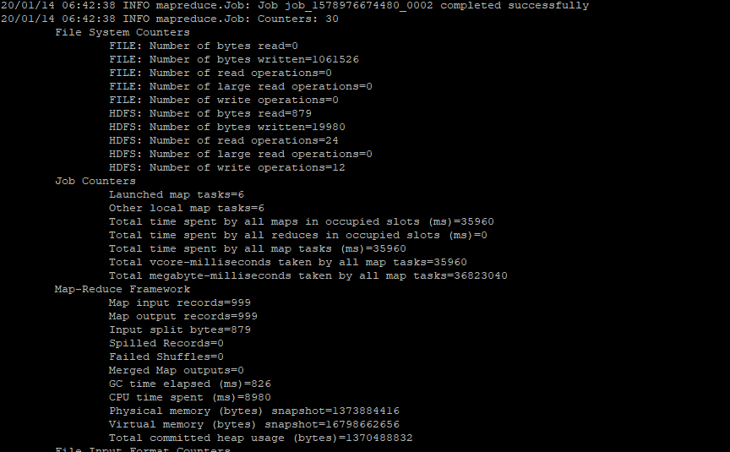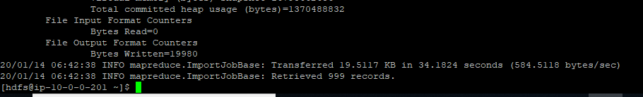

12. Create member_score table

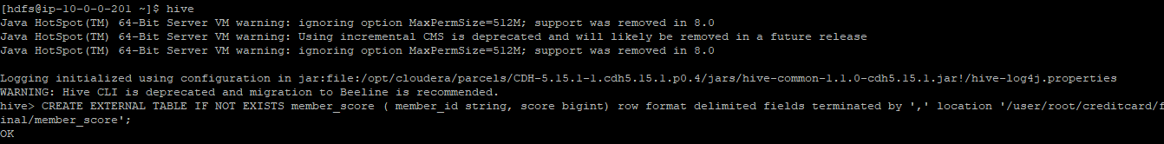

13. Load member_score table



14. Check if the data is inserted

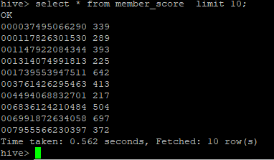

# TASK 3 ScreenShots

1. Create raw lookup table



2. Insert data into card_lookup_raw table

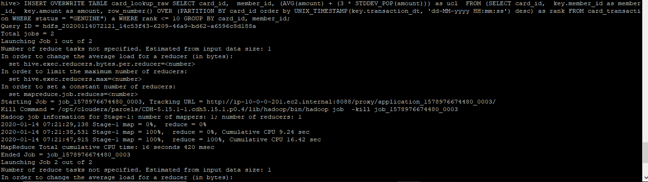

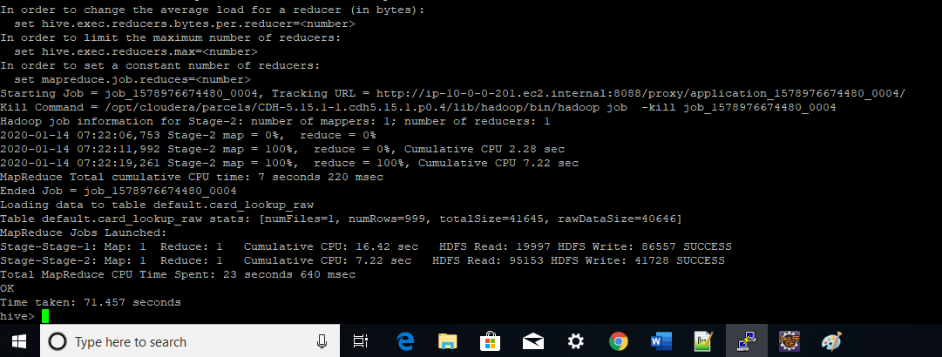

3. Check if the data is inserted

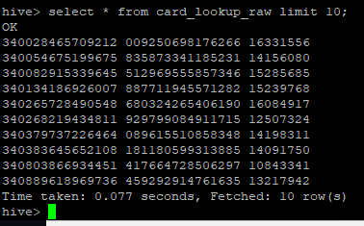

4. Create temporary lookup table



5. Insert UCL, score data into card_lookup_tmp by joining member_score and card_lookup_raw tables

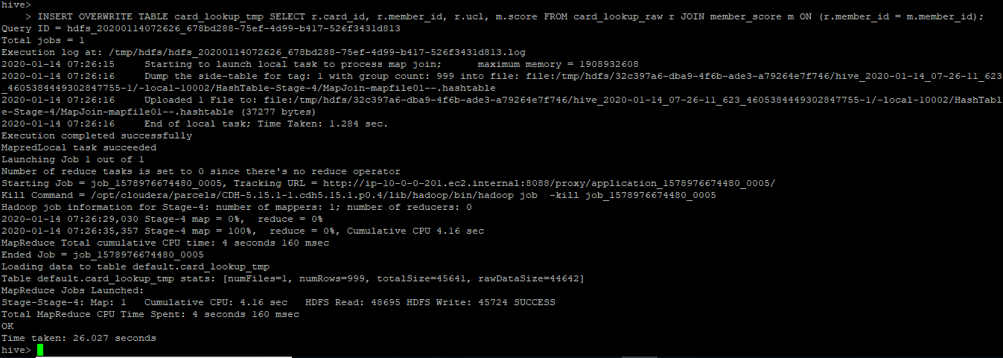

6. Check if the data is inserted

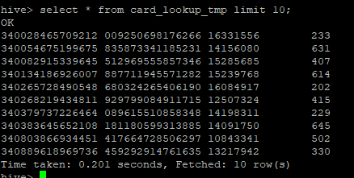

7. Create lookup temporary table for card transaction



8. Insert into lookup_tmp_trans, a record with latest GENUINE transaction date and postcode

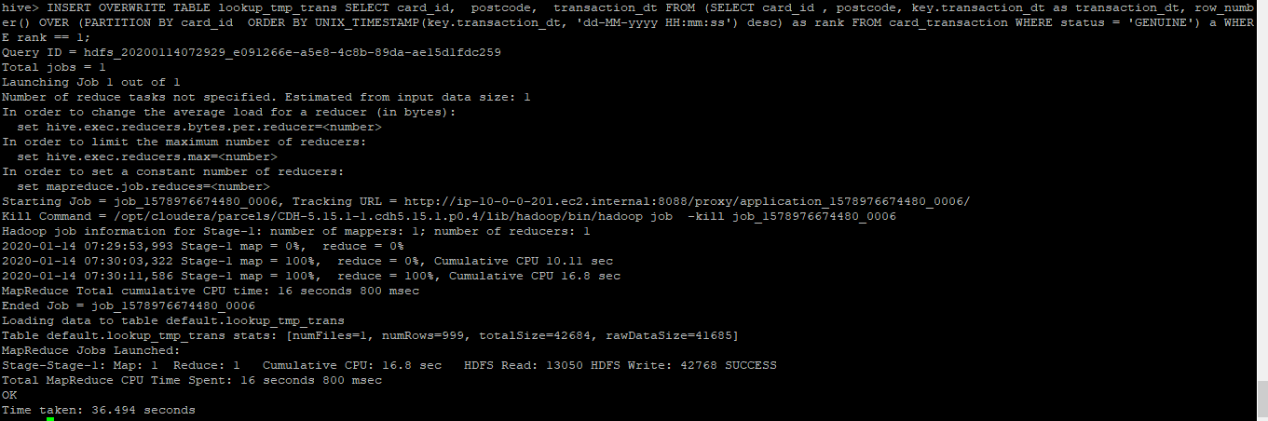

9. Check if the data is inserted correctly

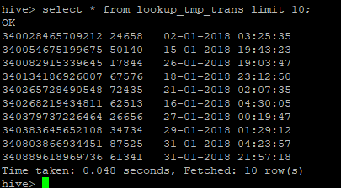

10. Insert into final lookup table (hive-hbase integrated)

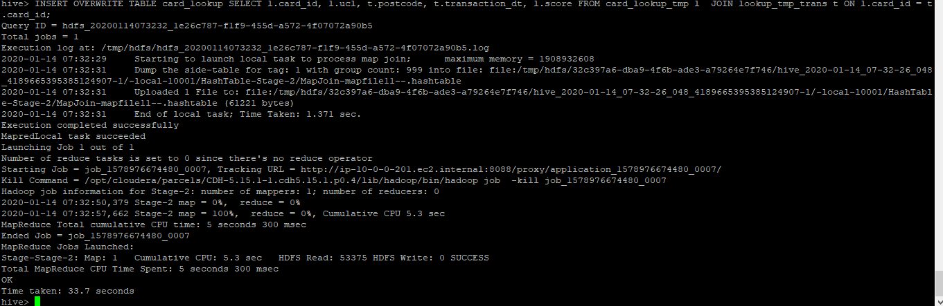

11. Check if the data is inserted correctly

