# Chocolate Supersales Dashboard - Summary & Insights (Task 2)

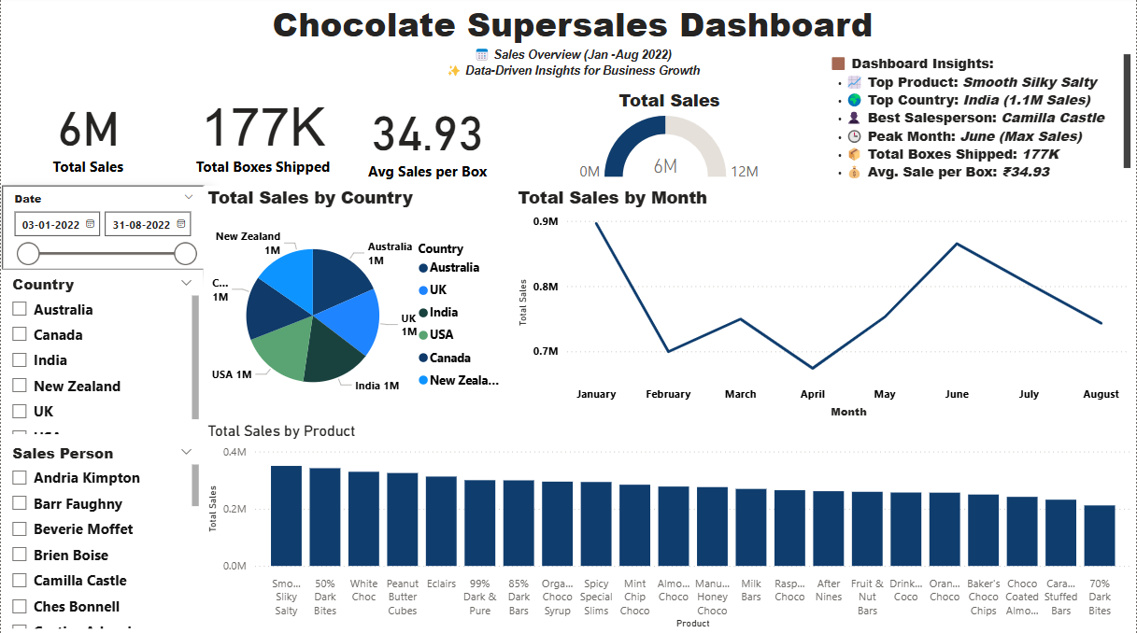

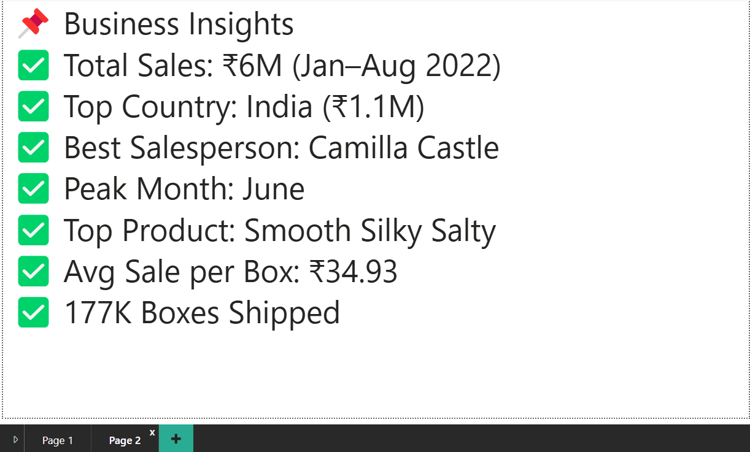

## Project Overview:

This dashboard visualizes chocolate sales data from January to August 2022 using Power BI. It helps identify sales trends, top-performing products, countries, and salespeople to support data-driven business decisions.

## KPI Cards:

* Total Sales

Formula: SUM(Sales)

Value: Rs.6,000,000

Insight: Overall revenue generated across all countries and products.

* Total Boxes Shipped

Formula: SUM(Quantity)

Value: 177K

Insight: Total number of chocolate boxes sold globally in the selected date range.

* Average Sales per Box

Formula: [Total Sales] / [Total Boxes Shipped]

Value: Rs.34.93

Insight: Average revenue earned per chocolate box.

## Charts & Graphs:

* Total Sales by Country (Pie Chart)

X-axis: Country

Y-axis: Total Sales (in INR)

Insight: India had the highest sales (~Rs.1.1M), followed by USA and Australia.

* Total Sales by Month (Line Chart)

X-axis: Month

Y-axis: Total Sales

Insight: June recorded the peak sales. April saw a dip.

* Total Sales by Product (Bar Chart)

X-axis: Product Name

Y-axis: Total Sales

Insight: Top-performing: 'Smooth Silky Salty', followed by '50% Dark Bites' and 'White Choc'.

## Dashboard Highlights:

* Top Product: Smooth Silky Salty
* Top Country: India (Rs.1.1M Sales)
* Best Salesperson: Camilla Castle
* Peak Month: June
* Total Boxes Shipped: 177K
* Avg. Sale per Box: Rs.34.93

## Filters Used:

* Date Range Slicer: Jan 3, 2022 - Aug 31, 2022
* Country Selector: Allows comparison across specific countries
* Salesperson Filter: Analyze sales performance by individual sales reps

## Key Business Insights:

* India is the strongest market; focus future campaigns and inventory here.
* June shows highest buying activity; leverage for seasonal promotions.
* Camilla Castle is a top performer; consider incentives or leadership roles.
* Products like "Smooth Silky Salty" can be expanded into other markets.

## Tools & Credits:

Tools Used: Power BI, Chocolate Sales Dataset (CSV)

Visualization Features: KPI Cards, Slicers, Pie Chart, Line Chart, Bar Chart, Gauge Chart, Dashboard Notes

Prepared By: Somya Sinha

Task: Task 2 - Power BI Visual Report Creation