**Module-4: Docker - II: Assignment - 1**

**To Do :**

● Launch the Apache2 container created in previous module

● Create a Docker volume on /var/www/html

**Solution :**

**Apache2 Container image was already successfully built and launched in the previous assignment using commands :**

**sudo nano Dockerfile**

**//** FROM ubuntu

RUN apt-get update

RUN DEBIAN_FRONTEND="noninteractive" apt-get -y install tzdata

RUN apt-get -y install apache2

ADD . /var/www/html

ENTRYPOINT apachectl -D FOREGROUND

ENV name Intellipaat

**sudo docker build . -t csd1 //**Successfully built 0c395ad5fa03

**sudo docker run -it -d -p 82:80 csd1 //**Running this container.

90569dbb3de58cef95a22dba0dca329efa4c22fc1e38e3e9767dcb6d1908524a

***Visiting the Apache2 webpage :*** Public IP Address of Instance : 82

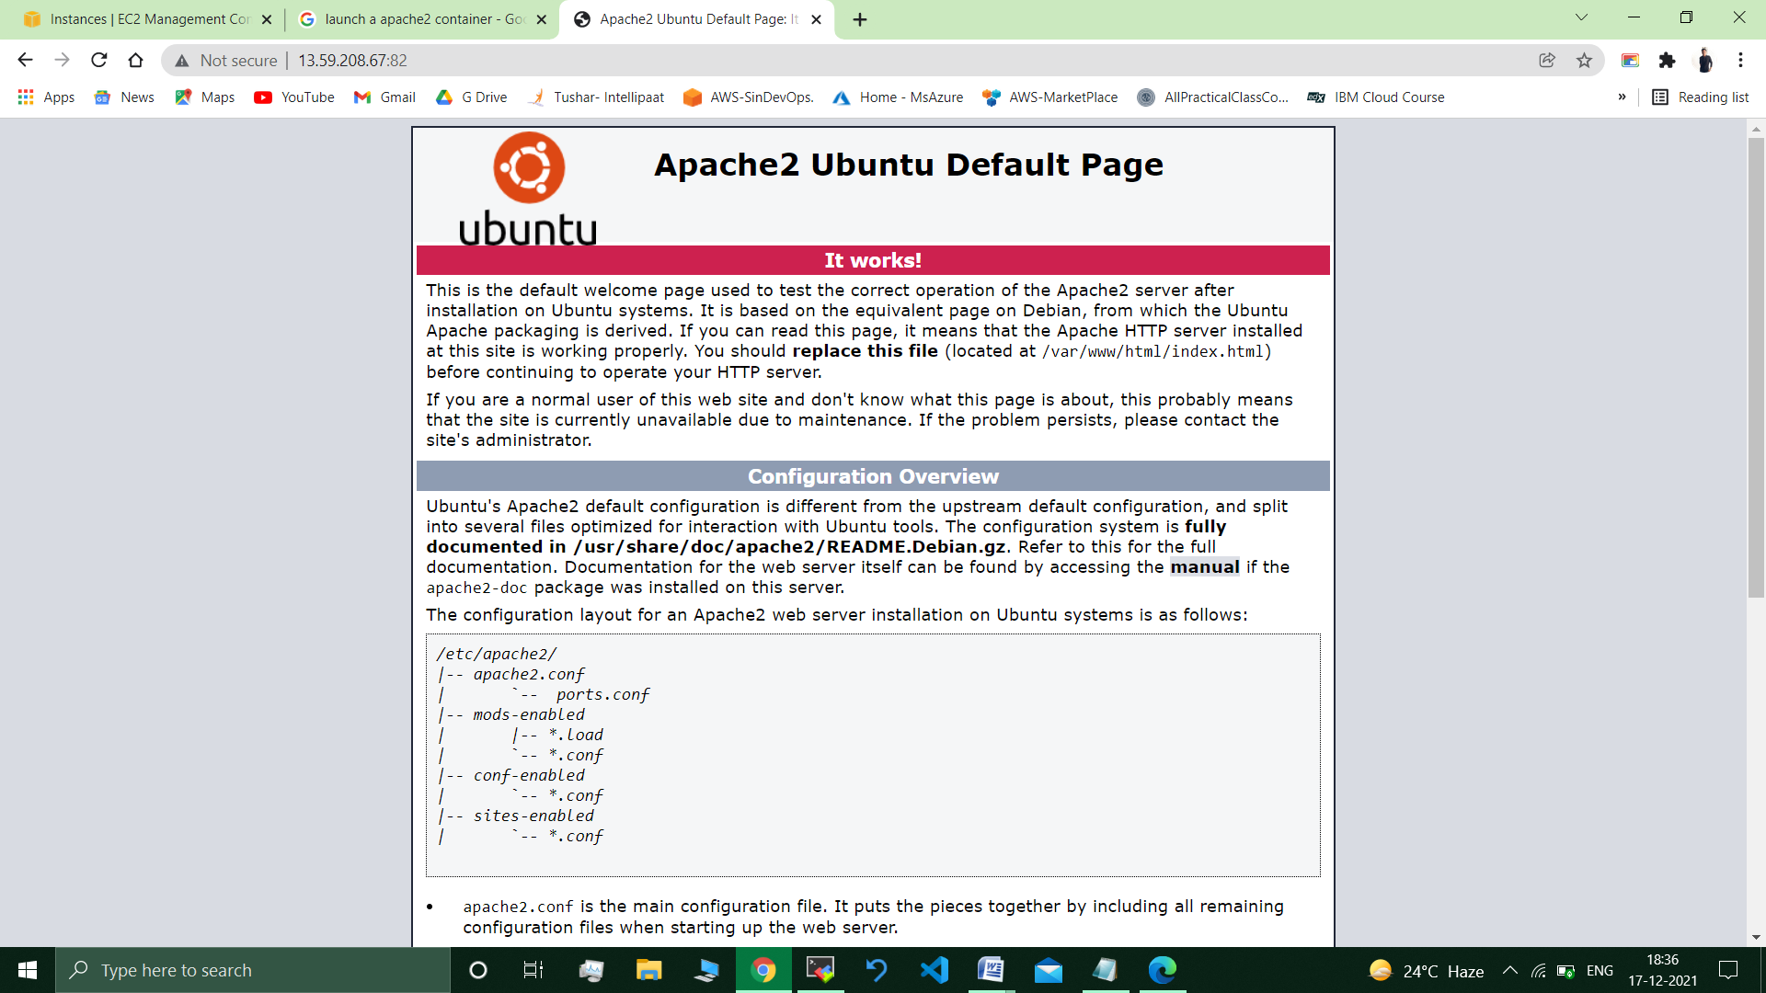

***Creating a Volume –***

sudo docker volume create demo-vol

/docker$ sudo docker volume ls

DRIVER VOLUME NAME

local demo-vol //demo-vol present

**Mountinng it to destintion :**

*Mounting and running container conataining this volume, image used is ubuntu :*

ubuntu@ip-172-31-39-154:~/docker$ sudo docker run -itd --mount source=demo-vol,destination=/var/www/html ubuntu

c9305388b8a3888c436d4c257452c203b8d615df466952ac25922c24b6b343d1

ubuntu@ip-172-31-39-154:~/docker$ sudo docker volume inspect demo-vol

[

{

"CreatedAt": "2021-12-21T11:26:56Z",

"Driver": "local",

"Labels": {},

"Mountpoint": "/var/lib/docker/volumes/demo-vol/_data",

"Name": "demo-vol",

"Options": {},

"Scope": "local"

}

]

*ubuntu@ip-172-31-39-154:~/docker$ cd /var/lib/docker/volumes/demo-vol/_data*

*-bash: cd: /var/lib/docker/volumes/demo-vol/_data:* **Permission denied**

ubuntu@ip-172-31-39-154:~/docker$ cd

ubuntu@ip-172-31-39-154:~$ **sudo su**

root@ip-172-31-39-154:/home/ubuntu# cd /var/lib/docker/volumes/demo-vol/_data

root@ip-172-31-39-154:/var/lib/docker/volumes/demo-vol/_data# ls

**root@ip-172-31-39-154:/var/lib/docker/volumes/demo-vol/_data# touch 1.txt**

root@ip-172-31-39-154:/var/lib/docker/volumes/demo-vol/_data# sudo docker ps

CONTAINER ID IMAGE COMMAND CREATED STATUS PORTS NAMES

**c9305388b8a3 ubuntu "bash" 3 minutes ago Up 3 minutes vigorous_ganguly**

**ubuntu@ip-172-31-39-154:~$ sudo docker exec -it vigorous_ganguly bash**

**root@c9305388b8a3:/# cd /var/www/html/**

**root@c9305388b8a3:/var/www/html# ls**

**1.txt**

-----------------------------------------------------------------------------------------------------------

***This "/var/lib/docker/volumes/demo-vol/_data" Location is only the Location /var/www/html where we want to mont the volume.***

***I have verified it also, by creating a 1.txt file in the location "/var/lib/docker/volumes/demo-vol/_data" , It was available in location : /var/www/html.***

***Which meant our demo-vol volume was mounted on the right path.***

**Submitted By : Tushar Sinha**

**Email ID :** [**sinhatushar17@gmail.com**](mailto:sinhatushar17@gmail.com)

**Enrolled in the “DevOps Architect Master’s Training Program”**