**Module-4: Docker - II: Assignment - 2**

**To Do :**

● Launch the Apache2 container created in previous module

● Create a bind mount on /var/www/html to replace html files dynamically

**Solution :**

**Apache2 Container image was already successfully built and launched in the previous assignment using commands :**

**sudo nano Dockerfile**

**//** FROM ubuntu

RUN apt-get update

RUN DEBIAN_FRONTEND="noninteractive" apt-get -y install tzdata

RUN apt-get -y install apache2

ADD . /var/www/html

ENTRYPOINT apachectl -D FOREGROUND

ENV name Intellipaat

**sudo docker build . -t csd1 //**Successfully built 0c395ad5fa03

**sudo docker run -it -d -p 82:80 csd1 //**Running this container.

90569dbb3de58cef95a22dba0dca329efa4c22fc1e38e3e9767dcb6d1908524a

***Visiting the Apache2 webpage :*** Public IP Address of Instance : 82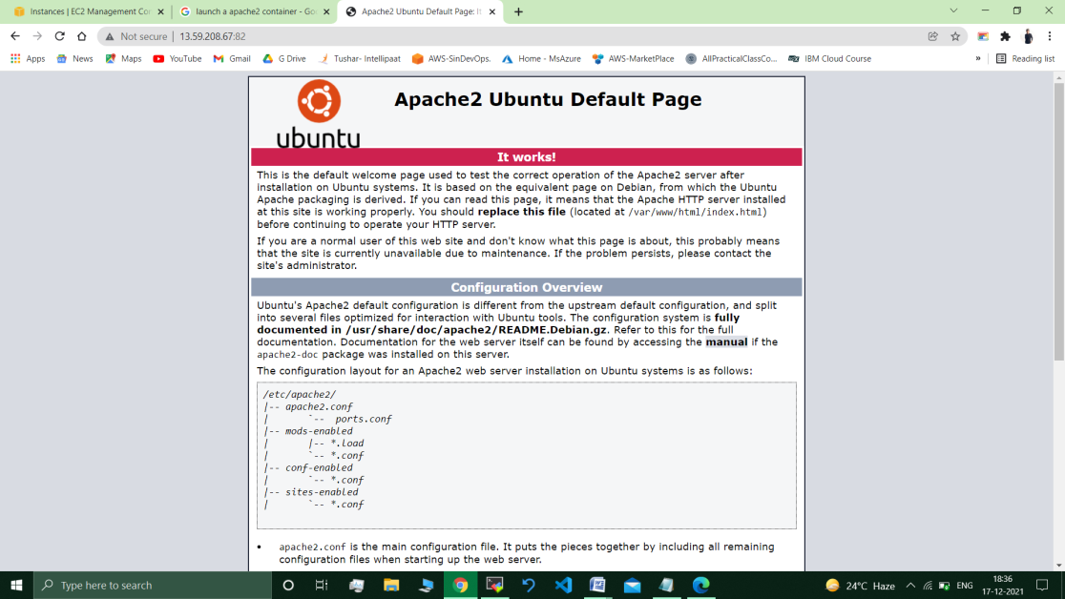

***Creating a bind mount –***

Cd ..

Pwd // /home/ubuntu

cd

sudo docker run -it -v /home/ubuntu/hello:/ var/www/html -d csd1

// 092d588367c9bcd83ac9aec0d2031384d41fcf94c5f7c1a63d2c0c895b93ff63

Sudo docker ps

43064208a097 csd1 "/bin/sh -c 'apachec…" 4 minutes ago Up 4 minutes 0.0.0.0:82->80/tcp, :::82->80/tcp keen_bhaskara

**:~/ sudo docker exec -it** 43064208a097 **bash // *Going inside the Container.***

/# cd /var/www/html/

root@34d977ad41b2:/var/www/html# **ls**  //Dockerfile hello index.html

:/var/www/html# apt get update && apt install nano

rm -f index.html // Default Apache2 web page deleted.

**root@34d977ad41b2:/var/www/html# nano index.html**

// Created new index.html file.

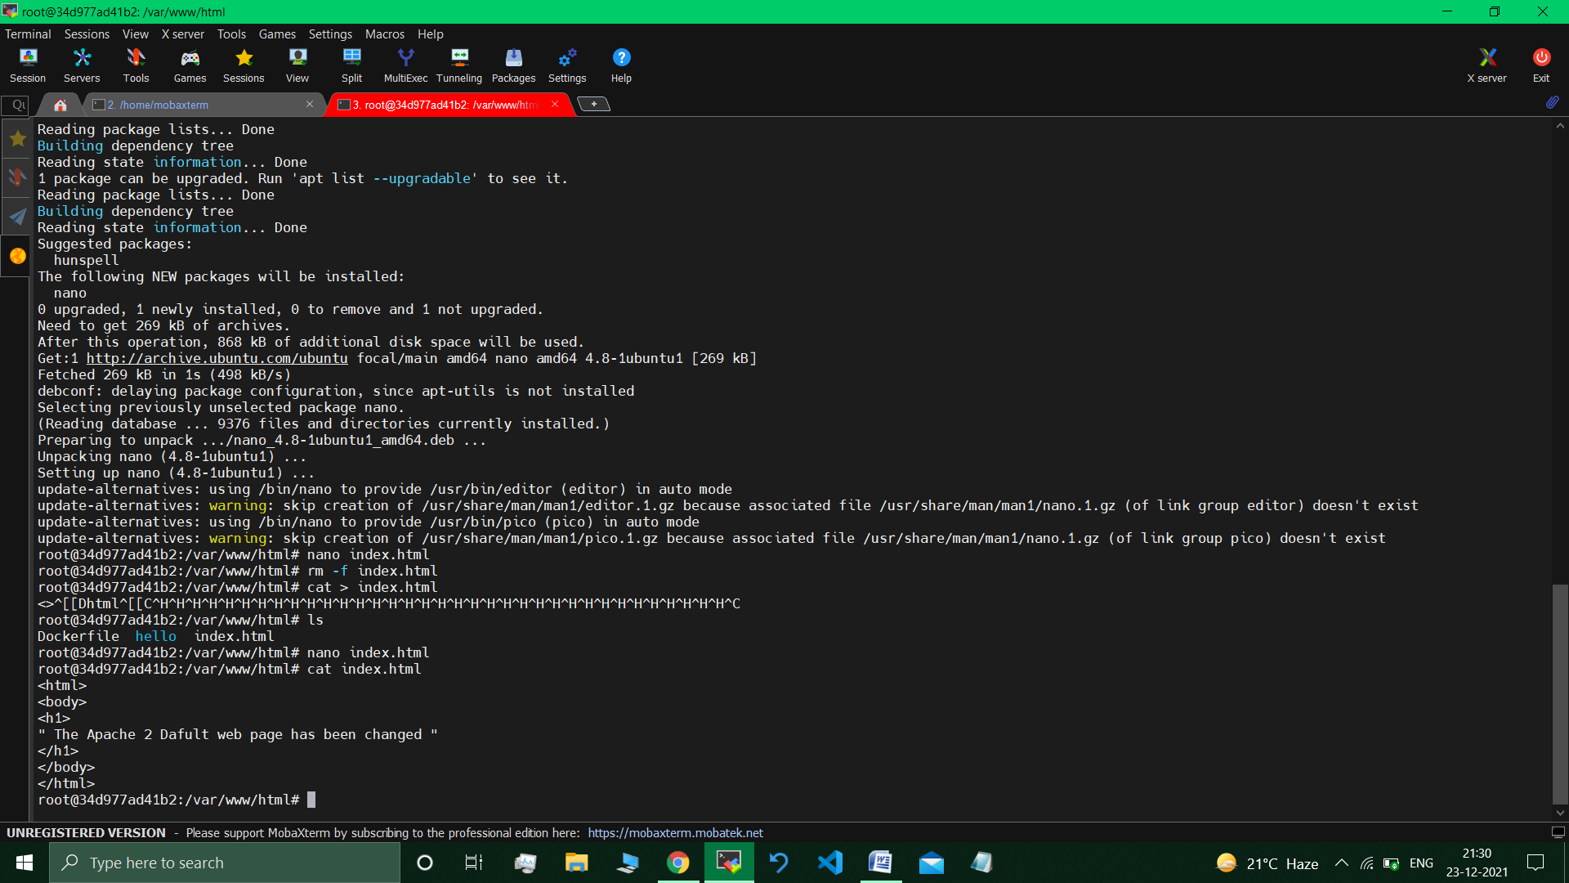

**Visited the apache 2 page :**

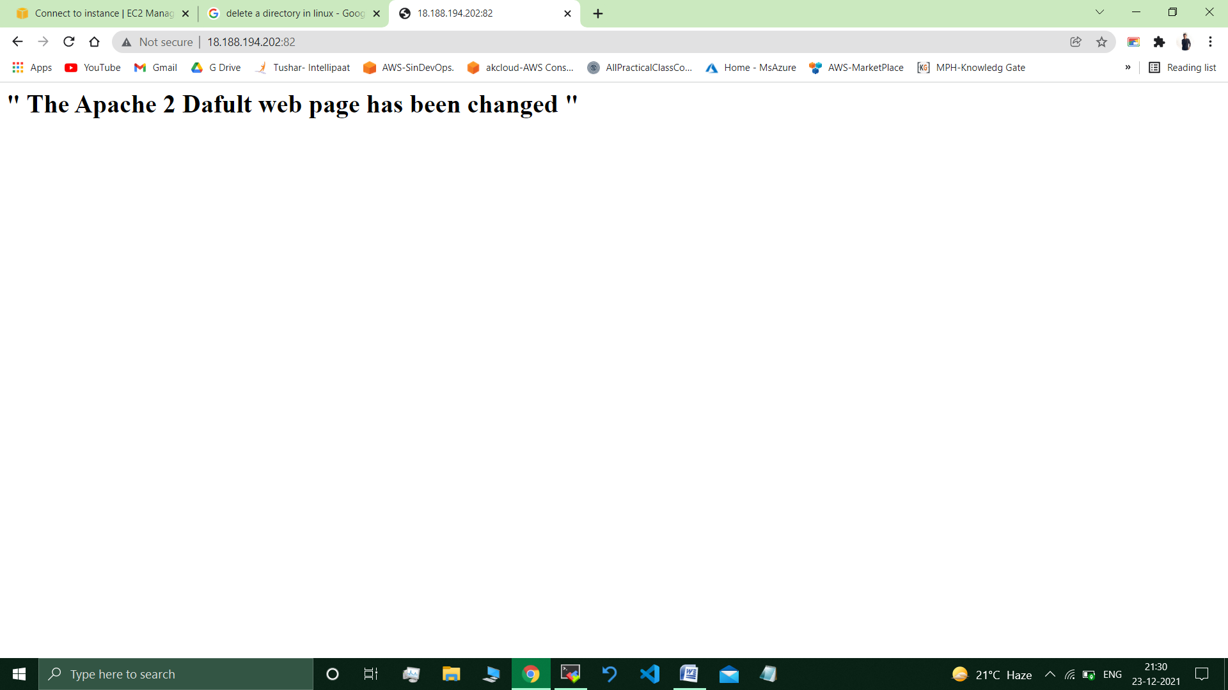

***//changes to default web page are available.***

**Submitted By : Tushar Sinha**

**Email ID :** [**sinhatushar17@gmail.com**](mailto:sinhatushar17@gmail.com)

**Enrolled in the “DevOps Architect Master’s Training Program”**