**Docker 2, Assignment 3**

**To Do :**  
● Create 5 custom container, with 5 different default pages

● Using docker compose, deploy these 5 containers on port 81, 82, 83, 84 and 85 respectively

**Solution :**

sudo apt-get update && sudo apt-get install docker.io –y

cmkdir docker

cd docker

ubuntu@ip-172-31-39-154:~/docker$ sudo nano docker-compose.yml

:~/docker$ cat docker-compose.yml

version: '3'

services:

sample1:

image: httpd

ports:

- "81:80"

sample2:

image: httpd

ports:

- "82:80"

sample3:

image: httpd

ports:

- "83:80"

sample4:

image: httpd

ports:

- "84:80"

sample5:

image: nginx

ports:

- "85:80" //

ubuntu@ip-172-31-39-154:~/docker$ sudo docker-compose up -d

Creating network "docker_default" with the default driver

Creating docker_sample1_1 ... done

Creating docker_sample5_1 ... done

Creating docker_sample2_1 ... done

Creating docker_sample3_1 ... done

Creating docker_sample4_1 ... done

ubuntu@ip-172-31-39-154:~/docker$ sudo docker ps

CONTAINER ID IMAGE COMMAND CREATED STATUS PORTS NAMES

6e319529ccb3 httpd "httpd-foreground" 5 minutes ago Up 5 minutes 0.0.0.0:84->80/tcp, :::84->80/tcp docker_sample4_1

5b63706e95f4 httpd "httpd-foreground" 5 minutes ago Up 5 minutes 0.0.0.0:82->80/tcp, :::82->80/tcp docker_sample2_1

00b2e900f3a3 httpd "httpd-foreground" 5 minutes ago Up 5 minutes 0.0.0.0:83->80/tcp, :::83->80/tcp docker_sample3_1

76f54a9cd9de nginx "/docker-entrypoint.…" 5 minutes ago Up 5 minutes 0.0.0.0:85->80/tcp, :::85->80/tcp docker_sample5_1

b813926ce3d9 httpd "httpd-foreground" 5 minutes ago Up 5 minutes 0.0.0.0:81->80/tcp, :::81->80/tcp docker_sample1_1

//**All containers created.**

**Going inside all the containers and creating/editing the default landing webpage**

$ sudo docker exec -it 6e319529ccb3 bash

*First we have to install nano editor inside the container*

**apt update && apt install nano**

find . -name index.html // ./htdocs/index.html

**cd ./htdocs/**

root@6e319529ccb3:/usr/local/apache2/htdocs# ls // **index.html** – Present

root@6e319529ccb3:/usr/local/apache2/htdocs#nano index.html

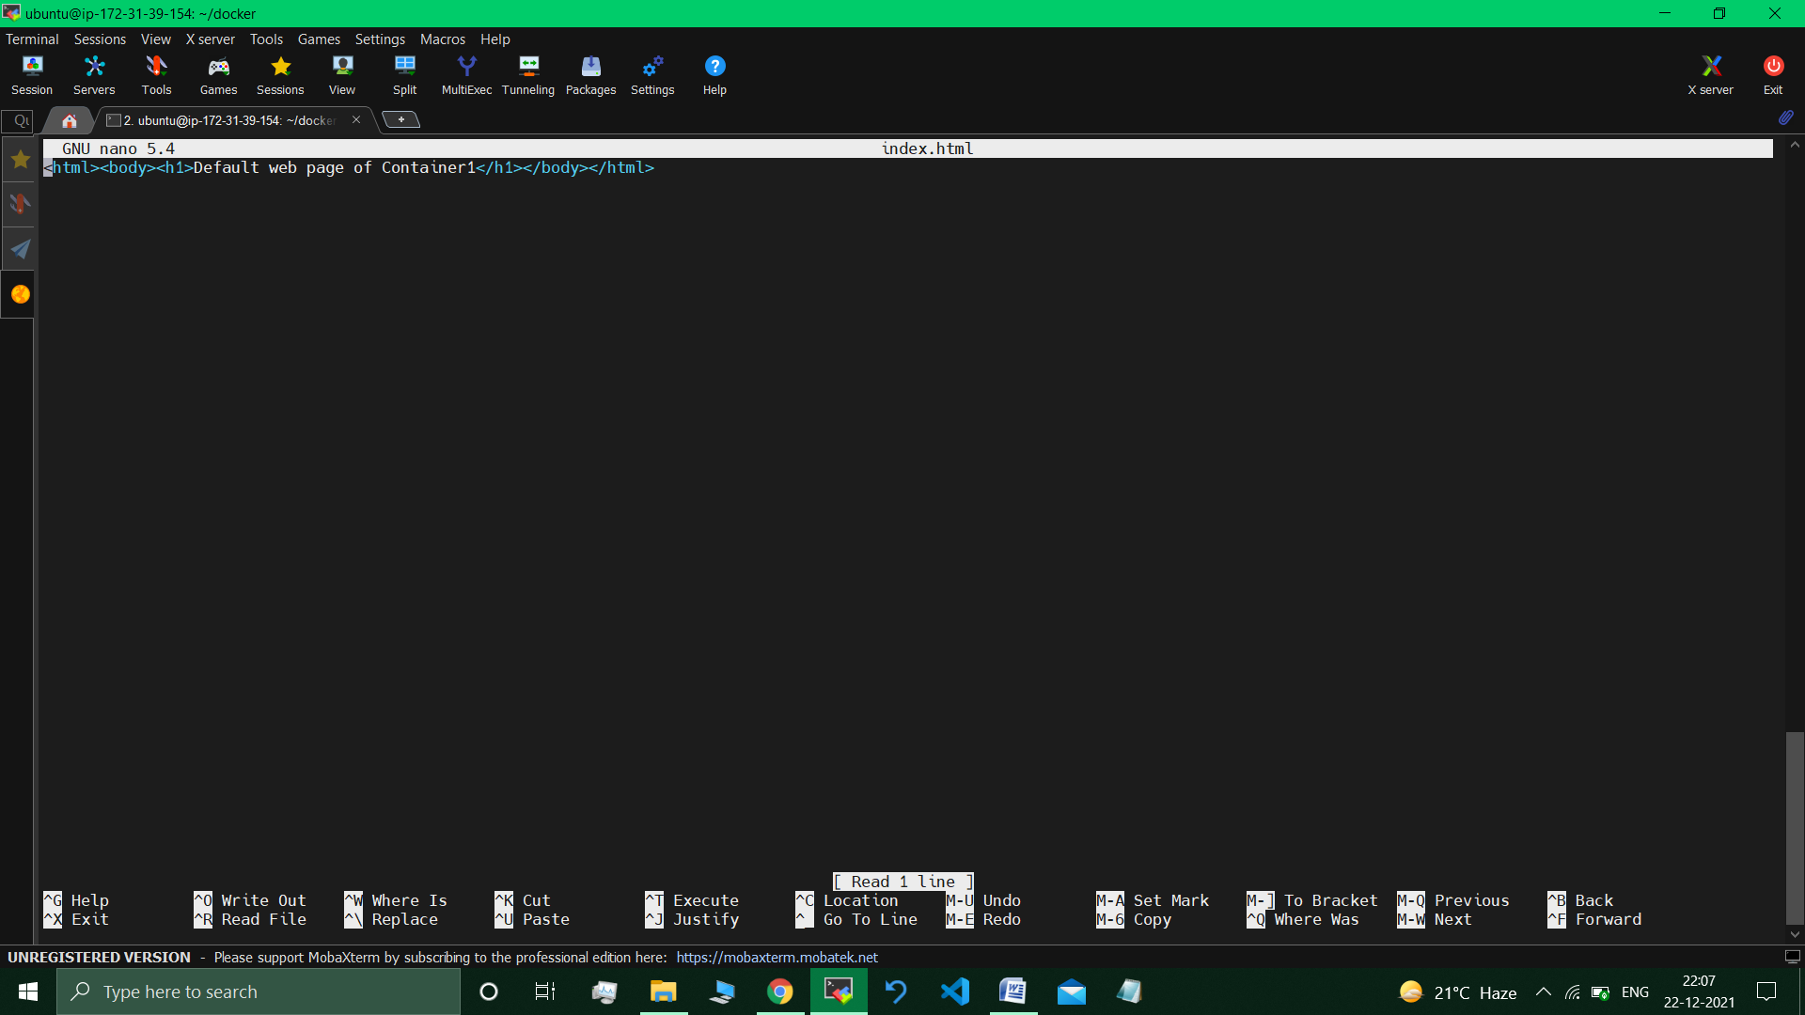

*//Default web page of container1 changed.*

root@6e319529ccb3:/usr/local/apache2/htdocs#exit //exiting the container.

*docker$ sudo docker exec -it 5b63706e95f4 bash //going inside container2.*

apt update && apt install nano

*# cd ./htdocs/*

:/usr/local/apache2/htdocs# nano index.html

:/usr/local/apache2/htdocs# exit

**Similarly for other containers :**

sudo docker exec -it 76f54a9cd9de bash

root@76f54a9cd9de:/# apt update && apt install nano

find . -name index.html

./usr/share/nginx/html/index.html

Cd ./usr/share/nginx/html/

ls // 50x.html index.html

nano index.html

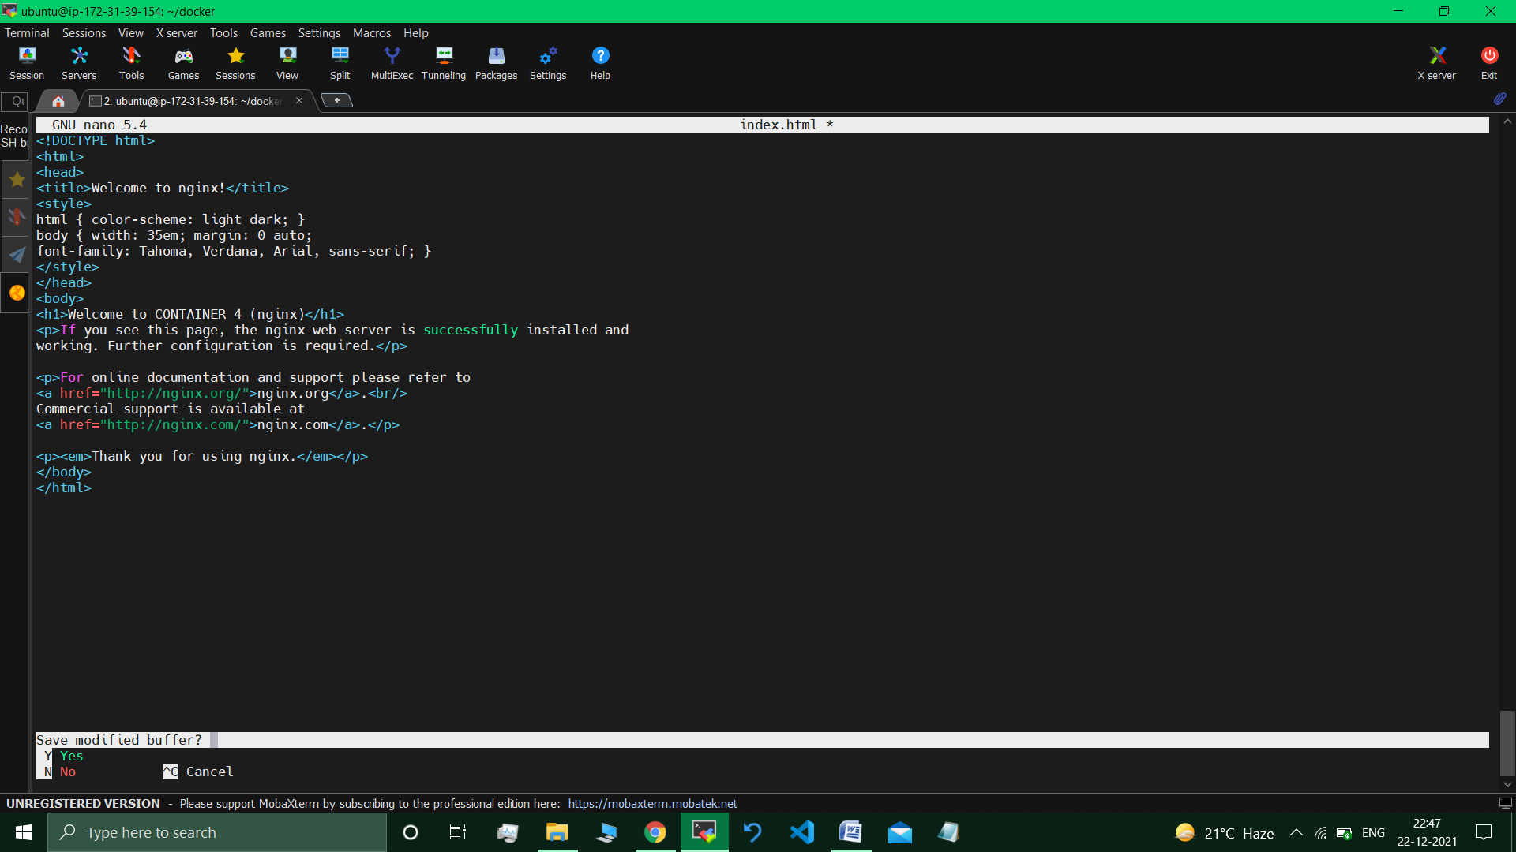

exit //exiting the container

**Restarting docker compose :**

ubuntu@ip-172-31-39-154:~/docker$ sudo docker-compose restart

Restarting docker_sample4_1 ... done

Restarting docker_sample2_1 ... done

Restarting docker_sample3_1 ... done

Restarting docker_sample5_1 ... done

Restarting docker_sample1_1 ... done

**Visiting the Ip address: ports (of the containers) -**

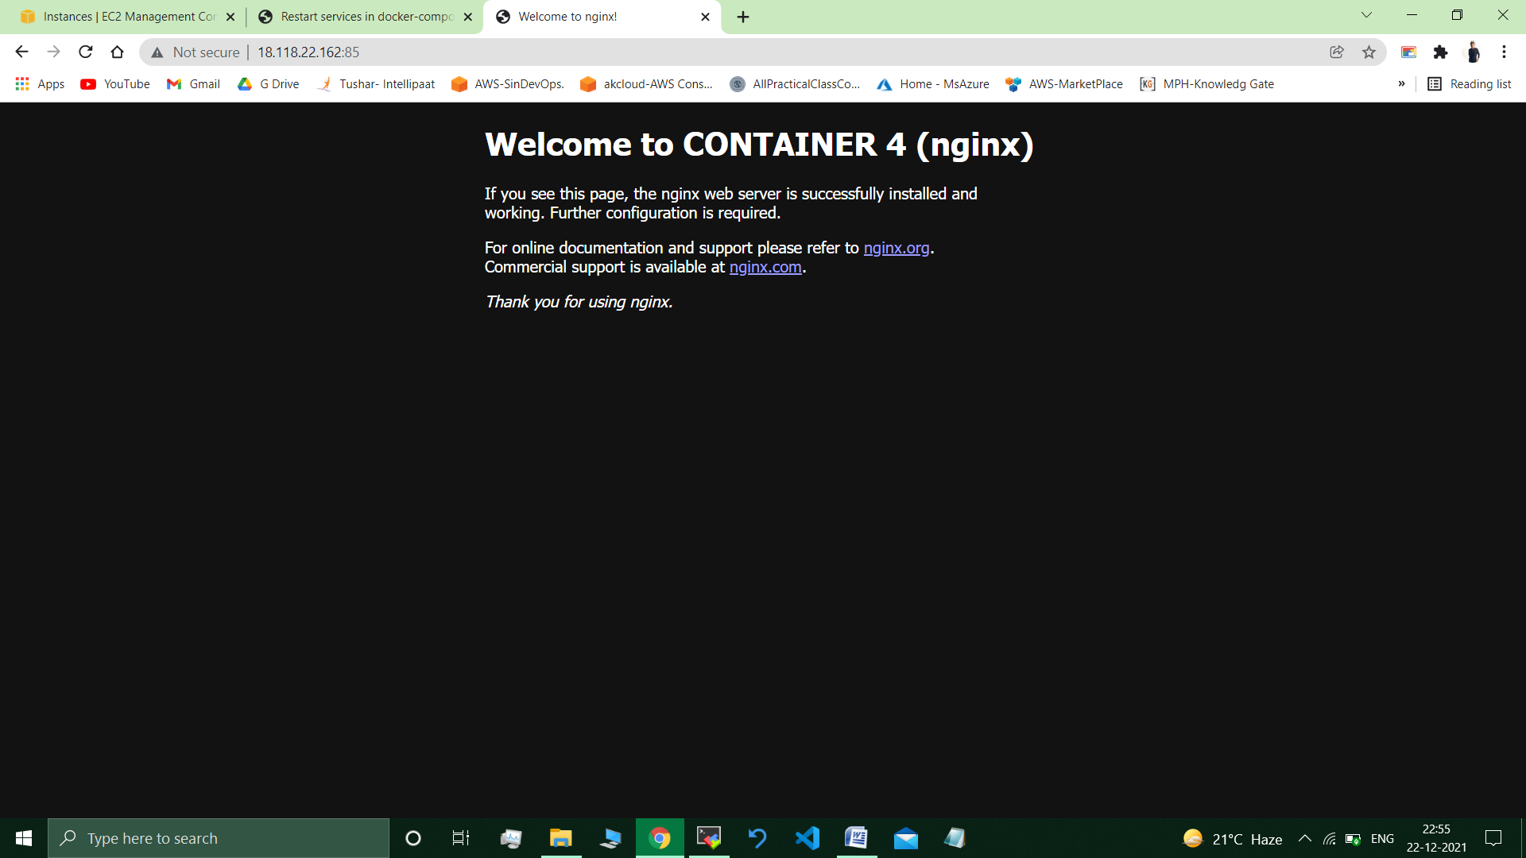 //Desired Output.

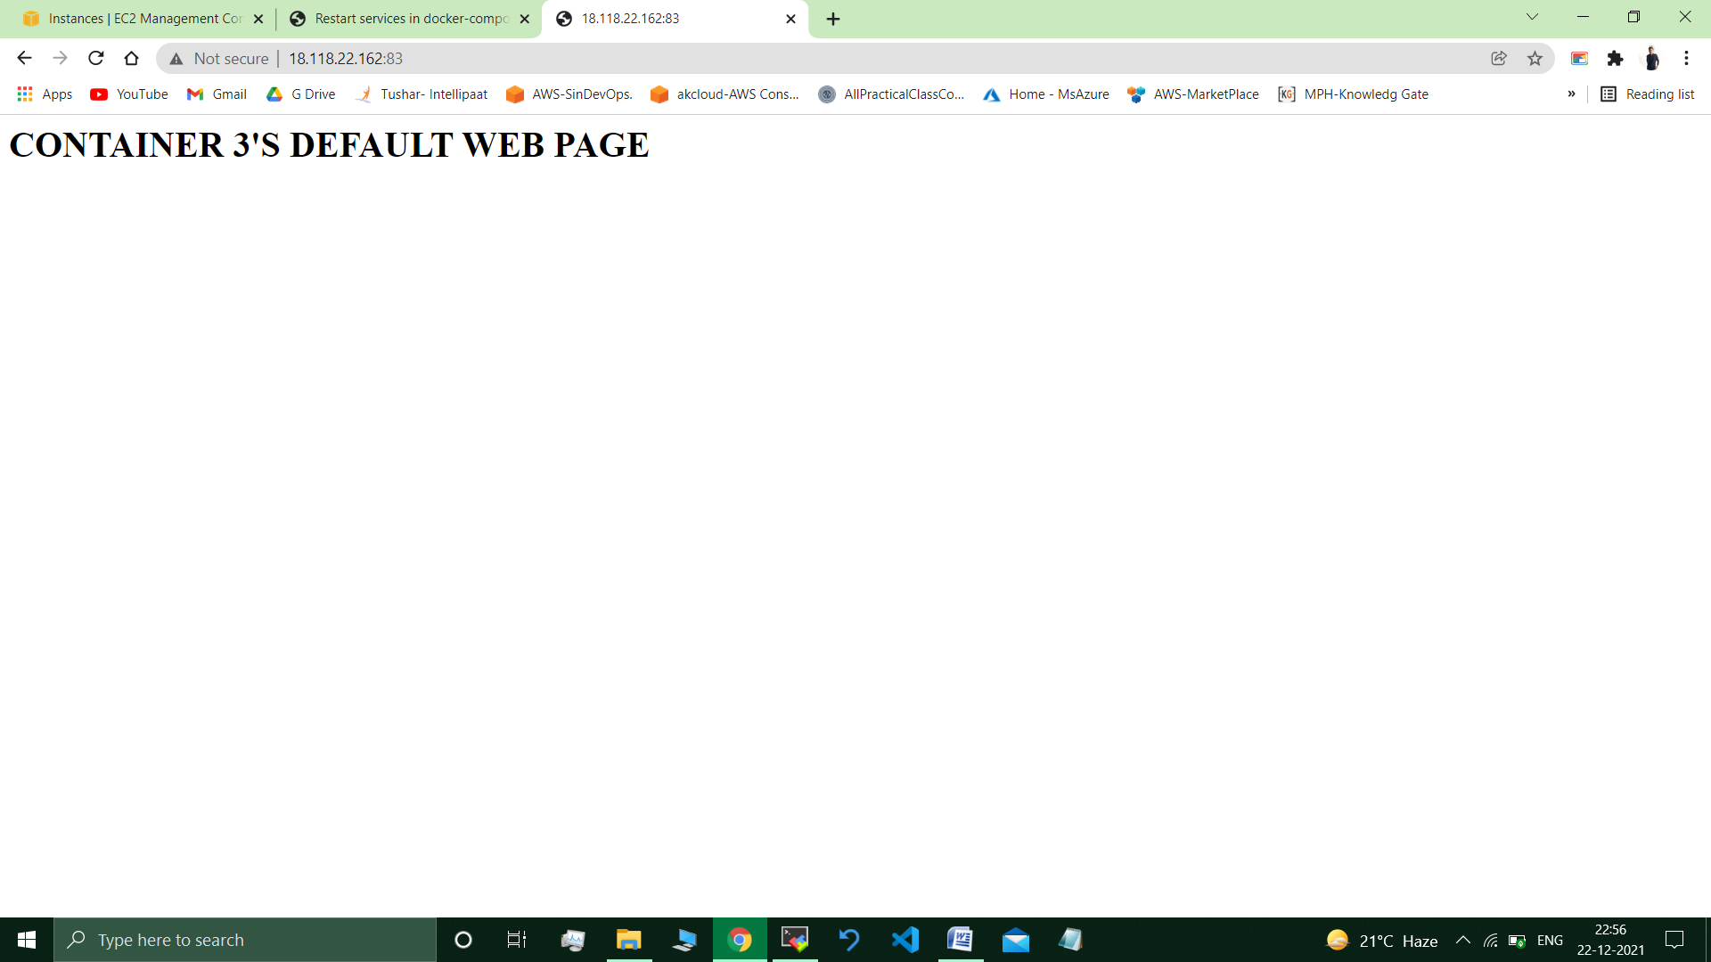 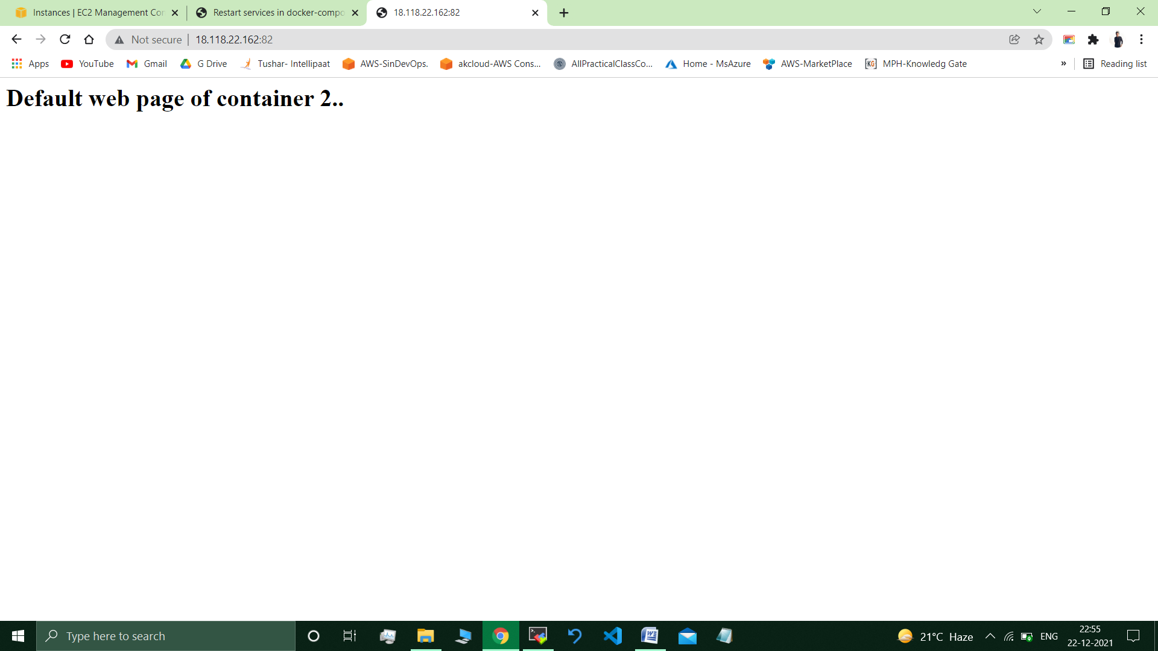

___________________________________________________________________

**Submitted By : Tushar Sinha**

**Email ID :** [**sinhatushar17@gmail.com**](mailto:sinhatushar17@gmail.com)

**Enrolled in the “DevOps Architect Master’s Training Program”**