**Module-4: Docker - II: Assignment – 4**

**To Do :**

● Create a Docker swarm cluster with 3 nodes

● Deploy an apache container with 4 replicas

**Solution** :

**HOW TO DO :**

PART 1: First we will create a leader of cluster (vm)

Then using swarn, we’ll initialize it as leader.

Worker Nodes of Cluster will join the Leader using the generated command.

PART 2 : Using docker swarn cluster,we will deploay apache container with 4 replicas.

$ mkdir compose

cd compose

**Creating a Docker swarm cluster with 3 nodes** :

~/compose$ sudo docker swarm init --advertise-addr 18.188.52.54

*Swarm initialized: current node (568hg34jxlqfwoss7osa0cjro) is now a manager.*

*To add a worker to this swarm, run the following command:*

docker swarm join --token SWMTKN-1-00j3mstkn9y7iqyt6ixpvq2he85s58ou4x29a9jen0ynr6c5pd-88naacpegnhz2gdngihyglu9s 18.188.52.54:2377

To add a manager to this swarm, run 'docker swarm join-token manager' and follow the instructions. //

**On Worker Machines :**

Updating and installing Docker on all three worker machines :

sudo apt-get update && sudo apt-get install docker.io -y

**sudo docker login**

**Node 1 :**

**sudo docker swarm join --token SWMTKN-1-00j3mstkn9y7iqyt6ixpvq2he85s58ou4x29a9jen0ynr6c5pd-88naacpegnhz2gdngihyglu9s 18.188.52.54:2377**

*// This node joined a swarm as a worker.*

*Sudo docker node ls // all nodes displayed.*

**Node 2 :**

ubuntu@ip-172-31-33-15:~$ sudo docker swarm join --token SWMTKN-1-00j3mstkn9y7iqyt6ixpvq2he85s58ou4x29a9jen0ynr6c5pd-88naacpegnhz2gdngihyglu9s 18.188.52.54:2377

*// This node joined a swarm as a worker.*

**Node 3 :**

ubuntu@ip-172-31-27-172:~$ sudo docker swarm join --token SWMTKN-1-00j3mstkn9y7iqyt6ixpvq2he85s58ou4x29a9jen0ynr6c5pd-88naacpegnhz2gdngihyglu9s 18.188.52.54:2377

//This node joined a swarm as a worker.

**On Master/Leader Machine :**

ubuntu@ip-172-31-39-154:~/compose$ **sudo docker node ls**

ID HOSTNAME STATUS AVAILABILITY MANAGER STATUS ENGINE VERSION

6zbpw1s683u7w7c59vhp5ks1t ip-172-31-27-172 Ready Active 20.10.7

qwuk8jup3uz41jl5vo3mn7pb8 ip-172-31-33-15 Ready Active 20.10.7

568hg34jxlqfwoss7osa0cjro * ip-172-31-39-154 Ready Active Leader 20.10.7

u390bzmrkdawkbuhmwwhd7l9o ip-172-31-47-72 Ready Active 20.10.7

// All the three Workers have been connected to the leader successfully,

**// Docker swarm cluster with 3 nodes created successfully.**

**Deploying an Apache container :**

**:~/compose$ sudo docker service create --name apache --replicas 4 -p 82:80 httpd**

uwju28wjy4izgkzzbggulo9mm

overall progress: 4 out of 4 tasks

1/4: running [==================================================>]

2/4: running [==================================================>]

3/4: running [==================================================>]

4/4: running [==================================================>]

**// Apache container (service) with 4 replicas created and running.**

Upon visiting the IP address : 82 (Port) : Apache web server is available -

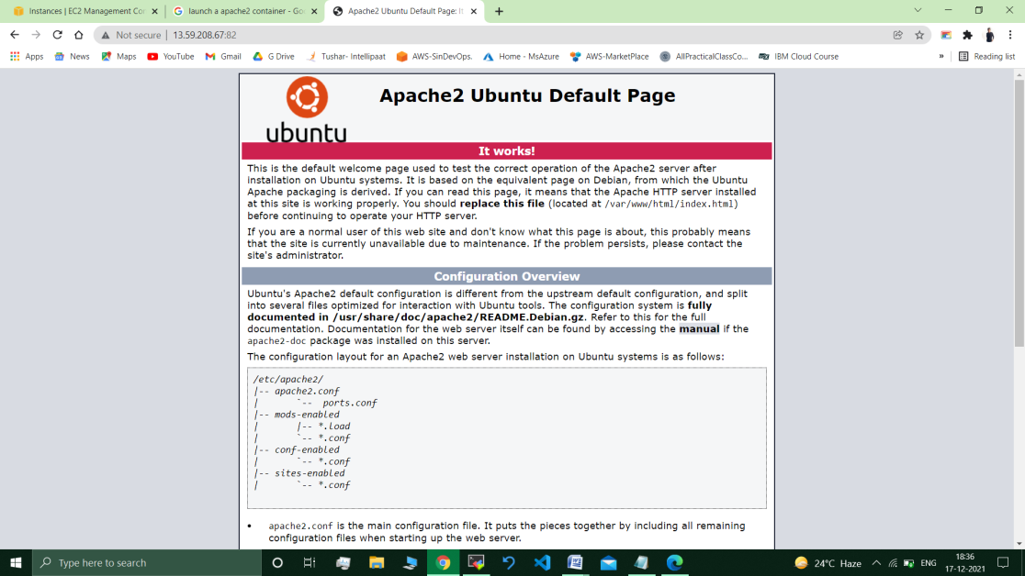

___________________________________________________________________

**Submitted By : Tushar Sinha**

**Email ID :** [**sinhatushar17@gmail.com**](mailto:sinhatushar17@gmail.com)

**Enrolled in the “DevOps Architect Master’s Training Program”**