**CASE STUDY - CONTAINERIZATION USING DOCKER I**

**To Do :**

**Problem Statement:** You work as a Devops Engineer in a leading Software Company. You have been asked to Dockerize the applications on the production server. The company uses custom software, therefore there is no pre-built container which can be used. Assume the following things:

1. Assume the software to be installed is apache

2. Use an Ubuntu container

**The company wants the following things:**

1. Push a container to DockerHub with the above config

2. The Developers will not be working with Docker, hence from their side you will just get the code. Write a Dockerfile which could put the code in the custom image that you have built.

**Solution :**

sudo apt-get update && sudo apt-get install docker.io -y

sudo docker pull ubuntu //Pulling ubuntu image.

sudo docker images //ubuntu image present

**//Running a container from ubuntu Image.**

sudo docker run -itd --name cont1 -p 80:80 ubuntu // 27e8d98dab5afe7307dbcd9a3d26948ad7567f4fe3e71ef4301c3afaa41254a9

sudo docker ps

CONTAINER ID IMAGE COMMAND CREATED STATUS PORTS NAMES

27e8d98dab5a ubuntu "bash" 39 seconds ago Up 38 seconds 0.0.0.0:80->80/tcp, :::80->80/tcp cont1

sudo docker exec -it 27e8d98dab5a bash

**//Installing Apache2**

apt-get update

apt-get install apache2 –y

service apache2 status //checking the apache2 service status

//service not started,

service apache2 start

service apache2 status //apache2 is running.

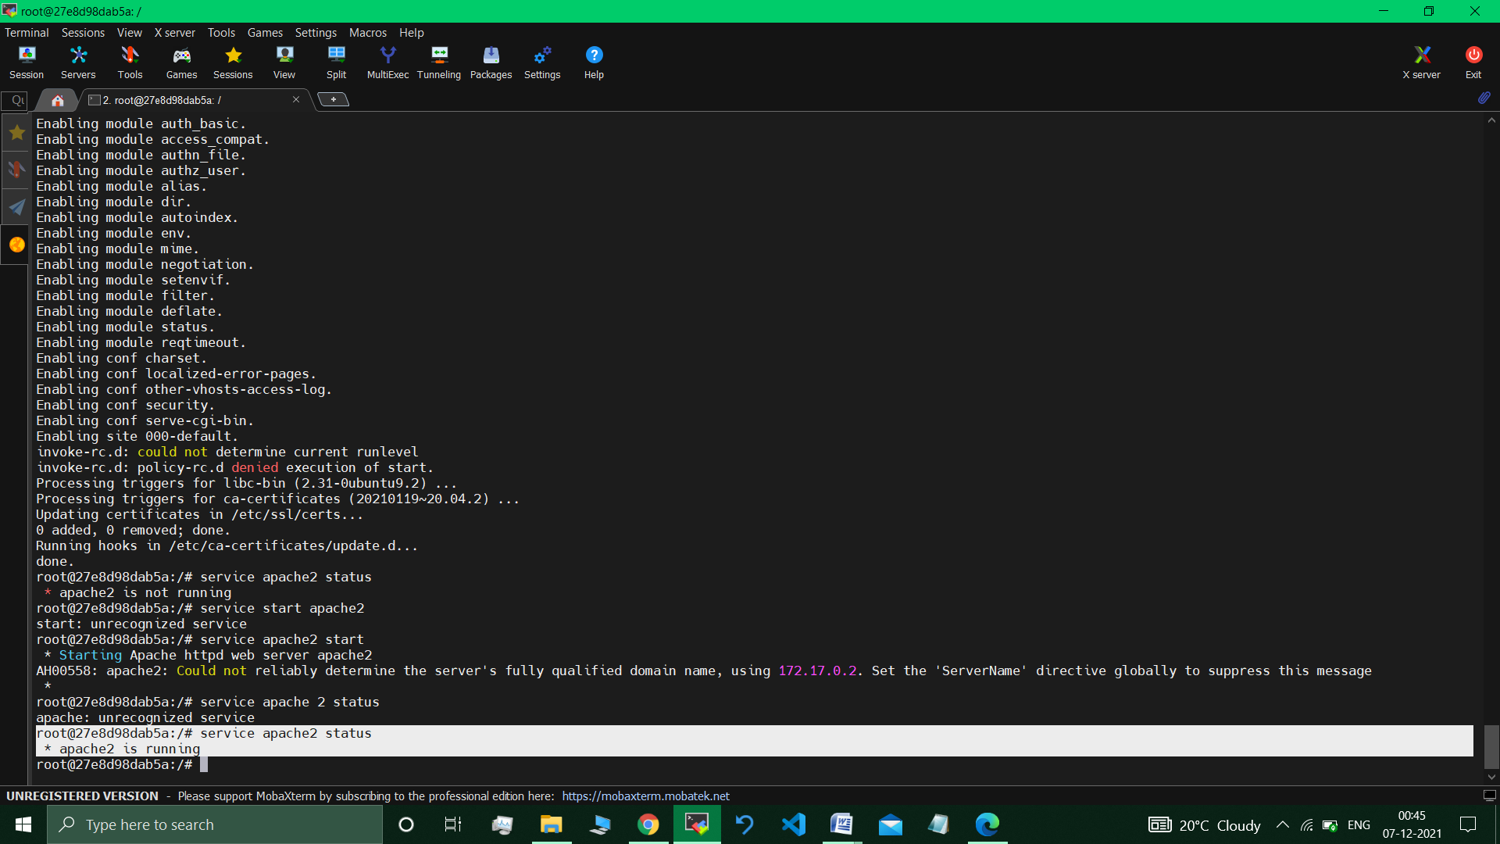

**sudo docker commit 27e8d98dab5a sindevops/cs1img**

sudo docker login

sudo docker push sindevops/cs1img

// Using default tag: latest

The push refers to repository [docker.io/sindevops/cs1img]

b6f3180c01a6: Pushed

9f54eef41275: Mounted from library/ubuntu

latest: digest: sha256:ce504ca199b4f2ce0457034e6be7ad575ab73cf1c8e57baabb04ccb339eb36e4 size: 741 //

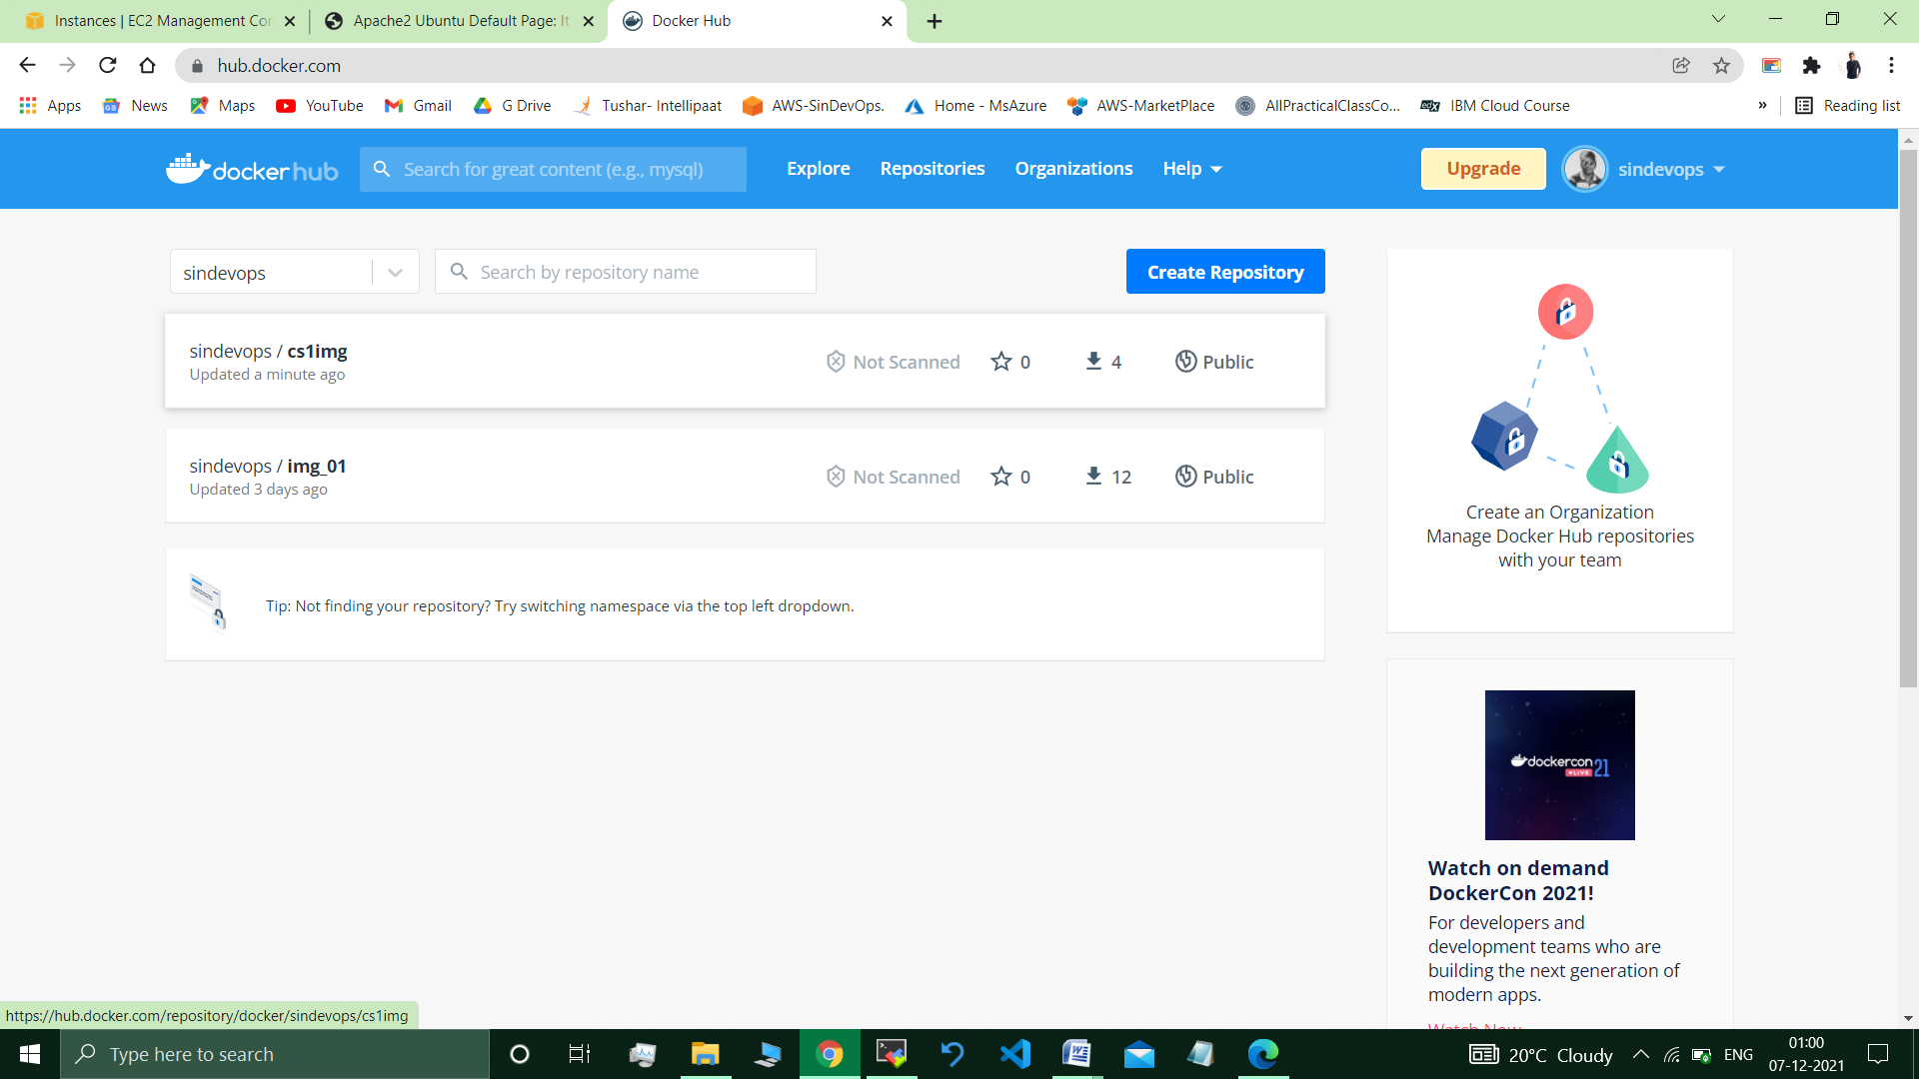

***Let’s assume that : pseudocode.html code was provided from developer’s side.***

**sudo nano Dockerfile**

**//** FROM ubuntu

RUN apt-get update

RUN DEBIAN_FRONTEND="noninteractive" apt-get -y install tzdata

RUN apt-get -y install apache2

ADD . /var/www/html

ENTRYPOINT apachectl -D FOREGROUND

ENV name Intellipaat

**sudo pseudocode.html**

// <html>

<head>

<title>intellipaat</title>

</head>

<body>

<h1>hello</h1>

<p>Docker 1 case study soluion</p>

</body>

</html>

**sudo docker build . -t csd1 //**Successfully built 0c395ad5fa03

**sudo docker run -it -d -p 82:80 csd1 //**Running this container.

90569dbb3de58cef95a22dba0dca329efa4c22fc1e38e3e9767dcb6d1908524a

***Visiting the page :*** Public IP Address of Instance : 82/pseudocode.html

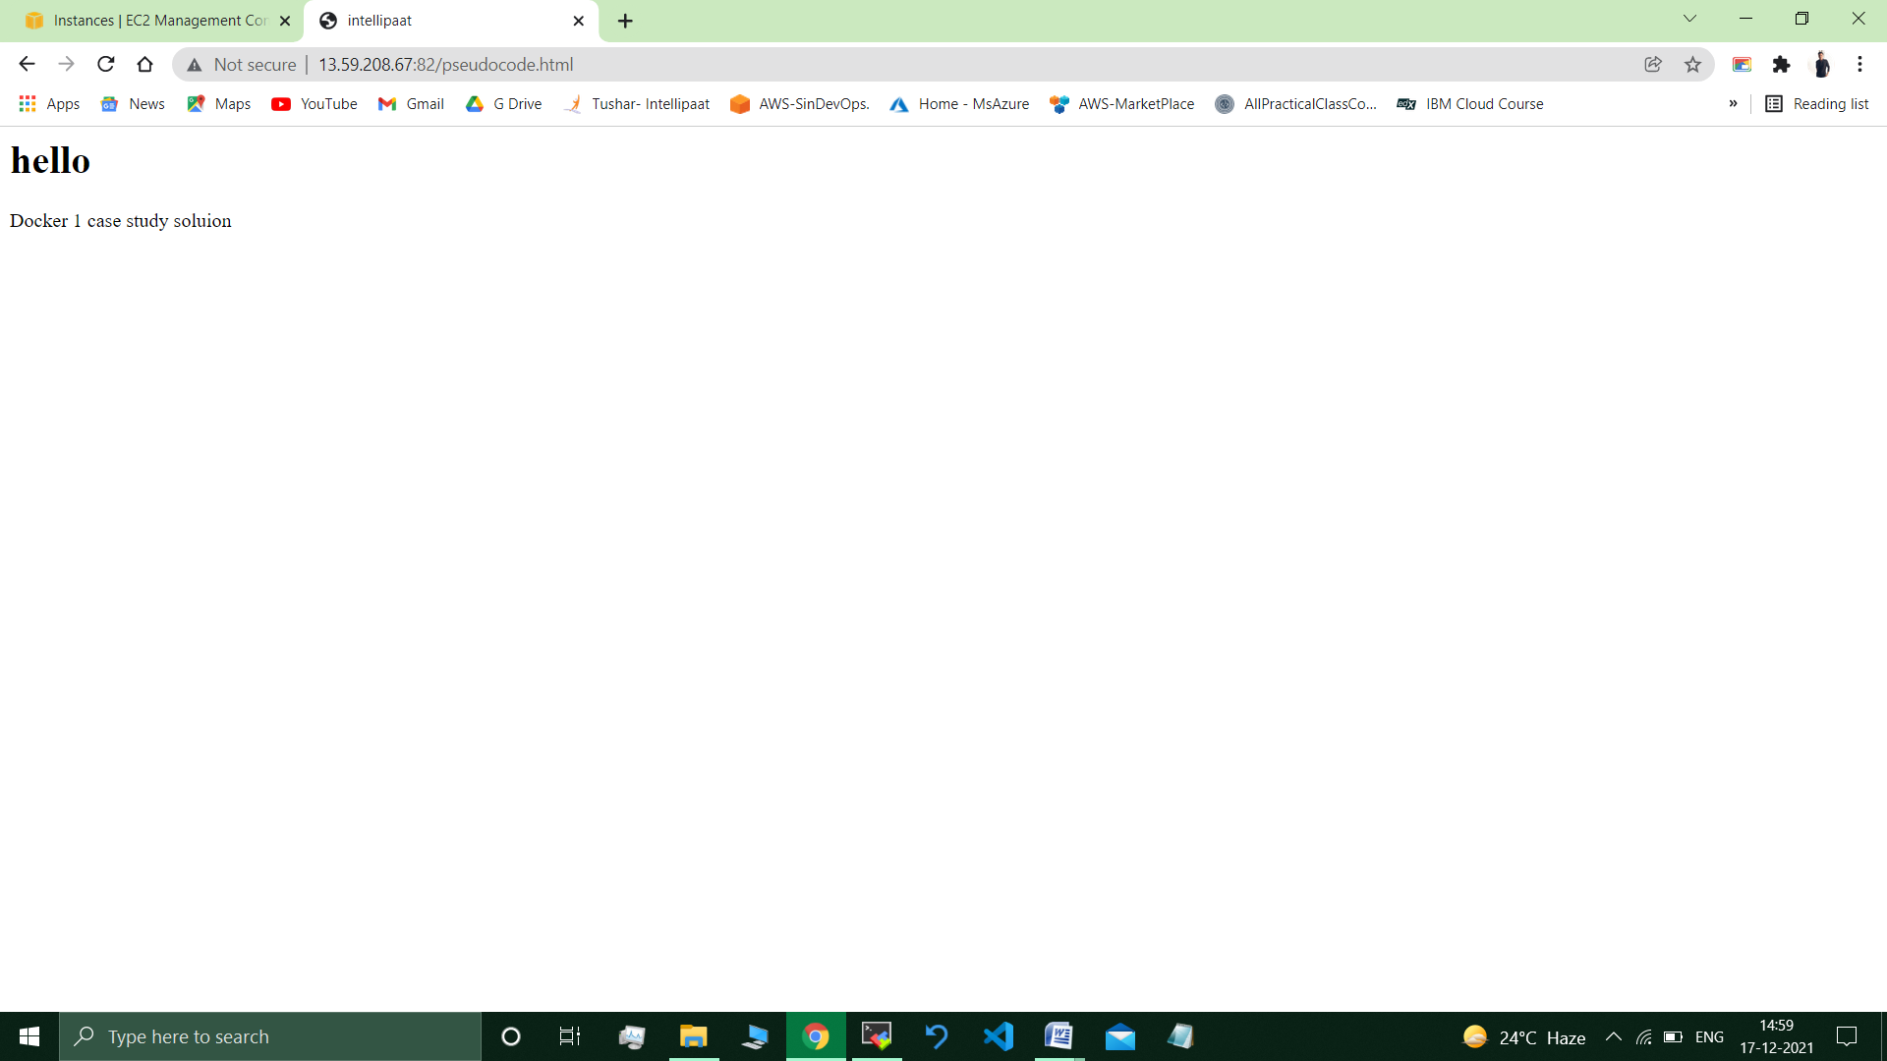

___________________________________________________________________

**Submitted By : Tushar Sinha**

**Email ID :** [**sinhatushar17@gmail.com**](mailto:sinhatushar17@gmail.com)

**Enrolled in the “DevOps Architect Master’s Training Program”**