**Module-5: Puppet Assignment - 1**

**To Do :**

● Setup puppet master-slave using 3 nodes

● Installing apache on slaves using manifests

**Solution :**

**On Master Machine :**

$ sudo apt-get update // Updating the master machine.

wget <https://apt.puppetlabs.com/puppet-release-bionic.deb> //downloading this file.

sudo dpkg -i puppet-release-bionic.deb // unzipping the file

sudo apt-get update

apt policy puppet master

sudo apt-get install puppet-master

sudo systemctl status puppet-master.service //checking status of service //

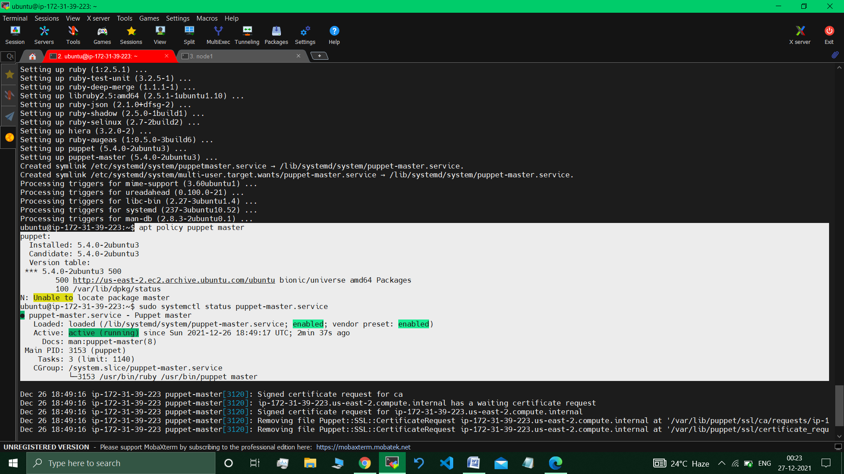

**Configuring settings :**

sudo vim /etc/default/puppet-master

Adding 512 mb of RAM instead of 1 gb default RAM :

**JAVA_ARGS="-Xms512m Xmx512m" //Adding this Line**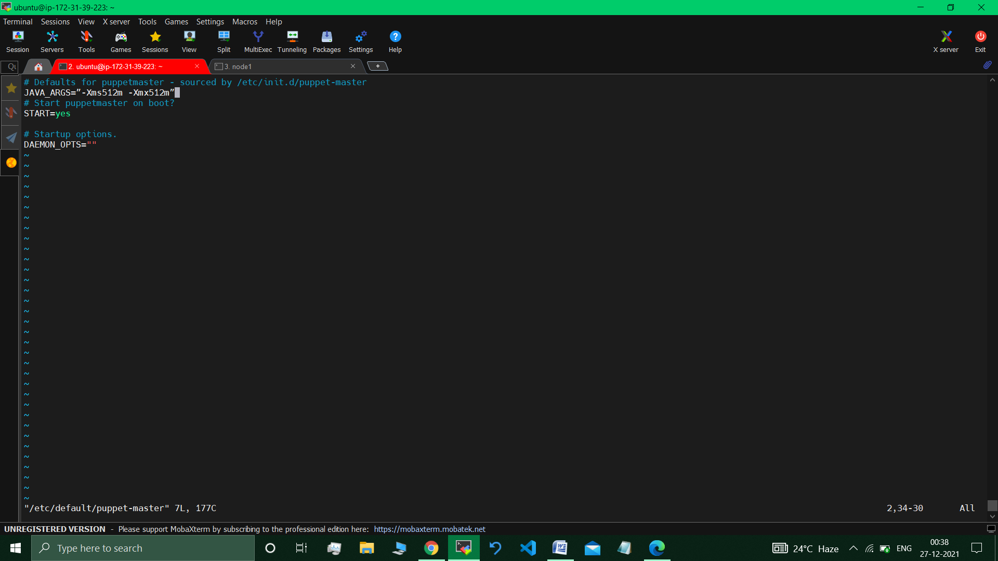

**Changing Host file :**

sudo nano /etc/hosts // added the IP address of master as well as of Nodes

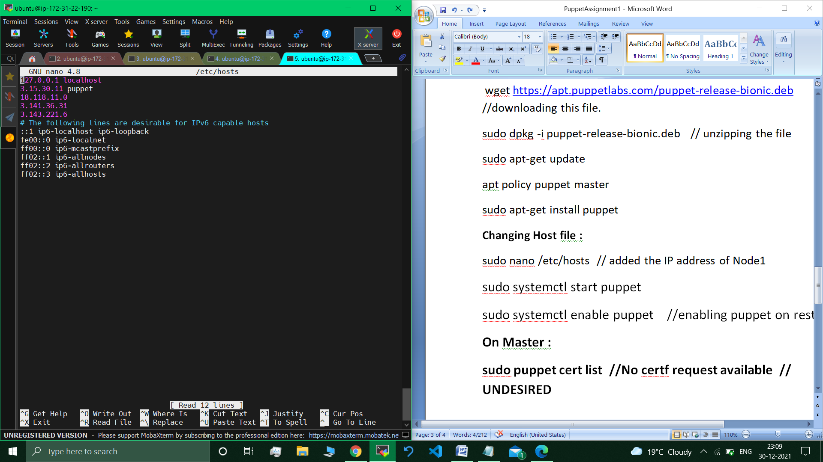

sudo systemctl restart puppet-master.service // restarting puppet service.

$ sudo ufw allow 8140/tcp // opening port 8140 (tcp)

Rules updated Rules updated (v6)

***Puppet Master is successfully all set.***

**On Nodes/Agents :**

$ sudo apt-get update // Updating the master machine.

wget <https://apt.puppetlabs.com/puppet-release-bionic.deb> //downloading this file.

sudo dpkg -i puppet-release-bionic.deb // unzipping the file

sudo apt-get update

apt policy puppet master

sudo apt-get install puppet

**Changing Host file :**

sudo nano /etc/hosts // added the IP address of master as well as of Nodes

sudo systemctl start puppet

sudo systemctl enable puppet //enabling puppet on restart.

***All nodes configured.***

**On Master :**

sudo puppet cert list*// Certificates request available*

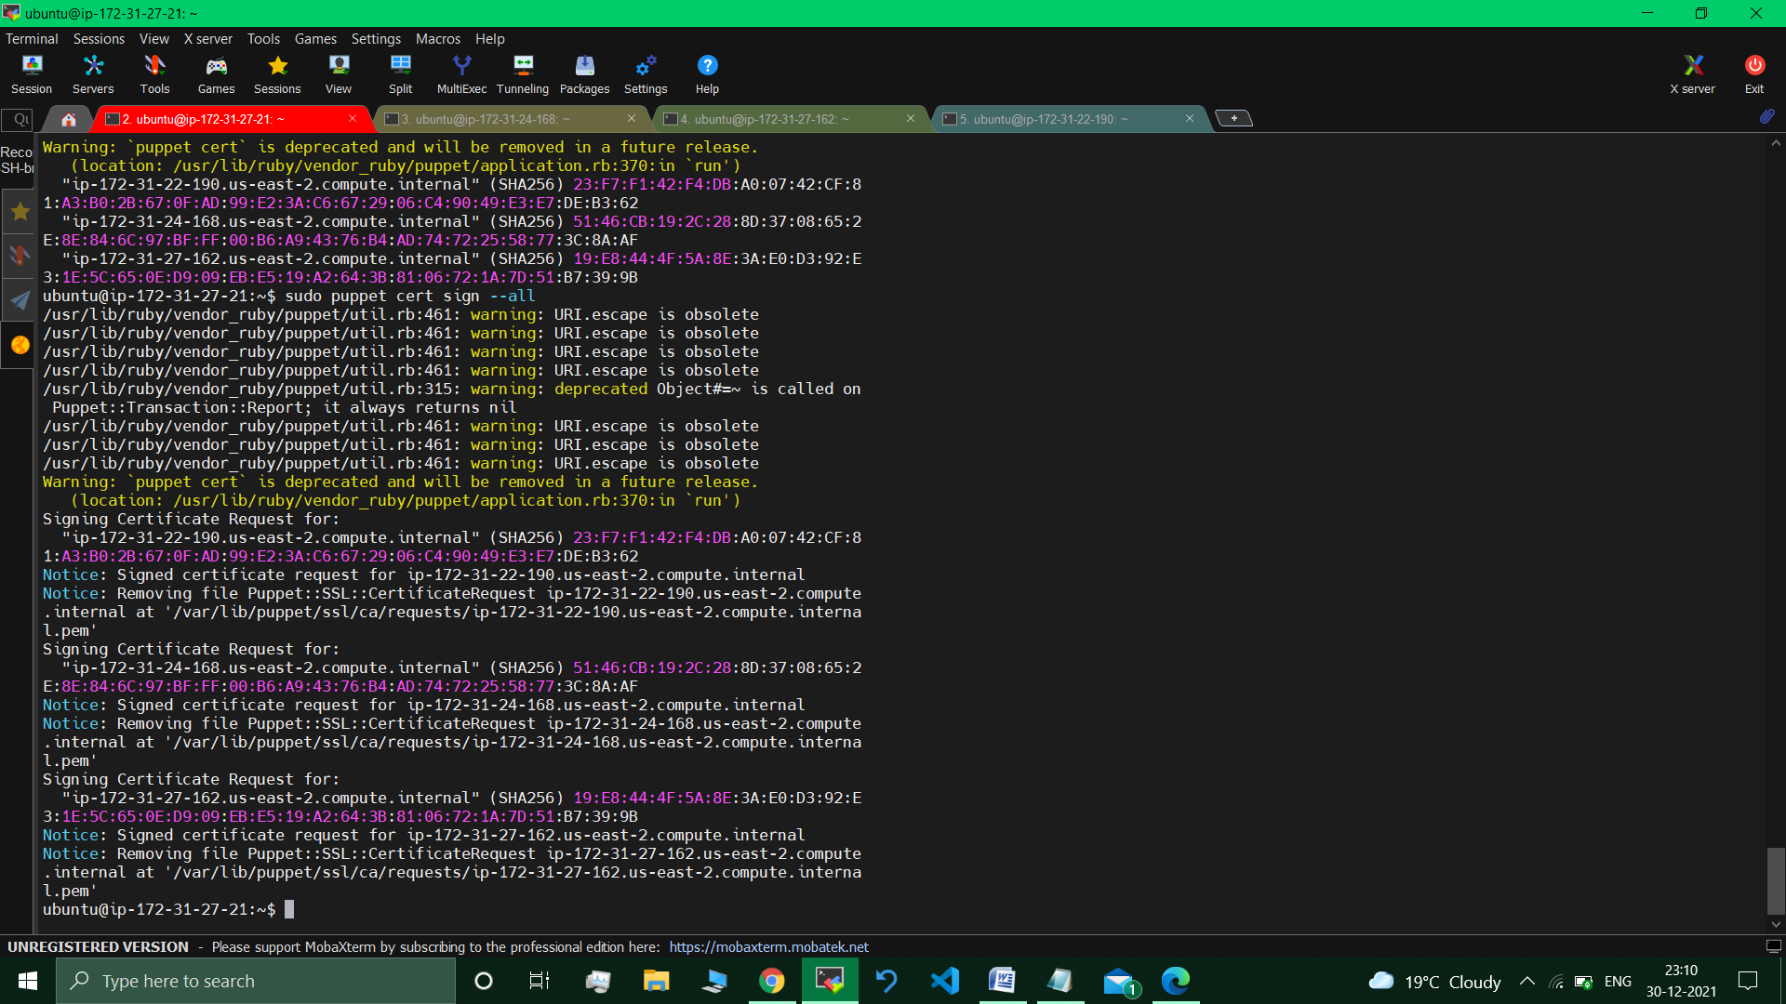

**sudo puppet cert sign –all**  *// Signing the certificates.*



***Master-Slave connection established.***

**Part 2 : on master :-**

sudo mkdir -p /etc/puppet/code/environments/production/manifests

cd /etc/puppet/code/environments/production/manifests

sudo nano site.pp

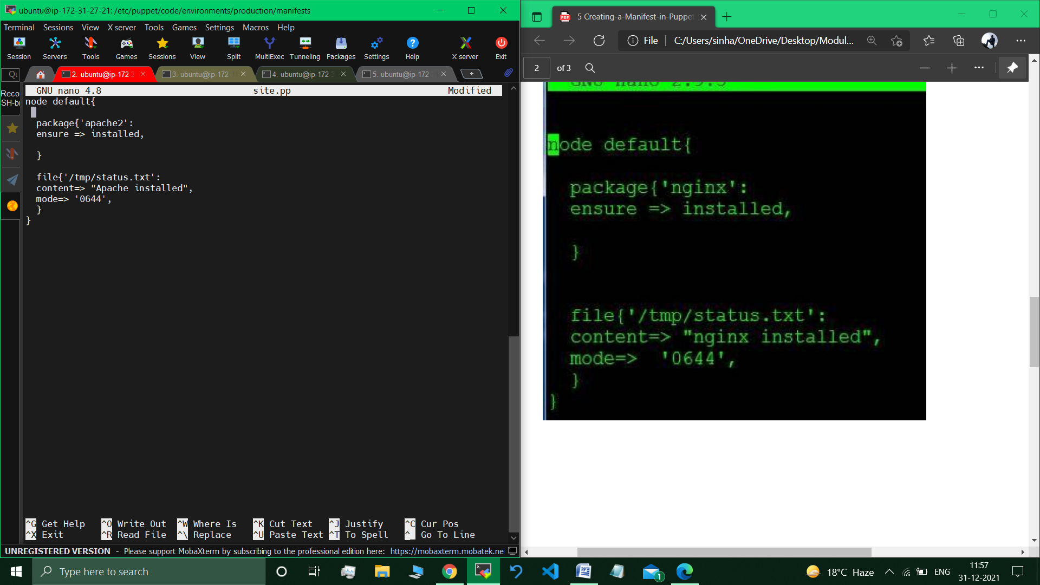

**On Nodes :**

sudo puppet agent –test

cat /tmp/status.txt

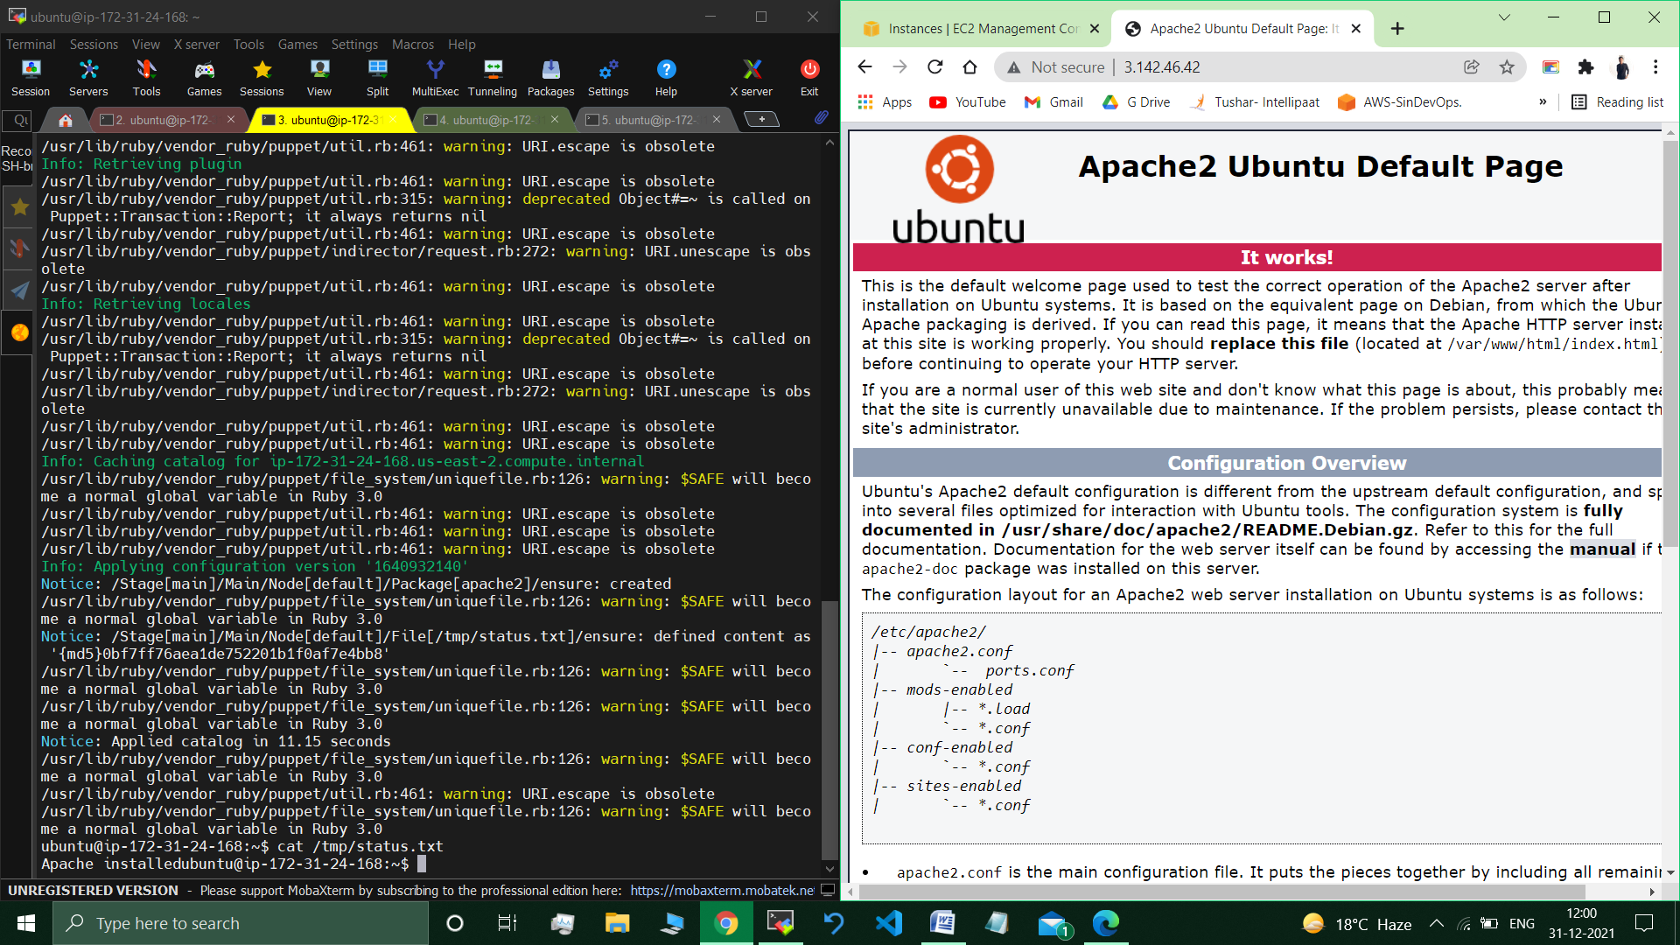

Verifying Apache2 Installation : Visited the Node’s Public IP Address.



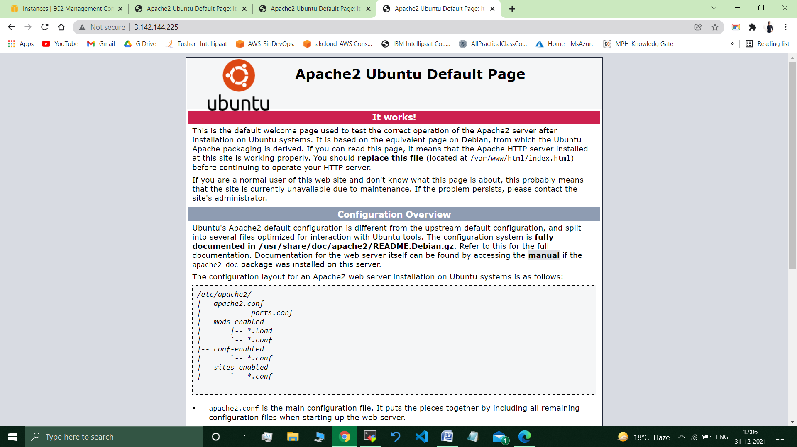

//*Apache webserver installed on all the Nodes/Slaves.*

**__________________________________________________________**

**Submitted By : Tushar Sinha**

**Email ID :** [**sinhatushar17@gmail.com**](mailto:sinhatushar17@gmail.com)

**Enrolled in the “DevOps Architect Master’s Training Program”**