**Module-5: Puppet Assignment – 3**

**You have been asked to:**

● Use the previous module’s deployment

● If apache is installed change index.html to “apache is installed”

● If nginx is installed change index.html to “nginx is installed”

**Solution :**

**Apache is Installed on Node2, whereas Nginx is installed on Node3.**

**On Node2 :**

>cd /var/ww/html

>ls *// index.html is present.*

>sudo rm –f index.html // Deleting the old Index.html file (Default apache file)

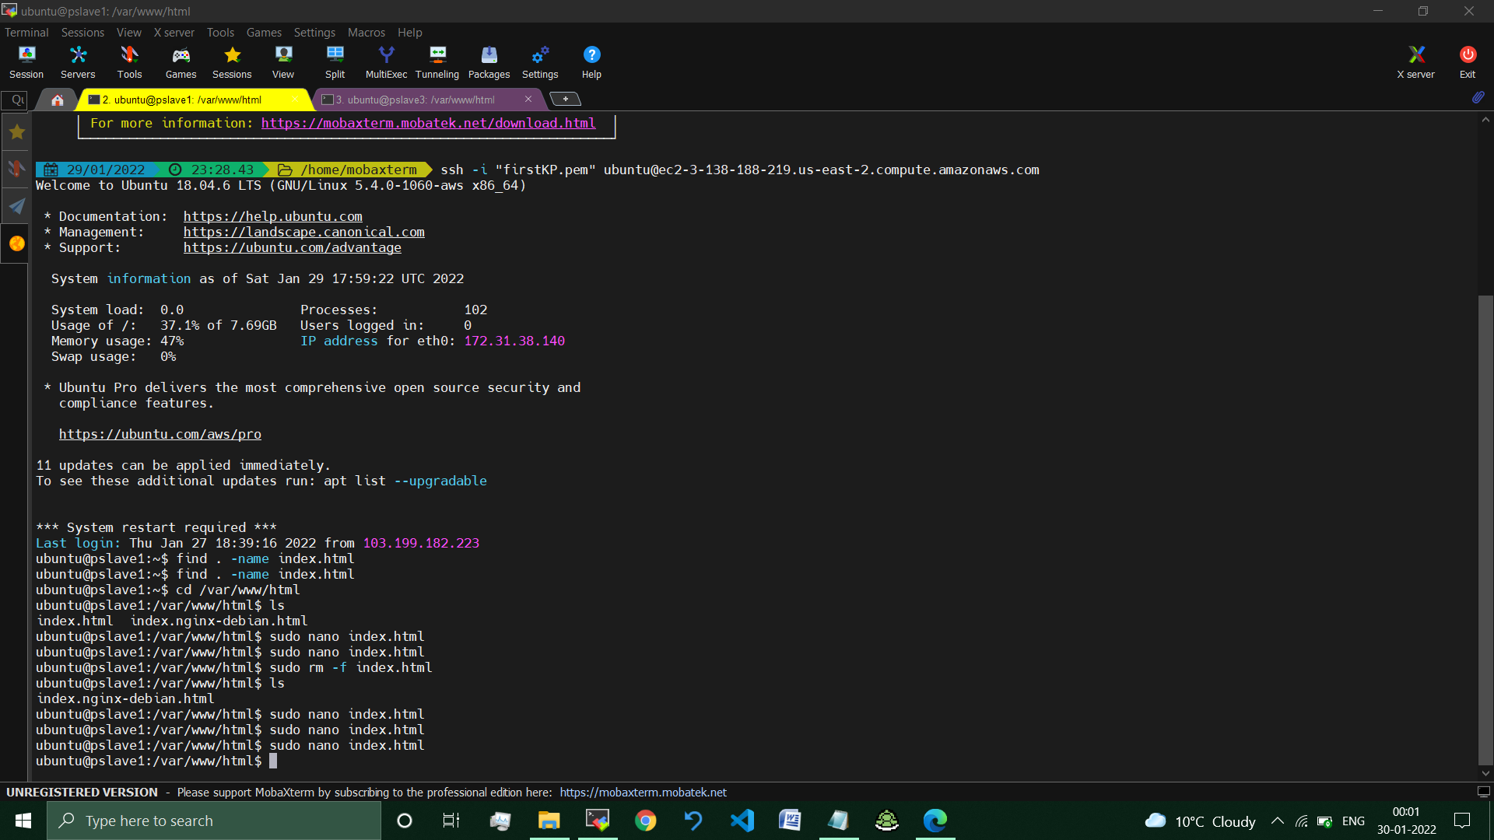

>sudo nano index.html *//created new index.html file.*

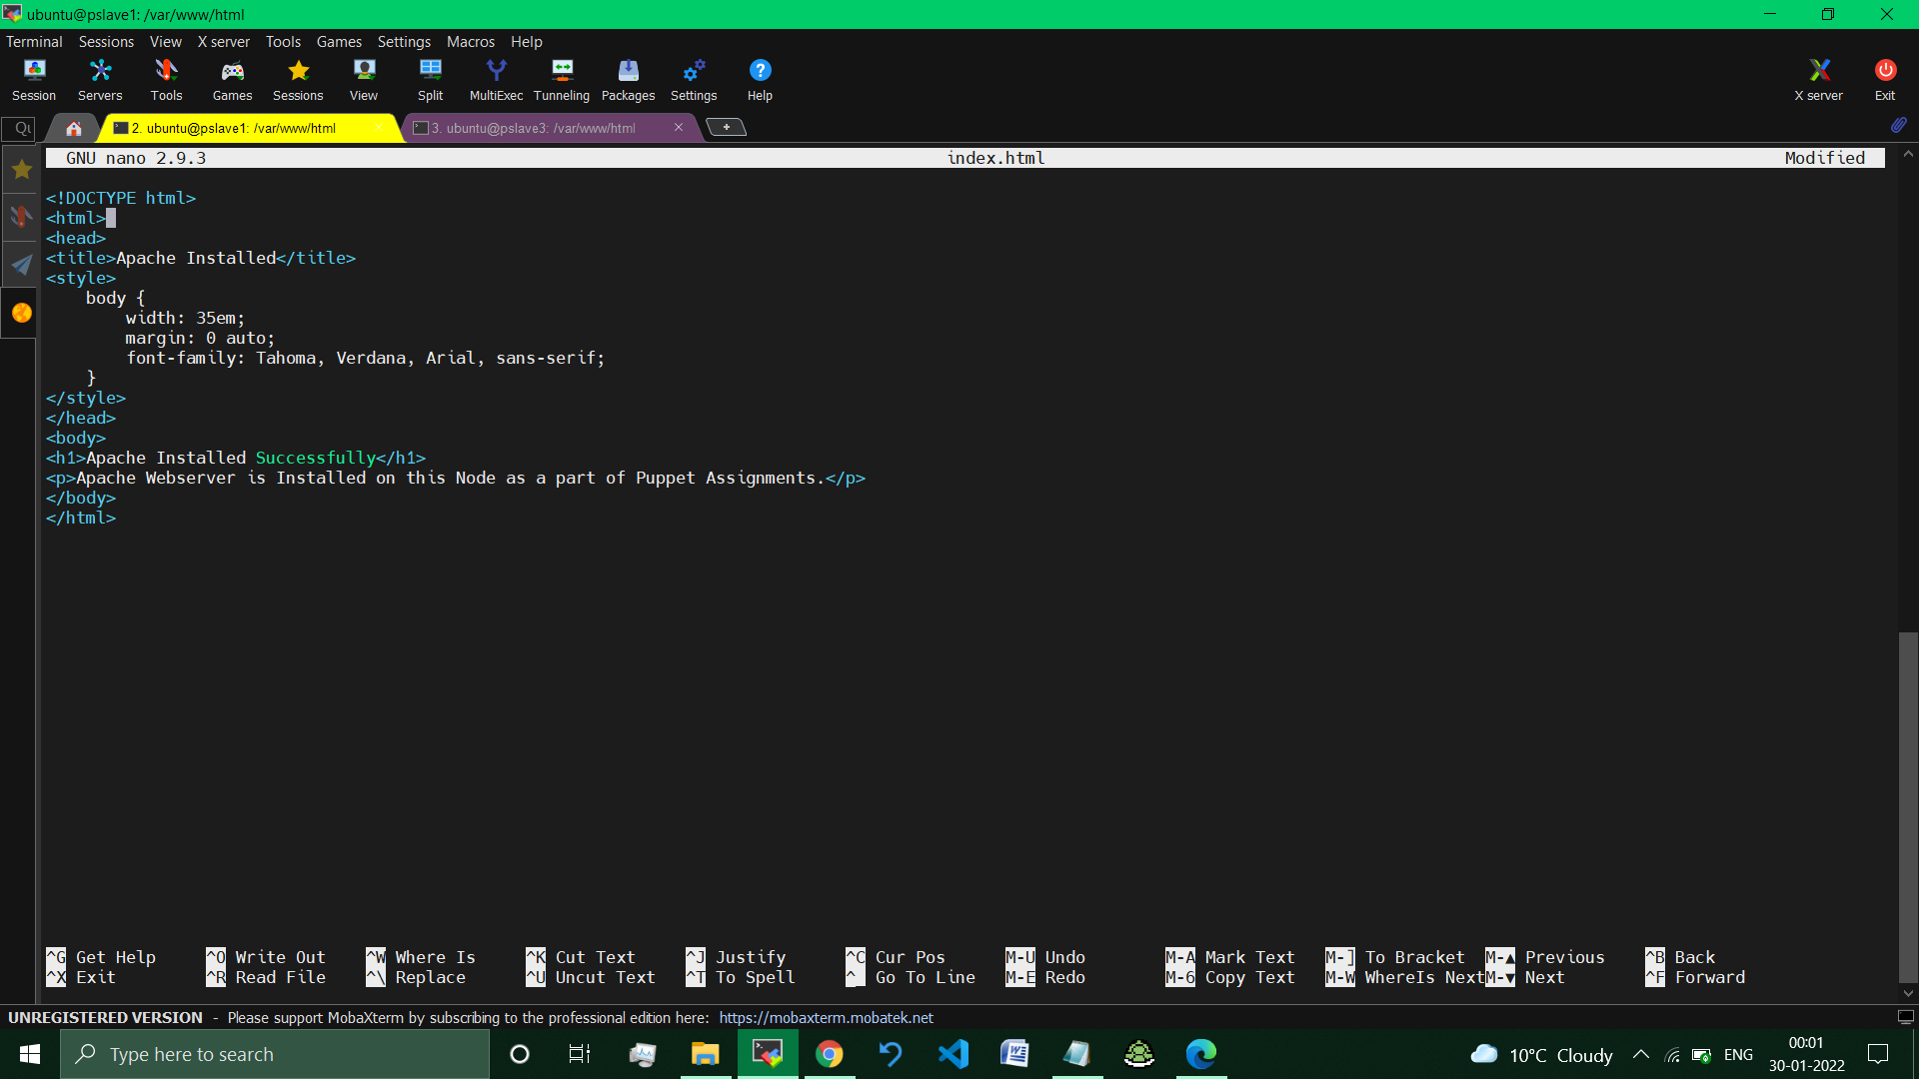

//Saving the html file and exiting.

**Visiting the IP Address of Node2, where Apache is installed.**

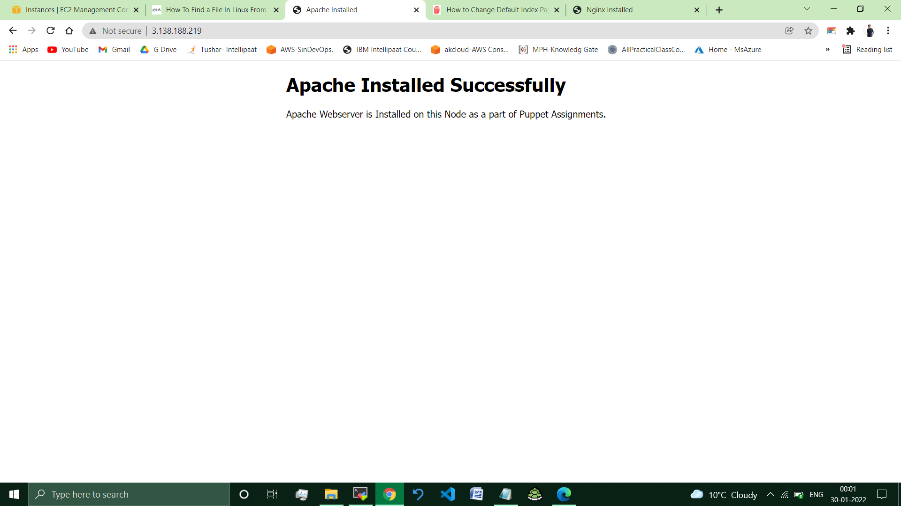

**// Default Apache Webpage Changed successfully.**

**On Node3 :**

**Nginx was already installed on this Node.**

**Removed Apache from this node and enabled an started Nginx server**

>cd /var/www/html

>ls //index.nginx-debian.html present.

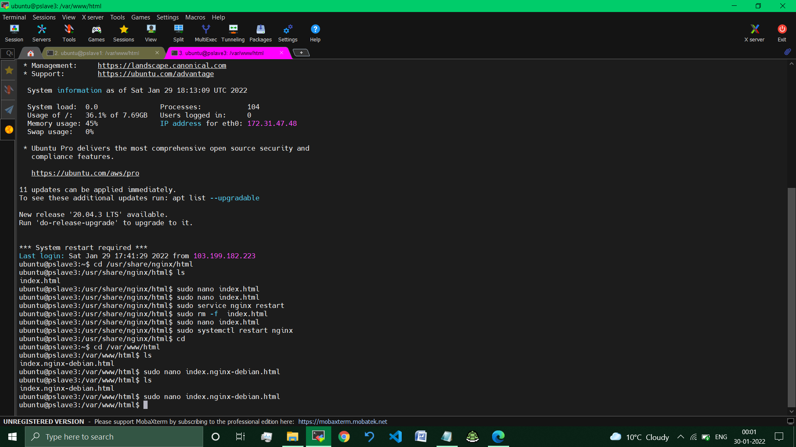

>sudo nano index.nginx-debian.html //Editing the default html file.

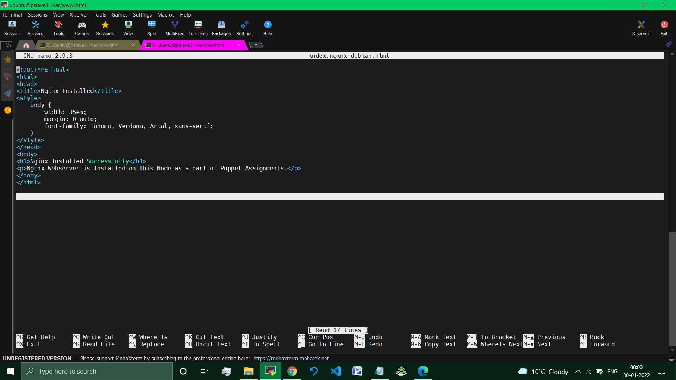

*//Saving the html file and exiting.*

**Visiting the IP Address of Node3, where Nginx is installed.**

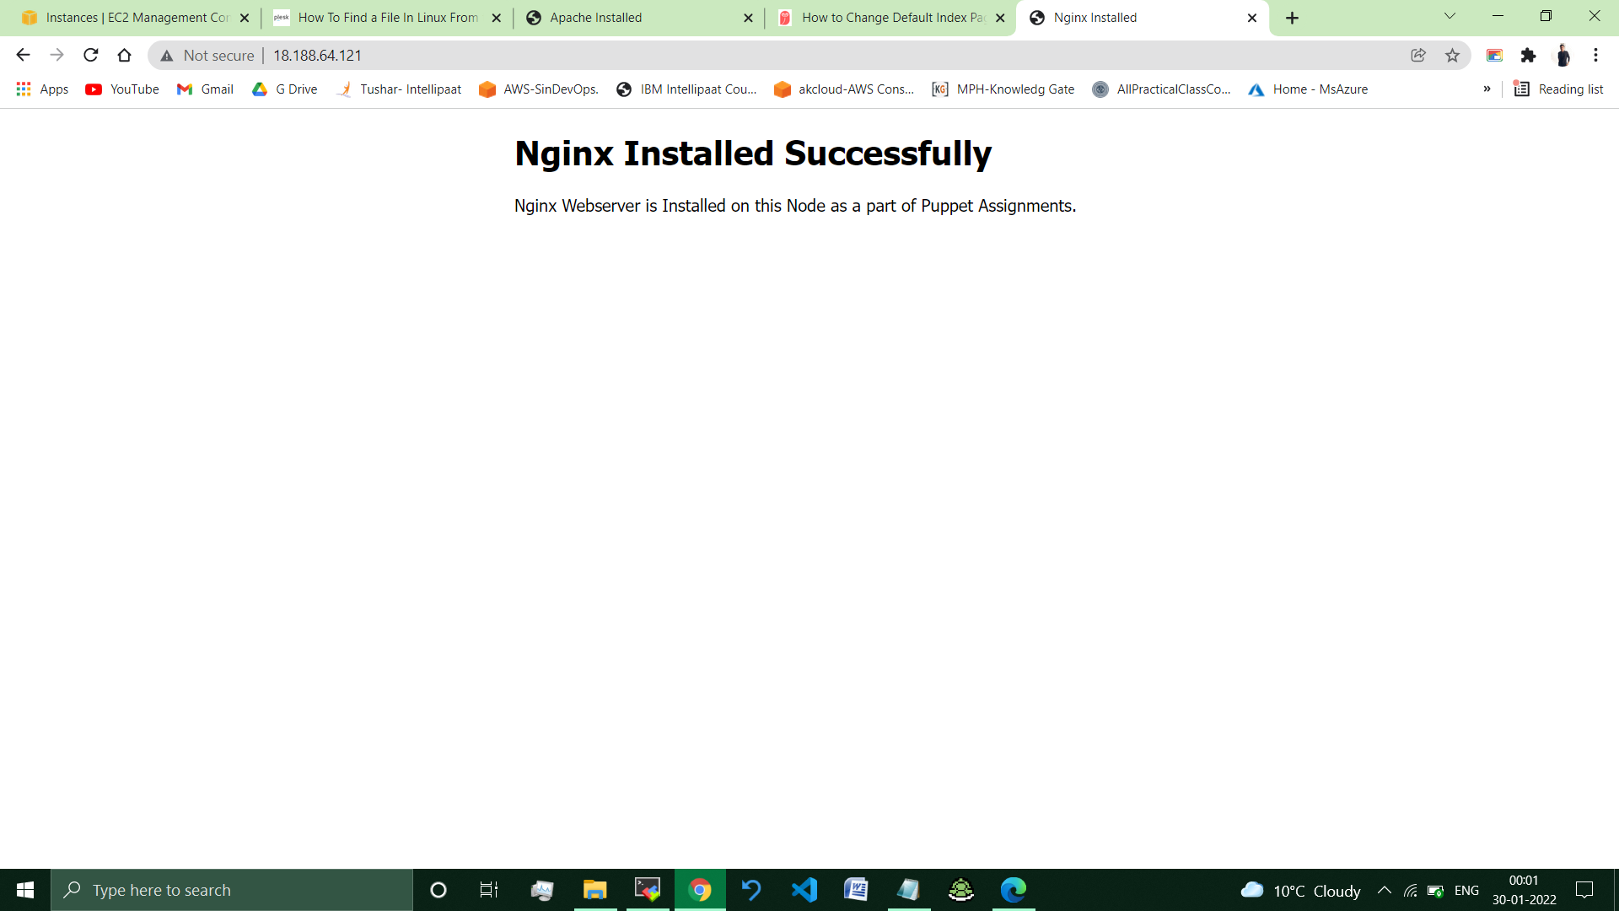

**// Default Nginx Webpage Changed successfully.**

**__________________________________________________________**

**Submitted By : Tushar Sinha**

**Email ID :** [**sinhatushar17@gmail.com**](mailto:sinhatushar17@gmail.com)

**Enrolled in the “DevOps Architect Master’s Training Program”**