**Module-5: Puppet Assignment - 4**

**You have been asked to:**

● Use the previous module deployment

● Use modules for this task

● Ensure mysql and java is installed on nginx machine

**Solution :-**

**On Master :**

First we have to create a Module.

Creating a Module named “Intelli-newmod”.

>mkdir newmod

>cd newmod

>sudo puppet module generate intelli-newmod

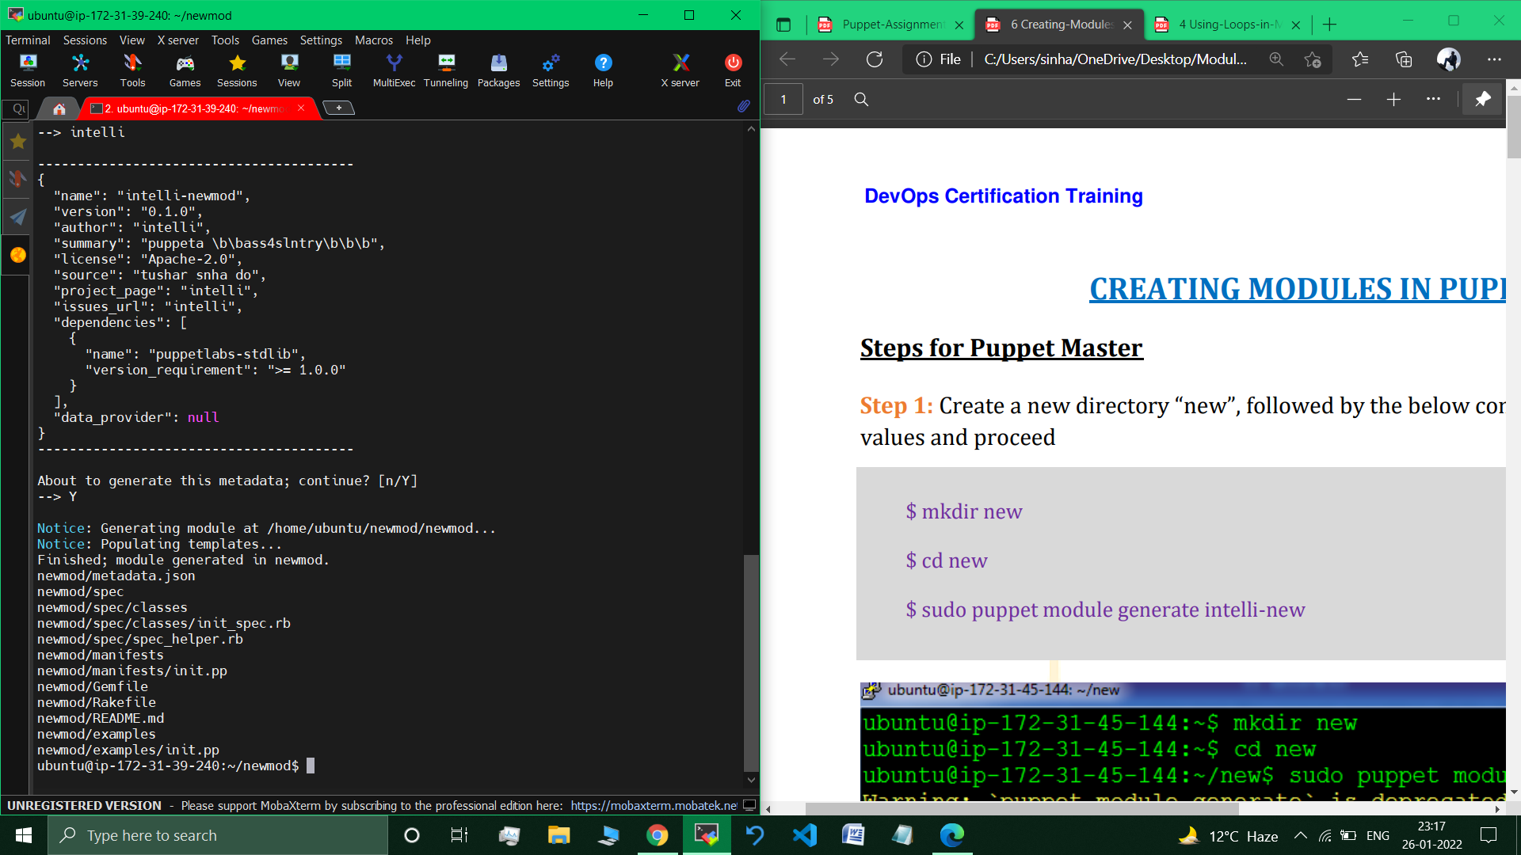 //Supplied default values to generate module.

// Module created successfully.

**On Node :**

sudo apt install default-jre // Downloading Java Runtime Environment inorder to install java on this node.

**On Master :**

>cd newmod

> cd ./new/manifests

>sudo nano init.pp //editing the init.pp manifest file and specifying the codes required to install MySQL and Java on Node.

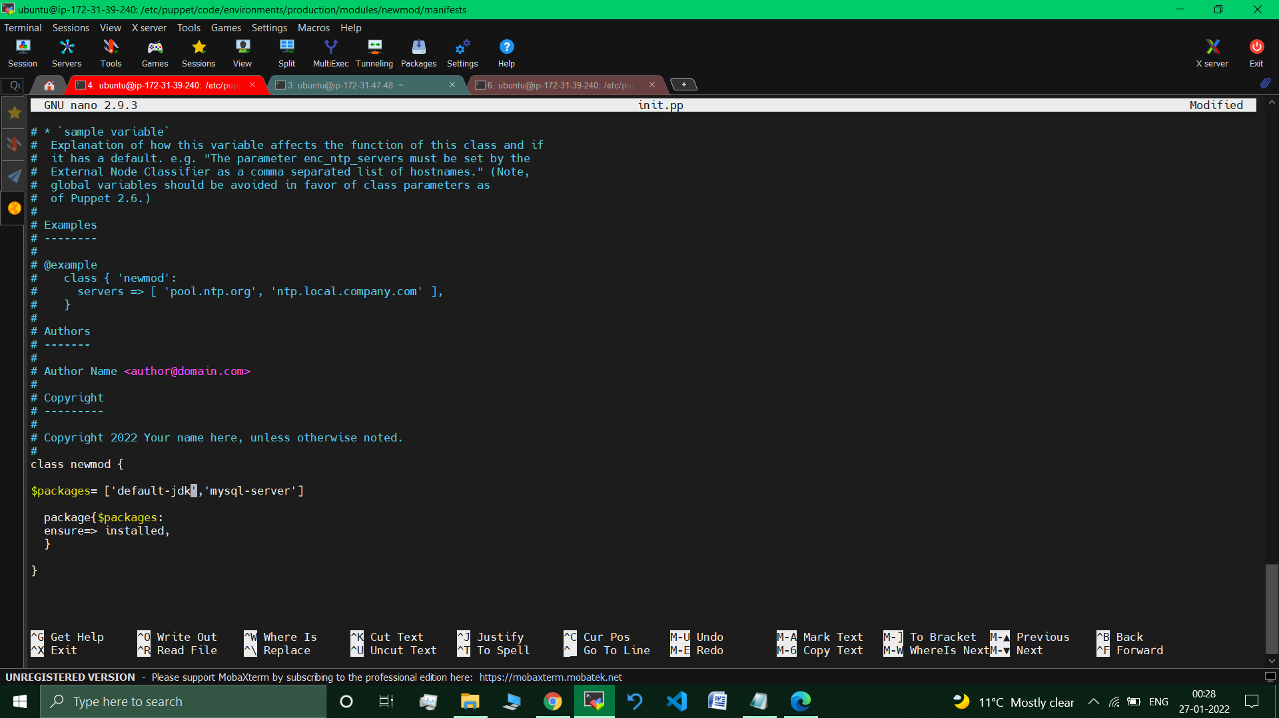

>sudo puppet module build newmod //Building Module

>sudo puppet module install ./newmod/pkg/intelli-new-0.1.0.tar.gz

// Installing the Module on master Machine.

**Going to the main manifest file :**

>cd /etc/puppet/code/environments/production/manifests

>sudo nano site.pp

// Included (called) the “newmod” module in the

main manifest file “site.pp”

node default{

include newmod

}

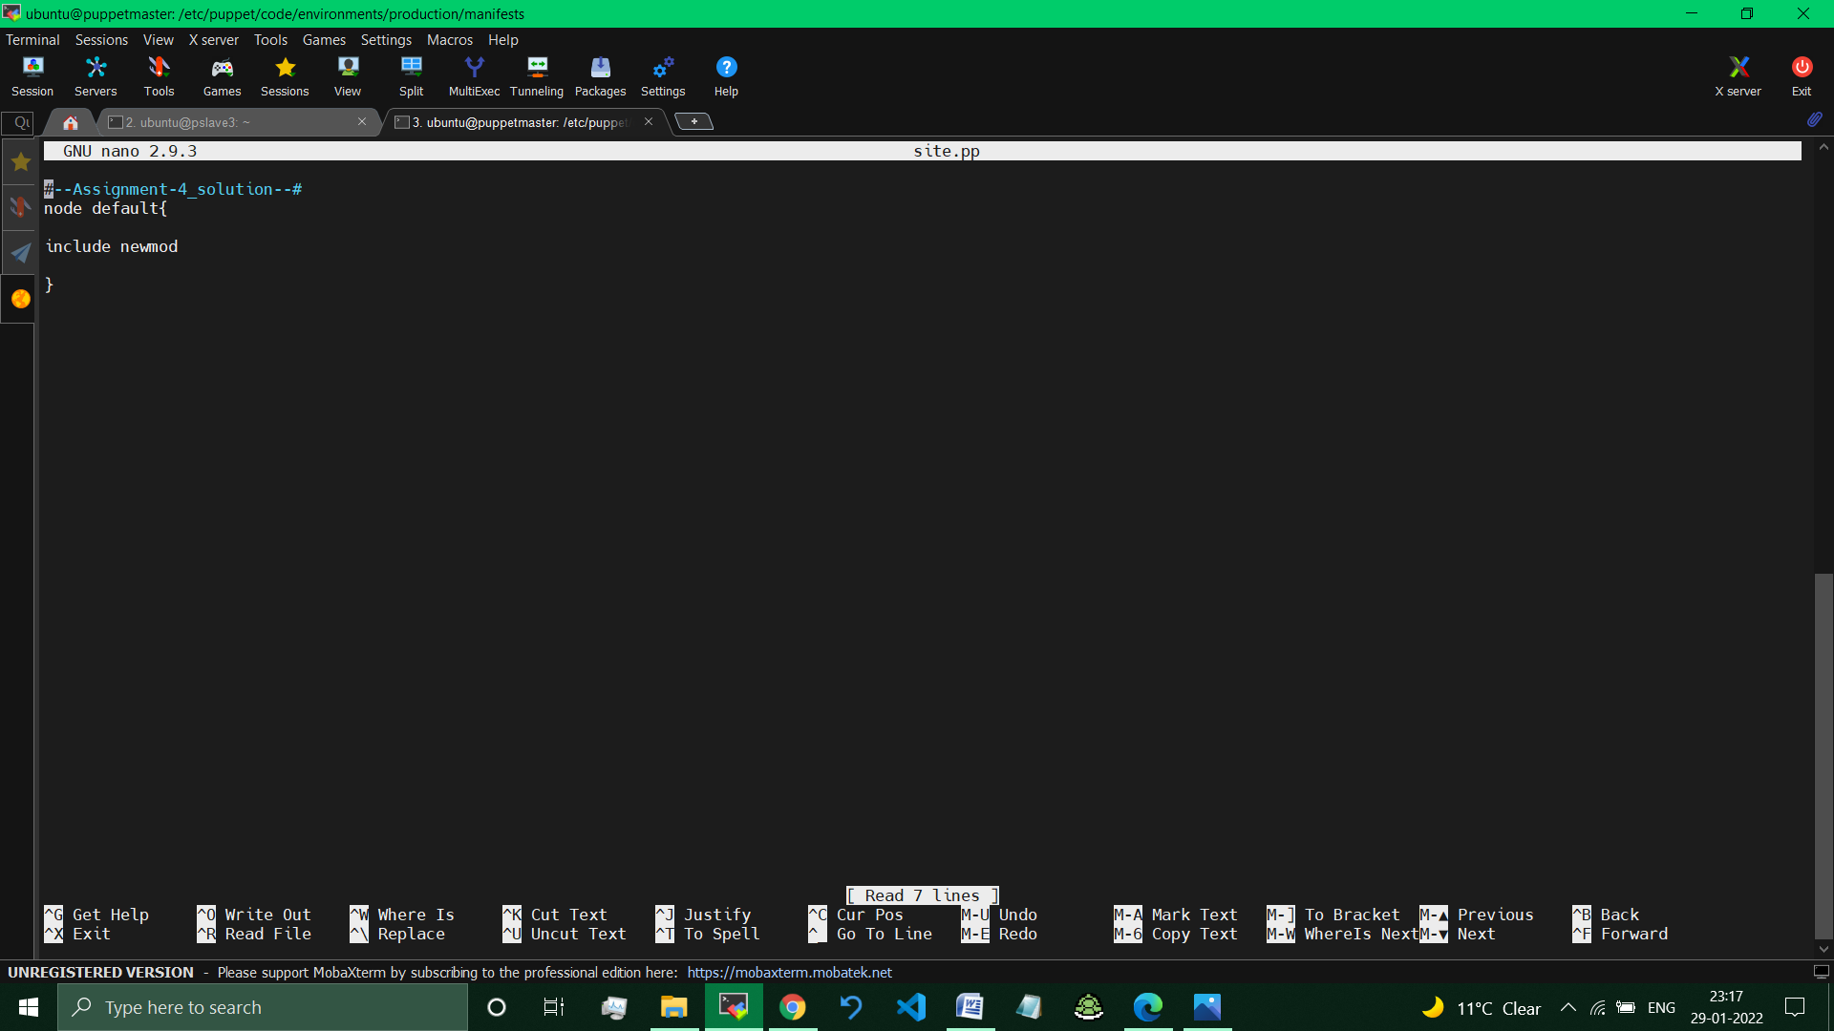

**On Node :**

>sudo puppet agent –test // Pulling changes

>sudo service –status-all //listing all the services present on node.

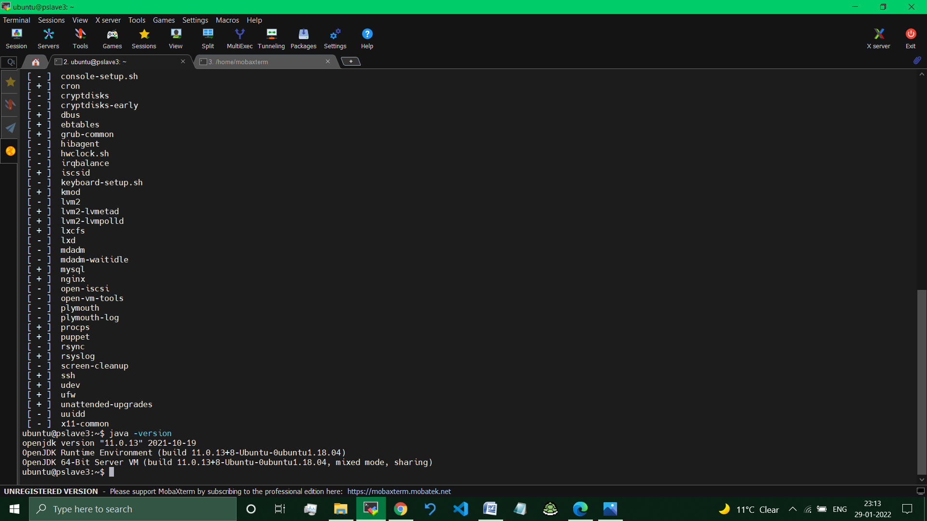

**//MySQL present (on Nginx machine).**

>java-version



**//Java is present**

**So, using modules we have successfully installed MySQL and Java on the Nginix Node Machine.**

**__________________________________________________________**

**Submitted By : Tushar Sinha**

**Email ID :** [**sinhatushar17@gmail.com**](mailto:sinhatushar17@gmail.com)

**Enrolled in the “DevOps Architect Master’s Training Program”**