**Module-5: Puppet Assignment – 5**

**You have been asked to:**

● Use the previous assignment’s deployment

● Define hostnames for slaves, as slave1, slave2 and slave3

● On slave1 create a file in /temp, which says this is slave1

● On slave2 create a file in /temp, which says this is slave2

● On slave3 create a file in /temp, which says this is slave3

**Solution :**

**On Master :**

Defining/Renaming Hostnames :

>sudo hostnamectl set-host name puppetmaster //master renamed

>hostname // “puppetmaster” displayed

*Similarly changing hostnames of Nodes :*

**On Node1 :**

>sudo hostnamectl set-host name pslave1new

>hostname // “pslave1new” displayed i.e Hostname changed successfully.

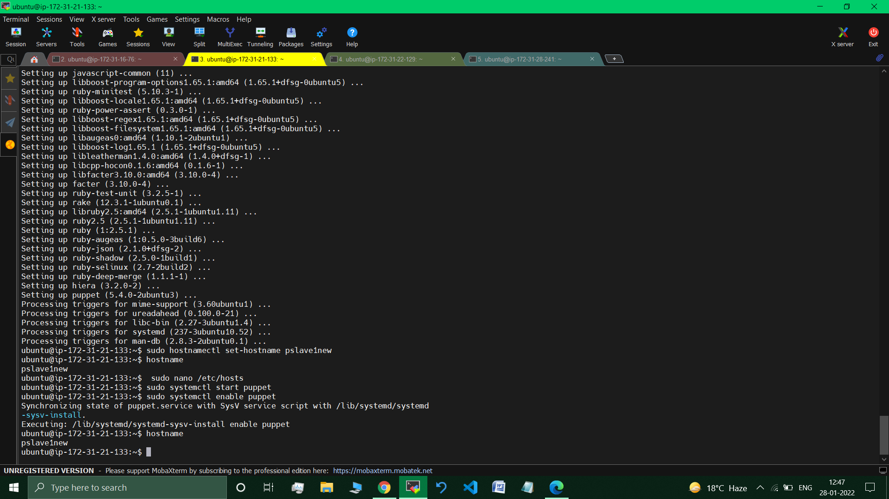

*Similarly doing the same for Node2 and Node3 :*

**On Node3 :**

>sudo hostnamectl set-host name pslave3new

>hostname // “pslave3new” displayed

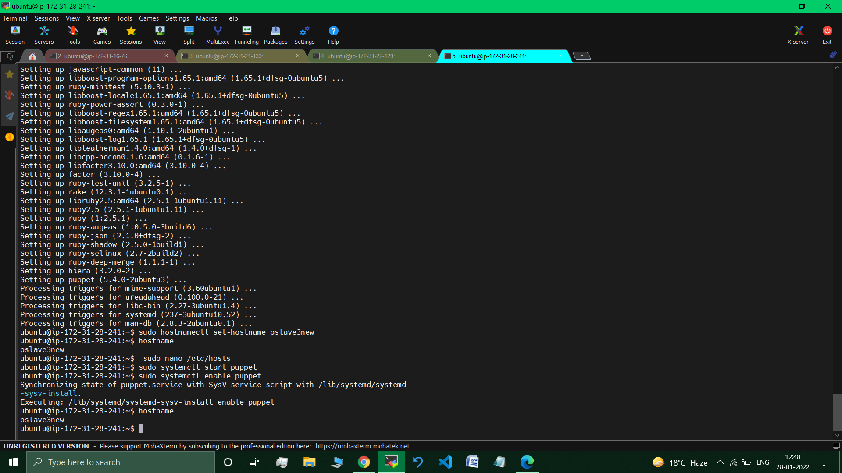

**//** Hostname changed successfully.

**Now, creating files on Nodes via manifest file :**

>cd /etc/puppet/code/environments/production/manifests

>sudo nano slave1.pp

*//Creating new manifest file for Slave1/Node1.*

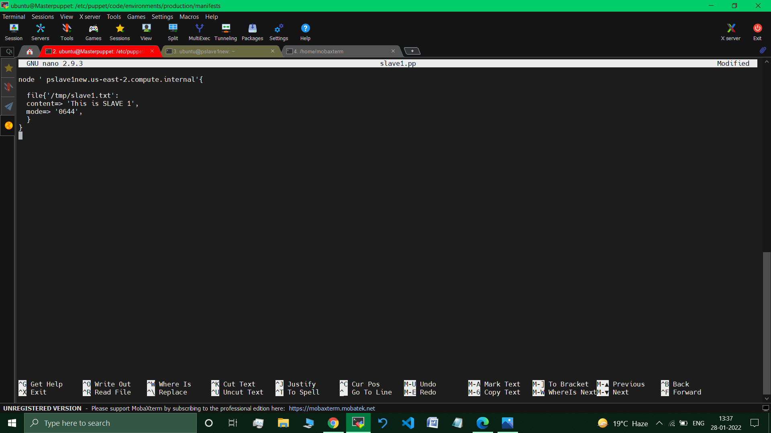

>sudo nano slave2.pp *//Creating new manifest file for Slave2/Node2.*

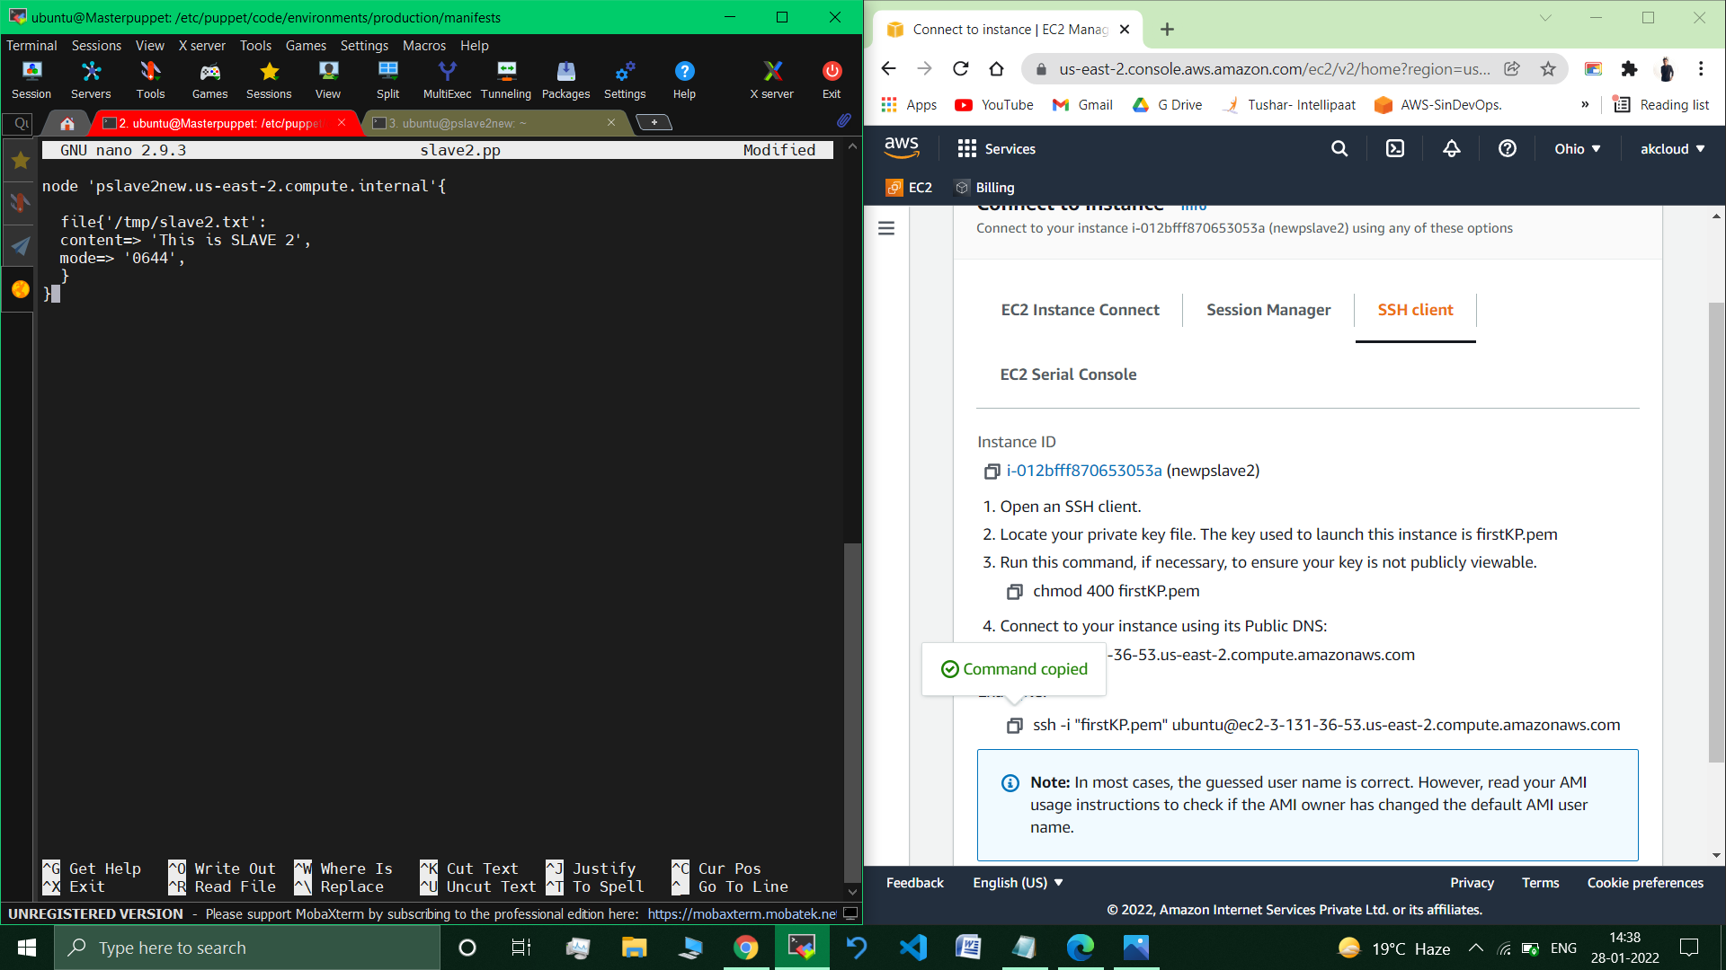

>sudo nano slave3.pp *//Creating new manifest file for Slave3/Node3.*

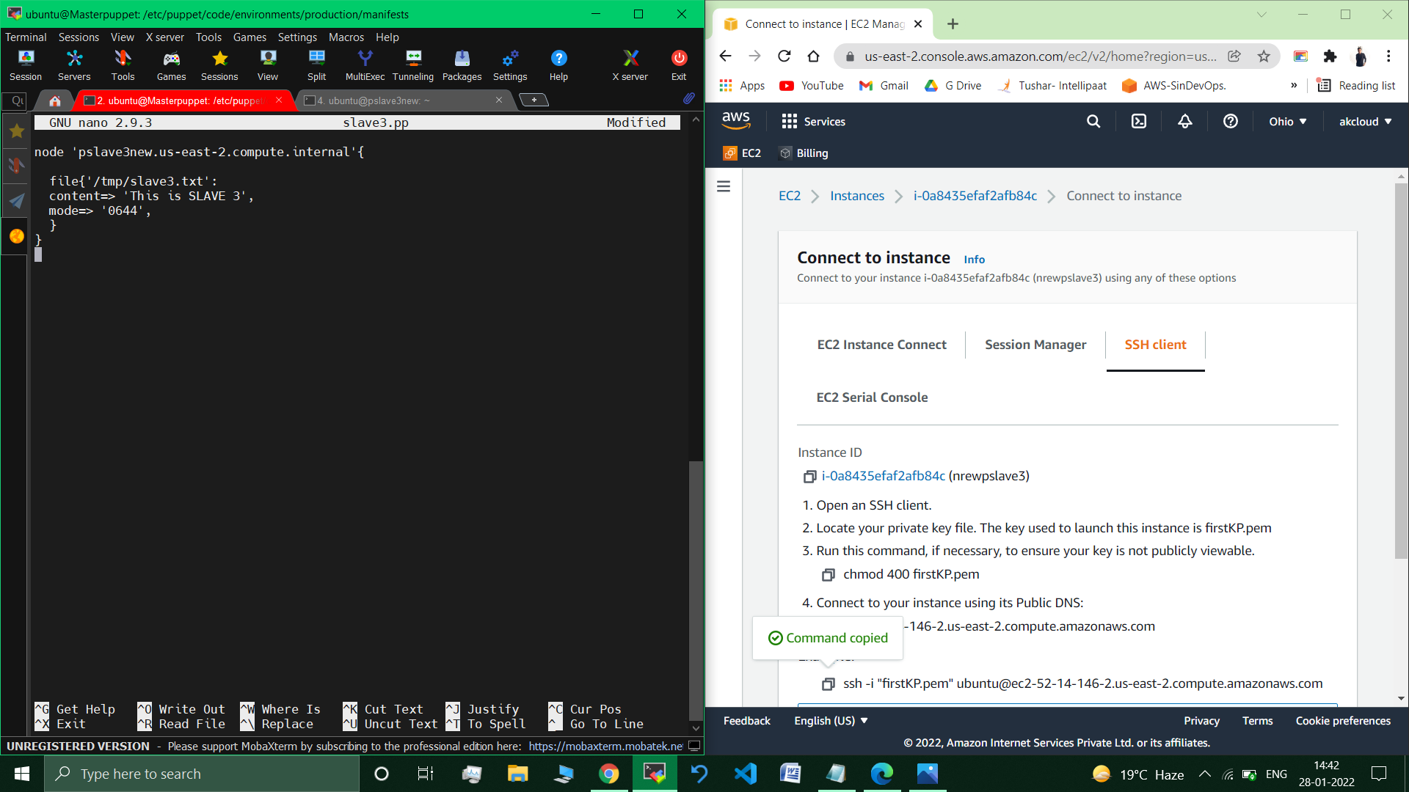

**Manifest files to create a text file for all the slaves has been created successfully.**

**Now fetcing the changes on Nodes respectively.**

**On Node1 :**

**>**sudo puppet agent –test

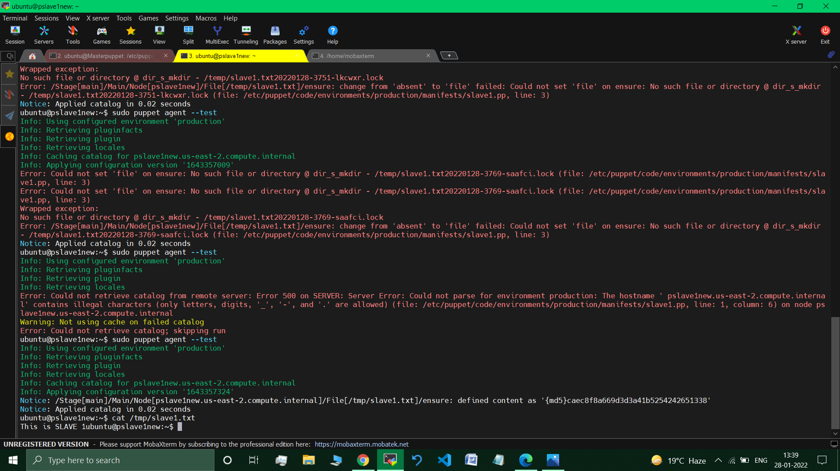

>cat /tnp/slave1.txt



**//This is Slave1** *//Displayed.*

***Similarly fetching the changes in the same wayfor Node2 and Node3 :***

**On Node2 :**

>cat /tnp/slave2.txt

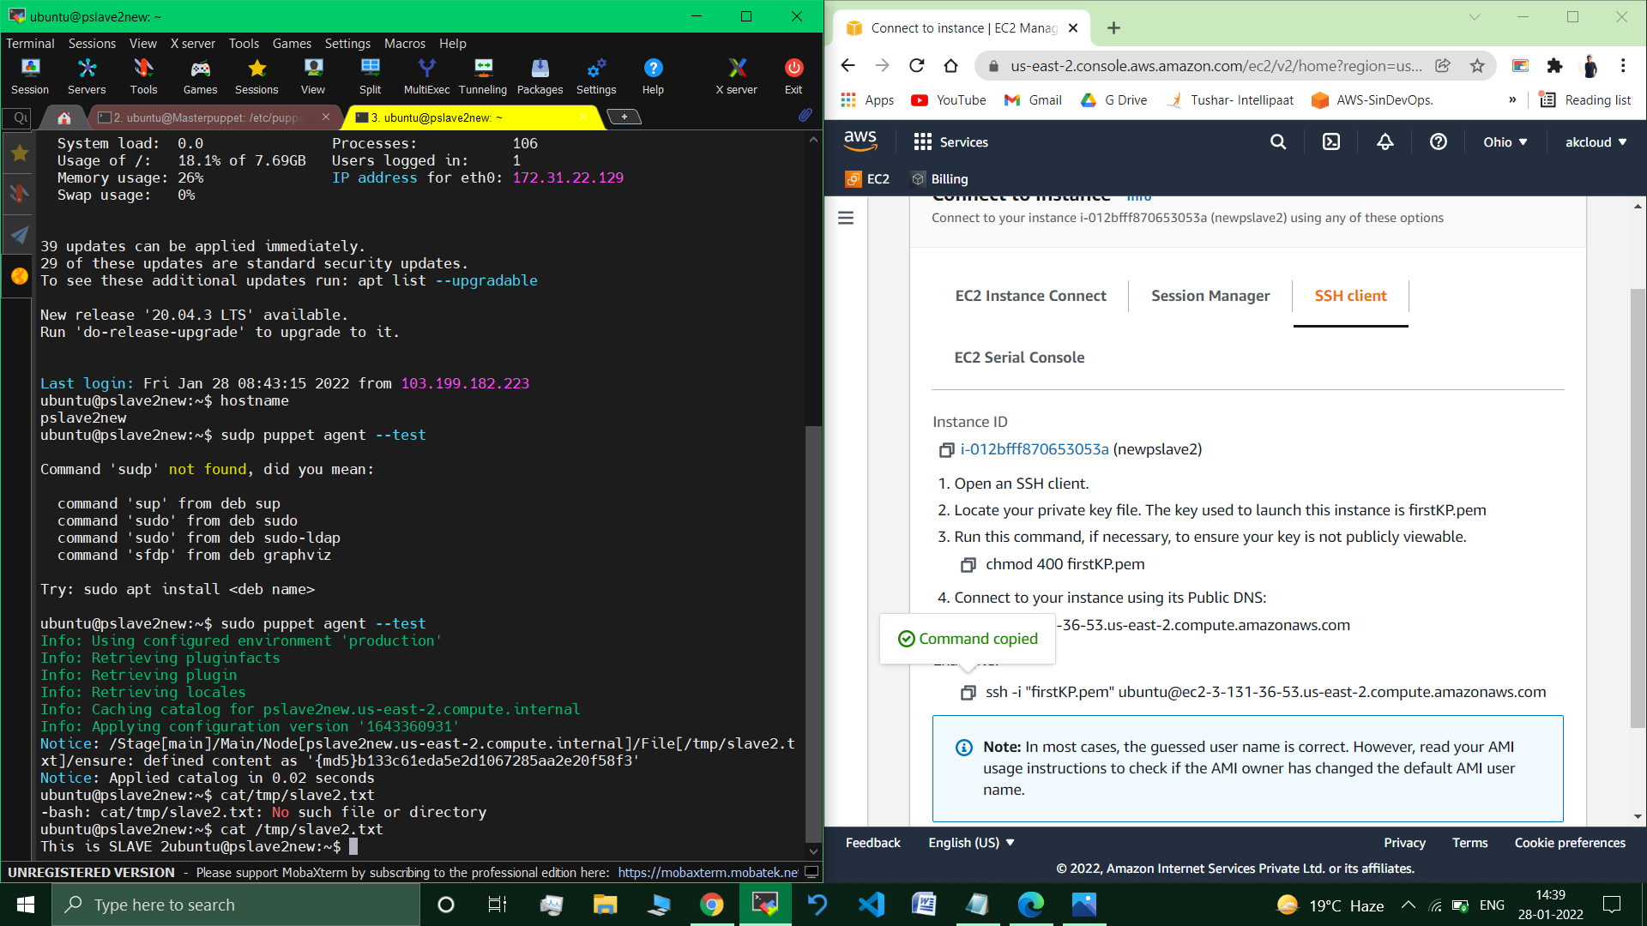

**On Node3 :**

>cat /tnp/slave3.txt



**//This is Slave3** *//Displayed.*

**__________________________________________________________**

**Submitted By : Tushar Sinha**

**Email ID :** [**sinhatushar17@gmail.com**](mailto:sinhatushar17@gmail.com)

**Enrolled in the “DevOps Architect Master’s Training Program”**