**Module-5: Puppet Assignment - 2**

**To Do :**

● Add one more slave to the setup

● Add a condition, if apache is already installed on the slaves, install nginx

**The result should be 3rd slave with nginx installed.**

**Solution :**

**On Master :**

>sudo nano /etc/hosts

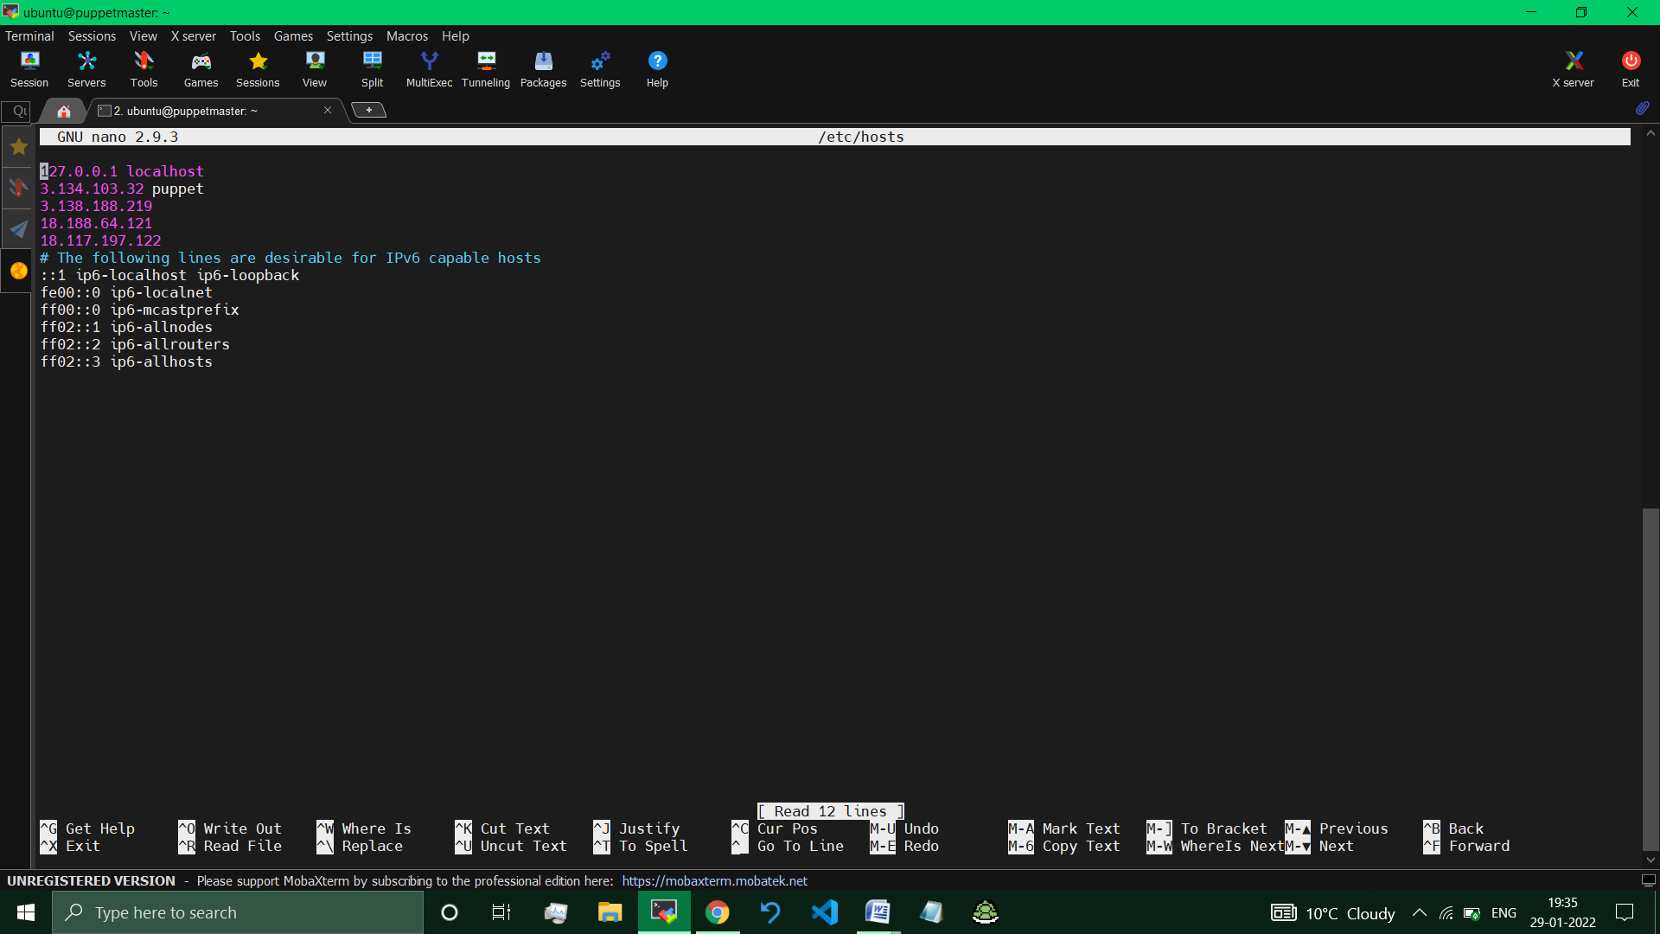 *//Added the IP Address of 3rd Machine in hosts file.*

**On Node :**

**Installed puppet (for node) on Node machine**

>sudo nano /etc/hosts

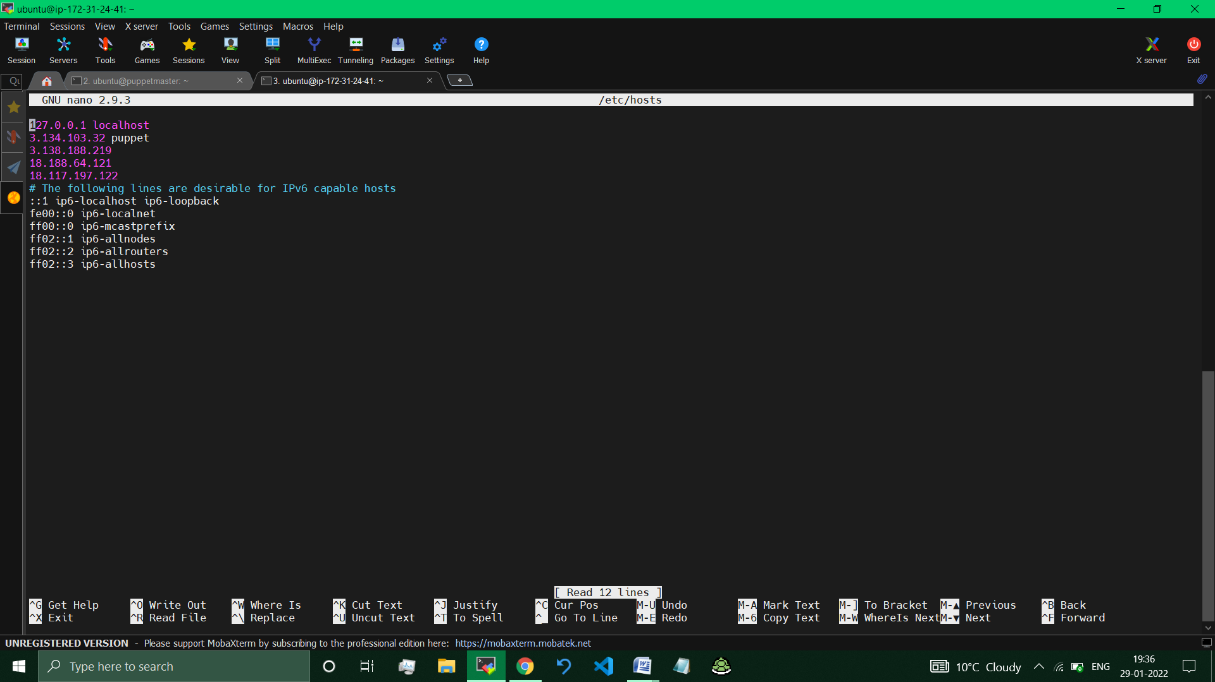

*//Added the IP Address of 3rd Machine in hosts file.*

**Installing Nginx on the Node Machine, as Apache is already installed.**

On Master :

> cd /etc/puppet/code/environments/production/manifests

> sudo nano site.pp

node default{

exec{'apachedocker':

    command=> 'apt-get install nginx -y',

    path =>'/usr/local/sbin:/usr/local/bin:/usr/sbin:/usr/bin:/sbin:/bin:/usr/games:/usr/local/games',

    onlyif=> '/bin/which apache2',

    }

}

*// provided the necessary conditions to install nginx if apache is already installed.*

> Sudo service –status–all

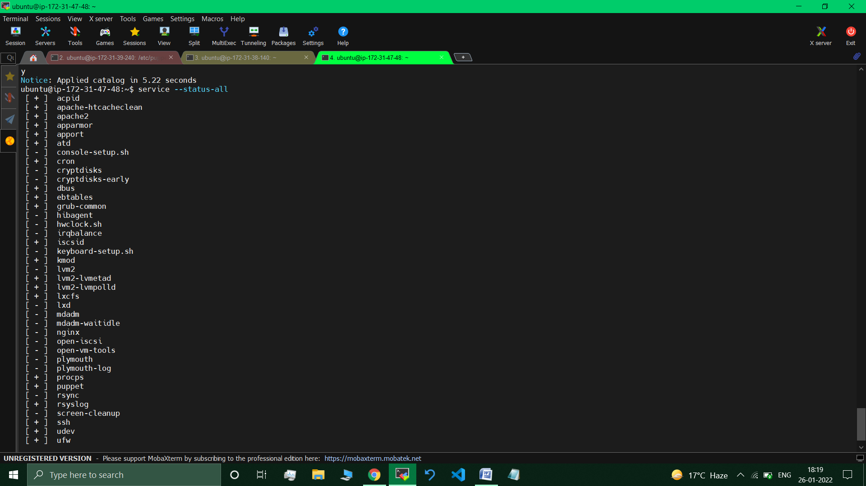 // nginx is present.

>sudo service nginx start // started nginx service

**Upon visiting the IP Address of the Node - nginx page is displayed**.

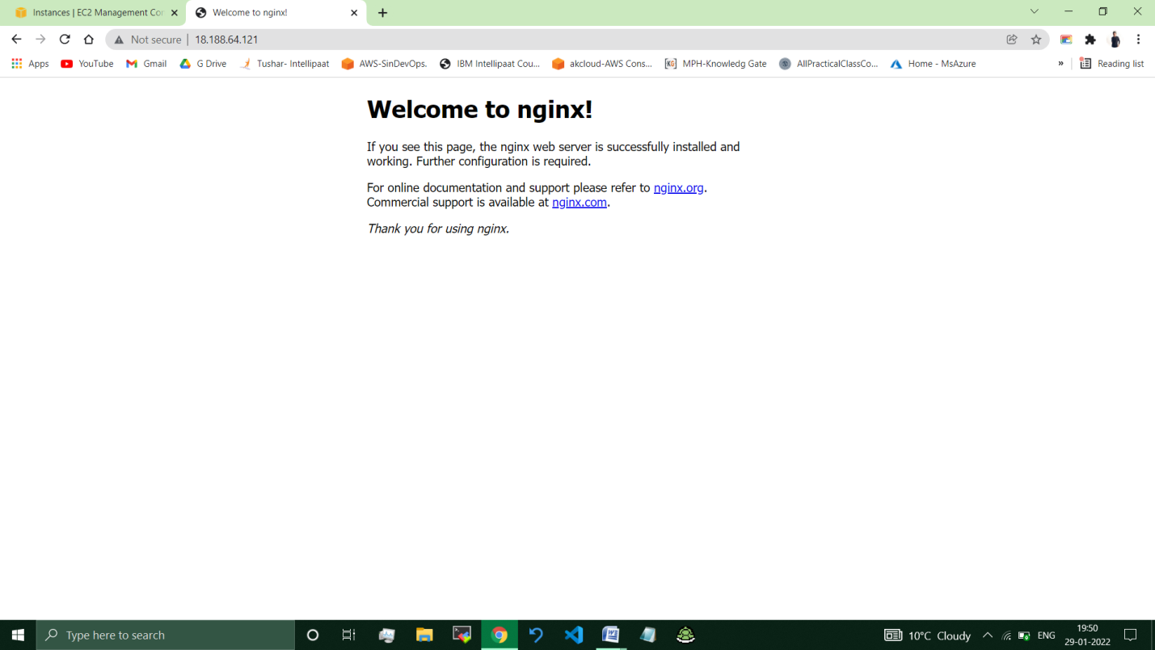

*// Nginx Successfully Installed.*

**__________________________________________________________**

**Submitted By : Tushar Sinha**

**Email ID :** [**sinhatushar17@gmail.com**](mailto:sinhatushar17@gmail.com)

**Enrolled in the “DevOps Architect Master’s Training Program”**