**ASSIGNMENT 1**

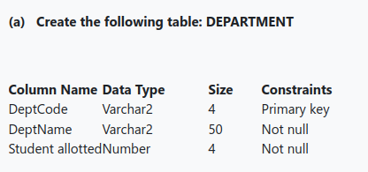

CREATE TABLE department2052

(DeptCode VARCHAR2(4) PRIMARY KEY,

DeptName VARCHAR2(50) NOT NULL,

StudentAllotted NUMBER(4) NOT NULL

);



DESC department2052

output:

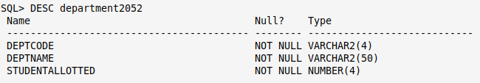



INSERT INTO department2052 VALUES('CSE','Computer Science and Engineering',120);

INSERT INTO department2052 VALUES('ECE','Electronics and Communication Engineering',60);

INSERT INTO department2052 VALUES('EE','Electrical Engineering',60);



SELECT * FROM department2052

output

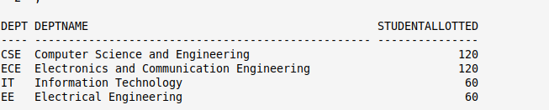

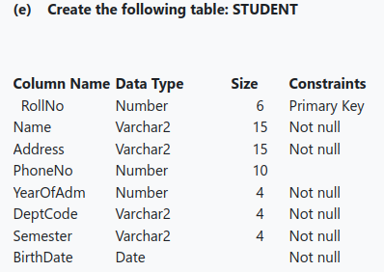

CREATE TABLE student2052

(RollNo NUMBER(6) PRIMARY KEY,

Name VARCHAR2(15) NOT NULL,

Address VARCHAR2(15) NOT NULL,

PhoneNo NUMBER(10) NOT NULL,

YearOfAdm NUMBER(4) NOT NULL,

DeptCode VARCHAR2(4) NOT NULL,

Semester VARCHAR2(4) NOT NULL,

BirthDate DATE NOT NULL

);



DESC student2052

output

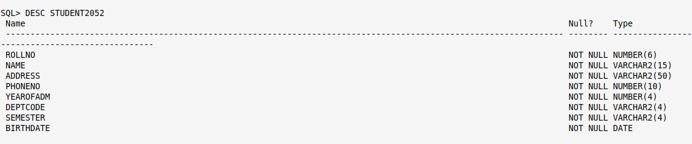



INSERT INTO student2052 VALUES

(1001,'Ankit Das','VIPRoad,Kolkata',983067522,2017,'CSE','SEM5','10-02-19');

INSERT INTO student2052 VALUES

(1002,'Moinak Ghosh','VIPRoad,Kolkata',798882220,2017,'CSE','SEM5','01-05-19');

INSERT INTO student2052 VALUES

(1003,'Parimal Kumar','NSB Road , Birati',8099922211,2016,'CSE','SEM5','17-03-20');

insert into STUDENT2052 values(2001, 'SANCHITASINGH', 'Tegharia, Kolkata', 9999110011, 2017, 'ECE', 'SEM5', '20-10-2000');

insert into STUDENT2052 values(2002, 'ANANYA BISWAS', 'MGRoad,Howrah', 766788001, 2017, 'ECE', 'SEM5', '05-11-2001');

insert into STUDENT2052 values(2101, 'ASHISH KUMAR', 'Baguiati, Kolkata', 654433212, 2017, 'ECE', 'SEM5', '17-09-2001');

insert into STUDENT2052 values(1029, 'NAITIK PRASAD', 'KGRpath, Belgaria', 0, 2018, 'CSE', 'SEM3', '08-10-2003');

insert into STUDENT2052 values(4011, 'SATNAM JYOTI', 'Garia, Kolkata', 893332212, 2018, 'IT', 'SEM3', '21-09-2002');

insert into STUDENT2052 values(3002, 'SAURAV ROY', 'Chandannagar', 0, 2017, 'EE', 'SEM5', '23-08-2000');

insert into STUDENT2052 values(3005, 'MOHAMMAD AZIB', 'Salt lake', 791000066, 2017, 'EE', 'SEM5', '20-05-2001');

insert into STUDENT2052 values(2004, 'NIKHIL SINGH', 'Central Howrah', 0, 2016, 'ECE', 'SEM5', '21-06-1999');

insert into STUDENT2052 values(1023, 'SAMPRIKTABISWAS', 'Barrackpore', 8877565643, 2018, 'CSE', 'SEM3', '13-12-2003');

insert into STUDENT2052 values(1011, 'RAHUL KHAN', 'Jadavpur, Kolkata', 0, 2017, 'CSE', 'SEM5', '07-07-2001');

insert into STUDENT2052 values(1060, 'SHUBHAM', 'Sealdah, Kolkata', 9833221098, 2017, 'CSE', 'SEM3', '09-08-2003');

insert into STUDENT2052 values(2009, 'GAURAV PRAKASH', 'Saltlake', 0, 2018, 'ECE', 'SEM3', '10-04-2004');

insert into STUDENT2052 values(3008, 'RAHUL JOSHI', 'ABblock, Saltlake', 9980765123, 2018, 'EE', 'SEM3', '20-06-2003');

insert into STUDENT2052 values(4200, 'MRIGENDRA', 'Belur, Howrah', 0, 2019, 'IT', 'SEM1', '01-07-2004');

insert into STUDENT2052 values(1500, 'SUBARNA MITRA', 'Gariahat, Kolkata', 6987654322, 0, 'CSE', 'SEM3', '02-01-2003');

insert into STUDENT2052 values(1101, 'AMARITA DEV', 'CGBlock, Saltlake', 0, 2019, 'CSE', 'SEM1', '06-01-2004');



SELECT * FROM studen2052;

output