Mid-Term Exam

2021 Fall

Name:

1. Depict the following training set in 3D space, and suggest whether linear separability is possible and why.

2. Solve the exercise problem 7 of Chapter 2 in textbook.

(The picture in the problem shows that the plane determined by the x1 and x3 axes. Present the corresponding perceptron as in Figure 2-4(a).)

3. Depict the following training set in 3D space. Present a perceptron that classifies this data with the least error rate.

4. The objective function of the perceptron can be defined differently as follows. Show the process of differentiating this expression, and using the differentiation result, present the weight update rule as the following delta rule.

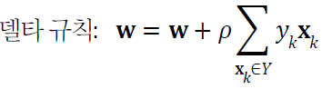Delta Rule:

Objective function

5. Answer to the following classification problem

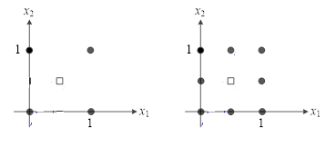

1. Present each multi-layered perceptron that solves this classification problem.
2. Answer whether the right situation can be solved with a perceptron with only two hidden nodes.