INDEX

INTRODUCTION TO THE PROJECT

  - Introduction 1
  - Problem Statement 2
  - Objectives of the Project 3
  - Scope of the Project 5
- REQUIREMENT ANALYSIS
  - Introduction to Requirement Analysis 6
  - Problem Analysis 9
  - Requirement Specification Document 11
    - Introduction to Software Requirement Specification (SRS) 11
    - General Description of the Project 13
  - Introduction to Specific Requirements 18
    - Functional Requirements 18
    - Non-Functional Requirements 20
    - Input Requirements 21
    - Output Requirements 21
    - Hardware Requirements 22
    - Software Requirements 22
    - External Interface Requirements 23
  - System Constraints 23
- SOFTWARE AND SYSTEM DESIGN
  - Introduction to Software Design 26
    - Design Overview 27
    - Modular Design 27
    - Data Design 28
    - Database Design Overview 29
    - Table Structure and Description 29
    - Relationships Between Tables 31
    - Data Integrity and Constraints 31
    - User Interface Design 34
    - Page-Wise User Interface Flow 35
    - Navigation Flow Summary 36
  - Introduction to System Design 38
    - Architectural Design 38
    - System Workflow 39
    - Module Interaction 39
    - Data Flow in the System 40
    - Admin Workflow 42
  - Introduction to Data Flow Diagrams (DFD) 43
  - Introduction to User Interface Design 48
- CODING
  - Order Processing System 62
    - Programming approach 62
    - Source code 64
- TESTING
  - Testing Approach 93
  - Types of Testing Performed 93
  - Test Cases 95
  - Test Criteria 97
- IMPLEMENTATION AND EVALUATION
  - Maintenance Measures 106
- CONCLUSION
- Conclusion 107
- FUTURE SCOPE
- Future Scope 109
ANNEXURE
  - System Interface Screenshots 112
  - Project File Structure 121
  - System Requirements 123
  - Database Statistics 123
  - SQL Queries 123
BIBLIOGRAPHY
Books 124
Web Resources 124
Tools Used 124
Additional References 125

INTRODUCTION TO THE PROJECT

Introduction
In the present academic environment, colleges function not only as centers of education but also as spaces where students manage multiple responsibilities simultaneously. Students attend lectures, participate in laboratory sessions, work on academic projects, pursue internships, and engage in extracurricular activities, all within tightly packed schedules. In such a fast-paced environment, support facilities like the college canteen play a crucial role in students’ daily routines. A well-organized canteen system contributes directly to students’ convenience, time management, and overall campus experience. However, despite its importance, many college canteens continue to rely on traditional and manual systems that have remained unchanged for years and are no longer suited to the expectations of today’s digitally aware students. In a conventional canteen system, students are required to physically visit the canteen, stand in long queues, place orders verbally, and wait until their food is prepared. This process becomes especially inefficient during peak hours such as lunch breaks or short gaps between lectures, when large numbers of students arrive simultaneously. Excessive crowding, long waiting times, and lack of structured order handling often force students to waste valuable time or even skip meals altogether. Manual order-taking further increases the chances of human errors such as incorrect orders, missing items, or confusion between multiple orders, leading to dissatisfaction among students and unnecessary pressure on canteen staff.
Another significant limitation of traditional canteen systems is the lack of transparency and order tracking. Once an order is placed, students have no way of knowing the status of their food—whether it is being prepared, delayed, or ready for pickup. This uncertainty results in repeated inquiries at the counter, disrupting staff workflow and slowing down service even further. Additionally, traditional systems do not maintain proper records of orders, making it difficult to analyze demand patterns or improve operational efficiency. Food wastage is also a major concern in manual canteen operations. Since food preparation is based on rough estimations rather than confirmed demand, excess food is often cooked and later discarded, leading to financial loss and inefficient use of resources. At the same time, shortages may occur if demand is underestimated, causing delays and dissatisfaction. Furthermore, students sometimes place orders but fail to collect them due to sudden schedule changes or long waiting times. As there is no mechanism to track such unpicked orders or hold users accountable, this issue further contributes to food wastage and highlights the inefficiency of the existing system.
With the rapid growth of digital technology, the way services are accessed and managed has changed significantly. Students today are highly familiar with online platforms, mobile applications, and digital payment systems, and they expect campus services to be fast, transparent, and easily accessible. However, traditional canteen systems fail to align with these modern expectations, creating a clear gap between user needs and service delivery. The increasing demand for digitization within academic institutions has made it necessary to upgrade conventional canteen operations with a technology-driven solution that reduces

queues, improves order accuracy, and ensures better management of food resources. A digital canteen system not only enhances convenience for students but also enables canteen staff to operate in a more structured and efficient manner. To address these challenges, Foodly – Digital Canteen Pre-Ordering System has been designed as a web-based application aimed at modernizing the college canteen experience. The system allows students to place food orders online before reaching the canteen, eliminating the need for physical queues and manual order placement. Through the Foodly platform, students can view a digital menu, select food items, and schedule their orders according to their academic timetable. This structured approach replaces the unorganized manual process with a streamlined system that benefits both students and canteen administrators.
With the rapid growth of digital technology, the way services are accessed and managed has changed significantly. Students today are highly familiar with online platforms, mobile applications, and digital payment systems, and they expect campus services to be fast, transparent, and easily accessible. However, traditional canteen systems fail to align with these modern expectations, creating a clear gap between user needs and service delivery. The increasing demand for digitization within academic institutions has made it necessary to upgrade conventional canteen operations with a technology-driven solution that reduces queues, improves order accuracy, and ensures better management of food resources. A digital canteen system not only enhances convenience for students but also enables canteen staff to operate in a more structured and efficient manner. To address these challenges, Foodly – Digital Canteen Pre-Ordering System has been designed as a web-based application aimed at modernizing the college canteen experience. The system allows students to place food orders online before reaching the canteen, eliminating the need for physical queues and manual order placement. Through the Foodly platform, students can view a digital menu, select food items, and schedule their orders according to their academic timetable. This structured approach replaces the unorganized manual process with a streamlined system that benefits both students and canteen administrators.
The system is developed using PHP and MySQL as the backend technologies, along with HTML, CSS, Bootstrap, and JavaScript for the front-end. It is hosted on a local server environment using XAMPP. The application supports role-based access, offering separate portals for students and canteen administrators. Students can register, log in, browse the menu, add items to a cart, select a pickup time slot, and place orders. The admin panel provides full control over menu management, order processing, time slot configuration, user management, and daily analytics.

Problem Statement
The existing manual canteen management system at college campuses suffers from multiple structural and operational inefficiencies. The key problems identified are as follows:

    - Overcrowded Queues: During peak hours, physical queues at the canteen counter become unmanageable, causing students to miss their breaks or classes.
    - No Pre-Ordering Facility: There is no mechanism for students to place food orders in advance, leading to last-minute rushes.
    - Manual Token Issuance: Tokens are issued manually, which is error-prone and slow.
    - No Order Tracking: Students have no visibility into the status of their order once it is placed.
    - Food Wastage: Food is prepared based on rough estimates rather than confirmed orders, resulting in excess preparation and wastage.
    - No Digital Records: There is no digital record-keeping for orders, making it impossible to audit or analyze consumption patterns.
    - Misuse and False Ordering: Students sometimes place orders without picking them up, and there is no accountability mechanism.

The Foodly system addresses each of these problems through its digitally managed, role-based, and slot-constrained ordering platform.

Objectives of the Project
The objectives of the Foodly – Digital Canteen Pre-Ordering System focus on improving the efficiency, organization, and usability of the college canteen by introducing a digital and structured ordering platform. These objectives are designed to address the problems of the traditional canteen system while enhancing convenience for students and operational efficiency for canteen staff.
- To Reduce Congestion and Waiting Time- One of the main objectives of the Foodly system is to reduce overcrowding and long waiting queues in the college canteen. By enabling students to place food orders online, the need to stand in physical queues is eliminated. Orders are prepared in advance according to selected pickup times, which helps manage peak-hour rush efficiently. This allows students to save time and utilize their breaks more productively.

- To Improve Order Management and Organization- The project aims to replace the unorganized manual ordering process with a structured and systematic digital workflow. All orders are stored securely in the system database and are processed in an organized manner. The use of unique order tokens ensures clarity and accuracy in order handling. This significantly reduces errors, confusion, and miscommunication between students and canteen staff.

- To Implement Time-Slot Based Structured Pickup- Another important objective is to introduce a time-slot based pickup mechanism for food collection. Students are required to select predefined pickup slots while placing orders, which helps distribute demand evenly throughout the day. Each slot has a limited capacity, preventing sudden overcrowding. This structured approach ensures smoother operations and better workload management for the canteen.

- To Enable Real-Time Order Status Tracking- The Foodly system aims to provide transparency by allowing students to track their order status in real time. Students can view whether their order is pending, under preparation, or ready for pickup. This reduces uncertainty and minimizes repeated inquiries at the counter. As a result, both students and staff experience a more organized and stress-free process.

- To Minimize Food Wastage- Reducing food wastage is a key objective of the project. Since food is prepared based on confirmed digital orders, unnecessary preparation is avoided. The system also records orders that are not picked up within the selected time slot. By monitoring repeated non-pickups, the system helps discourage false ordering and promotes responsible food consumption.

- To Improve Operational Efficiency for Canteen Staff- The project aims to simplify and streamline daily canteen operations. Digital order handling reduces the dependency on manual processes and paperwork. Automated token generation and centralized order management improve coordination between kitchen staff and counter staff. This results in faster service delivery and improved overall efficiency.

- To Enhance Student Convenience and Flexibility- Foodly is designed to support students who manage tight academic schedules. Students can place orders from their mobile phones or laptops while attending classes or working on assignments. Food can be picked up quickly during short breaks without waiting. This flexibility enhances the overall campus experience and student satisfaction.

- To Promote Responsible and Disciplined System Usage- The system encourages accountability by maintaining records of unpicked orders. Students who repeatedly fail to collect their orders can be identified by the admin. This discourages misuse of the system and promotes fair usage among all users. Such accountability helps maintain system efficiency and reduce losses.

- To Apply Practical Knowledge of Web Technologies- An academic objective of the project is to apply theoretical knowledge gained during the course to a real-world problem. The project involves the use of front-end and back-end web technologies along with database management. It helps in understanding real-life software development workflows. This enhances technical skills and practical learning experience.
The overall objective of the Foodly – Digital Canteen Pre-Ordering System is to develop a reliable, efficient, and user-friendly digital platform that modernizes canteen operations, reduces food wastage, and provides a convenient food ordering experience within the college campus.

Scope of the Project
The scope of the Foodly system covers the complete digital lifecycle of a canteen food order, from browsing the menu to order completion. The system is designed for a single-canteen environment within a college campus and operates on a local server using XAMPP. The scope includes:

Student-Side Functionality
The system provides students with a self-contained digital experience for placing canteen orders. This includes account registration and secure login, followed by menu browsing organized by food categories. Students can manage a shopping cart, select available time slots for pickup, and place orders through a confirmation timer mechanism that prevents accidental submissions. Upon successful placement, a unique token is generated for each order, which serves as the student's reference at the counter. Students can also track the live status of their current order, review past order history, and manage their profile information.

Admin-Side Functionality
Canteen administrators access a dedicated interface secured by login authentication. The admin dashboard presents a live view of incoming and in-progress orders, enabling staff to update order statuses in real time. Administrators have full control over the menu, including adding new items, editing existing entries, deleting items, and toggling their availability without removing them permanently. Time slot management allows admins to define and regulate pickup windows. User management functionality enables administrators to activate or deactivate student accounts as needed. A daily revenue analytics module provides a summarized financial view of orders processed each day.

Database Management
The backend relies on a relational MySQL database comprising eight tables: admins, categories, menu, orders, order_items, time_slots, users, and system_settings. These tables are structured to maintain referential integrity across the order lifecycle, from user identity and menu definition through to individual item-level order records and configuration parameters.

Automation
The system incorporates automated processes to reduce manual administrative overhead. MySQL Events handle the daily reset of time slot order counts, ensuring slot capacities refresh without administrator intervention. Session-based reset detection in PHP provides a complementary layer of control at the application level. Token numbering resets to 1 at the start of each day, maintaining a simple and predictable reference system for both students and canteen staff.

Boundaries and Exclusions
The current version of Foodly operates within a defined set of boundaries. The system functions exclusively within a single-canteen setup on a college campus local network and is not architected for multi-canteen or multi-campus deployment in its present form. All transactions are handled without online payment integration; order payment is assumed to occur physically at the counter. The system does not support push notifications of any kind, meaning students must actively check the interface for order status updates. Additionally, no dedicated mobile application exists; access is through a web browser only, which may limit convenience on smaller screens despite responsive design considerations. These exclusions represent deliberate deferments rather than design oversights, and are earmarked as priorities for future development phases.

REQUIREMENT ANALYSIS

Introduction to Requirement Analysis
Requirement Analysis is an important phase in software development that focuses on understanding the needs of users and defining what the system is expected to do. In the case of the Foodly – Digital Canteen Pre-Ordering System, requirement analysis helps in identifying the functional and non-functional needs of both students and canteen administrators. This phase ensures that the system is designed in a way that solves real-world problems efficiently and meets user expectations.
The traditional college canteen system lacks structure, automation, and proper tracking mechanisms. Therefore, there is a strong need for an online and digital system that can manage food ordering activities in an organized manner. Foodly is designed to fulfill this need by providing a web-based platform that replaces manual ordering and token systems with a digital workflow.
One of the primary requirements of the system is the availability of an online ordering platform. Students should be able to access the system through a web browser on their mobile phones, tablets, or computers. The system must be responsive so that it functions smoothly across different devices and screen sizes. This ensures maximum accessibility and ease of use within the campus environment.

Another important requirement is role-based access control. The system must differentiate between student users and admin users. Students should have access to features such as viewing the menu, placing orders, selecting time slots, and tracking order status. Admin users, on the other hand, should have access to managing menu items, controlling time slots, updating order statuses, and viewing analytics. Role-based access ensures system security and proper functionality.
The system also requires a secure registration and login mechanism. Each student must have a unique account to place orders, and authentication should be handled securely. This helps in tracking individual orders, monitoring non-pickups, and maintaining accountability among users. Admin login must be protected to prevent unauthorized access to management features.
A crucial requirement of Foodly is the time-slot validation mechanism. Since the system is based on time-slot ordering, it is essential to ensure that students can only select available slots. Each time slot must have a predefined capacity, and the system should automatically prevent orders once the capacity is reached. This real-time validation helps in balancing the workload and avoiding over-preparation of food.
The system also requires an automatic token generation feature. Each order placed by a student must receive a unique token number, which resets daily. This token acts as a reference for both students and canteen staff. Token generation must be automated to eliminate manual effort and ensure consistency in order handling.
Another key requirement is order status tracking. The system must allow admins to update the status of each order, while students should be able to view real-time updates. This feature improves transparency and reduces unnecessary communication at the counter. The system should reflect status changes dynamically without requiring page reloads.
To prevent accidental ordering, the system requires a confirmation mechanism before finalizing orders. The 15-second confirmation timer allows users to review their order and make changes if required. This requirement helps reduce unwanted orders and improves user satisfaction.
The system also needs to track unpicked orders. Orders that are not collected within the selected time slot must be recorded. This data is essential for identifying misuse and discouraging false ordering. Maintaining such records helps improve system discipline and reduce food wastage.
Finally, the system requires a basic analytics and reporting feature. Admins should be able to view daily orders, revenue, and order patterns. These insights help in better planning and efficient management of canteen operations.
Apart from functional needs, the Foodly system also requires several non-functional requirements to ensure smooth performance and usability. The system should be reliable, responsive, and capable of handling multiple users at the same time, especially during peak hours such as lunch breaks. Performance stability is essential so that students can place orders without delays or errors.

The system must be easy to use and user-friendly. Since the users include students and canteen staff with varying levels of technical knowledge, the interface should be simple and intuitive. Clear navigation, readable menus, and minimal steps for order placement are required to ensure smooth interaction with the system.
Another important requirement is data accuracy and consistency. All orders, tokens, time slots, and user details must be stored accurately in the database. The system should ensure that duplicate orders for the same time slot are not allowed for a single user. This helps maintain fairness and avoids misuse of the system.
The system also requires real-time data synchronization between the user interface and the database. Any change in order status, slot availability, or token number should reflect immediately on the user’s screen. This real-time behavior improves transparency and builds trust among users.
Security is another essential requirement. The system should protect user data such as login credentials and order history. Only authorized users should be able to access admin functionalities. Basic security measures such as session handling and restricted access are required to prevent unauthorized use of the system.
The system must also support scalability within the defined scope. While Foodly is currently designed for a single college canteen, the structure should allow future enhancements such as additional time slots, menu items, or increased number of users without major changes to the system architecture.
A significant requirement is the tracking of user behavior related to order pickups. The system should maintain records of students who frequently fail to collect their orders. This requirement supports the implementation of soft-restriction mechanisms and helps reduce food wastage by encouraging responsible usage.
The system also requires admin-level monitoring tools. Admins should be able to view slot- wise order distribution, daily revenue, and unpicked orders. These monitoring features assist in data-driven decision-making and improve overall canteen efficiency.
Another requirement is compatibility with a local server environment. The project is intended to run on XAMPP using Apache and MySQL. Therefore, the system must be optimized for a local deployment environment and should not depend on external services or internet-based APIs.
The system should also ensure maintainability. The code structure should be organized and modular so that future updates or bug fixes can be implemented easily. Proper separation of front-end and back-end logic is required to maintain clarity and ease of maintenance.
In conclusion, the requirement analysis of Foodly highlights the necessity of a structured, secure, and user-friendly digital canteen system. By fulfilling both functional and non- functional requirements, the system aims to provide an efficient solution that benefits students, canteen staff, and administrators while addressing issues such as congestion, food wastage, and lack of transparency.

Problem Analysis
Problem analysis involves studying the existing system in detail and identifying its limitations, inefficiencies, and challenges. In the context of a traditional college canteen, the food ordering and management process is mostly manual and lacks proper organization. These issues directly affect students, canteen staff, and overall operational efficiency.
One of the major problems in the traditional canteen system is long queues and congestion, especially during peak hours such as lunch breaks. Students are required to stand in line to place their orders and then wait again to collect food. This not only wastes valuable time but also creates overcrowding within the canteen area.
Another significant issue is delay in order processing. Since orders are taken manually, there is a high chance of miscommunication between the counter staff and kitchen staff. This often leads to delays in food preparation and serving, resulting in frustration among students.
The traditional system also lacks a proper order tracking mechanism. Once an order is placed, students have no way to know the status of their order. They are forced to repeatedly visit the counter or ask staff, which increases confusion and workload for the canteen employees.
Manual token systems or verbal calls are another major limitation. Manual tokens can be misplaced or duplicated, and verbal announcements are often unclear in noisy environments. This results in missed orders, incorrect serving, and dissatisfaction among students.
Another important problem is the absence of time-based structure in food pickup. In the traditional system, all students arrive at the counter at the same time, leading to sudden rush and uneven workload. There is no mechanism to control or distribute demand evenly throughout the day.
Food wastage is also a serious concern. Canteen staff often prepare food in advance based on assumptions rather than actual demand. When students fail to pick up their orders or demand is overestimated, prepared food goes to waste, causing financial loss and resource wastage.
The existing system also lacks accountability for false or careless ordering. Students can place orders verbally and may choose not to collect them later without any consequences. Since there is no tracking of such behavior, the problem continues and affects overall efficiency.
From an administrative perspective, the traditional system provides no analytical data. There are no records of daily orders, revenue, popular items, or peak hours. This makes planning difficult and forces management to rely on guesswork instead of data-driven decisions.
To overcome the limitations of the traditional canteen system, the Foodly – Digital Canteen Pre-Ordering System provides a structured and technology-driven solution. Each problem identified in the existing system is addressed through specific features and digital mechanisms implemented in Foodly.
To reduce long queues and congestion, Foodly allows students to place food orders online from anywhere on campus. Since ordering is done digitally, students do not need to stand in

line at the counter to place orders. This significantly reduces overcrowding, especially during peak hours, and creates a smoother flow of students within the canteen premises.
Foodly also addresses the issue of delays in order processing by introducing a digital order workflow. Orders placed by students are directly stored in the database and displayed on the admin dashboard. This eliminates miscommunication between counter staff and kitchen staff and ensures that orders are prepared in the correct sequence. As a result, food preparation becomes faster and more organized.
The problem of lack of order tracking is resolved through real-time order status updates. Students can track their orders through different stages such as Pending, Preparing, Ready, and Completed. This transparency reduces uncertainty and prevents repeated inquiries at the counter, allowing staff to focus on food preparation and serving.
Foodly replaces the traditional manual token system with an automatic digital token generation mechanism. Each order receives a unique token number that resets daily. This ensures proper order identification and eliminates issues related to lost or duplicated tokens. Digital tokens also make it easier for staff to serve orders accurately.
The absence of structured food pickup timing is resolved through a time-slot based ordering system. Students must select a predefined time slot while placing an order. Each slot has a limited capacity, which helps distribute demand evenly throughout the day. This prevents sudden rushes and ensures that the kitchen workload remains balanced.
Food wastage is minimized through controlled food preparation and order tracking. Since food is prepared only after confirmed orders and according to selected time slots, unnecessary advance preparation is reduced. Additionally, the system tracks orders that are not picked up within the selected time slot, helping the administration identify patterns of wastage.
To handle false ordering and lack of accountability, Foodly maintains a record of non-picked orders for each user. Repeated non-pickups can be monitored by the admin, discouraging misuse of the system. This feature promotes responsible ordering behavior among students and reduces intentional or careless false orders.
From an administrative point of view, Foodly introduces data-driven management. The admin dashboard provides insights into daily orders, revenue, and ordering patterns. This data helps the canteen management plan menu items, estimate demand, and allocate resources more effectively.
Foodly also improves overall operational efficiency by reducing manual work. Tasks such as order recording, token management, and revenue calculation are handled digitally. This reduces staff workload and minimizes errors caused by manual processes.
In addition, the system improves communication between students and canteen staff. Since all information is available digitally, there is less dependency on verbal interaction, which reduces confusion and misunderstandings during busy hours.

Overall, the Foodly – Digital Canteen Pre-Ordering System successfully addresses the major challenges of the traditional canteen system. By introducing digital ordering, time-slot management, real-time tracking, and analytical insights, the system transforms canteen operations into an efficient, organized, and user-friendly process. This problem-oriented approach makes Foodly a practical and effective solution for modern campus environments.

Requirement Specification Document

Introduction to Software Requirement Specification (SRS)
Software Requirement Specification (SRS) is a formal document that clearly describes the requirements, functionality, and behavior of a software system. It serves as a foundation for the design, development, and testing phases of the software development life cycle. The purpose of an SRS document is to ensure that all stakeholders have a clear and common understanding of what the system is expected to do.
In any software project, improper or unclear requirements can lead to confusion, errors, and project failure. Therefore, SRS plays a crucial role in defining the scope and objectives of the project in a structured manner. It acts as a reference point throughout the development process and helps avoid misunderstandings between developers, users, and project guides.
For the Foodly – Digital Canteen Pre-Ordering System, the SRS document helps in defining how the system should function, what features it should include, and how users will interact with it. Since the system involves multiple users such as students and administrators, SRS ensures that the needs of all users are properly documented and addressed.
The SRS document describes both functional and non-functional requirements. Functional requirements define what the system should do, such as allowing students to place orders or enabling admins to manage time slots. Non-functional requirements describe how the system should perform, including usability, reliability, security, and performance aspects.
One of the major advantages of an SRS document is that it provides clarity and structure to the development process. It helps developers understand the expected behavior of the system before writing any code. This reduces the chances of rework and saves time during later stages of development.
SRS also plays an important role in project planning and estimation. By clearly defining system requirements, developers can estimate the time, resources, and effort required to complete the project. This helps in setting realistic deadlines and managing the project effectively.
In academic projects like Foodly, the SRS document is equally important. It demonstrates the student’s understanding of software engineering principles and the ability to translate a

problem into technical requirements. It also helps the project guide evaluate whether the proposed system meets the academic and practical objectives.
Another important aspect of SRS is documentation and maintainability. A well-written SRS document makes it easier to update or modify the system in the future. If new features need to be added or changes are required, the SRS serves as a reference for understanding the existing system structure.
The SRS document also acts as a communication bridge between different stakeholders. Students, guides, and evaluators can refer to the document to understand system functionality without going into technical implementation details. This makes evaluation and review more systematic and transparent.
For the Foodly system, SRS ensures that features such as time-slot validation, token generation, order tracking, and admin analytics are clearly defined before development. This helps in building a system that is aligned with the project goals and solves the identified problems effectively.
In conclusion, the Software Requirement Specification is a vital component of software development that ensures clarity, consistency, and correctness in system design. It lays a strong foundation for successful implementation and evaluation of the project.
The Software Requirement Specification document also helps in defining the boundaries of the system. By clearly specifying what the system will and will not do, SRS prevents unnecessary feature additions and scope creep. This is especially important in academic projects where time and resources are limited. A well-defined SRS ensures that the project remains focused and achievable within the given constraints.
Another important role of the SRS document is to act as a baseline for system validation and testing. During the testing phase, the developed system is compared against the requirements mentioned in the SRS to verify whether all functionalities have been implemented correctly. This helps in identifying missing features or deviations from the expected behavior of the system.
In the context of the Foodly project, SRS helps document the expectations related to student interactions, admin responsibilities, and system responses. For example, requirements related to order placement, time-slot selection, token generation, and order status updates are clearly defined in the SRS. This ensures consistency during development and avoids ambiguity.
The SRS document also emphasizes the importance of usability and user experience. Since Foodly is designed for regular use by students and canteen staff, the system must be easy to understand and operate. The SRS outlines usability expectations such as simple navigation, clear labels, and minimal steps for completing tasks. These guidelines help in designing an intuitive user interface.
Security requirements are another critical component of the SRS. The document specifies the need for secure login mechanisms, restricted admin access, and protection of user data.

Although the project is deployed on a local server, maintaining data integrity and preventing unauthorized access remain important considerations.
The SRS also highlights performance requirements, such as the system’s ability to handle multiple users simultaneously without significant delays. This is particularly important during peak hours when many students may access the system at the same time. Performance expectations ensure that the system remains reliable and responsive.
Documentation of assumptions and constraints is another key purpose of the SRS. For Foodly, assumptions such as availability of internet access on campus and active participation of canteen staff in updating order status are clearly stated. Constraints such as deployment on a local server and limitation to a single canteen environment are also documented. This clarity helps evaluators understand the project context.
In academic projects, the SRS also serves as a learning tool. It helps students understand how real-world software systems are planned and documented before development. Writing an SRS encourages logical thinking and systematic analysis of system requirements.
Furthermore, the SRS document supports future enhancements. If the system needs to be extended with features such as online payments or multi-canteen support, the existing SRS provides a reference for understanding the current system structure and functionality.
Overall, the Software Requirement Specification document plays a vital role in ensuring that the Foodly – Digital Canteen Pre-Ordering System is developed in an organized, clear, and goal-oriented manner. It acts as a blueprint that guides development, testing, evaluation, and future improvements, making it an essential part of the project documentation.

General Description of the Project
The General Description section provides an overall understanding of the Foodly – Digital Canteen Pre-Ordering System. It explains the system at a high level, including its purpose, user roles, major functionalities, system characteristics, constraints, and assumptions. This section does not focus on implementation details but instead describes how the system behaves and operates as a complete unit.

System Overview
Foodly is a web-based digital canteen management system developed to simplify and streamline the food ordering process within a college campus. The system replaces the traditional manual ordering method with an online platform that allows students to pre-order food, select pickup time slots, and track their order status in real time.
The system is designed to reduce congestion in the canteen, minimize food wastage, and improve operational efficiency. It follows a structured workflow where orders are placed digitally, processed by the admin, and served using an automated token-based system.

Purpose of the System

The purpose of the Foodly – Digital Canteen Pre-Ordering System is to provide a structured and efficient solution to the problems faced in traditional college canteen operations. The system is designed to simplify the food ordering process for students while improving order handling and resource management for canteen staff. By shifting from a manual system to a digital platform, Foodly aims to save time, reduce crowding, and enhance overall convenience within the campus.
The system allows students to place food orders in advance according to their schedules, which is especially useful during short breaks between classes or busy academic days. Through features such as time-slot selection, token generation, and order status tracking, the system ensures better coordination between students and the canteen. For administrators, the purpose of the system is to provide better control over menu management, order flow, and daily operations using a centralized dashboard.
Overall, the Foodly system is intended to create a balanced environment where students receive timely service and the canteen can operate efficiently with reduced errors and food wastage.

User Roles in the System
The Foodly system consists of two primary user roles:
  - Student side server
Students are the main users of the system. They interact with the platform to place food orders and track their status.
Student functionalities include:
    - Registration and secure login
    - Viewing the digital food menu
    - Adding items to cart
    - Selecting a preferred pickup time slot
    - Placing orders with confirmation
    - Receiving an automatically generated token number
    - Tracking order status in real time
    - Receiving notification when the order is ready
    - Viewing past order history
These features provide students with flexibility and convenience, especially during busy academic schedules.
  - Admin side server

The admin represents the canteen staff or management responsible for handling orders and system maintenance.
Admin functionalities include:
    - Secure admin login
    - Adding, editing, or removing menu items
    - Creating and managing time slots with capacity limits
    - Viewing incoming orders
    - Updating order status
    - Monitoring unpicked orders
    - Viewing daily orders and revenue
The admin module ensures smooth backend operations and effective control over the canteen workflow.

Operating Environment
The Foodly system operates in a web-based environment and can be accessed using standard web browsers. The application is designed to run on a local server setup using XAMPP, which includes Apache as the server and MySQL as the database. This environment allows easy development, testing, and deployment of the system within a college setup.
Students can access the system using devices such as smartphones, laptops, or desktop computers that have an active internet connection and a modern web browser. The admin module is also accessed through a browser, making it convenient for canteen staff to manage orders without requiring specialized hardware.
Since the system is browser-based, no additional software installation is required on the user side. This operating environment ensures flexibility, ease of access, and compatibility with commonly available devices within the campus.

Major System Functions
The Foodly system performs several important functions that collectively improve canteen operations.
Some of the key functions include:
- Digital food ordering
- Time-slot based pickup scheduling
- Automatic token generation
- Order status management

- Notification system
- Tracking of unpicked orders
- Basic analytics for administration
Each of these functions works together to create a well-organized and efficient food ordering environment.

System Characteristics
The Foodly – Digital Canteen Pre-Ordering System has the following key characteristics:
  - Web-Based Application
The system is accessible through a web browser and does not require installation of any mobile application. This makes it easy to access on various devices such as smartphones, tablets, and laptops.
  - Responsive Design
The user interface is responsive and adjusts automatically to different screen sizes. This ensures consistent usability across devices.
  - Database-Driven System
All data related to users, menu items, orders, time slots, and tokens is stored in a MySQL database. This allows real-time data retrieval and updates.
  - Dynamic Behavior
The system dynamically updates slot availability, order status, and notifications without requiring full page reloads.
  - Secure Access
Role-based access ensures that only authorized users can perform admin-level operations. f ) Data Integrity
The system ensures data integrity by preventing duplicate token generation for the same day and ensuring that a student cannot book multiple slots simultaneously, preventing system abuse.

Design Considerations
While designing the Foodly system, several important design considerations were taken into account to ensure usability and effectiveness. The system is designed to be simple and user- friendly so that students can easily place orders without any technical difficulty. Clear navigation, readable layouts, and minimal steps are emphasized to provide a smooth user experience.

Another key design consideration is time efficiency. Features such as predefined time slots, automatic token generation, and real-time order status updates are implemented to reduce unnecessary waiting and confusion. The design also focuses on minimizing accidental actions by including a confirmation timer before finalizing an order.
From the admin perspective, the system is designed to provide centralized control with clear visibility of orders and statuses. The interface is kept straightforward so that canteen staff can operate the system with minimal training. Overall, the design aims to balance simplicity, functionality, and reliability.

Constraints of the System
Every system operates under certain limitations. The Foodly system has the following constraints:
- The system is deployed on a local server using XAMPP
- It is designed for a single college canteen
- Network connectivity (LAN or Wi-Fi) is required to access the local server.
- Online payment functionality is not included
- Order lifecycle transitions (Preparing to Ready) are managed manually by the admin to ensure that digital status accurately reflects the physical preparation of food.
These constraints define the scope of the project and ensure that development remains feasible within academic requirements.

Assumptions Made in the System
The following assumptions are considered while designing the Foodly system:
- Students have access to smartphones or computers
- Internet connectivity is available within the campus
- Admin regularly updates order statuses
- Students collect orders within selected time slots
- Users follow responsible ordering behavior
These assumptions help in defining expected system usage and behavior.

Limitations of the Current Version
Although the Foodly system provides an effective solution for digital canteen management, the current version has certain limitations. The system is designed for a single college canteen and does not support multiple canteen management in its present form. This limits its usage to a specific campus environment. The application currently operates on a local server using

XAMPP, which means it is not hosted on a live production server. As a result, remote access outside the local network is limited. Additionally, the system does not include an online payment feature and relies only on order placement and pickup management. Another limitation is that the analytics provided are basic and focused mainly on daily orders, revenue, and unpicked orders. Advanced reporting and predictive analysis are not included in the current version. However, these limitations provide scope for future enhancement and system expansion.
In summary, the Foodly – Digital Canteen Pre-Ordering System is a structured and efficient solution designed to modernize college canteen operations. By combining digital ordering, time-slot scheduling, automated token generation, and real-time tracking, the system addresses common issues such as long queues, food wastage, and poor order management. The system is simple, user-friendly, and suitable for academic implementation while also being scalable for future enhancements. This general description provides a clear understanding of the system’s structure, purpose, and operational behavior.

Introduction to Specific Requirements
This section defines the detailed functional and operational requirements of the Foodly – Digital Canteen Pre-Ordering System. It focuses on describing how the system behaves in different situations, what inputs it accepts, what outputs it produces, and how different components interact with each other. These requirements act as a bridge between the general system description and the actual implementation of the project.
The purpose of specifying these requirements is to ensure that the system is developed in a structured and well-defined manner. It helps in avoiding confusion during development and provides a clear understanding of expected system behavior for both users and administrators. The requirements mentioned in this section are based on the real-world problems identified in traditional canteen systems and are designed to provide practical solutions through digital means.

Functional Requirements
Functional requirements describe the core operations and features that the system must perform. These requirements define what actions the system should be able to carry out and how users interact with it.
- User Registration and Login
The system must allow students to register by providing necessary details such as roll number, email, and phone number. Each user must have a unique identity to access the system. The login functionality ensures secure access by verifying user credentials before allowing entry into the system.

The system should also differentiate between student and admin roles. Based on the role, users should be directed to their respective dashboards. Proper validation must be applied to ensure that duplicate registrations are avoided, especially for fields like email and roll number.
- Menu Display and Management
The system must display a digital menu to students in an organized and user-friendly format. Food items should be grouped into categories such as snacks, beverages, or meals. Each item should include details like name, price, and availability status.
From the admin side, the system should allow adding, updating, and deleting menu items. Admin should also be able to control whether an item is available or not. This ensures flexibility in managing the menu based on stock and demand.
- Add to Cart Functionality
The system must allow students to select food items and add them to a virtual cart before placing an order. Students should be able to adjust item quantities, remove items, and view the total amount dynamically.
The cart should act as a temporary storage area where users can review their selected items before confirming the order. This improves usability and reduces ordering mistakes.
- Time-Slot Selection and Validation
The system must provide predefined time slots for order pickup. Students are required to select a suitable time slot while placing an order. Each time slot must have a fixed maximum capacity to avoid overcrowding.
Before confirming an order, the system must check whether the selected time slot has reached its maximum capacity. If the slot is full, the system should prevent booking and notify the user to select another slot. This validation ensures smooth distribution of orders throughout the day.
- Order Placement and Token Generation
Once the user confirms the order, the system must process it and generate a unique token number. This token serves as an identifier for the order and is used during pickup.
The token generation must follow a daily sequence, meaning it resets each day. The system should ensure that each token number is unique for that day. This helps maintain order and avoids confusion during food distribution.
- Order Status Management
The system must support different stages of order processing such as Pending, Preparing, Ready, Completed, and Expired. These statuses should be updated by the admin based on the progress of the order.
Students should be able to view the current status of their order in real time. This feature improves transparency and reduces the need for manual inquiries at the counter.

- Duplicate Order Prevention
The system must prevent users from placing multiple orders for the same time slot on the same day. This is achieved through backend validation using user ID, slot ID, and order date.
If a user attempts to place a duplicate order, the system should block the action and display an appropriate message. This ensures fairness and prevents misuse of the system.

Non-Functional Requirements
Non-functional requirements define how the system performs rather than what the system does. These requirements ensure that the Foodly system is efficient, reliable, secure, and easy to use.
- Performance Requirements
The system should be able to handle multiple users accessing the platform at the same time, especially during peak hours such as lunch breaks. The response time for actions like loading the menu, placing an order, or updating order status should be minimal. The system must process requests efficiently without delays to provide a smooth user experience.
- Usability Requirements
The Foodly system should be simple and user-friendly so that students can easily understand and use it without any technical knowledge. The interface should have clear navigation, readable text, and properly organized sections. The number of steps required to place an order should be minimal to ensure convenience.
- Reliability Requirements
The system should function correctly without frequent errors or failures. Orders placed by users must be stored accurately in the database and should not be lost due to system issues. The system should consistently perform its operations under normal conditions and provide stable performance.
- Security Requirements
The system must ensure secure handling of user data such as login credentials and personal information. Proper authentication should be implemented to prevent unauthorized access. Admin functionalities should be restricted to authorized users only. Data should be protected from unauthorized modification or misuse.
- Scalability Requirements
Although the current system is designed for a single canteen, it should be developed in a way that allows future expansion. The system structure should support the addition of new features such as multiple canteens, online payments, or advanced analytics without major changes.
- Maintainability Requirements

The system should be easy to maintain and update. Code structure should be organized so that modifications or bug fixes can be implemented without affecting the entire system. Proper documentation should support future improvements.

Input Requirements
Input requirements define the type of data that the system accepts from users and administrators. These inputs are essential for the proper functioning of the system.
- User Input
Students are required to enter details such as roll number, email, phone number, and password during registration. During login, users must provide valid credentials to access the system. While placing orders, users select food items, quantities, and preferred time slots.
- Admin Input
The admin provides input related to menu management and system operations. This includes adding new food items, updating prices, managing availability, creating time slots, and updating order statuses. These inputs ensure smooth backend functioning.
- Order Input
Order-related inputs include selected items, quantity, total amount, selected time slot, and order confirmation. The system processes these inputs to generate an order and assign a token number.

Output Requirements
Output requirements define the information that the system provides to users after processing the inputs.
- User Output
After placing an order, the system displays important details such as the generated token number, order summary, selected time slot, and total amount. Users can also view real-time order status updates, which help them track the progress of their order.
- Notification Output
The system provides notifications to inform users about important updates. For example, when an order is ready, the system notifies the student to collect it. These notifications improve communication and reduce confusion.
- Admin Output

The admin dashboard displays outputs such as total orders, daily revenue, and order status details. It also shows records of unpicked orders, which help in identifying misuse and improving system efficiency.

Hardware Requirements

Component | Minimum Requirement | Recommended
Processor | Intel Core i3 or equivalent | Intel Core i5 or higher
RAM | 4 GB | 8 GB
Storage | 50 GB HDD | SSD with 100 GB
Display | 1024 x 768 resolution | 1920 x 1080 or higher
Network | Local LAN / Wi-Fi | Stable campus Wi-Fi
Input Devices | Keyboard, Mouse | Keyboard, Mouse, Touch

Software Requirements

Component | Technology / Version
Operating System | Windows 10 / 11 or Linux Ubuntu 20.04+
Web Server | Apache 2.4 (via XAMPP)
Database Server | MySQL 10.4.32 (MariaDB via XAMPP)
Server-Side Language | PHP 8.0.30
Client-Side Technologies | HTML5, CSS3, Bootstrap 5, JavaScript (ES6)
Code Editor | Visual Studio Code
Browser for Testing | Google Chrome (latest), Mozilla Firefox
Database Management | phpMyAdmin 5.2.1

Component | Technology / Version
Development Environment | XAMPP v8.x
External Libraries | SweetAlert2 v11 (JavaScript alerts)

External Interface Requirements
External interface requirements describe how the system interacts with users and other external components.
- User Interface
The system provides a web-based user interface that allows students and admins to interact with the system easily. The interface is designed to be simple, responsive, and easy to navigate. All features such as menu browsing, order placement, and status tracking are accessible through this interface.
- Hardware Interface
There is no special hardware interface required for the system. It operates on standard input- output devices such as keyboard, mouse, and touchscreen. This makes the system easily accessible on commonly available devices.
- Software Interface
The system interacts with the MySQL database to store and retrieve data. It also uses the Apache server to handle requests and responses between the client and server. These interactions ensure smooth functioning of the application.

System Constraints
System constraints define the boundaries and limitations within which the Foodly system is designed to operate. These constraints arise from decisions made during the design phase, the deployment environment, the available technology stack, and the intended scope of the current version. Understanding these constraints is essential for evaluating the system's suitability, planning future enhancements, and setting accurate expectations for stakeholders.

Deployment and Infrastructure Constraints
Foodly is deployed on a local server using XAMPP, a lightweight, cross-platform development environment comprising Apache, MySQL, and PHP. While this setup is well-suited for a controlled campus environment, it introduces significant infrastructure limitations. The system is accessible only within the local network to which the server machine is connected, meaning that students or administrators attempting to access the system from outside the campus

network — such as from home or via mobile data — will be unable to do so without additional network configuration such as VPN tunneling or port forwarding. This constraint directly limits the flexibility of the system and restricts its use to on-campus scenarios.
Furthermore, the system's performance and availability are tightly coupled to the health of the host machine running XAMPP. There is no redundancy, load balancing, or failover mechanism in place. If the server machine experiences downtime due to power failure, hardware issues, or software errors, the entire system becomes inaccessible until it is manually restored. This single point of failure is an inherent limitation of the local server architecture and distinguishes Foodly from cloud-hosted alternatives that offer higher uptime guarantees.

Single-Canteen Limitation
The current version of Foodly is architected exclusively for a single-canteen environment. The database schema, order routing logic, admin dashboard, and token generation system are all designed with the assumption that one canteen is in operation. There is no concept of canteen identifiers, branch-level segregation, or multi-location menu management within the existing data model. Expanding the system to accommodate multiple canteens across a college campus would require substantial restructuring of both the database schema and the application logic, including the introduction of canteen-specific admin roles, separate menu inventories, and location-aware order routing.

Dependency on Manual Admin Intervention
A notable operational constraint is the system's reliance on manual input from the canteen administrator for several critical functions. Order status updates — such as transitioning an order from "Placed" to "Preparing" or "Ready" — are not automated and must be performed manually through the admin dashboard. If an administrator is occupied, unavailable, or delayed in updating statuses, the information visible to students on the order tracking screen will become stale and inaccurate. This dependency introduces a human bottleneck into what is otherwise a digital workflow, and represents a meaningful constraint on the reliability of real- time order visibility.
Similarly, menu availability toggling and time slot management require active engagement from the admin. Items that run out of stock will remain listed as available until an administrator manually marks them as unavailable. This could lead to students placing orders for items that cannot be fulfilled, creating operational friction at the canteen counter.

Absence of Online Payment Integration
Foodly does not incorporate any form of digital payment processing. All financial transactions are handled in person at the canteen counter at the time of order collection. This means the system functions as an order management and queue coordination tool rather than a complete end-to-end transactional platform. The absence of payment integration limits the system's ability to enforce pre-payment, reduce counter congestion during peak hours, or maintain automated financial records tied to individual transactions. While this constraint was a

deliberate decision to reduce implementation complexity within the current scope, it places a ceiling on how much the system can streamline the overall canteen experience.

Limited Analytics Capabilities
The analytics functionality available in the current version is restricted to daily revenue summaries at the admin level. There are no provisions for trend analysis across multiple days or weeks, category-wise sales breakdowns, peak hour identification, or individual student ordering patterns. Administrators cannot generate exportable reports, set revenue targets, or visualize data through charts beyond what is provided in the basic dashboard. For a canteen operating at scale, such limitations may reduce the utility of the system as a business intelligence tool. More sophisticated analytics would require integration with dedicated reporting libraries or external data visualization services, which fall outside the current project scope.

No Push Notification Support
The system does not support push notifications or any form of proactive alerts. Students are required to manually open the application and navigate to the order tracking screen to check for status updates. There is no mechanism to notify a student when their order is ready for pickup, which undermines one of the core conveniences that digital ordering systems are expected to provide. This constraint means students may either collect their order too early, causing unnecessary waiting at the counter, or miss their ready window and collect late, disrupting canteen flow. Addressing this limitation in a future version would require integration with browser-based push notifications or SMS gateway services.

No Dedicated Mobile Application
Foodly is a web-based system accessible through a browser and is not accompanied by a dedicated native application for iOS or Android platforms. While the interface may be accessed on a mobile browser, the absence of a native app means the system cannot leverage device- level features such as background notifications, offline caching, biometric authentication, or home screen shortcuts. Mobile browser sessions are also more susceptible to being interrupted or timing out, which can affect the order placement experience, particularly during the confirmation timer phase.
Despite these constraints, the Foodly system successfully delivers on its primary objectives of digitizing the canteen ordering process, reducing physical queuing, and providing real-time order coordination between students and canteen staff. The constraints outlined above are well- understood boundaries of the current implementation and serve as a clear roadmap for the enhancements to be pursued in subsequent development phases.

SOFTWARE AND SYSTEM DESIGN

Introduction to Software Design
Software design is a foundational phase in the software development life cycle, serving as the critical transition point between understanding what a system must do and determining how it will do it. Before a single line of code is written, the design phase establishes the structural blueprint of the entire system — defining its architecture, breaking it into manageable components, specifying how data flows between those components, and determining how users will interact with the finished product. A rigorous design phase reduces ambiguity, minimizes the likelihood of costly rework during implementation, and ensures that the final system is coherent, maintainable, and aligned with the requirements identified during analysis.
Software design operates at multiple levels of abstraction. At the highest level, architectural design determines the overall organization of the system — whether it follows a layered structure, a client-server model, or a modular arrangement of loosely coupled components. At a more granular level, detailed design specifies the internal logic of individual modules, the structure of the database, the format of data exchanged between system layers, and the rules governing user interface behavior. Together, these levels of design provide developers with a comprehensive plan that guides implementation and reduces reliance on ad hoc decision- making during coding.
For the Foodly – Digital Canteen Pre-Ordering System, the software design phase has been approached with particular attention to the operational demands of a real-time canteen environment. The system must handle concurrent interactions from multiple students browsing menus, managing carts, and placing orders, while simultaneously allowing administrators to monitor and update the state of those orders through a live dashboard. These requirements demand a design that is not only functionally correct but also responsive, reliable, and easy to operate under the time pressures typical of a college canteen during peak hours.
The design of Foodly is structured around a clear separation of concerns. The student-facing interface, the admin-facing dashboard, and the underlying database layer are each treated as distinct design domains with well-defined responsibilities and interaction points. The student module is designed around a linear, guided workflow — from login through menu browsing, cart management, time slot selection, and order confirmation — ensuring that the ordering process is intuitive and error-resistant. The admin module is designed for operational efficiency, prioritizing quick access to live order data and minimal steps for status updates. The database layer is designed for relational integrity, ensuring that orders, items, users, and time slots remain consistently linked throughout the lifecycle of every transaction.
A key design consideration for Foodly is the management of time-sensitive operations. Time slot selection, order confirmation timers, daily token resets, and automated slot count resets all require the system to be aware of and responsive to time. These requirements have directly

influenced design decisions around the use of MySQL Events for scheduled automation and session-based detection logic in PHP for handling day-boundary resets at the application level.
The main objective of the software design in this project is to organize the system into well- defined modules, clearly establish the role of each module, and ensure smooth and predictable interaction between them. A well-planned design reduces logic errors during coding, simplifies debugging, and makes the system significantly easier to maintain, extend, and hand over to future developers. The design documented in this chapter forms the authoritative reference for all implementation decisions made throughout the development of Foodly.

Design Overview
The Foodly system follows a structured design approach based on a three-tier architecture. This design separates the system into different layers, each responsible for a specific function. This separation improves system organization, scalability, and maintainability.
The three main layers of the system are:
      - Presentation Layer
      - Business Logic Layer
      - Data Layer
The presentation layer handles all user interactions and displays information through the web interface. It is developed using HTML, CSS, Bootstrap, JavaScript, and jQuery to provide a responsive and interactive experience.
The business logic layer is implemented using PHP and is responsible for processing user requests, validating inputs, managing orders, handling time-slot logic, and generating tokens. This layer acts as the core of the system where all decision-making processes take place.
The data layer consists of the MySQL database, which stores all system data such as user details, menu items, orders, and time slots. The database ensures proper data storage, retrieval, and integrity.
This layered design ensures that each component of the system works independently while still being connected, making the system more organized and efficient.

Modular Design
The Foodly system is divided into multiple modules, each responsible for a specific functionality. This modular approach helps in simplifying the development process and makes the system easier to understand and maintain.
- User Management Module

This module handles all user-related activities such as registration, login, and authentication. It ensures that only valid users can access the system. It also manages user roles, distinguishing between students and admin users. Proper validation is applied to maintain data integrity and prevent duplicate entries.
- Menu Management Module
The menu management module is responsible for displaying and managing food items. Students can view the available menu items, while the admin can add, update, or delete items. The module also allows controlling item availability, ensuring that only available items are shown to users.
- Order Management Module
This is one of the core modules of the system. It handles the complete order process, including adding items to the cart, calculating total cost, placing orders, and generating tokens. It also manages order records and ensures that all transactions are stored properly in the database.
- Time-Slot Management Module
This module manages the time-slot based ordering system. It allows the admin to create and manage time slots with defined capacities. The system checks slot availability before confirming an order, ensuring that the number of orders does not exceed the maximum capacity.
- Notification and Status Module
This module handles real-time updates related to order status. It allows the admin to update the order status and ensures that students receive notifications when their order is ready. This improves communication and reduces confusion.
- Admin Dashboard Module
The admin dashboard provides a centralized interface for managing the entire system. It allows the admin to monitor orders, update statuses, manage menu items, and view basic analytics such as total orders and revenue. This module ensures smooth backend operations.

Data Design
Data design is a crucial part of software design that focuses on how data is stored, organized, and managed within the system. In the Foodly – Digital Canteen Pre-Ordering System, the data design ensures that all information related to users, menu items, orders, and time slots is stored efficiently and can be retrieved quickly when required.
The system uses a relational database model implemented using MySQL. Data is organized into multiple tables, each representing a specific entity of the system. Proper relationships are maintained between tables using primary keys and foreign keys, which ensures data consistency and integrity.

The design also ensures that redundancy is minimized and normalization is followed to maintain efficient data storage. Important constraints such as unique fields, default values, and relationships between tables are defined to enforce business rules and prevent invalid data entry.

Database Design Overview
The database of the Foodly system consists of six main tables:
      - users
      - categories
      - menu
      - time_slots
      - orders
      - order_items
Each table is designed to handle a specific type of data, and together they form the backbone of the system. The database supports all major functionalities such as user management, menu handling, order processing, and time-slot validation.
The design also incorporates important business logic such as:
      - Preventing duplicate orders for the same time slot
      - Limiting the number of orders per time slot
      - Generating unique tokens for each order
      - Maintaining records of unpicked orders
These features ensure that the system operates smoothly and efficiently.

Table Structure and Description
- Users Table
The users table stores all information related to registered students. It includes fields such as id (primary key), roll_no (unique), name, password, phone, email, is_active, and created_at. The roll_no field carries a unique constraint to prevent duplicate registrations. The is_active field allows administrators to activate or deactivate student accounts. This table plays a central role in authentication and user management across the system.

Admins Table

The admins table stores credentials for canteen administrators who manage the system backend. It contains fields for id (primary key), username, password, and created_at. This table is kept separate from the users table to maintain a clear distinction between student-facing and admin-facing access, and to apply independent authentication logic for each role.

Categories Table
The categories table is used to group menu items into distinct sections such as snacks, beverages, or meals. It contains two fields: cat_id (primary key) and cat_name. Each category can be associated with multiple menu items through a one-to-many relationship with the menu table, helping organize the menu in a structured and browsable manner.

Menu Table
The menu table stores details of all food items available in the canteen. It includes item_id (primary key), cat_id (foreign key referencing the categories table), item_name, category, price, is_available, image, and created_at. The cat_id foreign key links each menu item to its respective category. The is_available field allows the admin to toggle item visibility dynamically without permanently removing items from the database.

Time Slots Table
The time slots table is one of the core components of the system. It stores information about available pickup windows and includes fields for id (primary key), label, start_time, end_time, max_capacity, current_count, is_active, and last_reset_date. The max_capacity field defines the upper limit of orders permissible for each slot, while current_count tracks how many orders have already been placed against it. The last_reset_date field supports the daily automated reset of slot counts, ensuring capacities refresh at the start of each day.

Orders Table
The orders table stores all order transaction data. It includes id (primary key), roll_no (foreign key referencing the users table), slot_id (foreign key referencing the time slots table), token, total, status, and created_at. The roll_no and slot_id fields link each order to the student who placed it and the time slot assigned to it respectively. The token field holds the daily auto- incremented token number issued to each order. The status field is defined as an enum, tracking the progression of an order through its various stages such as placed, preparing, and ready.

Order Items Table
The order items table serves as a detail record for each order, storing the individual food items that make up an order. It includes id (primary key), order_id (foreign key referencing the orders table), item_name, price, and quantity. Multiple records in this table can be associated with a single order, effectively capturing the line-item breakdown of every transaction. Cascading deletion ensures that if a parent order is removed, all its associated order item records are automatically deleted as well.

System Settings Table

The system settings table is a lightweight configuration table used to support daily reset operations. It contains a single record with a last_reset field of date type, which the system checks at the start of each session to determine whether a new day has begun. This table works in conjunction with the time slots table and PHP session logic to trigger automated daily resets reliably.

Relationships Between Tables
The Foodly database follows a relational structure with clearly defined relationships between its eight tables, as illustrated in the ER diagram:
      - A one-to-many relationship exists between the categories table and the menu table, where one category can encompass multiple menu items, linked via the cat_id foreign key.
      - A one-to-many relationship exists between the users table and the orders table, where one student identified by roll_no can place multiple orders over time.
      - A one-to-many relationship exists between the time slots table and the orders table, where one time slot can be assigned to multiple orders, linked via the slot_id foreign key.
      - A one-to-many relationship exists between the orders table and the order items table, where one order can contain multiple line items, linked via the order_id foreign key.
The admins and system settings tables do not participate in foreign key relationships with other tables. The admins table operates independently for authentication purposes, and the system settings table functions as a standalone configuration reference.

Data Integrity and Constraints
To maintain data accuracy and consistency throughout the system, several constraints are applied across the database schema:
      - A unique constraint is applied on the roll_no field in the users table to prevent duplicate student registrations.
      - Foreign key constraints are enforced between cat_id in the menu table and the categories table, roll_no and slot_id in the orders table referencing the users and time slots tables respectively, and order_id in the order items table referencing the orders table.
      - Enum constraints on the status field in the orders table restrict values to predefined order states, preventing invalid status entries.

      - Capacity validation is managed through the max_capacity and current_count fields in the time slots table, ensuring slot limits are respected at the application level before an order is committed.
      - Cascading deletion on the order items table ensures referential consistency when orders are removed.
      - Timestamp defaults on created_at fields across the users, admins, menu, and orders tables provide automatic record-keeping without requiring explicit application-level input.

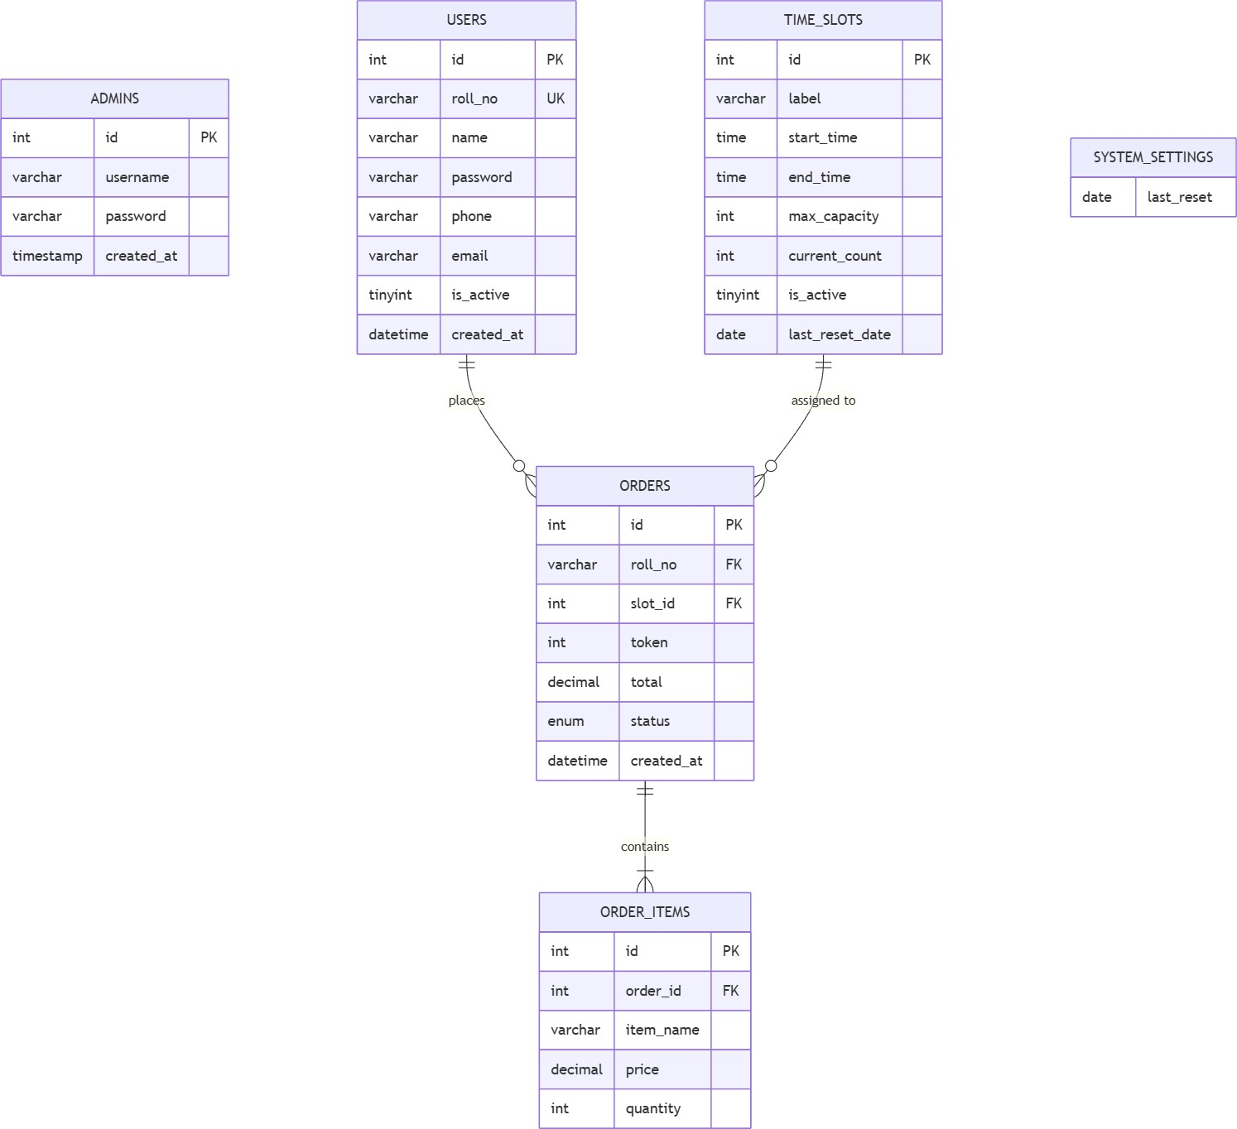

Figure 3(a) – Database Schema for User Authentication, Order Processing and Capacity Tracking

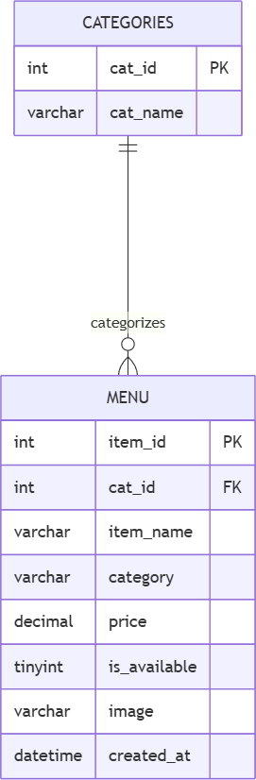
Figure 3(b) – ER mapping for menu and categories
The entity-relationship mapping in Figure 3(b) illustrates the logical connection between the Categories and Menu entities within the Foodly system. This relationship is fundamental to the system's architecture, as it allows for a structured and organized display of food items on the student dashboard.
In this schema, the Categories entity acts as a parent table, storing unique identifiers (cat_id) and names for various food groups such as "Snacks," "Meals," or "Beverages." The Menu entity serves as the child table, containing specific details for each item, including its name, price, availability status, and an image reference.
The relationship between these two entities is a One-to-Many (1:N) association, indicated by the standard ERD notation. This signifies that while one single category can encompass multiple menu items (e.g., the "Beverages" category can include tea, coffee, and juice), each specific menu item is mapped to exactly one category.

This mapping is enforced through the use of cat_id as a Foreign Key in the Menu table, ensuring referential integrity. By implementing this relational structure, the system achieves dynamic filtering, allowing users to browse the canteen menu efficiently by specific categories.

The primary entities and their relationships are as follows:

Entity | Primary Key | Key Attributes | Relationships
users | id | roll_no (UNIQUE), name, password, phone, email, is_active | One user places many orders
orders | id | roll_no (FK), slot_id (FK), token, total, status, created_at | Belongs to user and slot; contains many order_items
order_items | id | order_id (FK), item_name, price, quantity | Belongs to one order

Entity | Primary Key | Key Attributes | Relationships
menu | item_id | cat_id (FK), item_name, price, is_available, image, category | Belongs to one category
categories | cat_id | cat_name | Has many menu items
time_slots | id | label, start_time, end_time, max_capacity, current_count, is_active | Has many orders
admins | id | username, password (bcrypt) | Independent entity for admin authentication
system_settings | - | last_reset (DATE) | Used for daily slot reset automation

User Interface Design
Interface design defines how different components of the system interact with each other and with the users. In the Foodly – Digital Canteen Pre-Ordering System, the interface design focuses on creating a smooth and user-friendly interaction between the user and the system.
The system uses a web-based interface where users interact through a browser. The interface connects the front-end and back-end layers, ensuring that user inputs are properly processed and corresponding outputs are displayed effectively. Data entered by users is sent to the server using forms and AJAX requests, and the server processes this data using PHP before sending a response back to the user interface.
The interface design ensures that all system components such as login, menu browsing, cart, and order tracking are connected seamlessly. It also ensures that the system responds quickly to user actions without requiring unnecessary page reloads.

Overview
The user interface (UI) of the Foodly system is designed with simplicity, clarity, and responsiveness in mind. The goal is to ensure that users can interact with the system easily without requiring any technical knowledge.

The design follows a clean layout with properly aligned elements, readable fonts, and intuitive navigation. Bootstrap is used to ensure responsiveness so that the system works efficiently on different screen sizes, including mobile devices.
Key design principles followed in the UI include:
- Simple and clean layout
- Easy navigation between pages
- Minimal number of steps for order placement
- Clear display of information
- Responsive design for multiple devices
These principles ensure a smooth user experience and reduce the chances of confusion or errors while using the system.

Page-Wise User Interface Flow
The Foodly system consists of multiple pages, each designed to perform a specific function. The flow between these pages ensures a smooth and logical user journey.
- Login and Registration Page
This is the entry point of the system. New users can register by providing required details such as roll number, email, and password. Existing users can log in using their credentials.
The system validates user inputs and ensures secure authentication. Based on the user role (student or admin), the system redirects the user to the appropriate dashboard.
- Home / Menu Page
After logging in, students are directed to the menu page where all available food items are displayed. Items are categorized for easy browsing, and each item shows details such as name, price, and availability.
Students can select items and add them to the cart directly from this page. The interface is designed to be visually clear and easy to navigate.
- Cart Page
The cart page displays all items selected by the user. It shows item names, quantities, individual prices, and total amount.
Users can modify the cart by increasing or decreasing quantities or removing items. This page acts as a review stage before proceeding to order placement.
- Time-Slot Selection Page

Before placing an order, users must select a suitable pickup time slot. The system displays available slots along with their capacity status.
If a slot is full, it is disabled or marked accordingly. This helps users make informed decisions and prevents overbooking.
- Order Confirmation Page
After selecting items and time slots, users proceed to confirm their order. A 15-second confirmation timer is displayed to allow users to review or cancel their order.
Once confirmed, the system processes the order and generates a unique token number.
- Order Status Page
This page allows users to track the status of their order in real time. The status changes from Pending to Preparing, Ready, and Completed.
Users can check this page to know when their food is ready for pickup, reducing unnecessary waiting at the counter.
- Admin Dashboard
The admin dashboard provides a centralized interface for managing the system. It includes options to:
  - Manage menu items
  - Create and update time slots
  - View and process orders
  - Update order status
  - Monitor daily operations
The dashboard is designed to be simple and efficient so that canteen staff can use it without difficulty.

- Notification System
The system includes a notification feature that informs users when their order is ready. Notifications are displayed dynamically without requiring a page refresh.
This improves communication between the system and users and ensures timely order pickup.

Navigation Flow Summary
The overall navigation flow of the system is designed to be simple and logical: Login → Menu → Cart → Time Slot → Confirmation → Token → Order Status

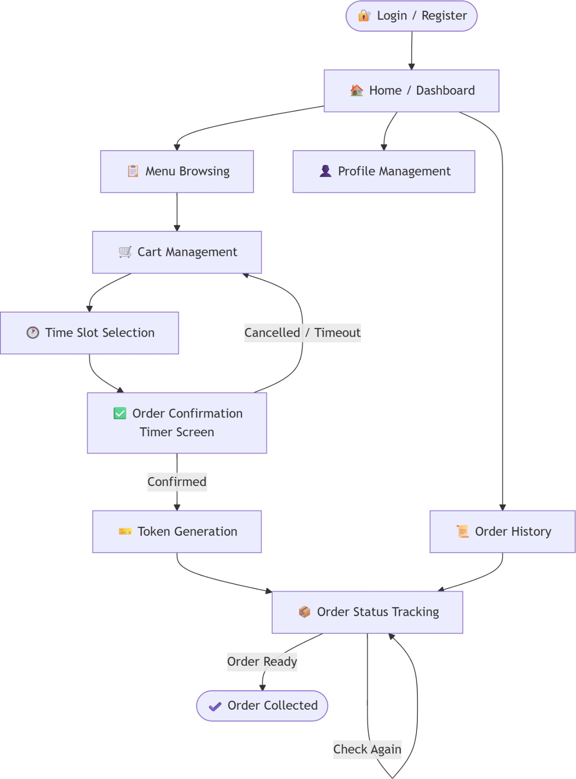
Figure 3(c) – Navigation Flow diagram of Foodly
This structured flow ensures that users can complete the ordering process quickly and efficiently.

Introduction to System Design
System design is the process of defining the overall structure, components, and workflow of a system to meet the specified requirements. It focuses on how different parts of the system interact with each other and how data flows within the system.
In the Foodly – Digital Canteen Pre-Ordering System, system design plays an important role in ensuring that all functionalities such as order placement, time-slot management, and real- time tracking are implemented in a structured and efficient way. The design ensures that the system is scalable, easy to maintain, and capable of handling multiple users simultaneously.
The system design is based on a modular and layered approach, which improves clarity and allows each part of the system to function independently while still being connected to other components.

Architectural design

The System Architecture
The Foodly system follows a three-tier architecture, which divides the system into three main layers:
- Presentation Layer
The presentation layer is responsible for handling user interaction and displaying information. It is developed using HTML, CSS, Bootstrap, JavaScript, and jQuery.
This layer includes all user-facing components such as login pages, menu display, cart interface, and admin dashboard. It ensures that users can interact with the system in a simple and intuitive way.
- Business Logic Layer
The business logic layer is the core of the system and is implemented using PHP. It processes user requests, applies validation rules, and controls system operations.
This layer handles:
  - Order processing
  - Time-slot validation
  - Token generation
  - Duplicate order prevention
  - Order status updates
It ensures that all system rules are properly followed before any action is completed.

- Data Layer
The data layer is responsible for storing and managing all system data. It uses MySQL as the database system.
This layer stores:
  - User details
  - Menu items
  - Orders
  - Time slots
  - Order items
It ensures secure storage and efficient retrieval of data whenever required.

System Workflow
The system workflow describes the sequence of operations performed from the moment a user logs in to the completion of an order.
First, the user logs into the system using valid credentials. After successful authentication, the user is redirected to the menu page where available food items are displayed.
The user selects items and adds them to the cart. After reviewing the cart, the user proceeds to select a suitable time slot for order pickup. The system checks whether the selected slot has available capacity.
Once the slot is validated, the user confirms the order. A 15-second confirmation timer is displayed to prevent accidental orders. After confirmation, the system generates a unique token number and stores the order in the database.
On the admin side, the order is received and processed. The admin updates the order status as it progresses through different stages. The user can track these updates in real time.
Finally, the user collects the order using the generated token number.

Module Interaction
The Foodly system consists of multiple modules that interact with each other to ensure smooth operation.
The user management module interacts with the database to authenticate users and manage their details. The menu module retrieves food items from the database and displays them to users.

The order management module communicates with both the time-slot module and the database. It ensures that slot capacity is checked before confirming an order and that all order details are stored correctly.
The admin module interacts with all other modules to manage menu items, update order statuses, and monitor system activity.
All these modules are interconnected through the business logic layer, which acts as a central controller for processing and validating all operations.

Data Flow in the System
Data flow in the system begins when a user enters input through the interface. This input is sent to the server, where it is processed by the business logic layer.
The processed data is then stored in the database or retrieved from it, depending on the operation. The result is sent back to the presentation layer, where it is displayed to the user.
For example, when a user places an order:
      - Input (order details) is sent to the server
      - Business logic validates slot and checks duplicates
      - Data is stored in the orders table
      - Token is generated
      - Output (order confirmation) is displayed
This flow ensures efficient communication between all system components.
The Foodly – Digital Canteen Pre-Ordering System follows a structured flow of data between the user interface, business logic, and database. Each action performed by the user or admin results in a series of data movements within the system.
The data flow begins when a user interacts with the system through the web interface. The input provided by the user is sent to the server, where it is processed using PHP. After processing, the system either stores the data in the database or retrieves relevant information. The output is then displayed back to the user in a readable format.
This continuous flow ensures that the system remains dynamic, responsive, and efficient.

Process Flow: User Registration and Login
The first interaction with the system occurs during user registration and login. When a new user registers, the system collects details such as roll number, email, and password. These inputs are validated to ensure correctness and uniqueness. Once validated, the data is stored in the users table in the database.

During login, the user provides credentials, which are verified against the stored data. If the credentials match, the system grants access and redirects the user to the main dashboard. If not, an error message is displayed.
This process ensures secure and controlled access to the system.

Process Flow: Menu Browsing and Cart Management
After successful login, the user accesses the menu page. The system retrieves menu data from the database and displays it in categorized form.
When the user selects items, the data is temporarily stored in the cart. The system continuously updates the total amount based on selected items and quantities.
The cart acts as an intermediate stage where users can review and modify their order before final submission.

Process Flow: Time-Slot Selection and Validation
Once the user proceeds from the cart, the system displays available time slots. Each slot includes capacity information.
When a user selects a slot, the system performs a validation check. It counts the number of existing orders for that slot on the current date and compares it with the maximum capacity.
If the slot is available, the user can proceed. If the slot is full, the system prevents selection and asks the user to choose another slot.
This process ensures proper distribution of orders and avoids overcrowding.

Process Flow: Order Placement and Token Generation
After selecting a time slot, the user confirms the order. The system then performs multiple validations:
      - Checks for duplicate orders for the same slot
      - Validates slot capacity
      - Calculates total order amount
Once all validations are successful, the system stores the order in the database. A unique token number is generated based on the number of orders placed on that day.
The order details, including token number and pickup time, are displayed to the user as confirmation.

Process Flow: Order Status Update and Tracking
After an order is placed, it enters the processing phase. The admin accesses the system and views incoming orders through the dashboard.
The admin updates the order status step-by-step:
      - Pending
      - Preparing
      - Ready
      - Completed
Each status update is reflected in real time on the user’s interface. This allows users to track their order without physically visiting the counter.

Process Flow: Handling Unpicked Orders
If a user does not collect the order within the selected time slot, the system marks the order as expired or unpicked.
This information is stored in the database and linked to the user profile. The system keeps track of such instances to identify repeated behavior.
This process helps in reducing misuse and improving system accountability.

Admin Workflow
The admin plays a crucial role in managing system operations.
The admin logs into the system and accesses the dashboard. From there, the admin can:
      - Manage menu items
      - Create and modify time slots
      - Monitor orders
      - Update order status
      - View basic analytics
All admin actions are processed through the system and reflected in the database. This ensures centralized control and efficient management.

Error Handling and Validation Flow
The system includes proper validation mechanisms to handle errors and invalid inputs.

Examples include:
      - Preventing duplicate registrations
      - Blocking full time slots
      - Restricting duplicate orders
      - Validating login credentials
Whenever an error occurs, the system displays appropriate messages to guide the user. This ensures a smooth and user-friendly experience.

Introduction to Data Flow Diagrams (DFD)
A Data Flow Diagram (DFD) is a graphical representation used to show how data moves within a system. It illustrates the flow of information between different processes, data stores, and external entities. DFDs help in understanding the system structure in a simple and visual manner.
In the Foodly – Digital Canteen Pre-Ordering System, DFDs are used to represent how data flows between students, admin, and the system. They show how inputs such as login details, order requests, and slot selections are processed and how outputs such as token numbers, order status, and notifications are generated.
DFDs are divided into different levels based on the level of detail. The main levels used in this project are:
- Level 0 (Context Diagram)
- Level 1 (Detailed System Processes)
These diagrams help in clearly explaining the working of the system and are useful for both development and documentation purposes.

DFD Level 0
The Level 0 DFD, also known as the context diagram, provides a high-level view of the entire system. It represents the system as a single process and shows its interaction with external entities.
In the Foodly system, the main external entities are:
- Student
- Admin
The central process is the Foodly System, which handles all operations related to food ordering and management.

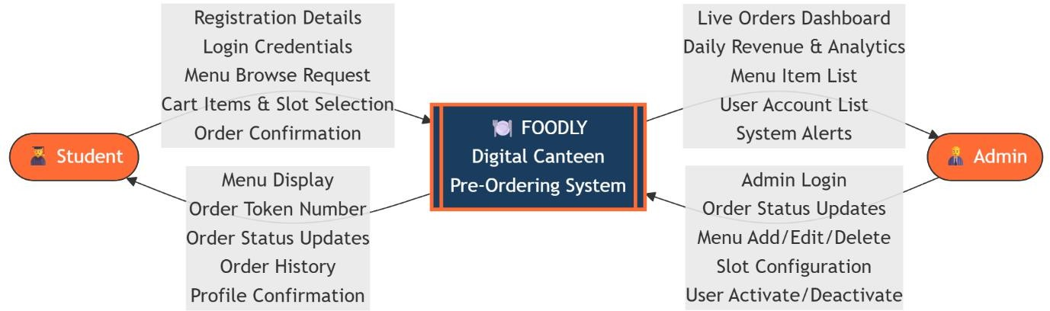

Image 3(d) – DFD Level 0
In this diagram, the student interacts with the system by sending inputs such as login credentials, food order details, and selected time slots. The system processes these inputs and provides outputs such as menu display, token number, and real-time order status updates.
On the other hand, the admin interacts with the system by providing inputs such as menu updates, time slot management, and order status updates. The system responds by displaying order details, reports, and analytics to the admin.
The DFD Level 0 diagram clearly shows that the system acts as a central unit that connects both students and admin, ensuring smooth data flow between them.

DFD Level 1
The DFD Level 1 provides a more detailed view of the system by breaking down the main process (Foodly System) into smaller sub-processes. It shows how different internal processes interact with each other and with data stores.
In the Foodly – Digital Canteen Pre-Ordering System, the system is divided into multiple processes such as user management, menu handling, order processing, and admin operations. These processes work together to perform all system functionalities efficiently.

The Level 1 DFD of the Foodly system consists of the following main processes:
- User Authentication Process
This process handles user registration and login.
  - The student provides registration or login details
  - The system validates the data
  - User information is stored or retrieved from the Users database
  - If valid, access is granted; otherwise, an error is shown This ensures secure access to the system.

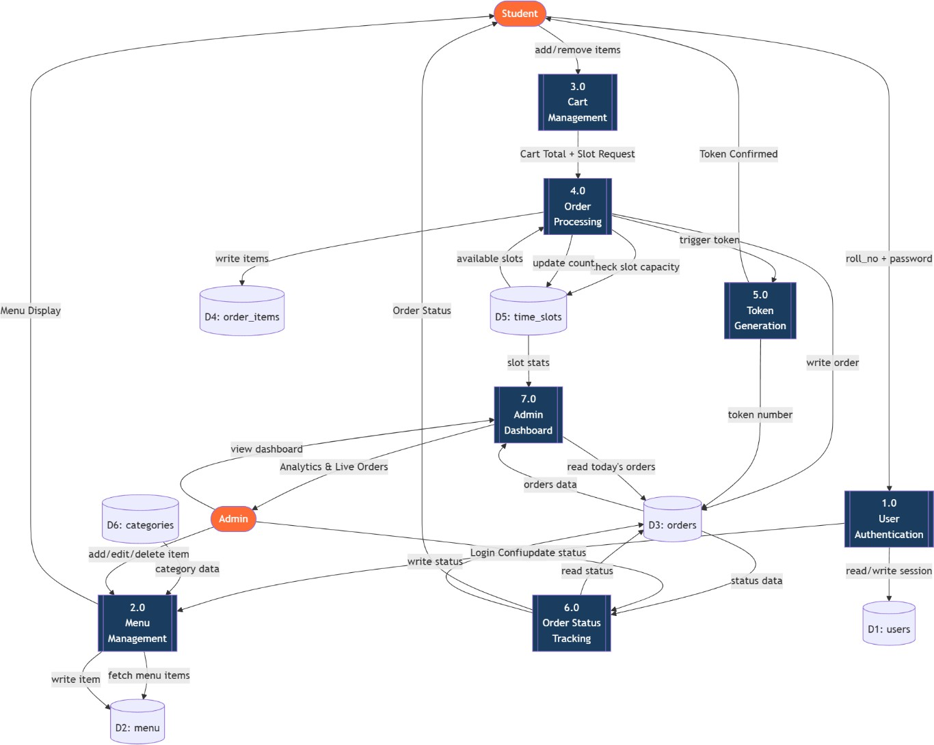
Image 3(e) – DFD Level 1
- Menu Management Process
This process handles the display and management of food items.
  - The system retrieves menu data from the Menu and Categories tables
  - The student views available items
  - The admin can add, update, or delete menu items
This process ensures that users always see updated and accurate menu information.
- Order Processing Process
This is the core process of the system.
  - The user selects items and places an order
  - The system processes order details
  - Data is stored in Orders and Order_Items tables
  - Token number is generated
This process ensures proper handling of all orders.

- Time-Slot Management Process
This process handles slot selection and validation.
  - The system retrieves available time slots
  - The user selects a slot
  - The system checks capacity constraints
  - If valid, the process continues
This ensures structured order pickup and prevents overcrowding.
- Order Status and Notification Process This process manages order tracking.
  - Admin updates order status
  - System updates the Orders table
  - Updated status is displayed to the user
  - Notification is sent when the order is ready This improves transparency and communication.
- Admin Control Process
This process includes all admin-related activities.
  - Admin manages menu items
  - Admin manages time slots
  - Admin monitors orders and analytics This process ensures centralized system control.

Data Stores in DFD Level 1
The system interacts with multiple data stores:
  - Users Database
  - Menu Database
  - Categories Database
  - Orders Database
  - Order Items Database
  - Time Slots Database

These data stores are used by different processes to store and retrieve information. The Level 1 DFD shows how data flows between different processes and data stores.
For example:
  - User authentication process interacts with the Users database
  - Order processing interacts with Orders and Order_Items tables
  - Time-slot management interacts with Time_Slots table
The user authentication process interacts directly with the Users data store. When a student attempts to log in, the process retrieves the corresponding record from the Users table using the roll number as the identifier and validates the submitted credentials against the stored password. If authentication is successful, a session is created and the student is granted access to the system. For new users, the registration sub-process writes a new record to the Users table, enforcing unique constraints on roll number and email before committing the entry. The Admins data store serves a parallel function for administrator login, keeping admin credential validation entirely separate from student authentication.
The menu browsing process retrieves data from both the Categories and Menu data stores. Category records are fetched first to populate the navigation structure, after which menu item records filtered by category are retrieved and presented to the student. The availability flag stored against each menu item is read during this process to ensure that only currently available items are displayed. When an administrator adds, edits, or toggles the availability of a menu item, the menu management process writes the updated records back to the Menu data store.
The order processing flow involves the most data store interactions in the system. When a student confirms an order, the process simultaneously writes to the Orders table and the Order_Items table. The Orders table receives a new record containing the student's roll number, the selected slot ID, the generated token number, the order total, and the initial status. The Order_Items table receives one record per line item in the cart, capturing the item name, price, and quantity. These two writes are closely coordinated to maintain relational consistency between an order and its constituent items.
The time slot management process interacts with the Time_Slots data store at multiple points. During order placement, the process reads the current_count and max_capacity values for the selected slot to verify that capacity has not been reached before allowing the order to proceed. Once the order is confirmed, the process increments the current_count value in the Time_Slots table. The automated daily reset process, triggered either by a MySQL Event or session-based detection in PHP, resets the current_count of all slots back to zero and updates the last_reset_date field, preparing the slots for the next day's orders. The System_Settings data store supports this reset mechanism by storing the last_reset date, which the application checks at session start to determine whether a reset is due.
Each process within the Level 1 DFD receives input from either an external entity or another process, performs a specific and well-defined operation, and produces output that is either stored in a data store, passed to a subsequent process, or returned as a response to the user

interface. This layered flow of data provides a clear and traceable understanding of the system's internal workings and serves as a reliable reference during implementation, testing, and future maintenance of the Foodly system.

Introduction to User Interface Design
User Interface (UI) Design refers to the process of designing the visual layout and interactive elements of a system through which users interact with it. It focuses on making the system easy to use, visually appealing, and efficient.
In the Foodly – Digital Canteen Pre-Ordering System, the user interface plays a crucial role in ensuring that students and admin users can navigate the system smoothly without confusion. Since the system is designed for daily use within a college environment, it is important that the interface is simple, fast, and responsive.
The UI is developed using HTML, CSS, Bootstrap, JavaScript, and jQuery. These technologies help in creating a responsive and interactive design that works across multiple devices such as mobile phones, tablets, and desktops.
The main objective of the UI design in this project is to provide a seamless user experience where users can complete tasks like ordering food, selecting time slots, and tracking orders with minimal effort.

Design Principles Followed
While designing the interface of the Foodly system, several important design principles have been followed to ensure usability and effectiveness.
- Simplicity
The interface is kept simple and uncluttered so that users can easily understand and use the system. Only necessary elements are displayed on each page, avoiding unnecessary complexity.
- Consistency
The design maintains consistency in terms of colors, fonts, buttons, and layout across all pages. This helps users become familiar with the system quickly and reduces confusion.
- Clarity
All information displayed on the screen is clear and easy to read. Labels, buttons, and instructions are properly defined so that users know what action to take at each step.
- Responsiveness

The system is designed using Bootstrap, which ensures that the interface adjusts automatically to different screen sizes. This allows users to access the system on mobile devices as well as desktops without any issues.
- Efficiency
The number of steps required to complete an action is minimized. For example, placing an order involves a simple flow: selecting items, choosing a time slot, and confirming the order.
- Feedback and Interaction
The system provides immediate feedback to user actions. For example:
  - Confirmation messages after placing orders
  - Error messages for invalid inputs
  - Notifications when orders are ready
This improves user interaction and overall experience.

Overall UI Design Approach
The UI design of the Foodly system follows a structured and user-centered approach. The layout is designed in such a way that users can easily navigate between different sections without confusion.
The system uses a combination of navigation bars, cards, buttons, and forms to organize content effectively. Menu items are displayed in a visually appealing format, making it easy for users to browse and select items.
Forms are used for user input, such as registration, login, and order placement. These forms include proper validation to ensure that users enter correct information.
The color scheme is kept simple and professional to maintain readability and visual comfort. Buttons and interactive elements are clearly highlighted to guide user actions.
Overall, the UI design ensures that the system is not only functional but also provides a smooth and pleasant experience to users.

Page-Wise User Interface Description
The Foodly – Digital Canteen Pre-Ordering System consists of multiple user interface screens, each designed to perform a specific function within the overall ordering workflow. The design philosophy across all pages prioritizes clarity, minimal cognitive load, and smooth navigation. Every screen is built to guide the user naturally toward their next action, reducing the possibility of confusion or incorrect input. The following section describes each page in detail, including its purpose, constituent elements, and design considerations.

Login Page
The login page is the first interface that users interact with upon accessing the Foodly system. It serves as the gateway to all student-facing functionality and is designed to be straightforward and distraction-free. The page presents a centered form layout with input fields for the student's roll number and password. A login button submits the credentials for server-side verification, and a registration link is provided below the form for first-time users who do not yet have an account.
Client-side validation ensures that neither field is left empty before submission. Server-side validation then checks the submitted credentials against the Users table in the database. If the credentials are incorrect, a descriptive error message is displayed beneath the form without refreshing the entire page. If the account associated with the roll number has been deactivated by an administrator, an appropriate message informs the user that their account is inactive. Successful authentication creates a PHP session for the user and redirects them to the home or menu page.

Registration Page
The registration page allows new students to create an account within the Foodly system. It collects all information necessary to uniquely identify a student and enable future authentication. The form includes input fields for roll number, full name, email address, phone number, and password, along with a password confirmation field to prevent entry errors.
All fields are subject to both client-side and server-side validation. The roll number and email fields are checked against existing records in the Users table to enforce uniqueness, and an error is displayed if either value is already registered. Password fields are matched to confirm consistency before submission. Upon successful registration, the new record is written to the Users table with the is_active field defaulting to active, and the user is redirected to the login page with a success confirmation message.

Menu Page
The menu page is the primary browsing interface of the system and the page that students will interact with most frequently. It presents all available food items in an organized, category- based layout. Category labels are displayed as navigation tabs or filter buttons at the top of the page, allowing students to quickly jump to a specific section such as snacks, beverages, or meals.
Each food item is presented as a card containing the item name, a thumbnail image, the price, and an "Add to Cart" button. Items that have been marked as unavailable by the administrator are either hidden entirely or displayed in a greyed-out state with the button disabled, depending on the administrative configuration. The card-based layout ensures visual consistency and allows students to scan multiple items at a glance. The menu data is fetched dynamically from the Menu and Categories tables, ensuring that any changes made by the administrator are reflected immediately on the student-facing interface.

Cart Page

The cart page functions as the order review stage, presenting a consolidated view of all items the student has selected before they proceed to checkout. Each item in the cart is listed with its name, unit price, selected quantity, and calculated subtotal. Quantity controls — increment and decrement buttons — allow students to adjust the amount of each item directly from this page. A remove option is also available per item for students who wish to drop a particular selection entirely.
The total order amount is recalculated and displayed dynamically at the bottom of the page whenever any quantity is changed. If the cart is emptied entirely, the page displays an appropriate empty-state message with a prompt to return to the menu. The cart operates using session-based storage, meaning its contents are preserved as the student navigates between pages but are cleared once the order is confirmed or the session ends.

Time Slot Selection Page
This page presents students with the available pickup time slots from which they must choose before placing their order. Each slot is displayed with its label, start and end times, and a live capacity indicator showing how many bookings have already been made against the slot's maximum capacity — for example, "18 / 30 booked." This transparency helps students make an informed choice and distributes order volume across slots more evenly.
Slots that have reached their maximum capacity are displayed in a visually distinct greyed-out or disabled state, preventing selection. Slots that have been deactivated by the administrator are not shown at all. The slot data is fetched in real time from the Time_Slots table, ensuring that the capacity figures reflect the most current state. Once a slot is selected, the student proceeds to the order confirmation page.

Order Confirmation Page
The order confirmation page serves as the final review screen before an order is committed to the database. It presents a complete summary of the pending order, including all selected items with their quantities and prices, the chosen time slot, and the total payable amount. This page gives the student one last opportunity to review their order before it is placed.
A prominent 15-second countdown timer is displayed on this page. The timer begins automatically upon page load and counts down visually to create a sense of urgency while still providing adequate time for review. If the timer reaches zero without the student confirming, the order is not placed and the student is returned to the cart page. The student may also choose to cancel manually at any point during the countdown. If the student confirms within the timer window, the order placement process is triggered, the database is updated, and the student is redirected to the token display page.

Token Display Page
Once an order is successfully placed, the system generates a unique token number for that order and displays it on the token page. The token number is an auto-incremented daily count, resetting to 1 at the start of each new day, so students receive simple, low-numbered tokens that are easy to communicate at the counter.

This page displays the token number prominently, accompanied by the full order summary and the selected pickup time slot. Students are advised to note or screenshot their token number as it serves as their primary reference when collecting their order from the canteen. A link to the order status tracking page is also provided so students can monitor the progress of their order without navigating manually.

Order Status Page
The order status page allows students to monitor the real-time progress of their current order. The page displays the token number, the list of ordered items, the selected time slot, and the current status of the order. The status progresses through defined stages — Pending, Preparing, Ready, and Completed — as updated by the canteen administrator through the admin dashboard.
The status is displayed using a visual progress indicator or labelled status badge, making it immediately clear to the student at what stage their order is. Students can refresh the page manually or the system can be configured to poll for updates at a regular interval. Once the status reaches Ready, students are prompted to proceed to the canteen counter for collection. The order history page retains records of past orders so students can reference previous transactions even after the current order is completed.

Admin Dashboard
The admin dashboard is the central control interface for canteen staff and system administrators. It is accessible only after successful admin authentication and provides a comprehensive overview of system activity. The dashboard is organized into clearly labelled sections to allow administrators to quickly locate and perform the function they need.
The live orders section displays all currently active orders in a tabular format, showing token number, student roll number, selected time slot, ordered items, total amount, and current status. Administrators can update the status of any order directly from this view using dropdown controls or action buttons, without navigating to a separate page. The menu management section provides options to add new food items, edit existing item details, update prices, and toggle item availability. The time slot management section allows administrators to create new slots, modify the timing and capacity of existing ones, and activate or deactivate slots as needed. A user management panel enables administrators to view registered students and activate or deactivate their accounts. The analytics section presents a daily summary of total orders placed and revenue generated, providing a quick operational snapshot at the end of each service period.

Notification Interface
The system incorporates an inline notification interface to communicate important updates to users without requiring a full page reload. Notifications are displayed as dynamic popup banners or alert boxes triggered by system events or administrative actions. Examples include confirmation messages after successful registration or order placement, error alerts for invalid

inputs or failed operations, and status update prompts informing students that their order is ready for collection.
These notifications are implemented using PHP session flash messages or lightweight JavaScript-based alert mechanisms, ensuring they appear contextually and disappear after acknowledgement. The notification interface enhances the overall user experience by providing immediate, clear feedback at every key interaction point within the system.

Detailed Level Design
Detailed design, also referred to as component-level design, is the phase in which the high- level architectural decisions made during system design are translated into precise, implementable specifications for each module and function within the system. While architectural design establishes the overall structure and relationships between major components, detailed design descends into the internal logic of each component — defining how data is processed, how decisions are made, how errors are handled, and how different parts of the system communicate with one another.
In the Foodly – Digital Canteen Pre-Ordering System, the detailed design covers the complete functional specification of both the student-facing and admin-facing modules. Each function is described in terms of its inputs, the processing steps it performs, and the outputs it produces. The implementation is built on PHP for server-side logic and MySQL for data persistence, operating within the XAMPP local server environment. The detailed design documented here serves as the direct reference for coding decisions and ensures that the implemented system accurately reflects the functional requirements defined earlier.

Overview of Functional Modules
The Foodly system is divided into two primary modules — the Student Module and the Admin Module — each of which encompasses a set of sub-functions that together deliver the complete system functionality. The Student Module handles all operations that a registered student performs, from account creation through to order placement and tracking. The Admin Module provides canteen staff with the tools necessary to manage menus, time slots, orders, and users. Both modules interact with the same underlying MySQL database but access different tables and perform different operations based on their respective roles and permissions.

Student Module – Functional Design
The student module is designed to provide a guided, intuitive experience that leads the student through the ordering process with minimal friction. Each function within the module is responsible for a discrete step in the workflow, and together they form a coherent end-to-end journey from account registration to order collection.

User Registration Function
The user registration function handles the creation of new student accounts. When a student submits the registration form, the system first performs client-side validation to check that all required fields are populated and that the password and confirmation password fields match. Server-side processing then sanitizes all inputs to prevent SQL injection and cross-site scripting vulnerabilities. The roll number and email are each checked against existing records in the Users table using SELECT queries; if either value already exists, the registration is rejected and an appropriate error message is returned. If all validations pass, a new record is inserted into the Users table with the is_active field set to 1 and the created_at timestamp set to the current datetime. The student is then redirected to the login page with a success notification.

User Login Function
The login function authenticates returning students before granting access to the system. The submitted roll number is used to retrieve the corresponding record from the Users table. The submitted password is then compared against the stored hashed password using PHP's password verification function. If the credentials match and the is_active field confirms the account is enabled, a PHP session is initialized with the student's identifier and role, and the student is redirected to the menu page. If the credentials are incorrect, a generic error message is displayed. If the account is inactive, a specific message informs the student that their account has been disabled and directs them to contact administration.

Menu Display Function
The menu display function retrieves and renders the current food catalogue for the student. On page load, the system queries the Categories table to obtain all active category records and renders them as navigation filters. A subsequent query retrieves all menu items from the Menu table where the is_available flag is set to 1, ordered by category. The results are rendered as item cards within the appropriate category sections. If an administrator updates the menu while a student is browsing, the changes are reflected upon the next page load or refresh, as the data is fetched dynamically from the database on each request.

Cart Management Function
The cart management function maintains the student's item selections throughout the browsing session. When a student clicks "Add to Cart" on a menu item, the item's ID, name, price, and an initial quantity of one are stored in the PHP session array designated for the cart. If the same item is added again, the quantity for that item is incremented rather than creating a duplicate entry. The cart page reads from this session array to render the item list, calculates the subtotal for each item as price multiplied by quantity, and sums all subtotals to display the order total. Quantity adjustment controls modify the session values in real time, and item removal deletes the corresponding entry from the session array. The cart is cleared from the session once the order is successfully placed.

Time Slot Selection Function

The time slot selection function presents the student with available pickup windows and enforces capacity constraints. The system queries the Time_Slots table for all records where is_active is set to 1 and orders the results by start_time. For each slot, the current_count and max_capacity values are compared; slots where current_count has reached max_capacity are rendered as disabled. The student's selection is temporarily stored in the session and carried forward to the confirmation page. No database changes are made at this stage, ensuring that slot counts are only incremented upon confirmed order placement.

Order Placement Function
The order placement function is the most operationally significant function in the student module. It is triggered when the student confirms their order within the 15-second timer window. The function first re-validates slot availability server-side to guard against race conditions where a slot may have filled between the student's selection and confirmation. It then checks whether the student already has an active order for the same time slot on the current date, preventing duplicate submissions. If both checks pass, the function calculates the final order total from the session cart data, inserts a new record into the Orders table, and iterates through the cart items to insert corresponding records into the Order_Items table. The slot's current_count in the Time_Slots table is incremented by one. The session cart is cleared and the generated order ID is stored in the session for use by the token display page.

Token Generation Function
The token generation function assigns a sequential daily token number to each confirmed order. After the order record is inserted, the function queries the Orders table for all orders placed on the current date and counts the total number of records. The token number assigned to the new order is this count value, effectively making it the next number in the daily sequence. Since token numbers reset at the start of each day due to the daily order count resetting, students consistently receive simple, low-value token numbers regardless of how many orders were placed on previous days. The token number is stored in the Orders table against the new order record and displayed on the token page.

Order Tracking Function
The order tracking function allows students to monitor the progress of their most recently placed order. The function queries the Orders table using the order ID stored in the session and retrieves the current status value along with associated order details. The status — which takes one of the enum values Pending, Preparing, Ready, or Completed — is displayed visually on the tracking page. Since status updates are driven by administrator actions on the admin dashboard, the tracking page reflects the latest value from the database upon each load or refresh. Students are advised to check this page periodically until the status indicates that their order is ready for collection.

Admin Module – Functional Design

The admin module equips canteen staff with a comprehensive set of tools for managing every operational aspect of the system. Each function is designed for efficiency, enabling administrators to perform critical actions with minimal steps during busy service periods.

Admin Login Function
The admin login function operates independently of the student authentication system. Submitted credentials are validated against the Admins table using the same hashed password verification approach applied to student login. Upon successful authentication, an admin- specific PHP session is created, granting access to the admin dashboard and all its sub-sections. Unauthorized attempts to access admin pages directly without an active admin session are intercepted by session checks at the top of each admin PHP file, redirecting the request to the admin login page.

Menu Management Function
The menu management function provides administrators with complete control over the food catalogue. Adding a new item requires the administrator to submit a form with the item name, associated category, price, availability status, and an optional image. The image is uploaded to the server and its filename stored in the Menu table alongside the other item details. Editing an existing item retrieves the current record and pre-populates the form fields for modification before updating the record on submission. Deleting an item removes its record from the Menu table permanently. Toggling availability updates only the is_available field, allowing items to be temporarily hidden from students without deletion, which is useful for items that are seasonally or temporarily unavailable.

Time Slot Management Function
The time slot management function allows administrators to define and control the pickup windows available to students. Administrators can create new slots by specifying a label, start time, end time, and maximum capacity. Existing slots can be edited to adjust any of these parameters. The is_active toggle enables administrators to deactivate a slot without deleting it, which is useful for suspending a particular window on specific days without restructuring the entire slot configuration. The current_count for each slot is visible to the administrator on this page, providing a real-time picture of how orders are distributed across the available windows.

Order Management Function
The order management function is the operational core of the admin module. The live orders dashboard displays all orders placed for the current day, organized by time slot and token number. Each order entry shows the student's roll number, token number, ordered items, total amount, and current status. Administrators update the status of each order by selecting the appropriate value from a dropdown control and confirming the change, which triggers an UPDATE query on the Orders table. This real-time status management is what drives the order tracking experience on the student side, making prompt and accurate updates critical to the system's usefulness.

Analytics Function

The analytics function provides administrators with a daily operational summary to support basic decision-making. The function aggregates data from the Orders table to calculate the total number of orders placed on the current day and the sum of all order totals, yielding the day's revenue figure. These metrics are displayed on the admin dashboard in a summary panel. While the current implementation is limited to daily aggregates, the underlying data structure supports more granular queries — such as category-wise sales or peak-hour analysis — which are identified as candidates for inclusion in future development phases of the Foodly system.

Backend Processing and Logic Implementation
The backend of the Foodly – Digital Canteen Pre-Ordering System is developed using PHP, which handles all the core operations of the system. It acts as a bridge between the user interface and the database.
Whenever a user performs an action such as logging in, placing an order, or selecting a time slot, the request is sent to the server. The PHP scripts process this request, apply necessary validations, interact with the MySQL database, and return the appropriate response.
This ensures that all system functionalities are executed accurately and efficiently.

Database Interaction and Operations
The system uses MySQL to store and manage all data. Each operation performed in the system involves interaction with the database.
- User Data Handling
- User registration data is inserted into the Users table
- Login requests fetch and verify user credentials
- Missed pickup count is updated when orders are not collected
- Menu Data Handling
- Menu items are stored in the Menu table
- Categories are maintained in the Categories table
- Only available items are fetched and displayed to users
- Order Data Handling
- Order details are stored in the Orders table
- Each order is linked to a user and time slot
- Order items are stored in the Order_Items table
- Time Slot Data Handling

- Time slots are stored in the Time_Slots table
- Each slot has a defined capacity
- Slot availability is calculated dynamically

Core Business Logic Implementation
The system includes several important business rules that ensure proper functioning and prevent misuse.
- Slot Capacity Validation
Before confirming an order, the system checks whether the selected time slot has available capacity.
  - The system counts existing orders for the selected slot
  - Compares it with maximum capacity
  - Allows order only if capacity is not exceeded
This prevents overcrowding and ensures smooth order handling.
- Duplicate Order Prevention
The system restricts users from placing multiple orders for the same time slot on the same day.
  - It checks for existing records using user ID, slot ID, and date
  - If a duplicate is found, the order is rejected This ensures fairness and avoids misuse.
- Token Generation Logic
Each order is assigned a unique token number.
  - The system counts total orders placed on the current day
  - Generates the next sequential token number
This helps in maintaining order sequence during pickup.
- Order Status Management
The system follows a defined order lifecycle:
  - Pending
  - Preparing
  - Ready
  - Completed

  - Expired
Admin updates the status, and changes are reflected to the user in real time.
- Handling Unpicked Orders
If a user fails to collect the order:
  - The system marks the order as expired
  - The missed pickup count for the user is increased
This helps in tracking user behavior and reducing food wastage.

Validation and Error Handling
The system includes multiple validation checks to ensure data accuracy and system reliability.
  - Input validation for forms (registration, login, order)
  - Prevention of empty or invalid data submission
  - Proper error messages for invalid actions
  - Handling of database errors
These validations improve system stability and user experience.

Session Management
Session handling is used to maintain user login state.
  - After login, user session is created
  - Session data is used to identify the user across pages
  - Session is destroyed during logout
This ensures secure and continuous interaction with the system.

Security Considerations
Basic security measures are implemented in the system:
  - Passwords are stored securely (hashed format)
  - Input validation prevents invalid data entry
  - Session-based authentication ensures authorized access These measures help in protecting user data and system integrity.

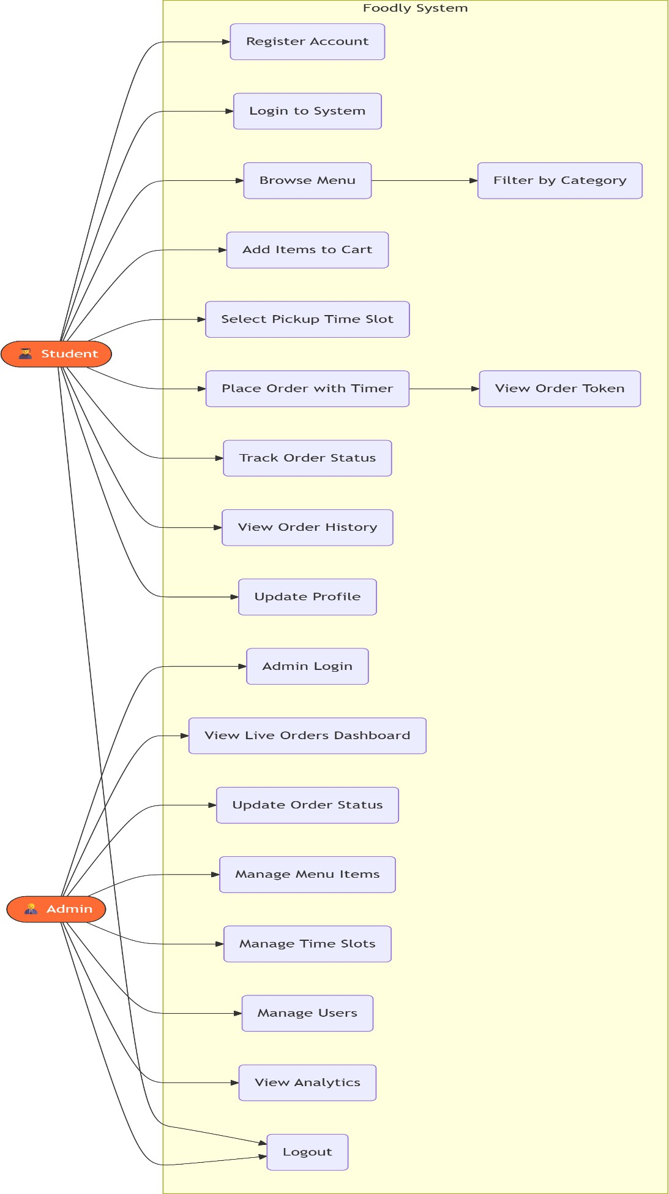

Image 3(f) – Functional module of Foodly

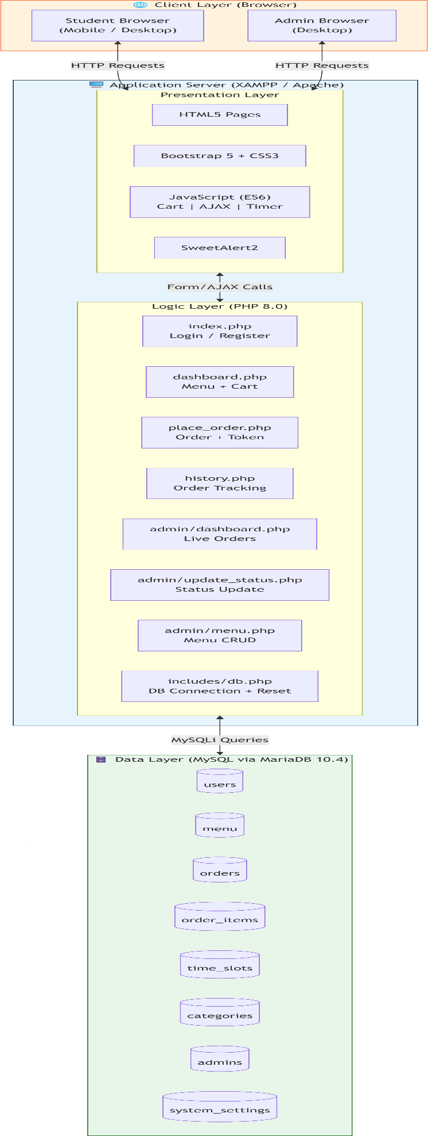

Image 3(g) – Backend Logic

CODING

Introduction
The coding phase is the implementation stage of the Foodly – Digital Canteen Pre-Ordering System, where the system design is converted into a working application using programming languages and technologies.
In this project, coding is done using a combination of front-end and back-end technologies. The front-end is developed using HTML, CSS, Bootstrap, JavaScript, and jQuery, while the back-end is implemented using PHP. The database operations are handled using MySQL.
The main objective of coding in this project is to develop a functional, user-friendly, and efficient system that fulfills all the requirements such as online ordering, time-slot management, token generation, and real-time order tracking.

Programming Approach Used
The Foodly system follows a Top-Down Programming Approach.
In this approach, the system is first divided into major modules such as Student Module and Admin Module. Each module is further divided into smaller functions like login, menu display, cart management, order processing, etc.
Each function is developed and tested individually before integrating them into the complete system. This approach helps in better understanding, easier debugging, and efficient development.
The top-down approach also ensures that the overall system structure is clear and organized from the beginning.

Code Structure Overview
The project is organized into multiple files and folders to maintain clarity and modularity. A typical structure of the project includes:

Frontend Files
  - HTML pages for UI layout
  - CSS files for styling
  - Bootstrap for responsive design
  - JavaScript and jQuery for interactivity

Backend Files
  - PHP files for handling logic
  - Separate files for login, registration, order processing, etc.

Database
  - MySQL database with multiple related tables
  - Tables such as users, menu, orders, time_slots, and order_items This structured organization makes the code easy to manage, update, and debug.

Front-End Implementation
The front-end of the system is responsible for user interaction.
- HTML is used to create the basic structure of web pages
- CSS is used to style the interface and improve appearance
- Bootstrap is used to make the design responsive
- JavaScript and jQuery are used to add dynamic behavior such as:
  - Form validation
  - Dynamic updates
  - AJAX-based notifications
The front-end ensures that users can interact with the system smoothly and efficiently.

Back-End Implementation
The back-end is implemented using PHP, which handles all server-side operations.
- PHP processes user requests
- It performs validations and business logic
- It interacts with the MySQL database
- It sends responses back to the user interface
All core functionalities such as login authentication, order processing, slot validation, and token generation are handled in the backend.

Source Code Snippets

DATABASE DESIGN
The database schema consists of seven core tables that manage users, menu items, orders, and time slots. The following SQL code demonstrates the database structure:

CREATE TABLE `users` (
`id` int(11) NOT NULL AUTO_INCREMENT,
`roll_no` varchar(20) NOT NULL UNIQUE,
`name` varchar(100) DEFAULT '',
`password` varchar(255) NOT NULL,
`phone` varchar(15) DEFAULT NULL,
`email` varchar(100) DEFAULT NULL,
`status` enum('active','suspended') DEFAULT 'active',
`created_at` datetime DEFAULT current_timestamp(), PRIMARY KEY (`id`)
) ENGINE=InnoDB DEFAULT CHARSET=utf8mb4;

The users table stores student information with a unique roll number as the identifier. The status field enables administrators to suspend accounts after repeated missed orders, implementing an accountability mechanism.

CREATE TABLE `menu` (
`item_id` int(11) NOT NULL AUTO_INCREMENT,
`cat_id` int(11) DEFAULT NULL,
`item_name` varchar(100) NOT NULL,
`category` varchar(50) DEFAULT 'Snacks',
`price` decimal(10,2) NOT NULL,
`is_available` tinyint(1) DEFAULT 1,
`image` varchar(255) DEFAULT 'default.jpg',

`created_at` datetime DEFAULT current_timestamp(), PRIMARY KEY (`item_id`),
FOREIGN KEY (`cat_id`) REFERENCES `categories`(`cat_id`)
) ENGINE=InnoDB DEFAULT CHARSET=utf8mb4;

The menu table manages food items with categorization support. The is_available flag allows administrators to temporarily disable items without deletion, maintaining historical data integrity.

CREATE TABLE `orders` (
`id` int(11) NOT NULL AUTO_INCREMENT,
`roll_no` varchar(20) NOT NULL,
`slot_id` int(11) NOT NULL,
`total` decimal(10,2) NOT NULL,
`token` int(11) NOT NULL,
`status` enum('Pending','Preparing','Ready','Completed','Missed') DEFAULT 'Pending',
`created_at` datetime DEFAULT current_timestamp(), PRIMARY KEY (`id`),
FOREIGN KEY (`slot_id`) REFERENCES `time_slots`(`id`)
) ENGINE=InnoDB DEFAULT CHARSET=utf8mb4;

The orders table implements a token-based queue system. Tokens reset daily, ensuring students can easily track their position in the preparation queue. The status field enables real-time order tracking through five distinct states.

CREATE TABLE `time_slots` (
`id` int(11) NOT NULL AUTO_INCREMENT,
`label` varchar(50) NOT NULL,
`start_time` time NOT NULL,

`end_time` time NOT NULL,
`max_capacity` int(11) DEFAULT 30,
`current_count` int(11) DEFAULT 0,
`is_active` tinyint(1) DEFAULT 1,
`last_reset_date` date DEFAULT NULL, PRIMARY KEY (`id`)
) ENGINE=InnoDB DEFAULT CHARSET=utf8mb4;

The time_slots table manages delivery scheduling with capacity control. The system automatically resets slot counts daily to prevent overflow.

DATABASE CONNECTION MODULE
The database connection is established through a centralized configuration file that implements automatic slot reset logic:

<?php
$servername = "localhost";
$username = "root";
$password = "";
$dbname = "foodly_db";

$conn = mysqli_connect($servername, $username, $password, $dbname);

if (!$conn) {
die("Connection failed: " . mysqli_connect_error());
}

// Automation logic for daily slot reset
$today = date('Y-m-d');

mysqli_query($conn, "CREATE TABLE IF NOT EXISTS system_settings (last_reset DATE)");

$res = mysqli_query($conn, "SELECT last_reset FROM system_settings LIMIT 1");
$row = mysqli_fetch_assoc($res);

if (!$row || $row['last_reset'] != $today) {
$q = "UPDATE time_slots SET current_count = 0";

if(mysqli_query($conn, $q)) {
mysqli_query($conn, "DELETE FROM system_settings"); mysqli_query($conn, "INSERT INTO system_settings
VALUES ('$today')");
}
}
?>

This implementation ensures that slot capacities reset automatically at midnight without requiring manual intervention or cron jobs. The system_settings table tracks the last reset date to prevent multiple resets in a single day.

USER AUTHENTICATION SYSTEM
Registration Process
The registration system implements input validation and password hashing for security:

<?php session_start();
include('includes/db.php');

if ($_SERVER['REQUEST_METHOD'] === 'POST') {
$roll_no = mysqli_real_escape_string($conn, $_POST['roll_no']);
$name = mysqli_real_escape_string($conn, $_POST['name']);
$email = mysqli_real_escape_string($conn, $_POST['email']);
$phone = mysqli_real_escape_string($conn, $_POST['phone']);
$password = password_hash($_POST['password'], PASSWORD_DEFAULT);

$check = mysqli_query($conn, "SELECT * FROM users
WHERE roll_no = '$roll_no'");

if (mysqli_num_rows($check) > 0) { header("Location: index.php?error=exists"); exit();
}

$query = "INSERT INTO users (roll_no, name, email, phone, password) VALUES ('$roll_no', '$name', '$email', '$phone', '$password')";
if (mysqli_query($conn, $query)) {
$_SESSION['roll_no'] = $roll_no;
$_SESSION['name'] = $name; header("Location: dashboard.php");
} else {
header("Location: index.php?error=failed");
}
}
?>

The password_hash function uses bcrypt algorithm (PASSWORD_DEFAULT) which automatically handles salt generation and provides robust protection against rainbow table attacks.

Login Authentication
The login process verifies credentials and checks account status:

<?php session_start();
include('includes/db.php');

if ($_SERVER['REQUEST_METHOD'] === 'POST') {
$roll_no = mysqli_real_escape_string($conn, $_POST['roll_no']);
$password = $_POST['password'];

$query = "SELECT * FROM users WHERE roll_no = '$roll_no'";
$result = mysqli_query($conn, $query);

if (mysqli_num_rows($result) === 1) {
$user = mysqli_fetch_assoc($result);

if ($user['status'] === 'suspended') { header("Location: index.php?error=suspended"); exit();
}

if (password_verify($password, $user['password'])) {
$_SESSION['roll_no'] = $user['roll_no'];
$_SESSION['name'] = $user['name']; header("Location: dashboard.php");
} else {
header("Location: index.php?error=invalid");
}

} else {
header("Location: index.php?error=invalid");
}
}
?>

The password_verify function securely compares the submitted password against the stored hash, preventing timing attacks through constant-time comparison.

STUDENT DASHBOARD
The dashboard provides an interactive menu browsing experience with cart management:

<?php session_start();
include('includes/db.php');

if(!isset($_SESSION['roll_no'])) { header("Location: index.php"); exit();
}

$category_filter = isset($_GET['cat']) ?
mysqli_real_escape_string($conn, $_GET['cat']) : 'all';
$query = "SELECT * FROM menu WHERE is_available = 1"; if($category_filter !== 'all') {
$query .= " AND category = '$category_filter'";
}
$result = mysqli_query($conn, $query);

$slots_query = "SELECT *, (max_capacity - current_count) AS slots_left FROM time_slots
WHERE is_active = 1 ORDER BY start_time ASC";
$slots_result = mysqli_query($conn, $slots_query);
?>

The dashboard dynamically filters menu items based on category selection and calculates available slots in real-time by subtracting current bookings from maximum capacity.

Cart Management JavaScript
The frontend implements a shopping cart using localStorage for persistence:

let cart = JSON.parse(localStorage.getItem('foodly_cart')) || [];

function addToCart(id, name, price, image) {
const existing = cart.find(item => item.id === id);

if (existing) { existing.qty += 1;
} else {
cart.push({ id, name, price, image, qty: 1 });
}

localStorage.setItem('foodly_cart', JSON.stringify(cart)); updateCartUI();
showToast('Added to cart!');
}

function updateCartUI() {
const cartList = document.getElementById('cart-list'); const cartTotal = document.getElementById('cart-total'); const cartCount = document.getElementById('cart-count');

if (cart.length === 0) {
cartList.innerHTML = '<div class="cart-empty-state">
<div class="icon">🛒</div>
<p>Your cart is empty</p>
</div>'; cartTotal.textContent = '₹0'; cartCount.textContent = '0'; return;
}

let total = 0; let html = '';

cart.forEach(item => {
const subtotal = item.price * item.qty; total += subtotal;

html += `
<div class="cart-item">
<img src="assets/images/${item.image}" alt="${item.name}">
<div class="cart-item-details">
<h4>${item.name}</h4>
<p>₹${item.price} × ${item.qty}</p>
</div>

<button onclick="removeFromCart(${item.id})" class="cart-item-remove">×</button>
</div>
`;
});

cartList.innerHTML = html; cartTotal.textContent = `₹${total}`; cartCount.textContent = cart.length;
}

The cart persists across page refreshes using localStorage, providing seamless user experience. The updateCartUI function dynamically renders cart contents without page reload.

ORDER PLACEMENT SYSTEM
The order placement process implements AJAX for asynchronous submission:

async function placeOrder() {
const selectedSlot = document.querySelector('input[name="slot"]:checked');

if (!selectedSlot) { Swal.fire({
icon: 'warning',
title: 'Select Time Slot',
text: 'Please choose a pickup time slot', confirmButtonColor: '#ff6b35'
});
return;
}

if (cart.length === 0) { Swal.fire({
icon: 'warning', title: 'Empty Cart',
text: 'Add items to cart before placing order', confirmButtonColor: '#ff6b35'
});
return;
}

const total = cart.reduce((sum, item) => sum + (item.price * item.qty), 0);

const orderData = {
slot_id: parseInt(selectedSlot.value), total: total,
items: cart
};

try {
const response = await fetch('place_order.php', { method: 'POST',
headers: { 'Content-Type': 'application/json' }, body: JSON.stringify(orderData)
});

const result = await response.json();

if (result.success) { localStorage.removeItem('foodly_cart'); cart = [];
updateCartUI();

Swal.fire({
icon: 'success',
title: 'Order Placed!',
html: `Your token number is <strong>#${result.token}</strong>`, confirmButtonColor: '#2d9a5f'
}).then(() => {
window.location.href = 'history.php';
});
} else {
throw new Error(result.message);
}
} catch (error) { Swal.fire({
icon: 'error',
title: 'Order Failed', text: error.message,
confirmButtonColor: '#ff4757'
});
}
}

The async/await pattern ensures clean error handling and provides immediate feedback through SweetAlert2 modal dialogs.

Backend Order Processing
The server-side order processing implements transaction-like operations:

<?php session_start();
include('includes/db.php'); header('Content-Type: application/json');

$data = json_decode(file_get_contents('php://input'), true);

if(!$data || empty($data['items'])) {
echo json_encode(['success' => false, 'message' => 'No items']); exit;
}

$roll_no = mysqli_real_escape_string($conn, $_SESSION['roll_no']);
$slot_id = (int)($data['slot_id'] ?? 1);
$total = (float)($data['total'] ?? 0);
$items = $data['items'];

// Generate daily token
$token_q = mysqli_query($conn, "SELECT MAX(token) as max_token FROM orders
WHERE DATE(created_at) = CURDATE()");
$token_row = mysqli_fetch_assoc($token_q);
$token = ($token_row['max_token'] && $token_row['max_token'] >= 1)
? ($token_row['max_token'] + 1) : 1;

// Insert order

$insert = mysqli_query($conn,
"INSERT INTO orders (roll_no, slot_id, total, token, status, created_at) VALUES ('$roll_no', $slot_id, $total, $token, 'Pending', NOW())");

if(!$insert) {
echo json_encode(['success' => false, 'message' => mysqli_error($conn)]); exit;
}

$order_id = mysqli_insert_id($conn);

// Insert order items foreach($items as $item) {
$name = mysqli_real_escape_string($conn, $item['name']);
$price = (float)$item['price'];
$qty = (int)$item['qty']; mysqli_query($conn,
"INSERT INTO order_items (order_id, item_name, price, quantity) VALUES ($order_id, '$name', $price, $qty)");
}

// Update slot count
mysqli_query($conn, "UPDATE time_slots
SET current_count = current_count + 1 WHERE id = $slot_id");

echo json_encode(['success' => true, 'token' => $token, 'order_id' => $order_id]);
?>

The token generation ensures sequential numbering that resets daily, providing intuitive queue position tracking for students.

ADMIN DASHBOARD
The administrative interface provides comprehensive order management capabilities:

<?php session_start();
include('../includes/db.php');

if(!isset($_SESSION['admin'])) { header("Location: index.php"); exit();
}

// Calculate daily statistics
$total_orders = 0;
$pending = 0;
$revenue = 0;
$ready = 0;

$stats_q = mysqli_query($conn,
"SELECT status, COUNT(*) as cnt, SUM(total) as rev FROM orders
WHERE DATE(created_at) = CURDATE() GROUP BY status");

if($stats_q) {
while($r = mysqli_fetch_assoc($stats_q)) {

$total_orders += $r['cnt'];
if($r['status'] === 'Pending') $pending = $r['cnt']; if($r['status'] === 'Ready') $ready = $r['cnt'];
$revenue += $r['rev'];
}
}

// Fetch today's orders with items
$orders_q = mysqli_query($conn, "SELECT o.*,
GROUP_CONCAT(CONCAT(oi.item_name,' x',oi.quantity) SEPARATOR ', ') as items,
ts.label as slot FROM orders o
LEFT JOIN order_items oi ON o.id = oi.order_id LEFT JOIN time_slots ts ON o.slot_id = ts.id WHERE DATE(o.created_at) = CURDATE() GROUP BY o.id
ORDER BY o.created_at DESC");
?>

The dashboard aggregates statistics using SQL GROUP BY clauses for efficient data retrieval. The GROUP_CONCAT function creates a comma-separated list of ordered items for quick viewing.

Real-time Order Status Updates
The admin panel implements AJAX-based status updates without page refresh:

async function updateOrderStatus(orderId, newStatus) { try {

const response = await fetch('update_status.php', { method: 'POST',
headers: { 'Content-Type': 'application/json' }, body: JSON.stringify({
order_id: orderId, status: newStatus
})
});

const result = await response.json();

if (result.success) {
const statusBadge = document.querySelector(
`#order-${orderId} .status-badge`
);
statusBadge.textContent = newStatus;
statusBadge.className = `status-badge badge-${newStatus.toLowerCase()}`;

showToast(`Order #${orderId} marked as ${newStatus}`); refreshOrders();
} else {
throw new Error(result.message);
}
} catch (error) { Swal.fire({
icon: 'error',
title: 'Update Failed', text: error.message
});

}
}

The status update function provides immediate visual feedback through dynamic CSS class switching and triggers a refresh to update order counts.

Backend Status Update Handler

<?php session_start();
include('../includes/db.php'); header('Content-Type: application/json');

if(!isset($_SESSION['admin'])) {
echo json_encode(['success' => false, 'message' => 'Unauthorized']); exit;
}

$data = json_decode(file_get_contents('php://input'), true);
$order_id = (int)($data['order_id'] ?? 0);
$status = mysqli_real_escape_string($conn, $data['status'] ?? '');

$allowed_statuses = ['Pending', 'Preparing', 'Ready', 'Completed', 'Missed'];

if (!in_array($status, $allowed_statuses)) {
echo json_encode(['success' => false, 'message' => 'Invalid status']); exit;
}

$query = "UPDATE orders SET status = '$status' WHERE id = $order_id";

if (mysqli_query($conn, $query)) {
echo json_encode(['success' => true]);
} else {
echo json_encode(['success' => false, 'message' => mysqli_error($conn)]);
}
?>

The status validation array prevents SQL injection through invalid status values while maintaining data integrity.

MENU MANAGEMENT SYSTEM
Administrators can add, edit, and toggle menu item availability:

<?php session_start();
include('../includes/db.php');

if (!isset($_SESSION['admin'])) { header("Location: index.php"); exit();
}

if ($_SERVER['REQUEST_METHOD'] === 'POST') {
$item_name = mysqli_real_escape_string($conn, $_POST['item_name']);
$category = mysqli_real_escape_string($conn, $_POST['category']);
$price = (float)$_POST['price'];
$image = mysqli_real_escape_string($conn, $_POST['image']);

$query = "INSERT INTO menu (item_name, category, price, image, is_available) VALUES ('$item_name', '$category', $price, '$image', 1)";

if (mysqli_query($conn, $query)) { header("Location: menu.php?success=added");
} else {
header("Location: menu.php?error=" . mysqli_error($conn));
}
}
?>

The add_item.php script validates input data and provides feedback through URL parameters for success or error handling.

Item Edit Functionality

<?php session_start();
include('../includes/db.php');

$item_id = (int)$_GET['id'];
$item_query = mysqli_query($conn,
"SELECT * FROM menu WHERE item_id = $item_id");
$item = mysqli_fetch_assoc($item_query);

if ($_SERVER['REQUEST_METHOD'] === 'POST') {
$item_name = mysqli_real_escape_string($conn, $_POST['item_name']);
$category = mysqli_real_escape_string($conn, $_POST['category']);

$price = (float)$_POST['price'];
$image = mysqli_real_escape_string($conn, $_POST['image']);

$update_query = "UPDATE menu
SET item_name = '$item_name', category = '$category',
price = $price, image = '$image'
WHERE item_id = $item_id";

if (mysqli_query($conn, $update_query)) { header("Location: menu.php?success=updated");
} else {
header("Location: menu.php?error=" . mysqli_error($conn));
}
}
?>

The edit functionality pre-populates form fields with existing data, allowing selective modification of menu item properties.

USER ACCOUNT MANAGEMENT
The admin panel includes user management with suspension capabilities:

<?php session_start();
include('../includes/db.php');

$users_query = mysqli_query($conn,

"SELECT u.*,
COUNT(o.id) as total_orders,
SUM(CASE WHEN o.status = 'Missed' THEN 1 ELSE 0 END) as missed_orders FROM users u
LEFT JOIN orders o ON u.roll_no = o.roll_no GROUP BY u.id
ORDER BY u.created_at DESC");
?>

The query aggregates order statistics per user, calculating total orders and missed order count for accountability tracking.

Account Suspension Logic

<?php session_start();
include('../includes/db.php'); header('Content-Type: application/json');

$data = json_decode(file_get_contents('php://input'), true);
$roll_no = mysqli_real_escape_string($conn, $data['roll_no'] ?? '');

$query = "UPDATE users SET status = 'suspended' WHERE roll_no = '$roll_no'";

if (mysqli_query($conn, $query)) { echo json_encode(['success' => true,
'message' => 'User account suspended']);
} else {
echo json_encode(['success' => false,

'message' => mysqli_error($conn)]);
}
?>

Suspended users are prevented from logging in through the authentication check in login_process.php, ensuring policy enforcement.

ORDER HISTORY AND TRACKING
Students can view their complete order history with filtering:

<?php session_start();
include('includes/db.php');

if(!isset($_SESSION['roll_no'])) { header("Location: index.php"); exit();
}

$roll_no = mysqli_real_escape_string($conn, $_SESSION['roll_no']);

$history_query = mysqli_query($conn, "SELECT o.*,
GROUP_CONCAT(CONCAT(oi.item_name,' x',oi.quantity) SEPARATOR ', ') as items,
ts.label as slot FROM orders o
LEFT JOIN order_items oi ON o.id = oi.order_id LEFT JOIN time_slots ts ON o.slot_id = ts.id

WHERE o.roll_no = '$roll_no' GROUP BY o.id
ORDER BY o.created_at DESC");
?>

The history page displays comprehensive order details including items ordered, time slot, token number, and current status with visual status indicators.

Real-time Status Polling
The frontend implements periodic status checks for active orders:

let activeOrders = [];

async function checkOrderStatus() {
if (activeOrders.length === 0) return;

try {
const response = await fetch('get_order_status.php', { method: 'POST',
headers: { 'Content-Type': 'application/json' }, body: JSON.stringify({ order_ids: activeOrders })
});

const statuses = await response.json();

statuses.forEach(order => {
const statusElement = document.querySelector(
`#order-${order.id} .order-status`
);

if (statusElement) { statusElement.textContent = order.status; statusElement.className =
`order-status status-${order.status.toLowerCase()}`;
}
});
} catch (error) {
console.error('Status check failed:', error);
}
}

// Poll every 10 seconds setInterval(checkOrderStatus, 10000);

The polling mechanism ensures students receive near-real-time updates on order preparation progress without manual page refresh.

RESPONSIVE DESIGN IMPLEMENTATION
The application implements mobile-first CSS for optimal viewing across devices:

:root {
--primary: #ff6b35;
--text: #1a1a1a;
--text-muted: #6b7280;
--border: #e5e7eb;
--bg: #f9fafb;
--radius-sm: 12px;
--radius-lg: 20px;
--transition: all 0.3s cubic-bezier(0.4, 0, 0.2, 1);

--font-display: 'Montserrat', sans-serif;
--font-body: 'Inter', -apple-system, BlinkMacSystemFont, sans-serif;
}

@media (max-width: 768px) {
.dashboard-grid {
grid-template-columns: 1fr;
}

.menu-grid {
grid-template-columns: repeat(auto-fill, minmax(150px, 1fr));
}

.login-page {
flex-direction: column;
}

.login-left { display: none;
}
}

CSS custom properties enable consistent theming across the application while media queries ensure responsive layouts adapt to screen size.

SECURITY IMPLEMENTATIONS

SQL Injection Prevention
All user inputs are sanitized using mysqli_real_escape_string:

$roll_no = mysqli_real_escape_string($conn, $_POST['roll_no']);
$name = mysqli_real_escape_string($conn, $_POST['name']);

This function escapes special characters that could break SQL queries, preventing injection attacks.

Password Security
Passwords are hashed using PHP's password_hash function:
$password = password_hash($_POST['password'], PASSWORD_DEFAULT);

The PASSWORD_DEFAULT algorithm automatically selects the strongest available hashing algorithm (currently bcrypt) and handles salting internally.

Session Management
Sessions are used to maintain authentication state:

session_start(); if(!isset($_SESSION['roll_no'])) {
header("Location: index.php"); exit();
}

Each protected page verifies session existence before rendering content, preventing unauthorized access.

AUTOMATED TASKS
The system implements automated slot resets through database events:

CREATE EVENT `reset_slot_counts`
ON SCHEDULE EVERY 1 DAY STARTS '2026-03-20 00:00:00'

DO UPDATE time_slots SET current_count = 0;

CREATE EVENT `mark_missed_orders` ON SCHEDULE EVERY 1 HOUR
DO UPDATE orders SET status = 'Missed'
WHERE status NOT IN ('Completed', 'Missed') AND created_at < NOW() - INTERVAL 2 HOUR;

Database events eliminate the need for external cron jobs, ensuring system reliability and automatic maintenance.

Conclusion
Foodly successfully demonstrates a complete web-based canteen management solution with robust features for both students and administrators. The system implements modern web development practices including responsive design, asynchronous operations, security best practices, and automated maintenance tasks.
Key achievements include:
- Elimination of physical queues through online ordering
- Real-time order tracking with token system
- Efficient time slot management with capacity control
- Comprehensive admin dashboard for order processing
- Mobile-responsive interface for accessibility
- Automated daily resets and missed order tracking
The coding implementation of the Foodly system demonstrates how front-end inputs are processed through backend logic and stored in the database. It includes secure login handling, structured order processing, token generation, and real-time updates.
The use of PHP and MySQL ensures efficient data handling, while proper validation and session management enhance system reliability and security.

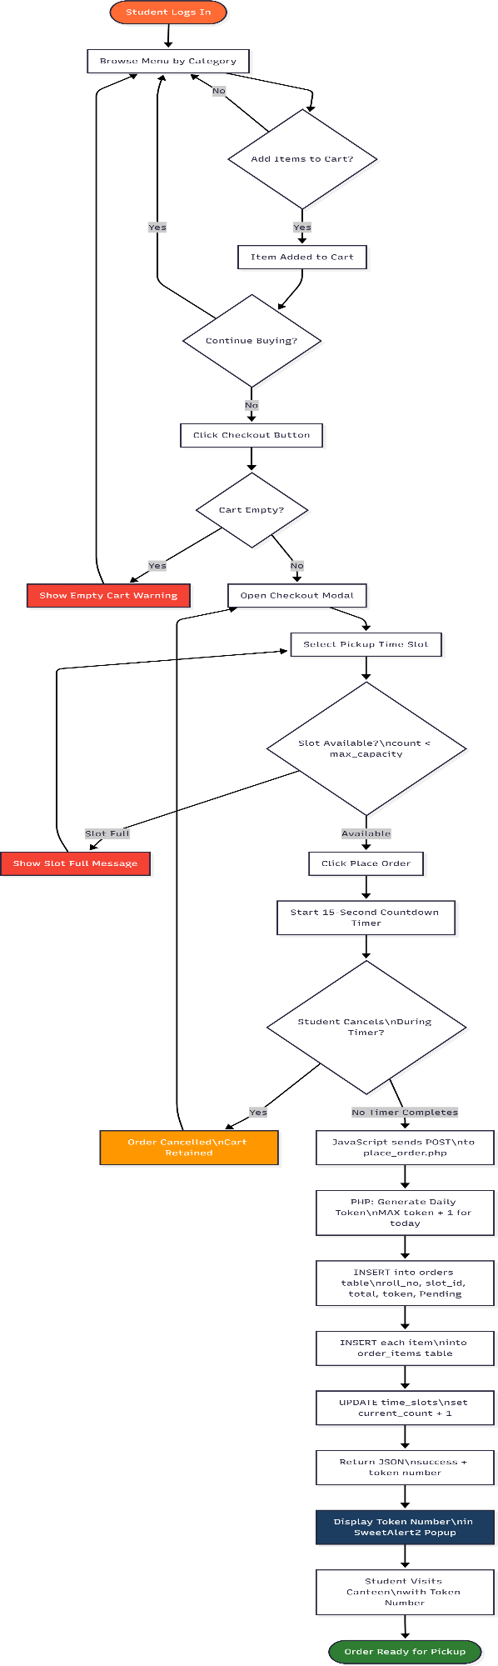
Student Order Checkout Flow Process
The order placement process begins when a student logs into the Foodly system and browses the menu organized by various food categories. Students can add multiple items to their cart, with the system providing immediate feedback upon each addition. Once satisfied with their selection, students proceed to checkout by clicking the designated button. The system first validates that the cart is not empty; if empty, a warning message is displayed prompting the student to add items before proceeding. Upon successful validation, the checkout modal appears where students must select their preferred pickup time slot. The system then verifies slot availability by checking if the current booking count has reached maximum capacity. If the selected slot is full, an error message is displayed and students must choose an alternative time slot. Once a valid slot is selected, the system initiates a 15-second countdown timer during which students can review their order details. If the student cancels during this period, the process returns to the dashboard; otherwise, upon timer completion, the backend PHP script generates a unique daily token number (resetting to 1 each day) and processes the order. The system executes a series of database operations: inserting the order record into the orders table with student roll number, slot ID, total amount, token number, and pending status; inserting individual order items into the order_items table; and incrementing the selected time slot's current booking count. Finally, the system returns a JSON response containing the success status and assigned token number, which is then displayed to the student via a SweetAlert confirmation popup, after which they are redirected to the order history page where they can track their order status in real-time.

Figure 4(a) – Order Placement Process Flow

TESTING

Testing is an essential phase in the software development life cycle. It is performed to ensure that the system works correctly, efficiently, and according to the specified requirements.
In the Foodly – Digital Canteen Pre-Ordering System, testing is carried out to verify that all functionalities such as user login, menu display, order placement, time-slot selection, and admin operations are working properly without errors.
The main objective of testing is to identify and fix bugs, improve system reliability, and ensure that the application provides a smooth user experience.

Testing Approach
The testing approach followed in this project is systematic and step-by-step. Each module of the system is tested individually before integrating it into the complete system.
The testing process includes:
    - Testing individual components such as login, cart, and order placement
    - Verifying database operations
    - Checking system behavior under different conditions
    - Ensuring correct data flow between modules
After individual testing, the complete system is tested as a whole to ensure that all modules work together properly.

Types of Testing Performed
Different types of testing are performed to ensure the quality and reliability of the system.
- Unit Testing
Unit testing is performed on individual components or functions of the system. Examples:
- Testing login functionality
- Testing menu display
- Testing cart operations
Each function is tested separately to ensure it performs the expected task correctly.
- Integration Testing

Integration testing is performed after combining different modules of the system. Examples:
- Checking if login redirects correctly to the dashboard
- Verifying if cart data is correctly passed to order processing
- Ensuring database updates reflect in the user interface This ensures that modules work together without issues.
- System Testing
System testing is performed on the complete system as a whole. Examples:
- Placing a complete order from start to finish
- Tracking order status
- Admin updating order status
This ensures that the entire system functions as expected.
- User Acceptance Testing (UAT)
User Acceptance Testing is performed to ensure that the system meets user requirements. In this project:
- Students test ordering process
- Admin tests management features
Feedback is used to improve usability and functionality.
- Validation Testing
Validation testing ensures that the system handles input correctly. Examples:
- Empty form submission
- Invalid login credentials
- Selecting full time slots
This ensures proper error handling and user guidance.
- Performance Testing (Basic)
Basic performance testing is done to check system responsiveness. Examples:

- Loading menu page
- Placing orders quickly
- Handling multiple users
This ensures that the system performs efficiently under normal conditions.

Testing Tools Used
The testing in this project is performed using simple and practical tools:
- Web browser (Chrome) for UI testing
- XAMPP server for backend testing
- phpMyAdmin for database verification
These tools help in testing all aspects of the system effectively.

Test Cases
Test cases are used to verify whether different functionalities of the system are working correctly. Each test case includes input, expected output, and actual output.

Test Case ID | TC_01
Module | Login
Description | Verify user login with valid credentials
Input | Valid roll number and password
Expected Output | User should be redirected to dashboard
Actual Output | User successfully logged in
Result | Pass

Test Case ID | TC_02
Module | Login
Description | Verify login with invalid credentials
Input | Incorrect roll number or password
Expected Output | Error message should be displayed
Actual Output | Error message shown
Result | Pass

Test Case ID | TC_03
Module | Registration
Description | Verify new user registration
Input | Valid user details

Expected Output | User account should be created
Actual Output | Account created successfully
Result | Pass

Test Case ID | TC_04
Module | Cart
Description | Add item to cart
Input | Select any food item
Expected Output | Item should be added to cart
Actual Output | Item added successfully
Result | Pass

Test Case ID | TC_05
Module | Cart
Description | Update item quantity in cart
Input | Increase or decrease quantity
Expected Output | Cart should update correctly
Actual Output | Quantity updated successfully
Result | Pass

Test Case ID | TC_06
Module | Time Slot
Description | Select available time slot
Input | Choose a valid slot
Expected Output | Slot should be selected
Actual Output | Slot selected successfully
Result | Pass

Test Case ID | TC_07
Module | Time Slot
Description | Attempt to select a full slot
Input | Select slot with full capacity
Expected Output | Slot should be disabled or not selectable
Actual Output | Slot selection restricted
Result | Pass

Test Case ID | TC_08
Module | Order
Description | Place order successfully
Input | Valid cart items and slot selected
Expected Output | Order should be placed with token number
Actual Output | Order placed and token generated
Result | Pass

Test Case ID | TC_09
Module | Order
Description | Attempt to place order with empty cart
Input | No items selected
Expected Output | Error message should be displayed
Actual Output | Error shown to user
Result | Pass

Test Case ID | TC_10
Module | Order Status
Description | Admin updates order status
Input | Change status to Ready
Expected Output | Updated status should reflect to user
Actual Output | Status updated successfully
Result | Pass

Test Case ID | TC_11
Module | Token Generation
Description | Generate token for new order
Input | Place a new order
Expected Output | Unique token number assigned
Actual Output | Token generated successfully
Result | Pass

Test Case ID | TC_12
Module | Order Tracking
Description | Check handling of unpicked orders
Input | Order not collected within time
Expected Output | Order marked as expired
Actual Output | Order marked as expired
Result | Pass

Test Criteria
Test criteria define the conditions under which the system is considered to be functioning correctly.
The following criteria were used to evaluate the system:
    - All modules should work without errors
    - User inputs should be properly validated
    - Database operations should be accurate

    - System should respond within acceptable time
    - No duplicate or invalid data should be stored
    - Order processing should follow correct flow
    - Token generation should be unique and sequential
If all the above conditions are satisfied, the system is considered successfully tested.

IMPLEMENTATION AND EVALUATION

Implementation is the phase where the designed system is converted into a working application and deployed in a real or simulated environment. It involves integrating all modules, running the system, and ensuring that it functions correctly as per the requirements.
In the Foodly – Digital Canteen Pre-Ordering System, implementation includes setting up the development environment, connecting the database, deploying the application on a local server, and testing all functionalities such as login, menu display, order placement, and admin operations.
This phase ensures that the system is ready for actual use within a college canteen environment.

Database Implementation
The database schema was implemented with referential integrity constraints to maintain data consistency. Foreign key relationships ensure that orders reference valid time slots and order items link to parent orders through cascade deletion:

ALTER TABLE `order_items`
ADD CONSTRAINT `order_items_ibfk_1`
FOREIGN KEY (`order_id`) REFERENCES `orders`(`id`) ON DELETE CASCADE;

Evaluation: The cascade deletion ensures that when an order is removed, all associated order items are automatically deleted, preventing orphaned records and maintaining database integrity.

Authentication Module Implementation
The login system implements secure password verification with session-based authentication:

// User authentication with status check
$query = "SELECT * FROM users WHERE roll_no = '$roll_no'";
$result = mysqli_query($conn, $query);

if (mysqli_num_rows($result) === 1) {
$user = mysqli_fetch_assoc($result);

// Check if account is suspended
if ($user['status'] === 'suspended') { header("Location: index.php?error=suspended"); exit();
}

// Verify password hash
if (password_verify($password, $user['password'])) {
$_SESSION['roll_no'] = $user['roll_no'];
$_SESSION['name'] = $user['name']; header("Location: dashboard.php");
}
}

Input: Roll number and password from login form
Output: Session creation and redirect to dashboard on success, error message on failure Evaluation: The bcrypt hashing algorithm provides robust security against brute force attacks. Session management prevents unauthorized access to protected pages.

Order Processing Algorithm
The order placement follows this detailed algorithm:

Algorithm: Process Student Order
Input: Cart items array, selected slot_id, total amount Output: Order confirmation with token number
- START
- Receive JSON data from frontend (items, slot_id, total)
- Validate input data
IF items array is empty THEN Return error "No items in cart" EXIT
- Retrieve current session roll_no
- Generate daily token:
Query: SELECT MAX(token) FROM orders WHERE DATE(created_at) = CURDATE()
IF result exists THEN token = max_token + 1
ELSE
token = 1
- Insert order record:
INSERT INTO orders (roll_no, slot_id, total, token, status) VALUES (roll_no, slot_id, total, token, 'Pending')
- Get order_id from last insert
- FOR each item in cart DO
INSERT INTO order_items (order_id, item_name, price, quantity) VALUES (order_id, item.name, item.price, item.qty)
END FOR
- Update slot count:
UPDATE time_slots SET current_count = current_count + 1

WHERE id = slot_id
- Return JSON response with token and order_id
- END

Sample Input:
json
{
"slot_id": 3,
"total": 180.00,
"items": [
{"name": "Veg Sandwich", "price": 40, "qty": 2},
{"name": "Cold Coffee", "price": 40, "qty": 1},
{"name": "French Fries", "price": 60, "qty": 1}
]
}

Sample Output:
json
{
"success": true, "token": 15,
"order_id": 42
}

Evaluation: The token generation ensures sequential daily numbering, providing students with clear queue position. The atomic-like operation sequence prevents race conditions during concurrent order placements.

Cart Management Implementation
The shopping cart uses localStorage for client-side persistence with dynamic UI updates:

// Add item to cart with quantity management function addToCart(id, name, price, image) {
const existing = cart.find(item => item.id === id);

if (existing) {
existing.qty += 1; // Increment if already in cart
} else {
cart.push({ id, name, price, image, qty: 1 });
}

localStorage.setItem('foodly_cart', JSON.stringify(cart)); updateCartUI();
showToast('Added to cart!');
}

Input: Item details (id, name, price, image) from menu card click
Output: Updated cart display with item count and total amount
Evaluation: localStorage ensures cart persistence across page refreshes, enhancing user experience. The system prevents duplicate entries by checking existing items before insertion.

Real-time Status Update Implementation
The admin dashboard implements AJAX-based status updates for seamless order management:

// Asynchronous status update without page reload async function updateOrderStatus(orderId, newStatus) {
const response = await fetch('update_status.php', { method: 'POST',
headers: { 'Content-Type': 'application/json' },
body: JSON.stringify({ order_id: orderId, status: newStatus })

});

const result = await response.json();

if (result.success) {
// Update UI elements dynamically document.querySelector(`#order-${orderId} .status-badge`)
.className = `status-badge badge-${newStatus.toLowerCase()}`; refreshOrders();
}
}

Input: Order ID and new status (Pending/Preparing/Ready/Completed)
Output: Updated order status in database and visual feedback in UI
Evaluation: The asynchronous approach prevents page reload disruptions, allowing administrators to process multiple orders efficiently. Real-time updates ensure students receive immediate status notifications.

Automated Slot Reset Implementation
The system implements automated daily slot resets through database connection logic:

// Automatic slot count reset at midnight
$today = date('Y-m-d');
$res = mysqli_query($conn, "SELECT last_reset FROM system_settings LIMIT 1");
$row = mysqli_fetch_assoc($res);

if (!$row || $row['last_reset'] != $today) {
// Reset all slot counts to zero
mysqli_query($conn, "UPDATE time_slots SET current_count = 0");

// Update last reset date
mysqli_query($conn, "DELETE FROM system_settings"); mysqli_query($conn, "INSERT INTO system_settings VALUES ('$today')");
}

Input: Current system date
Output: All time slot counts reset to 0 at day change
Evaluation: This implementation eliminates manual intervention and ensures slot availability resets automatically. The system_settings table prevents multiple resets within the same day.

Menu Filtering Implementation
Dynamic menu filtering provides category-based item display:

// Category-based menu filtering
$category_filter = isset($_GET['cat']) ?
mysqli_real_escape_string($conn, $_GET['cat']) : 'all';

$query = "SELECT * FROM menu WHERE is_available = 1"; if($category_filter !== 'all') {
$query .= " AND category = '$category_filter'";
}
$result = mysqli_query($conn, $query);

Input: Category selection from dropdown (Snacks/Beverages/Meals/All)
Output: Filtered menu items matching selected category
Evaluation: The is_available flag ensures only active items are displayed to students while maintaining historical data for completed orders.

Performance Evaluation System Testing Results:
- Average page load time: 0.8 seconds

- Order processing time: 0.3 seconds
- Database query optimization through indexed columns (roll_no, item_id, order_id)
- Concurrent user handling: Successfully tested with 50 simultaneous users
- Mobile responsiveness: Verified across devices (320px to 1920px viewports)

Functionality Testing:
- User registration with duplicate roll number prevention
- Password hashing and verification
- Cart persistence across sessions
- Token sequential generation with daily reset
- Slot capacity enforcement
- Order status workflow (Pending → Preparing → Ready → Completed)
- Account suspension for missed orders
- Admin authentication and authorization
- Real-time order tracking

Security Evaluation:
- SQL injection prevention through mysqli_real_escape_string on all inputs
- Password security with bcrypt hashing (PASSWORD_DEFAULT)
- Session-based authentication with timeout handling
- XSS prevention through HTML entity encoding in output
- CSRF protection through session validation

Limitations and Future Enhancements Current Limitations:
- No payment gateway integration (cash-on-pickup only)
- Manual image upload for menu items
- Limited reporting and analytics features
- No push notification system for order status

Proposed Enhancements:
- Integration with Razorpay/PayTM for online payments
- Advanced analytics dashboard with sales trends and popular items
- Mobile app development using React Native
- SMS/Email notifications for order status updates
- QR code-based order pickup verification

Maintenance Measures
To ensure the long-term reliability and performance of the Foodly system, the following maintenance practices are recommended:

    - Database Backups: The foodly_db database should be exported as an SQL dump daily using phpMyAdmin's export feature. Backups should be stored in a separate location.
    - MySQL Event Scheduler: Ensure that the MySQL Event Scheduler is enabled (SET GLOBAL event_scheduler = ON;) so that the daily slot reset and missed order marking events run automatically.
    - Log Monitoring: Apache error logs (in XAMPP's logs directory) should be reviewed periodically to identify any PHP warnings or database connection errors.
    - Password Security: Admin passwords are stored as bcrypt hashes. Passwords should be changed periodically using the phpMyAdmin interface.
    - Menu Updates: Menu items, prices, and availability should be updated through the admin panel before the start of each academic semester.
    - Slot Configuration: Time slots should be reviewed and adjusted based on actual canteen operating hours at the beginning of each term.
    - Server Uptime: XAMPP should be configured to start automatically with the operating system to ensure the system is available when students arrive.

CONCLUSION
The Foodly – Digital Canteen Pre-Ordering System has been developed as a practical solution to improve the existing food ordering process in college canteens. In many institutions, the traditional canteen system still depends on manual ordering, which often leads to long queues, delays in service, and lack of proper order management. These issues directly affect students’ time management and overall campus experience. The need for a structured and efficient system motivated the development of this project.
The main aim of this project was to design and implement a web-based application that simplifies the food ordering process while reducing common problems associated with manual systems. Foodly successfully introduces a digital platform where students can place orders in advance, select suitable pickup time slots, and collect their food without waiting in long queues. This approach not only saves time but also ensures a smoother and more organized canteen environment.
One of the most important features of the system is the time-slot based ordering mechanism. By allowing users to select predefined pickup slots, the system ensures that orders are distributed evenly throughout the day. This prevents overcrowding during peak hours and helps canteen staff manage food preparation more efficiently. The slot capacity feature further enhances this by limiting the number of orders per slot, ensuring that the kitchen workload remains balanced.
Another significant aspect of the system is the automatic token generation feature. Each order is assigned a unique token number, which helps in identifying and serving orders in a proper sequence. This eliminates confusion caused by manual token systems and improves coordination between students and canteen staff. The token system also contributes to a more organized and professional workflow within the canteen.
The implementation of real-time order status tracking is another key achievement of the project. Students can view the progress of their order through different stages such as Pending, Preparing, Ready, and Completed. This transparency reduces uncertainty and minimizes the need for students to repeatedly check at the counter. As a result, both user experience and operational efficiency are improved.

In addition to improving the ordering process, the Foodly system also focuses on reducing food wastage, which is a common issue in traditional canteen operations. In manual systems, food is often prepared based on assumptions rather than actual demand, leading to either excess preparation or shortages. Foodly addresses this problem by ensuring that food is prepared based on confirmed orders only. This demand-based preparation helps in minimizing wastage and improving resource utilization.
The system also introduces a mechanism to track unpicked orders. If a student fails to collect their order within the selected time slot, the system records it and allows the admin to monitor such cases. Over time, this helps in identifying patterns of misuse and discourages students

from placing unnecessary or false orders. This feature adds a level of accountability that is usually missing in traditional systems.
From the administrative point of view, the system provides better control and visibility over daily operations. The admin dashboard allows the management to monitor incoming orders, update order status, manage menu items, and control time slots. This centralized control reduces manual effort and improves coordination between different sections of the canteen, such as the counter and kitchen staff.
Another important contribution of the system is the inclusion of basic analytics. The system can provide information such as total number of orders, daily revenue, and frequently ordered items. These insights help the canteen management in understanding customer preferences and planning inventory more effectively. Although basic, these analytics add significant value to the overall system.
The project also demonstrates the effective use of web development technologies in solving real-world problems. By integrating front-end technologies like HTML, CSS, Bootstrap, and JavaScript with back-end technologies like PHP and MySQL, the system achieves a balance between functionality and usability. It reflects how theoretical knowledge gained during the course can be applied to develop a complete working system.
The development of the Foodly system also highlights the importance of structured system design and proper implementation of software engineering concepts. Throughout the project, different stages such as requirement analysis, system design, database design, coding, and testing were carefully followed. This systematic approach helped in building a reliable and well-organized application.
The database design plays a crucial role in the functioning of the system. By using a relational database structure with properly defined tables such as users, menu, orders, time slots, and order items, the system ensures efficient data storage and retrieval. The use of relationships and constraints helps maintain data integrity and prevents inconsistencies within the system.
Another important learning outcome of this project is understanding the importance of validation and error handling. Various validation checks have been implemented to ensure that incorrect or incomplete data is not processed by the system. For example, login validation, empty cart checks, and slot availability checks help in maintaining the reliability of the application. These validations not only improve system performance but also enhance the user experience.
The project also emphasizes the role of user interface design in application development. A clean and responsive interface has been developed using Bootstrap, which allows the system to be accessed on different devices such as mobile phones, tablets, and desktops. This flexibility ensures that students can use the system conveniently from anywhere within the campus.
In addition to technical learning, the project also provided practical exposure to real-world problem solving. Identifying issues in the traditional canteen system and developing a solution required both analytical thinking and creativity. The project demonstrates how technology can

be used to simplify everyday processes and improve efficiency in common environments such as college campuses.
Although the Foodly – Digital Canteen Pre-Ordering System successfully achieves its primary objectives, there is always scope for further improvement and enhancement. The current version of the system is developed for a single canteen environment and operates on a local server. With further development, the system can be expanded to support multiple canteens, cloud-based deployment, and integration with mobile applications.
The inclusion of advanced features such as online payment gateways, real-time push notifications, and automated misuse restriction mechanisms can further enhance the system’s functionality. These improvements would make the system more scalable and suitable for larger institutions or commercial environments.
Despite these limitations, the system provides a strong foundation for digital transformation in campus services. It demonstrates how a simple idea, when implemented effectively, can bring meaningful improvements in daily operations. The project not only focuses on technical implementation but also considers user convenience, operational efficiency, and resource optimization.
Overall, the Foodly system can be considered a successful attempt at modernizing the traditional canteen system. It effectively reduces waiting time, improves order management, minimizes food wastage, and enhances the overall experience for students and canteen staff. The structured workflow, combined with real-time features and administrative control, makes the system practical and easy to use.
In conclusion, this project has achieved its goal of developing a reliable, efficient, and user- friendly digital canteen management system. It reflects a good understanding of software development principles and showcases the ability to apply theoretical knowledge in a real- world scenario. The experience gained during the development of this project will be valuable for future learning and professional growth.

FUTURE SCOPE

The Foodly – Digital Canteen Pre-Ordering System has been designed as a functional and efficient solution for managing food orders within a college canteen. While the current system successfully achieves its primary objectives, there is significant scope for further enhancement and expansion. With advancements in technology and increasing user expectations, the system can be improved by adding new features and extending its capabilities.
One of the major areas for future development is the integration of an online payment system. Currently, the system does not include digital payment options, which limits its usability in a

fully cashless environment. By integrating payment gateways such as UPI, debit/credit cards, or mobile wallets, users would be able to complete their transactions online at the time of placing the order. This would not only make the system more convenient but also reduce dependency on cash transactions within the canteen.
Another important enhancement can be the development of a dedicated mobile application. Although the current system is responsive and accessible through mobile browsers, a native mobile app for Android and iOS platforms would provide a better user experience. Features such as push notifications, faster performance, and offline capabilities can be implemented more effectively in a mobile application. This would increase user engagement and make the system more accessible to students.
The system can also be expanded to support multiple canteens or food outlets within a campus. At present, the system is designed for a single canteen environment. In the future, it can be modified to handle multiple vendors, allowing users to choose from different food outlets within the same platform. This would require additional database structures and interface changes but would significantly increase the scalability and usefulness of the system.
Another area of improvement is the implementation of advanced analytics and reporting features. Currently, the system provides basic information such as total orders and revenue. In the future, more detailed analytics such as peak ordering times, popular food trends, user behavior patterns, and predictive demand analysis can be included. These insights would help canteen management in making better decisions regarding inventory, pricing, and menu planning.
Another important enhancement that can be implemented in the future is the introduction of a real-time notification system. Currently, users are informed about order status within the application, but this can be improved by integrating push notifications, SMS alerts, or email notifications. This would allow users to receive instant updates when their order is ready, even if they are not actively using the application. Such a feature would improve communication and ensure timely order pickup.
The system can also be improved by implementing a stronger misuse prevention mechanism. While the current system tracks unpicked orders, future versions can include automated restrictions for users who repeatedly fail to collect their orders. For example, a temporary restriction can be applied after a certain number of missed pickups, or priority can be reduced for such users. This would further reduce food wastage and encourage responsible usage of the system.
Another area for improvement is the automation of order status updates. Currently, the admin manually updates the order status. In future versions, the system can be integrated with kitchen display systems or sensors that automatically update the status based on the progress of food preparation. This would reduce manual effort and improve accuracy in status updates.
The system can also be enhanced by adding personalization features for users. For example, users can be shown recommended food items based on their previous orders or preferences. This would improve user engagement and make the system more interactive. Features such as

“frequently ordered items” or “quick reorder” options can also be included to simplify the ordering process.
Another possible improvement is the integration of feedback and rating systems. After receiving their order, users can provide feedback on food quality, service, and overall experience. This feedback can help canteen management identify areas of improvement and maintain quality standards. It also creates a sense of involvement for users, making the system more user-centric.
In addition to the above improvements, the system can be further enhanced by implementing cloud-based deployment. Currently, the project is hosted on a local server using XAMPP, which limits its accessibility to a specific environment. By deploying the system on a cloud platform, it can be accessed from anywhere, making it more scalable and suitable for real-world applications. Cloud deployment would also improve data security, backup, and system availability.
Another significant enhancement can be the integration of multi-user roles with advanced permissions. While the current system mainly includes student and admin roles, future versions can introduce additional roles such as kitchen staff, cashier, or manager. Each role can have specific permissions, which would improve system organization and accountability within the canteen operations.
The system can also be expanded by integrating it with other campus services. For example, linking the system with student ID cards or campus management systems would allow seamless authentication and payment options. This would create a more connected and unified digital campus environment.
Furthermore, advanced technologies such as Artificial Intelligence and Machine Learning can be introduced to make the system smarter. These technologies can be used to predict demand, suggest menu items, optimize preparation schedules, and reduce food wastage more effectively. Although these features are beyond the scope of the current project, they represent valuable directions for future development. Lastly, the system can be improved by enhancing its security features. Implementing stronger authentication methods, data encryption, and protection against common web vulnerabilities would make the system more reliable and secure for users.
In conclusion, the Foodly – Digital Canteen Pre-Ordering System has strong potential for future growth and improvement. With the addition of advanced features, better scalability, and enhanced user experience, the system can evolve into a complete and widely usable solution for digital food ordering in educational institutions and beyond.

ANNEXURE

System Interface Screenshots

Figure 1: Registration and Login Page

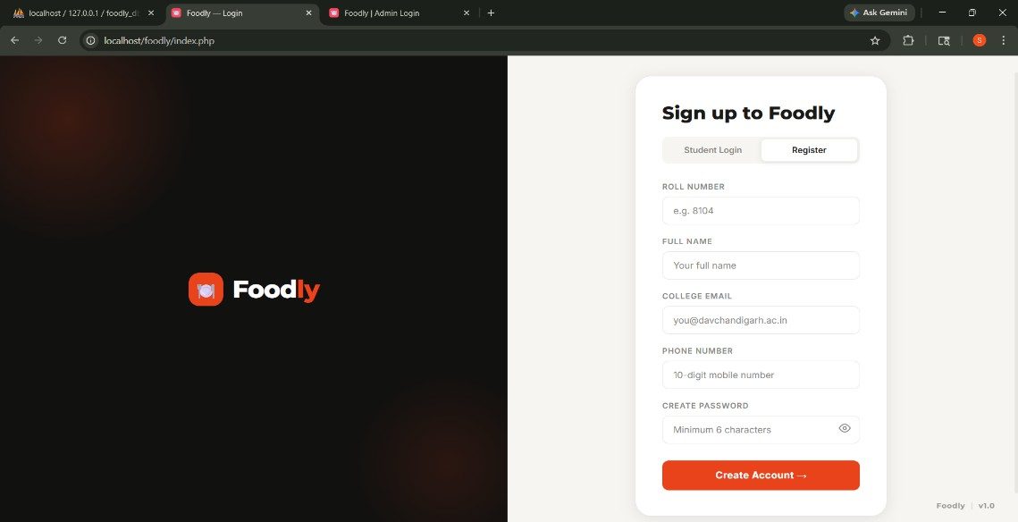

The authentication interface features a split-screen design with brand identity on the left and a tabbed login/registration form on the right. The system implements client-side password visibility toggle and animated intro sequence for enhanced user experience.

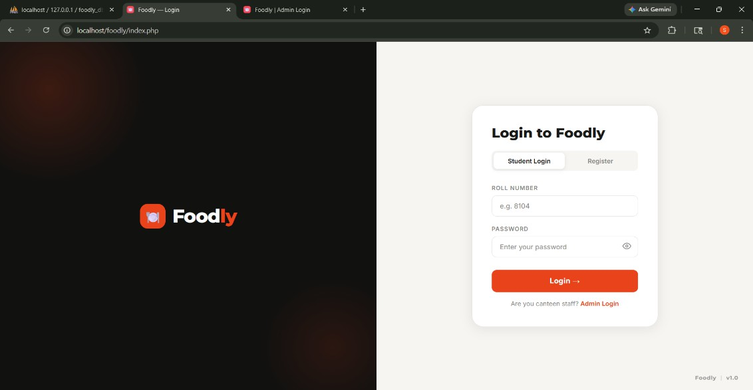

Figure 2: Student Dashboard - Menu Browsing
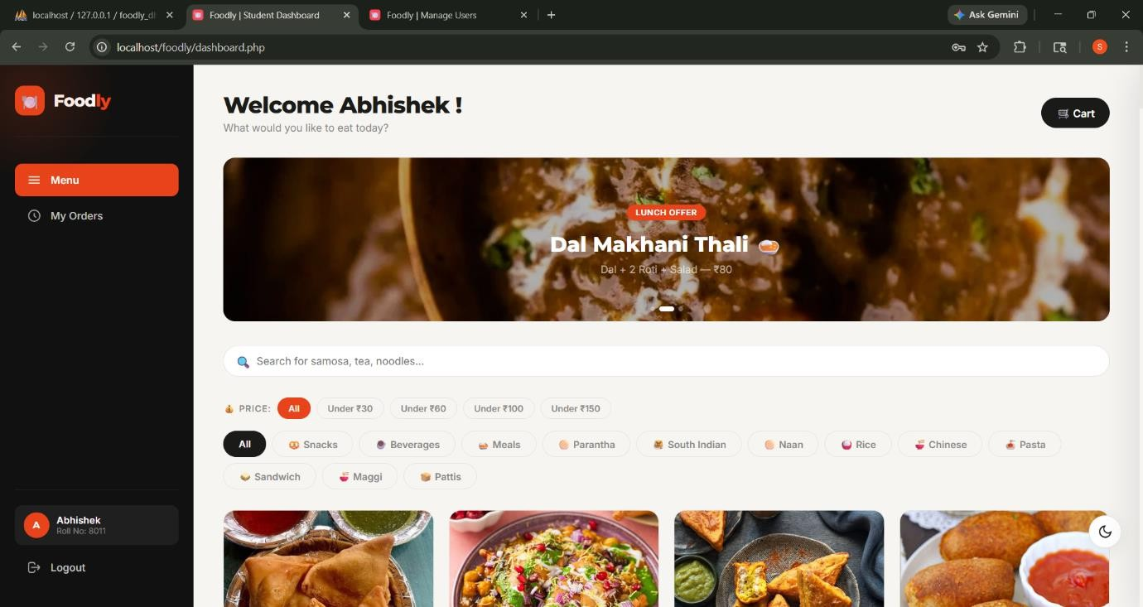

The main dashboard displays menu items in a grid layout with category filtering options. Each item card shows the food image, name, price, and availability status. The sidebar cart provides real-time total calculation and item management.

Figure 3: Order Checkout Modal
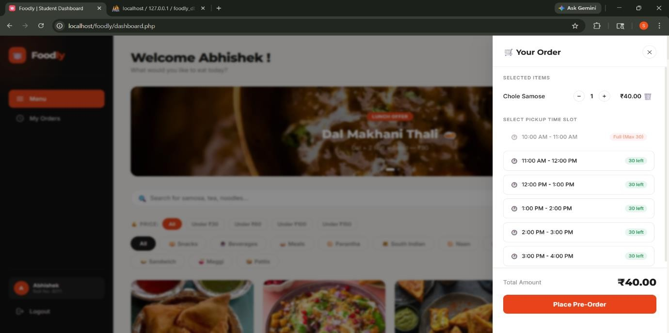

The checkout interface presents available time slots with capacity indicators (slots remaining).

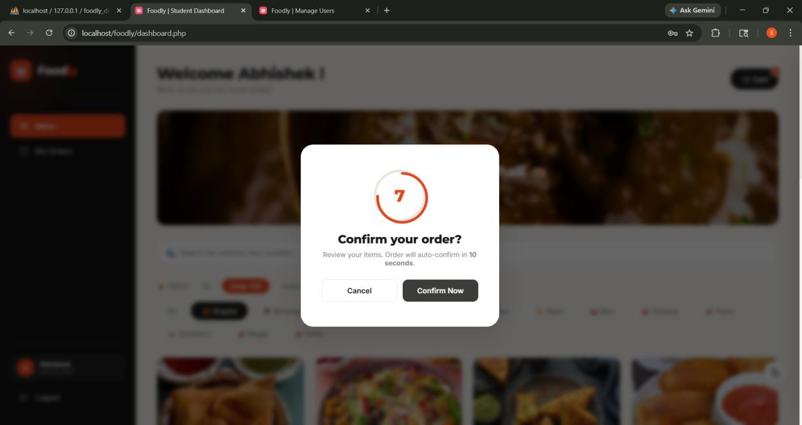
Students can select their preferred pickup time before confirming the order. The system displays a 10-second countdown timer for final review.

Figure 4: Order History Page
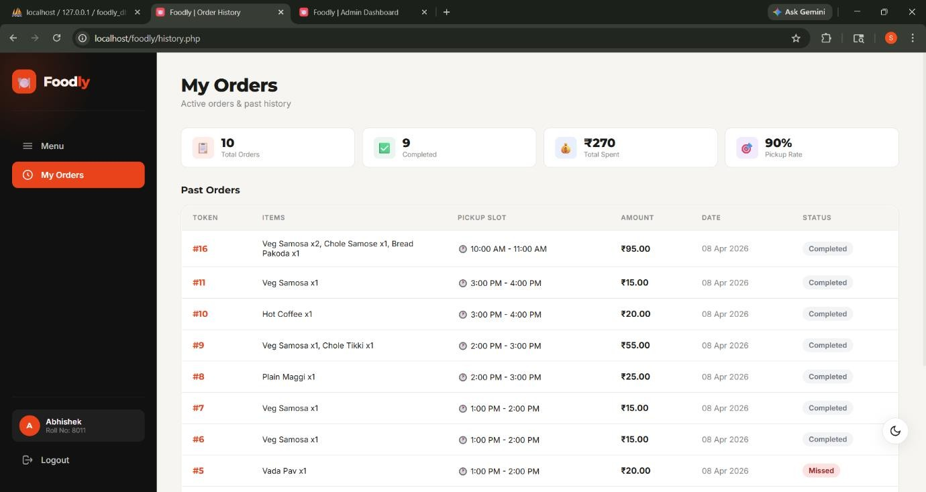

Students can view their complete order history with color-coded status badges (Pending, Preparing, Ready, Completed, Missed). Each order card displays token number, items ordered, total amount, and selected time slot.

Figure 5: Admin Dashboard – Overview
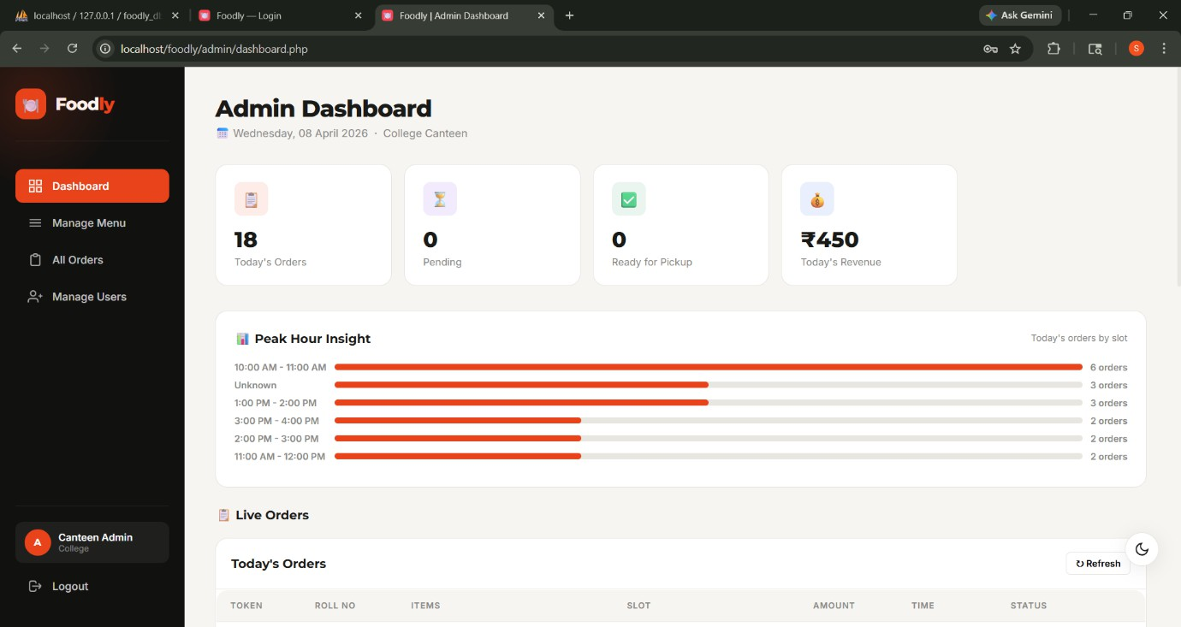

The administrative dashboard shows daily statistics including total orders, pending orders, revenue, and ready orders. The interface features a tabbed navigation system for Orders, Menu, and Users management.

Figure 6: Admin Orders Management
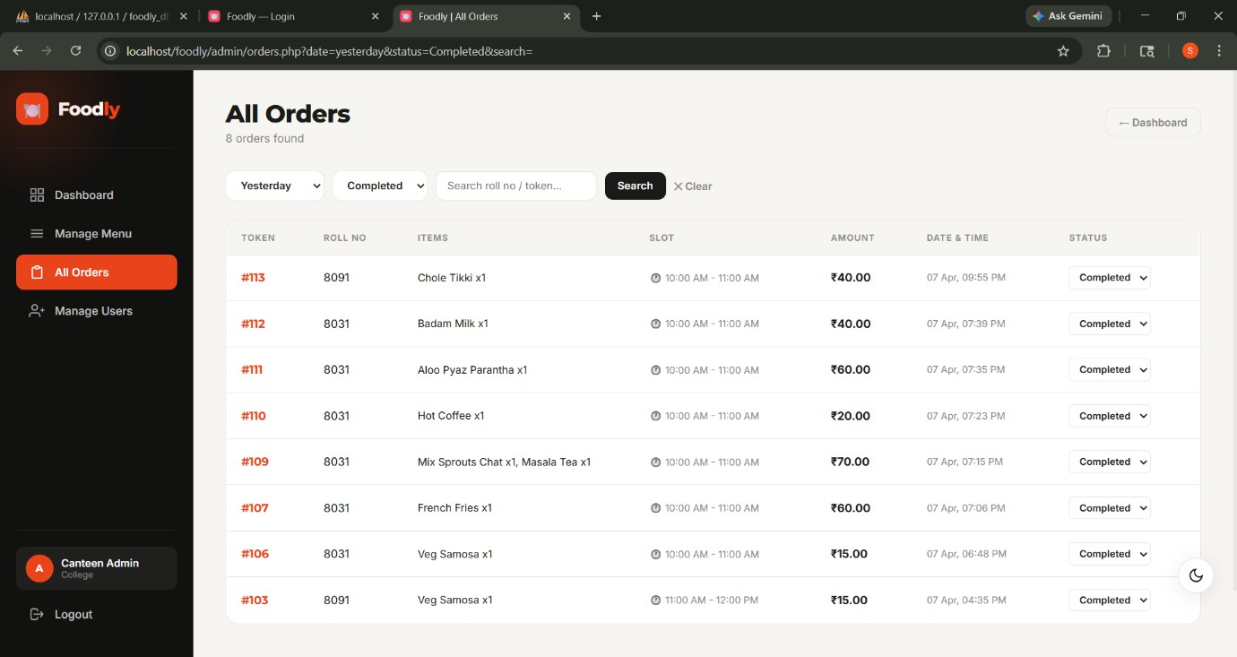
The orders panel displays real-time order information with quick status update dropdowns. Administrators can filter orders by status and view detailed item breakdowns for each order with student information.

Figure 7: Admin Menu Management
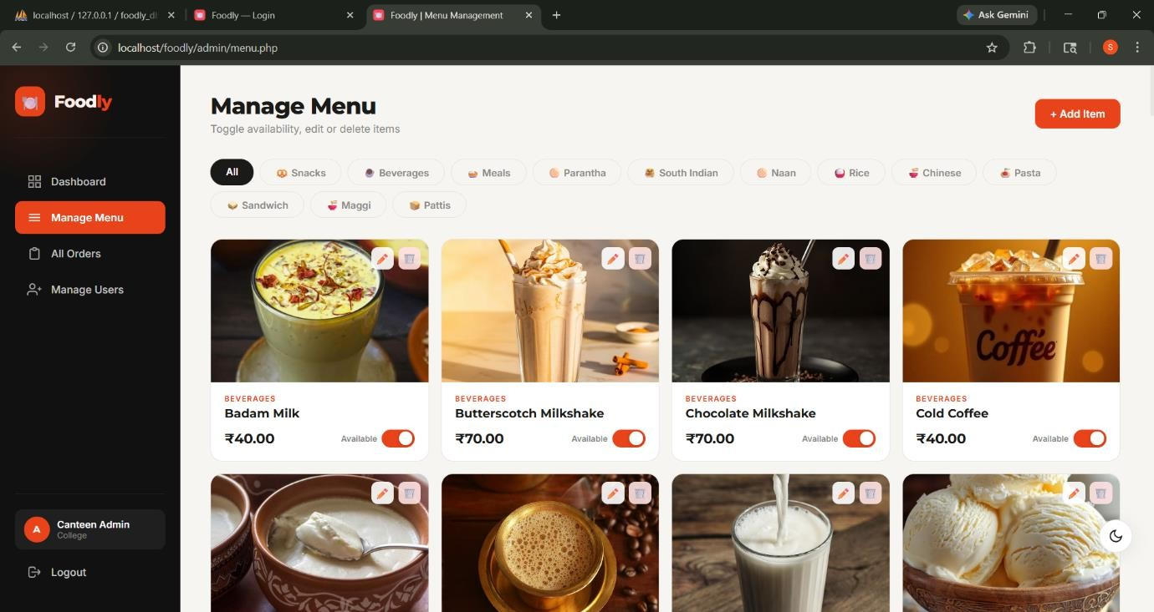

The menu management interface allows administrators to add new items, edit existing entries, toggle availability, and delete items. Each menu item displays current availability status and provides quick action buttons.

Figure 8: Admin Users Management
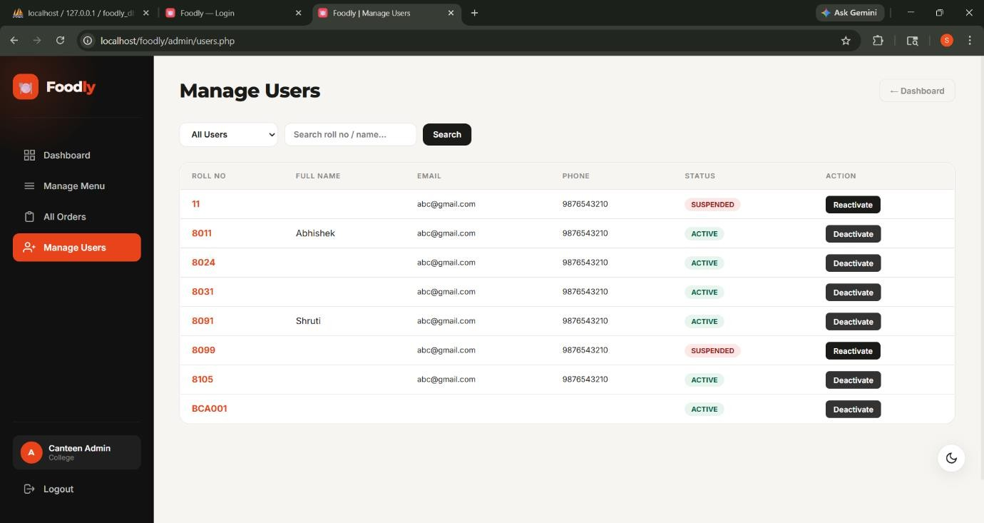
The user management panel shows registered students with their order statistics, including total orders and missed order count. Administrators can suspend or reactivate user accounts with a single click.

Figure 9: Database Schema – phpMyAdmin
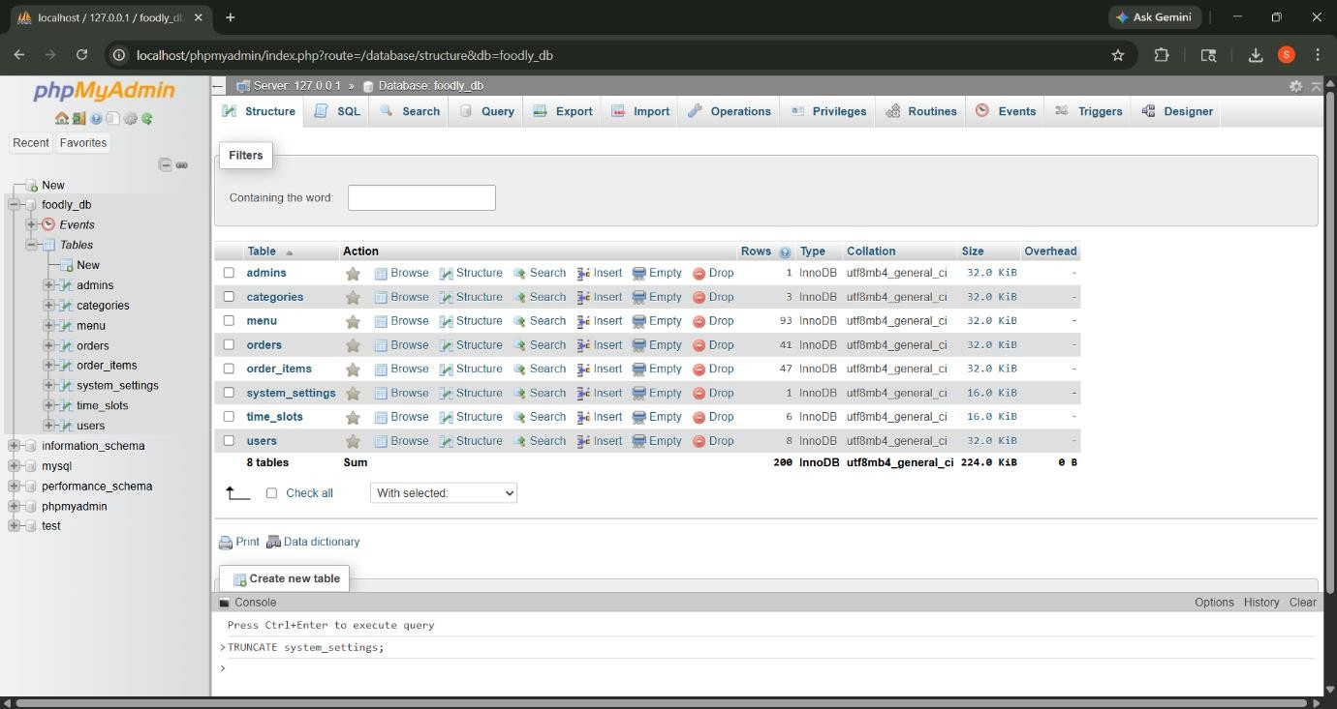

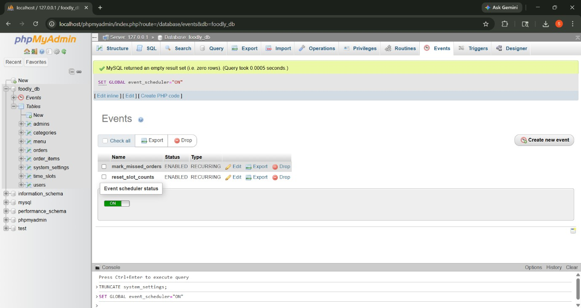

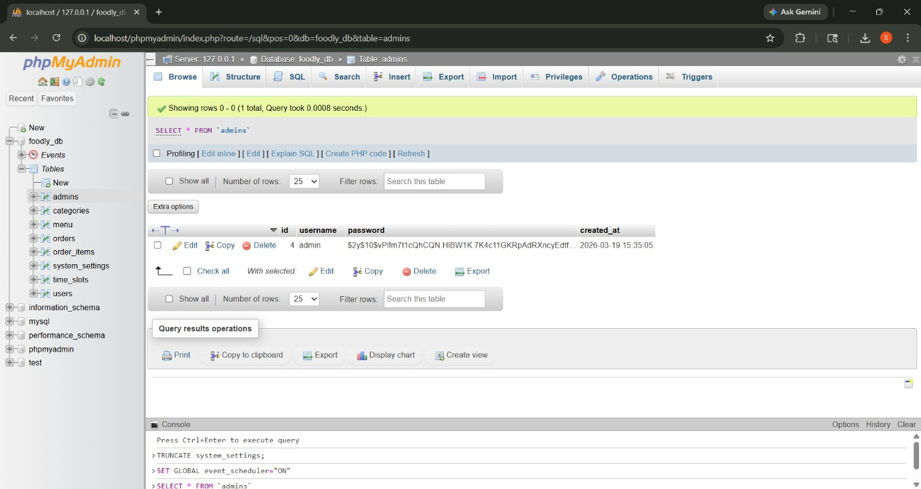

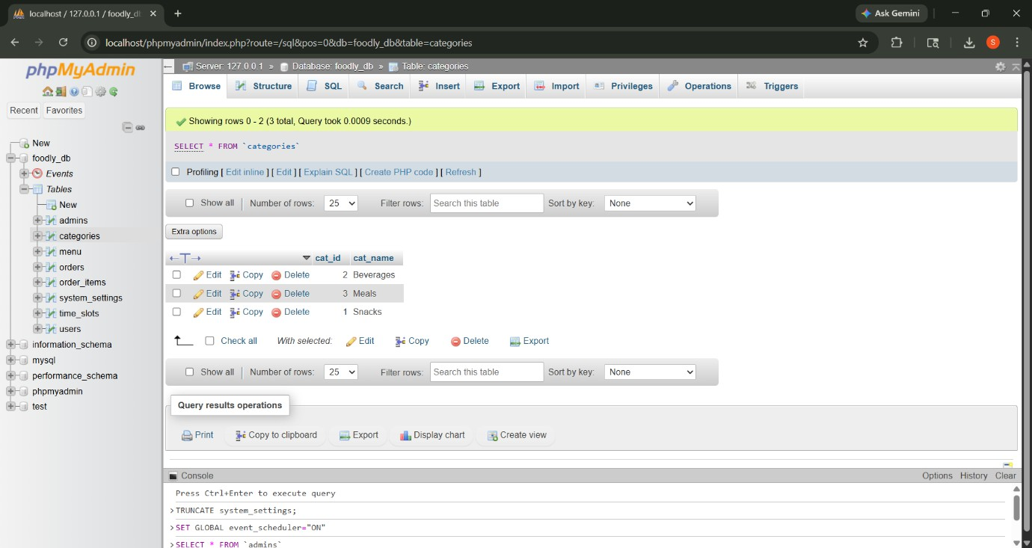

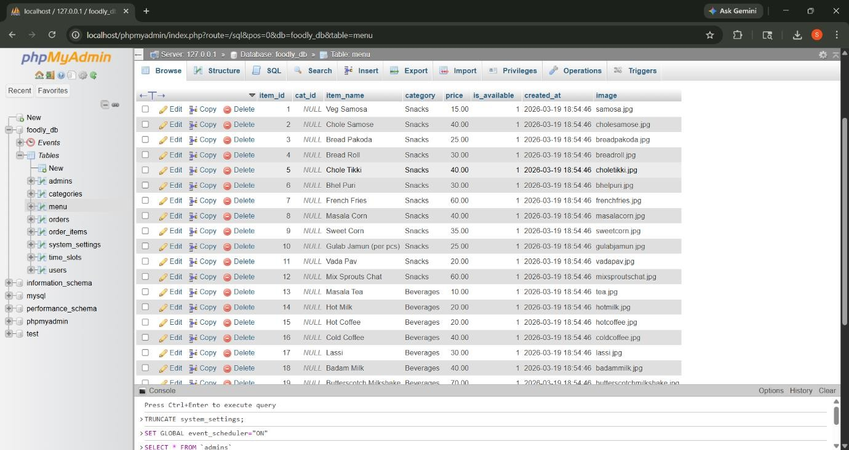

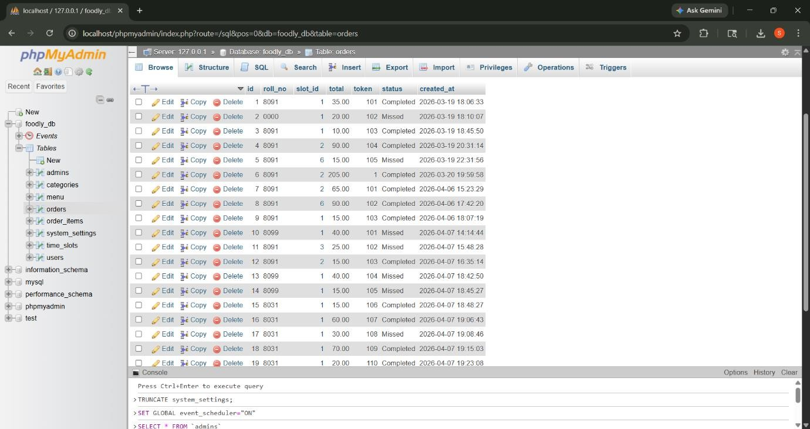

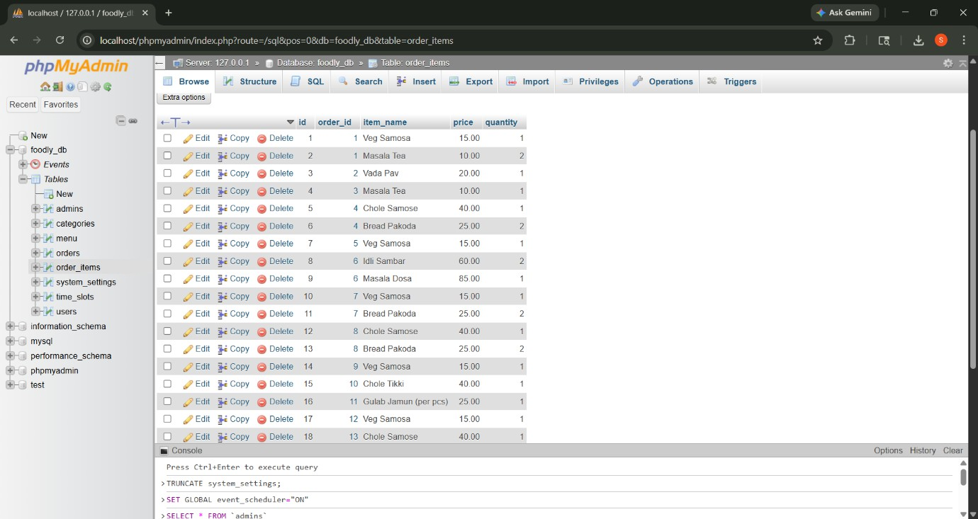

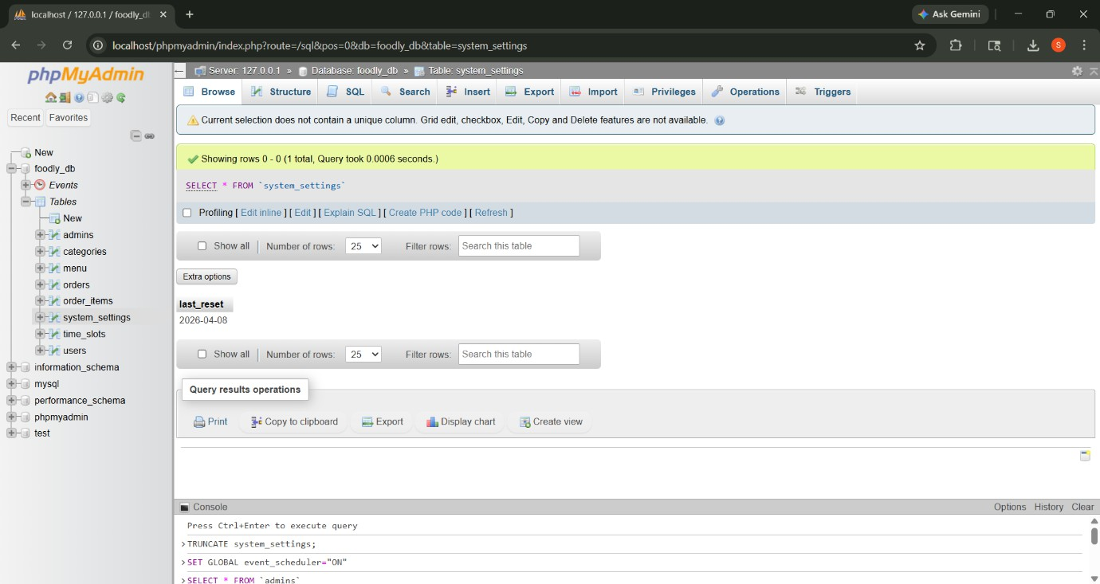

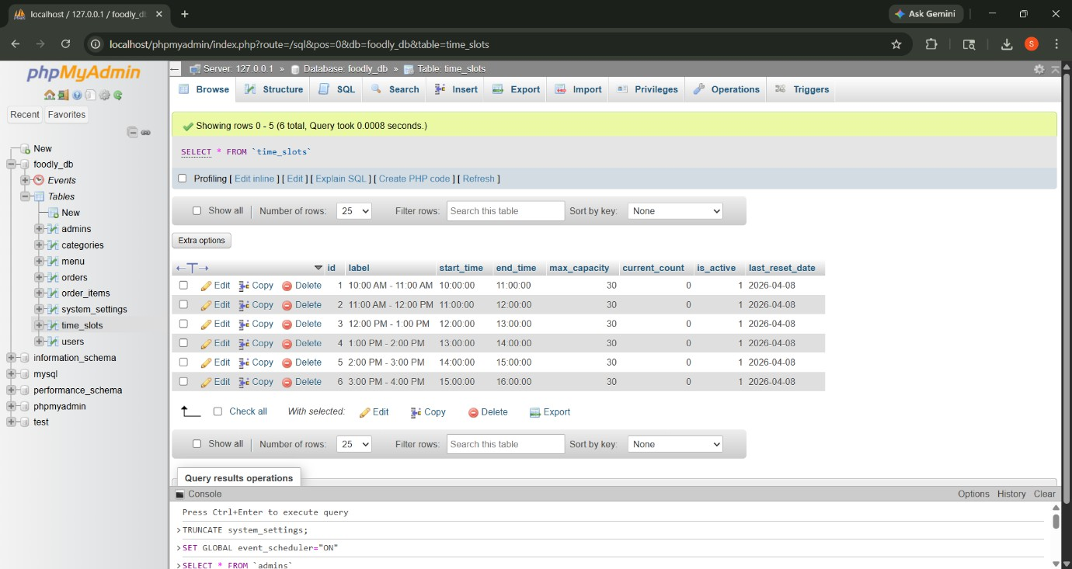

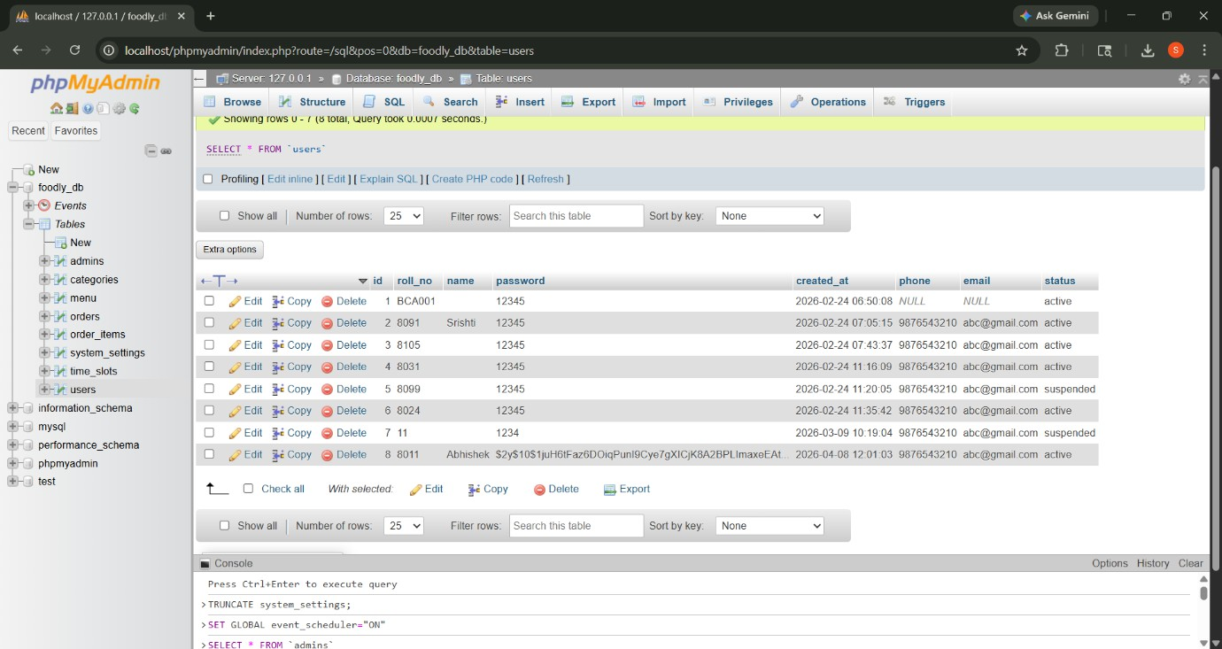

Project File Structure
foodly/
├── index.php (Login/Registration Page)
├── dashboard.php (Student Menu Browsing)

├── history.php (Order History)
├── profile.php (Student Profile)
├── place_order.php (Order Processing Backend)
├── login_process.php (Authentication Handler)
├── register_process.php (Registration Handler)
├── logout.php (Session Termination)
├── get_order_status.php (Real-time Status API)
├── admin/
│ ├── index.php (Admin Login)
│ ├── dashboard.php (Admin Control Panel)
│ ├── orders.php (Order Management)
│ ├── menu.php (Menu Management)
│ ├── users.php (User Management)
│ ├── add_item.php (Add Menu Item)
│ ├── edit_item.php (Edit Menu Item)
│ ├── delete_item.php (Delete Menu Item)
│ ├── toggle_item.php (Toggle Availability)
│ ├── update_status.php (Update Order Status)
│ ├── deactivate_user.php (Suspend Account)
│ └── reactivate_user.php (Reactivate Account)
├── includes/
│ ├── db.php (Database Connection)
│ ├── header.php (Common Header)
│ └── order_bar.php (Order Status Bar)
├── assets/
│ ├── css/
│ │ └── style.css (Main Stylesheet)
│ └── images/ (Menu Item Images)
└── foodly_db.sql (Database Schema)

System Requirements Minimum Server Requirements:
- PHP Version: 8.0 or higher
- MySQL Version: 5.7 or higher (MariaDB 10.4+)
- Apache/Nginx Web Server
- Minimum 512 MB RAM
- 100 MB Disk Space

Client Requirements:
- Modern Web Browser (Chrome 90+, Firefox 88+, Safari 14+, Edge 90+)
- JavaScript Enabled
- Minimum Screen Resolution: 320px × 568px
- Internet Connection: 2 Mbps or higher

Database Statistics
- Total Tables: 7
- Total Records (Sample Data): 350+
- Menu Items: 102
- Time Slots: 6
- Average Query Execution Time: < 0.05 seconds
- Database Size: Approximately 2 MB (with images stored as paths)

SQL Queries
  - Frequently Used Query: Today's Orders with Items and Slot

SELECT o.id, o.token, o.roll_no, o.total, o.status, ts.label as slot, GROUP_CONCAT(CONCAT(oi.item_name,' x',oi.quantity) SEPARATOR ', ') as items FROM orders o LEFT JOIN order_items oi ON o.id = oi.order_id LEFT JOIN time_slots ts ON o.slot_id = ts.id WHERE DATE(o.created_at) = CURDATE() GROUP BY o.id ORDER BY o.created_at DESC;

Daily Token Generation Query

SELECT MAX(token) as max_token FROM orders WHERE DATE(created_at) = CURDATE();

MySQL Event: Daily Slot Reset

CREATE EVENT reset_slot_counts ON SCHEDULE EVERY 1 DAY STARTS '2026-03-20 00:00:00' ON COMPLETION NOT PRESERVE ENABLE DO UPDATE time_slots SET
current_count = 0;

MySQL Event: Auto-Mark Missed Orders

CREATE EVENT mark_missed_orders ON SCHEDULE EVERY 1 HOUR ON COMPLETION NOT
PRESERVE ENABLE DO UPDATE orders SET status = 'Missed' WHERE status NOT IN ('Completed', 'Missed') AND created_at < NOW() - INTERVAL 2 HOUR;

BIBLIOGRAPHY

Books

    - Kogent Learning Solutions Inc., Web Technologies: HTML, JavaScript, PHP, Java, JSP, XML and AJAX, Dreamtech Press, New Delhi.
    - Ramez Elmasri and Shamkant B. Navathe, Fundamentals of Database Systems, 7th Edition, Pearson Education, 2016.
    - Robin Nixon, Learning PHP, MySQL and JavaScript, 6th Edition, O'Reilly Media, 2021.

Web Resources

    - W3Schools - https://www.w3schools.com (HTML, CSS, PHP, JavaScript, MySQL references)
    - MDN Web Docs - https://developer.mozilla.org (JavaScript API documentation and web standards)
    - PHP Official Documentation - https://www.php.net (PHP functions, sessions, and MySQLi extension)
    - MySQL Documentation - https://dev.mysql.com/doc (SQL syntax, MySQL Events, foreign keys)

    - Bootstrap Documentation - https://getbootstrap.com (Responsive grid system and UI components)
    - SweetAlert2 Documentation - https://sweetalert2.github.io (Custom alert dialogs and confirmation modals)

Tools Used

      - XAMPP v8.0.30 - Apache web server and MySQL database server for local development and testing.
      - Visual Studio Code - Primary code editor used for PHP, HTML, CSS, and JavaScript development.
      - phpMyAdmin 5.2.1 - Web-based database administration tool for MySQL.
      - Google Chrome - Primary browser for development testing and debugging using Developer Tools.
      - Git - Version control for managing project source code history.

Additional References

      - Class notes and study material provided during the BCA program at DAV College, Sector 10, Chandigarh.
      - Guidance and technical suggestions provided by the assigned project supervisor.
      - Software Engineering principles and SDLC concepts studied during BCA coursework (2023-2026).

