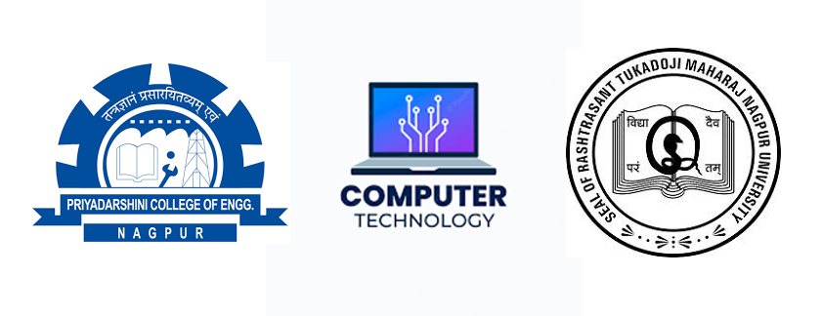

RTMNU - PCE
B. TECH. - Computer Technology
8th Sem CBCS - Summer 2024
Date | 29/04/24 | 02/04/24
Day | Monday | Thursday
Subject | SN | BCA / DAP
Timing - 02:30pm - 05:30pm
SN | - | Social Networks
BCA | - | Blockchain and its Applications
DAP | - | Data Analytics with Python

