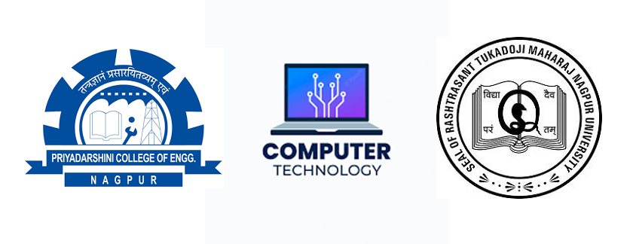

RTMNU - PCE - NPTEL - Swayam
B. TECH. - Computer Technology
Date | 27/04/24 | 28/04/24 | 29/04/24 | 02/04/24
Day | Saturday | Sunday | Monday | Thursday
Timing | 9:00 – 12:00 | 9:00 – 12:00 | 02:30 - 05:30 | 02:30 - 05:30
Subject | BCA / DAP | SN | SN | BCA / DAP
8th Sem CBCS - Summer 2024
SN | - | Social Networks
BCA | - | Blockchain and its Applications
DAP | - | Data Analytics with Python

