

LAB JOURNAL 03
Course: Database Management System Lab

Instructor: Syed Adeel Khalid
Semester: Spring 2026

NAME: SAIM ZAFAR

ENROLLMENT: 01-135241-045
Title: SELECT Statement in SQL.

Objectives:
- Basic Understanding of Select Statement.
- Using of Select Statement and retrieving information

Task 01
Create a table name Employee with (ID, F_name, L_Name, Salary, City)
Task to be performed.
- Select *
- Select single column
- Select multiple columns
- Concatenate Two columns AS New Column
- Use of Alias for column
- Select Distinct from table
- Use if Arithmetic expression using select statements
- Use parentheses and observe order

Note:
Provide detail document for your task performed and paste screenshot of the outputs.

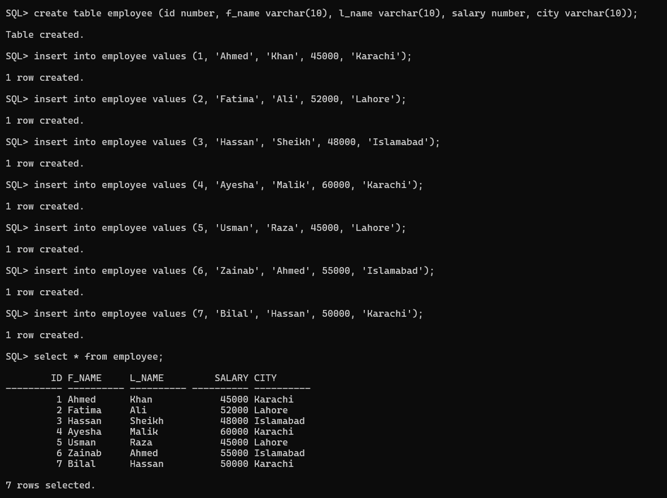
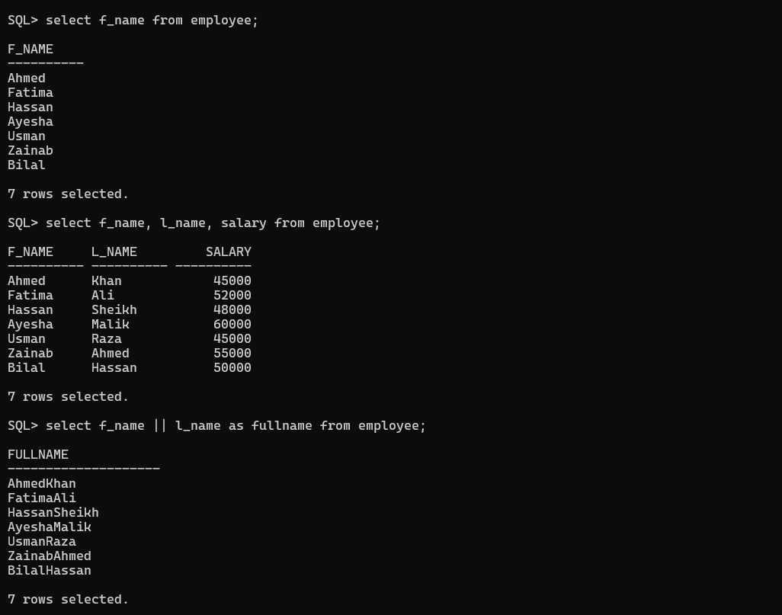
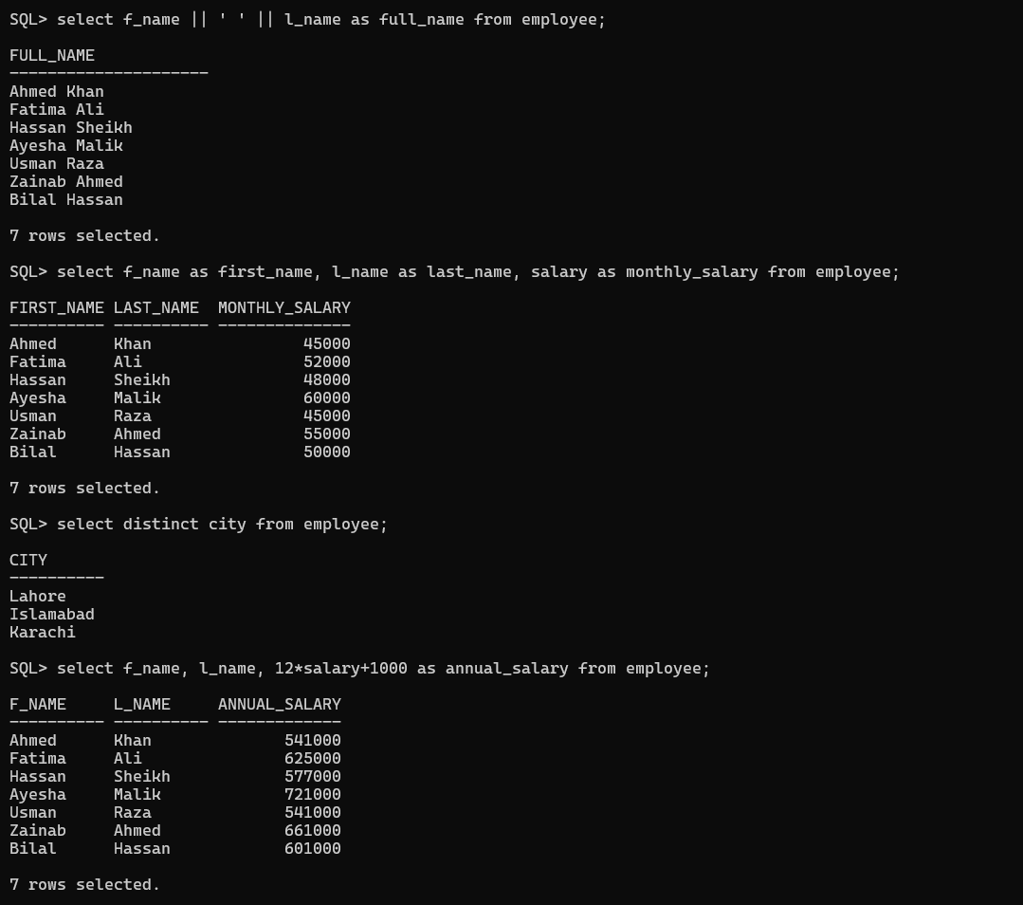
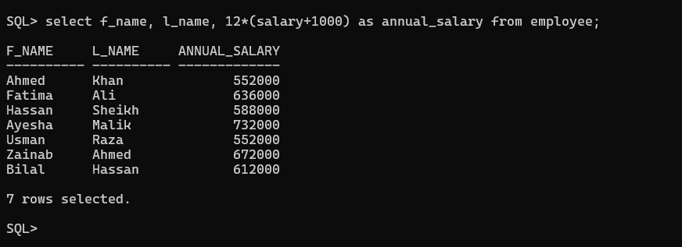

Report:
Creation of Employee Table
The employee table was created to store basic information about workers. It contains five columns which are id, f_name, l_name, salary, and city. The id and salary columns store numeric values, while first name, last name, and city store text values. This table structure allows us to keep employee details in an organized form inside the database.
Insertion of Records
After creating the table, seven employee records were inserted. Each record includes complete information such as employee id, first name, last name, salary, and city. The employees belong to three different cities which are Karachi, Lahore, and Islamabad. This step confirms that data can be successfully added into the table using insert statements.
Displaying All Records
The query select * from employee was used to display all columns and all rows from the table. The output shows seven employees with their complete details. This verifies that the table was created correctly and all records were stored properly in the database.
Selecting Specific Columns
Different select queries were used to retrieve only specific columns. First only the first names were displayed. Then first name, last name, and salary were shown together. This demonstrates that SQL allows us to fetch only required data instead of showing the full table every time. It helps in reducing unnecessary information in the output.
Concatenation of First Name and Last Name
The concatenation operator was used to combine first name and last name into one column. When both columns were joined without space, the names appeared together as one word. When a space was added between them, the full name appeared properly separated. This shows how SQL can combine multiple columns to create meaningful output.
Use of Column Aliases
Column aliases were used to rename headings in the result. For example, f_name was displayed as first_name and salary was displayed as monthly_salary. This does not change the actual table structure but improves readability of the result. It is useful when we want more understandable column titles in reports.
Use of Distinct Keyword
The distinct keyword was used to display unique city names from the table. Although multiple employees belong to the same city, the output showed each city only once. This proves that distinct removes duplicate values from the result.
Arithmetic Operations on Salary
Arithmetic operations were performed on the salary column to calculate annual salary. In the first query, the formula 12 multiplied by salary plus 1000 was used. In the second query, the formula 12 multiplied by salary plus 1000 inside brackets was used. The results were different because of operator precedence.
In the first case, salary was multiplied by 12 and then 1000 was added once. In the second case, 1000 was first added to salary and then the total was multiplied by 12. Because 1000 was multiplied by 12 in the second formula, the annual salary values became higher. The difference between both results for each employee is 11000. This shows how brackets change the order of calculation and affect the final result.

