Database Management System Lab



LAB JOURNAL 04

Instructor: Syed Adeel Khalid
Semester: Spring 2026

NAME: SAIM ZAFAR
ENROLLMENT: 01-135241-045

Department of Computer Sciences

BAHRIA UNIVERSITY, ISLAMABAD
Title: Restricting and sorting data and type casting functions.

Objectives:

- Basic Understanding of Data Sorting and Type Casting Functions.
- Using of Data Sorting and Type Casting Functions for retrieving information

Lab Tasks:
1. Create a query to display the First name and salary of employees earning more than 12,000. Place.
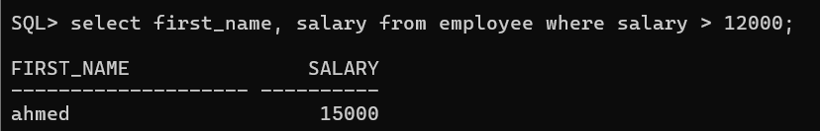
2. Create a query to display the employee First name and department id for employee number 200.
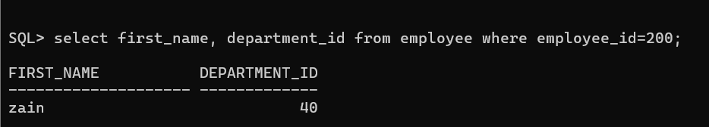
3. Display First name and salary for all employees whose salary is not in the Range of 5,000 and 12,000.
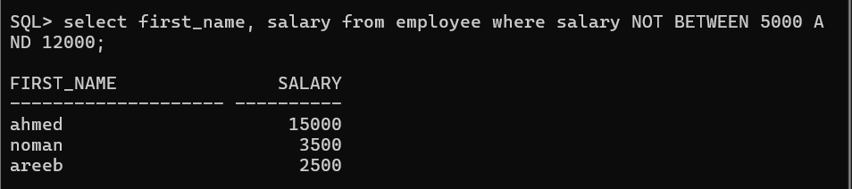
4. Display the employee first name, Employee Number, and start date of employees hired betwe
February 10 2026 and Feb 17 2026. Order the query in ascending order.
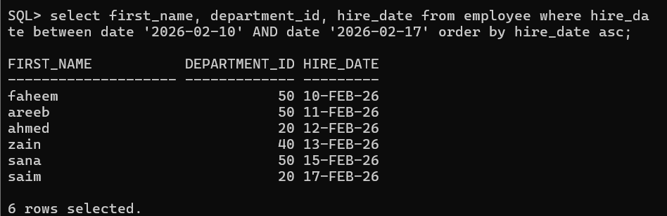
5. Display the First name and department id of all employees in departments 20 and 50 in
Alphabetical order by name.
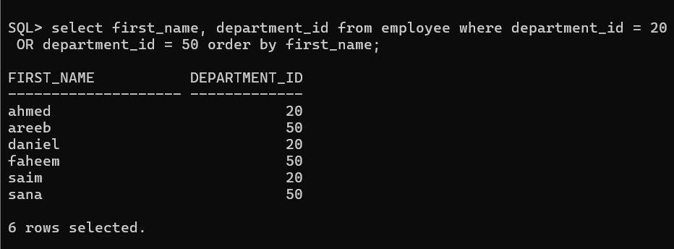
6. List the First name and salary of employees who earn between 5,000 and 12,000, and are in department 20 or 50. Label the columns Employee and Monthly Salary.
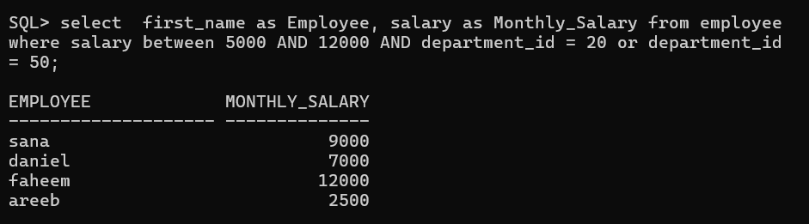
7. Display the First name and hire date of every employee who was hired in 2026.
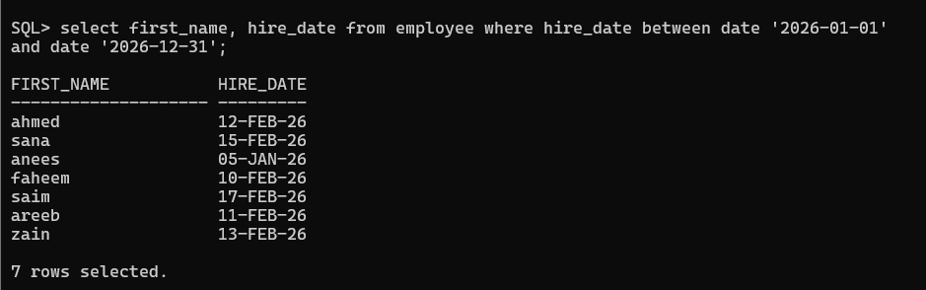
9. Display the First name, salary, for all employees and check for Null Values.
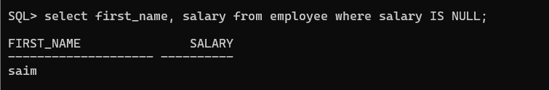

10. Display the First names of all employees where the third letter of the name is an n.
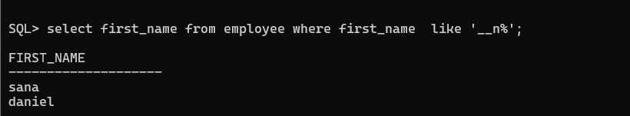
11. Display the First name of all employees who have an a and an e in their First name
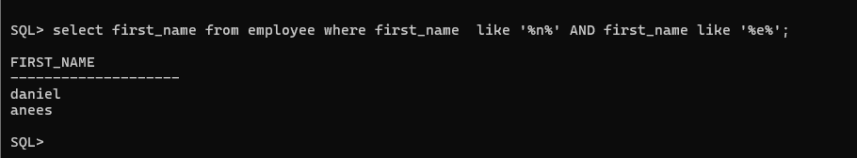
12. Display the First name and salary for all employees whose salary is
Is not equal to 2,500, 3,500, or 7,000.
