

LAB JOURNAL 02
Course: Database Management System Lab

Instructor: Syed Adeel Khalid
Semester: Spring 2026

NAME: SAIM ZAFAR
ENROLLMENT: 01-135241-045

Title: DDL Operations in DBMS

Objectives:
- Basic Understanding of DDL Operations using oracle as RDBMS
- Insertion of records in a table using DDL Operations

Task 01

Kindly manage to create 15 records in a table with your name data must be 5 Columns of your personal information. Use appropriate
- Insert Records
- Alter the Records
- Rename the Table
- Truncate the table
- Drop the Table
- Create one more table with 10 more records for the next Lab.

Solution:

- Insert Records

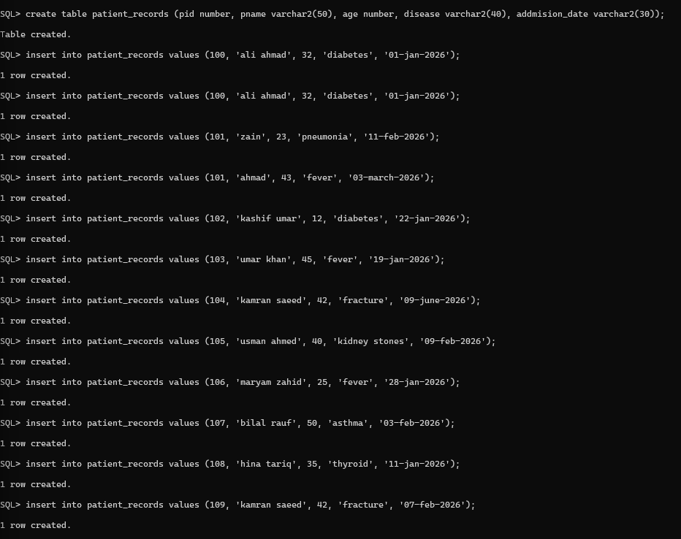

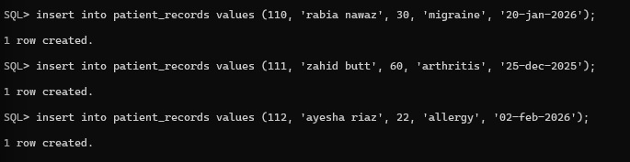

- Alter the Records

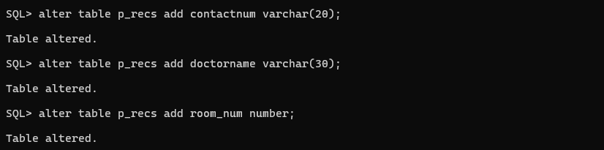

- Rename the Table

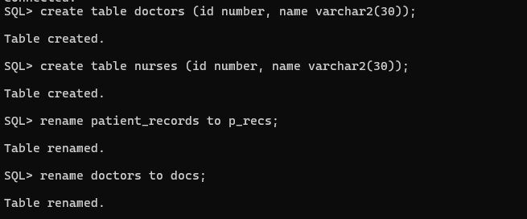

- Truncate the table

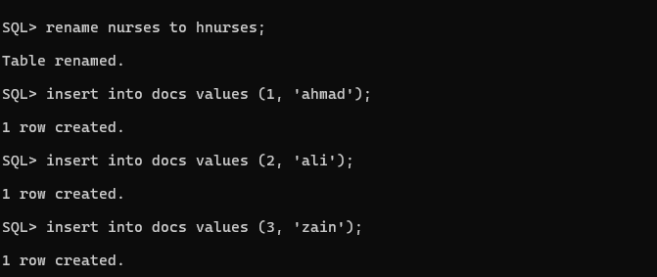

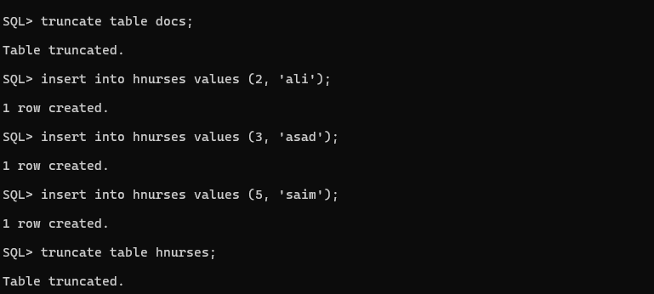
- Drop the Table

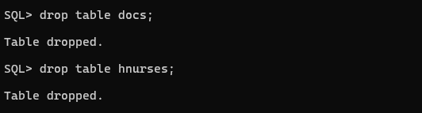
- Create one more table with 10 more records for the next Lab.

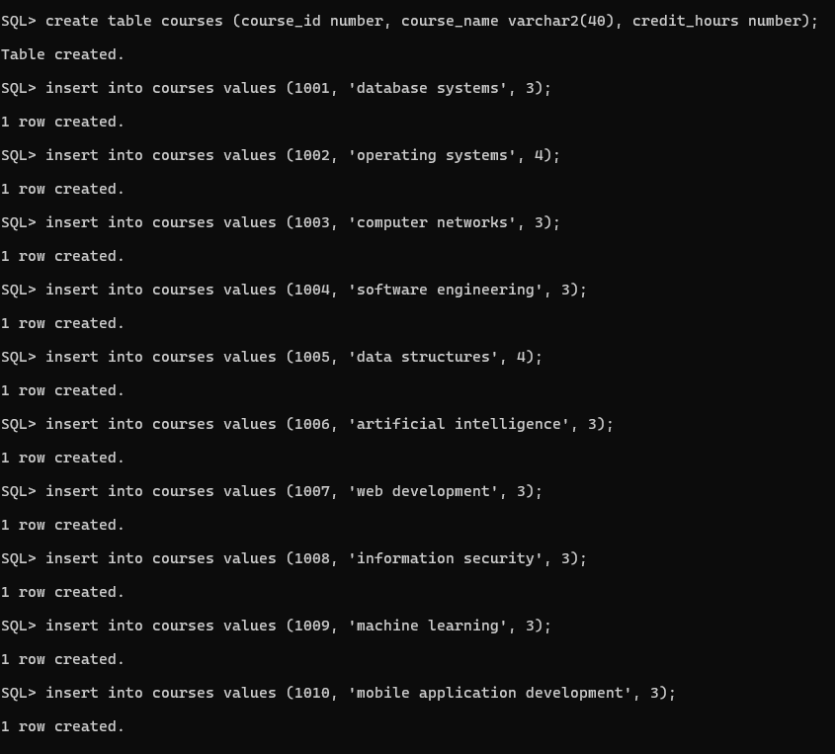
Database Lab Report:

Introduction
In this lab we worked on oracle sql.
The aim of this lab was to learn table creation and management.
We used ddl commands on hospital related tables.

Table Creation
In this step a table named patient_records was created.
This table stored patient information.
Example syntax:
create table patient_records (pid number, pname varchar(50), age number, disease varchar(40), addmision_date varchar(30));

Insert Records
After creating the table records were added.
Fifteen patient records were inserted into the table.
Example syntax:
insert into patient_records values (100, 'ali ahmad', 32, 'diabetes', '01-jan-2026');

Alter Table
In this task table structure was changed.
Only alter add command was used.
New columns were added to the table.
Example syntax:
alter table patient_records add doctor_name varchar(30);

Rename Table
In this step the table name was changed.
Patient_records was renamed to hospital_records.
Example syntax:
rename patient_records to hospital_records;

Create More Tables
Three simple hospital related tables were created.
These tables were doctors nurses and rooms.
Example syntax:
create table doctors (id number, name varchar(30));

Rename New Tables
The created tables were renamed.
Doctors was renamed to hospital_doctors.
Example syntax:
rename doctors to hospital_doctors;

Truncate Table
Before truncating some data was inserted.
Truncate command removed all records from the table.
Table structure remained safe.
Example syntax:
truncate table hospital_doctors;

Drop Table
In the last step tables were deleted permanently.
Drop command removed table and its structure.
Example syntax:
drop table hospital_doctors;

Next Lab Task Courses Table
For the next lab a new table named courses was created.
Ten records with four digit ids were added.
Example syntax:
create table courses (course_id number, course_name varchar(40), credit_hours number);
insert into courses values (1001, 'database systems', 3);

