

LAB JOURNAL 06
Course: Database Management System Lab

Instructor: Syed Adeel Khalid
Semester: Spring 2026

NAME: SAIM ZAFAR

ENROLLMENT: 01-135241-045

Title: Aggregate Functions, Group By & Having Clause

Objectives:

- Basic Understanding of Aggregate Functions.
- Using of Aggregate Functions for retrieving information

Lab Tasks:

- Display the total salary amount being dispersed every month of an organization
Assuming the records are placed in EMP table.
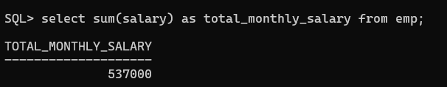
- Show the lowest and highest salary of employees.
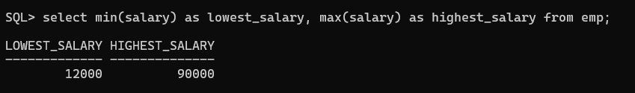
- Display the variation using standard deviation and variance in salaries of
Employees.
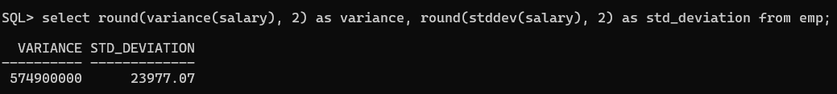
- Show the total number of employees in an organization.
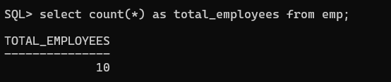
- Display the highest, lowest & average salaries of employees who were hired in January
And Feb month.

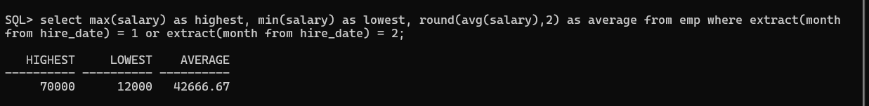

- Write a query that displays the difference between the highest and lowest salaries.
Label the column DIFFERENCE.
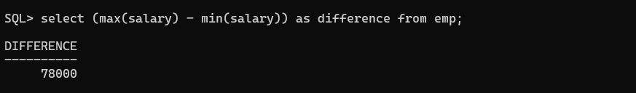
- Display the salary of the lowest paid employee Exclude anyone whose hire_date is null or not known. Exclude any groups where the Minimum salary is less than 1100. Sort the output in descending order of salary
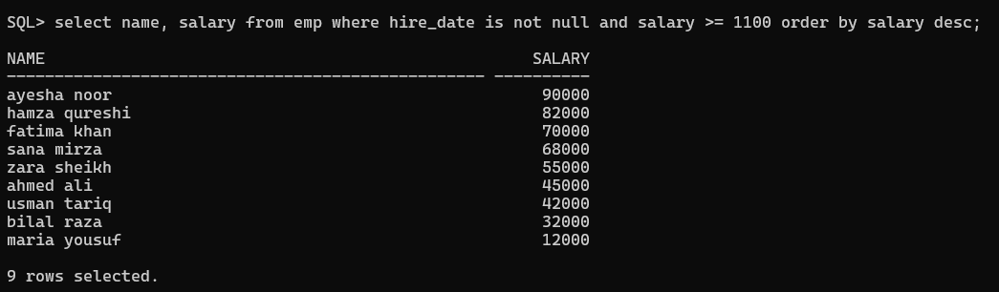
- Create a query that will display the total number of employees and, of that total, the
Number of employees hired in 2010, 2011, 2012, and 2013. Create appropriate column
Heading
