

LAB JOURNAL 05
Course: Database Management System Lab
NAME: SAIM ZAFAR
ENROLLMENT: 01-135241-045

Instructor: Syed Adeel Khalid
Semester: Spring 2026

Title: Single Rows Function including Date Functions.

Objectives:

- Basic Understanding of Single Rows Function including Date Functions.
- Using of Functions Single Rows and Date functions for retrieving information

Lab Tasks:
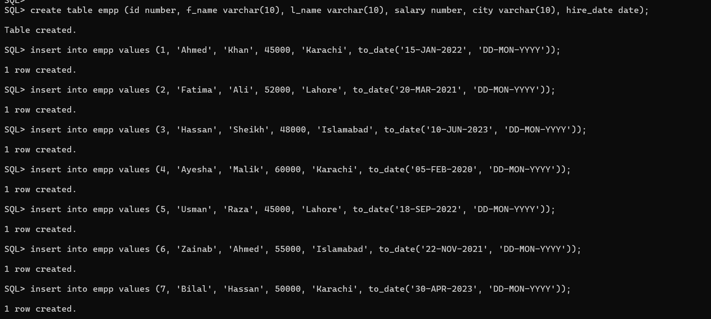
- Write a query to display the current date. Label the column Date.
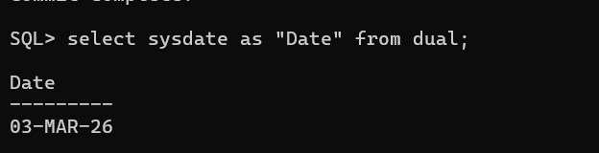

2. For each employee, display the employee ID number, last_name, salary, and salary increased
By 15% and expressed as a whole number. Label the column New Salary.
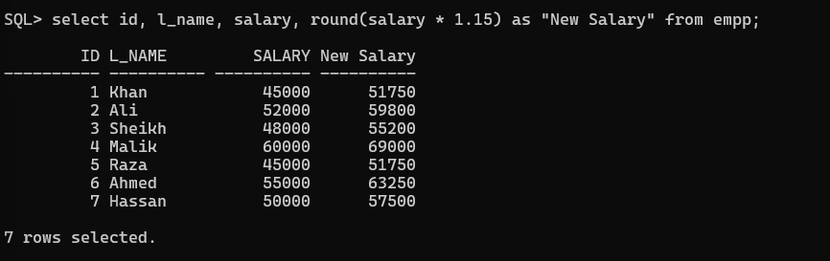

3. Modify your query add a column that subtracts the old salary from the new salary.
Label the column Increase.
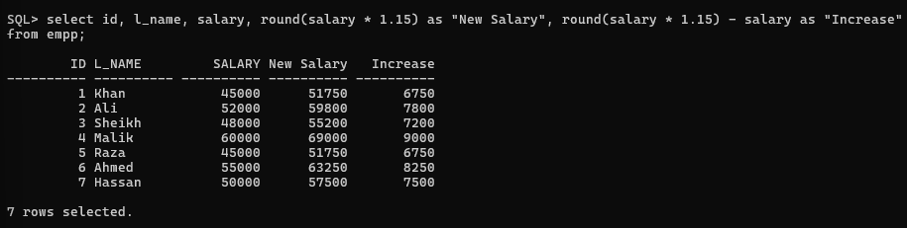

4. Write a query that displays the employee’s last names with the first letter capitalized and all
Other letters lowercase and the length of the names, for all employees whose name starts with
J, A, or M. Give each column an appropriate label. Sort the results by the employees’ last
Names.
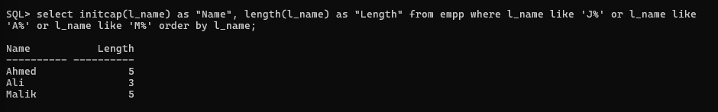

5. For each employee, display the employee’s last name, and calculate the number of months
Between today and the date the employee was hired. Label the column MONTHS_WORKED.
Order your results by the number of months employed. Round the number of months up to the
Closest whole number. Note: Your results will differ.
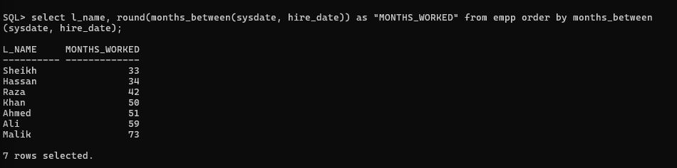

6. Display each employee’s last name, hire date, and salary review date, which is the first Monday
After six months of service. Label the column REVIEW. Format the dates to appear similar to
“Monday, the Thirty-First of July, yyyy.”
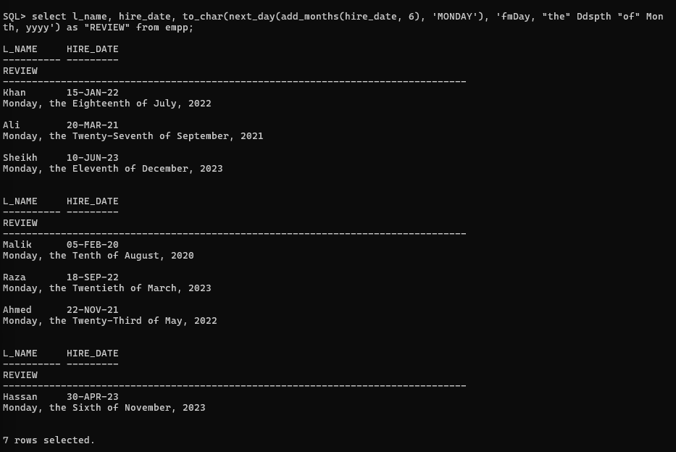

7. Display the last name, hire date, and day of the week on which the employee started. Label the
Column DAY. Order the results by the day of the week starting with Monday.
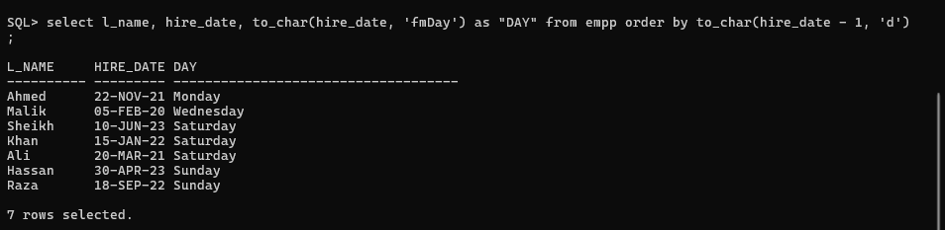

8. Create a query that displays the employees’ last names and indicates the amounts of their annual
Salaries with asterisks. Sort the data in descending
Order of salary. Label the column EMPLOYEES_AND_THEIR_SALARIES.

