Cs320 Lab 4 Practice tasks

NAME: SAIM ZAFAR
ENROLLMENT: 01-135241-045
Task 1:
Write a shell script named hello.sh that:
- Takes an integer input from the user.
- Checks whether the number is even or odd.
- Displays an appropriate message.
- Prints the current date after displaying the result.
Requirements:
- Use #!/bin/bash
- Use read to take input
- Use if-else statement
- Add proper comments in the script
Sample Output:
Enter a number: 7
7 is an Odd number
Today's date is: Mon Feb 16 10:15:30 PKT 2026
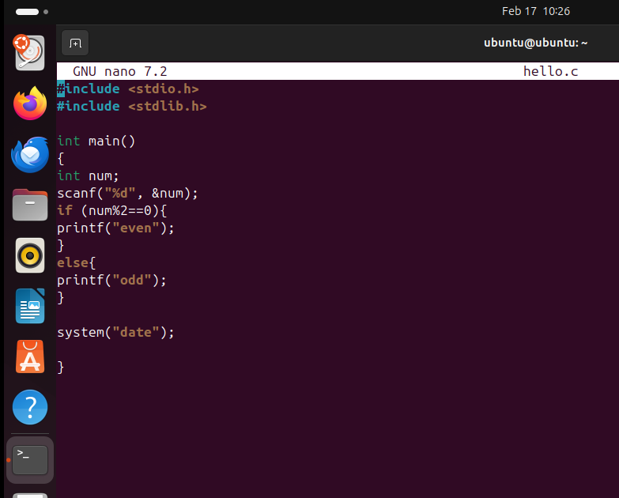
Task 2:
Write a shell script named table.sh that:
- Takes a number from the user.
- Prints the multiplication table of that number up to 10.
- Uses a for or while loop.
Requirements:
- Use #!/bin/bash
- Use loop (for or while)
- Display output in proper format
- Add comments in script
Sample Output:
Enter a number: 5
Multiplication Table of 5
5 x 1 = 5
5 x 2 = 10
5 x 3 = 15
...
5 x 10 = 50
