CSL 320 LAB 1

NAME: SAIM ZAFAR
ENROLLMENT: 01-135241-045

Task 1:
Remove a subdirectory name capital from country directory from the home directory
  - Make a directory name capital. In capital directory create subdirectory name country. Now come back to the home directory and remove country subdirectory directly from home directory.
Answer:
- Go to the home directory: cd ~
- Create a directory named capital: mkdir capital
- Inside the capital directory, create a subdirectory named country: mkdir capital/country
- Return to the home directory: cd ~
- Remove the country subdirectory directly from the home directory: rmdir capital/country

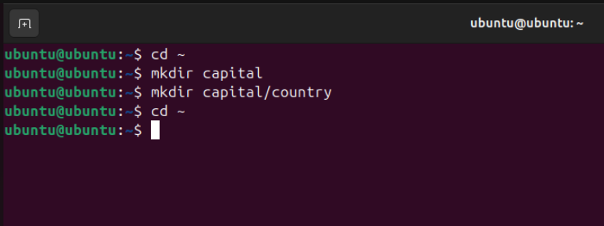
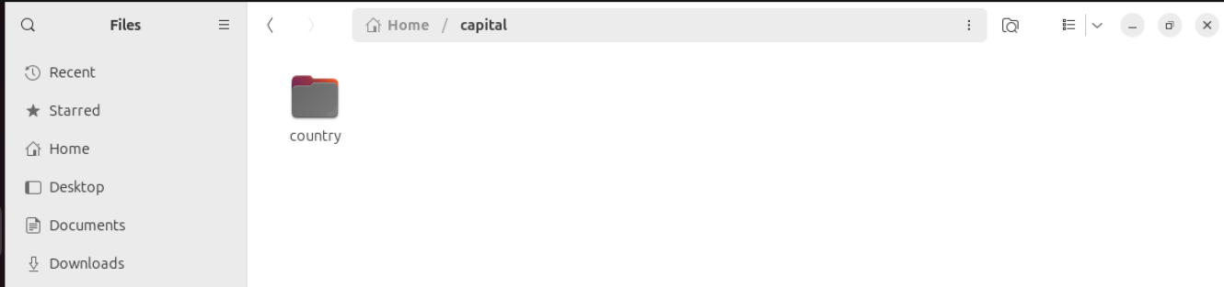
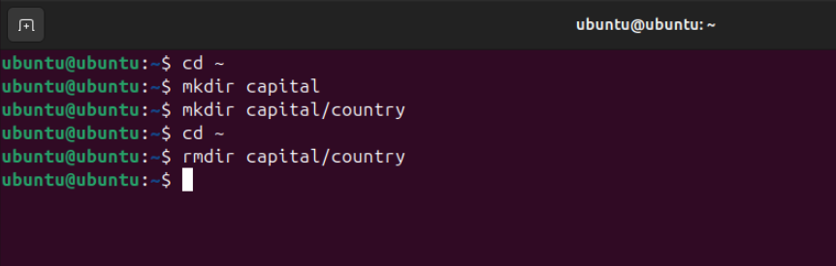
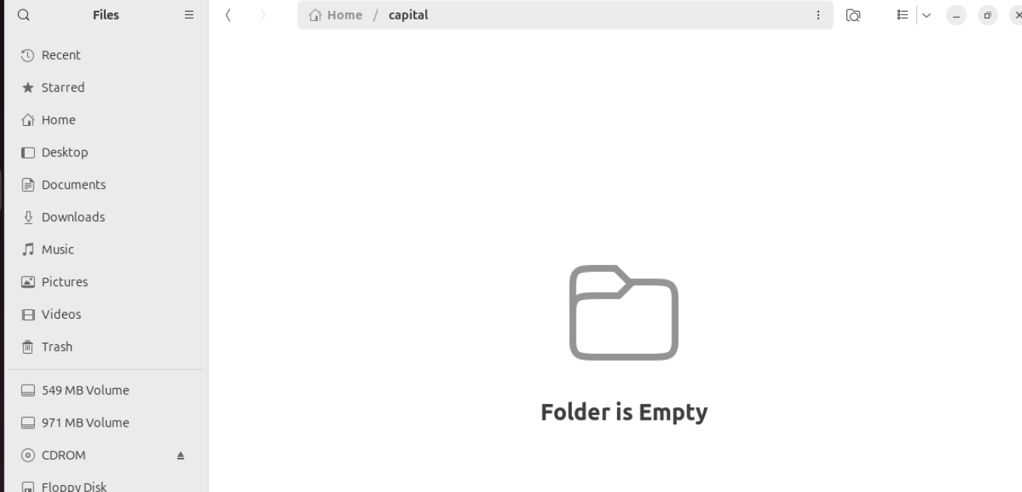

Task 2:
Move to a directory name plant directly from a subdirectory name lion
  - Make a directory name plant in home directory. Create another directory name animals in home directory as well. Now create a subdirectory name lion in animal directory. Move to the directory name plant from the lion subdirectory directly
Answer:
1. Go to the home directory: cd ~
2. Create a directory named plant: mkdir plant
3. Create a directory named animals: mkdir animals
4. Inside the animals directory, create a subdirectory named lion: mkdir animals/lion
5. Move to the plant directory directly from the lion subdirectory: cd ../../plant

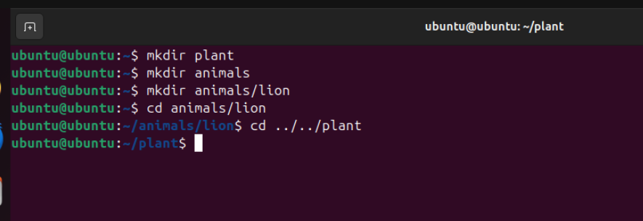

Task 3:
Rename a file name data.txt with new name lab_data.txt in a folder name data_file
  - Create a directory name data_file. In data_file directory create a file name data.txt. After creation of data.txt rename it to lab_data.txt
  - Find the Inode number of file named lab_data.txt by keeping yourself in home directory
Answer:
- Go to the home directory: cd ~
- Create a directory named data_file: mkdir data_file
- Inside the data_file directory, create a file named data.txt: touch data_file/data.txt
- Rename data.txt to lab_data.txt: mv data_file/data.txt data_file/lab_data.txt
- Find the inode number of lab_data.txt while in home directory: ls -i data_file/lab_data.txt
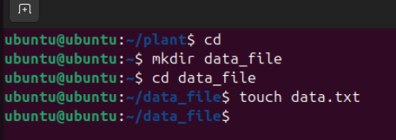
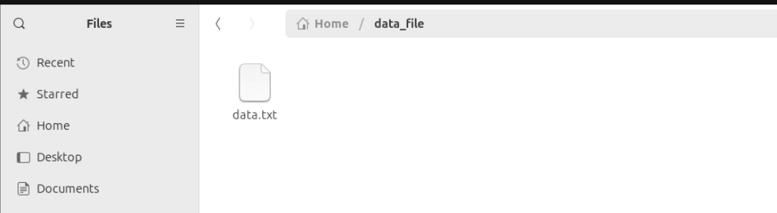
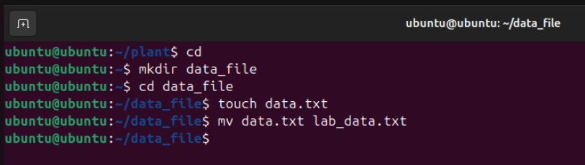
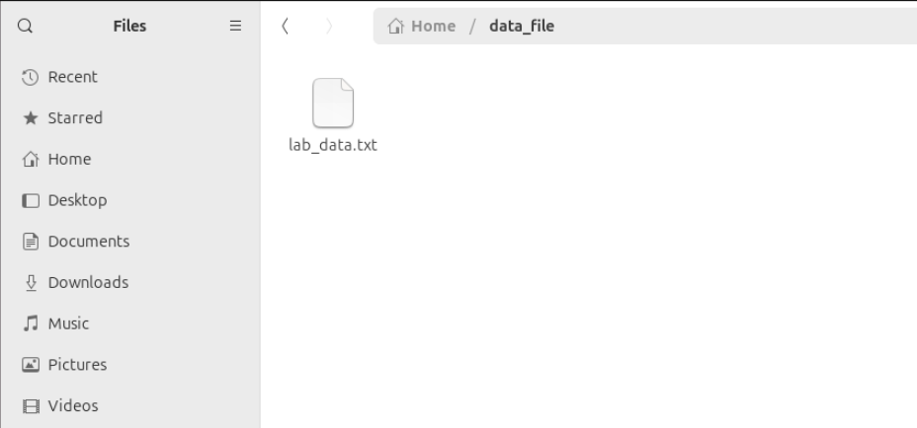
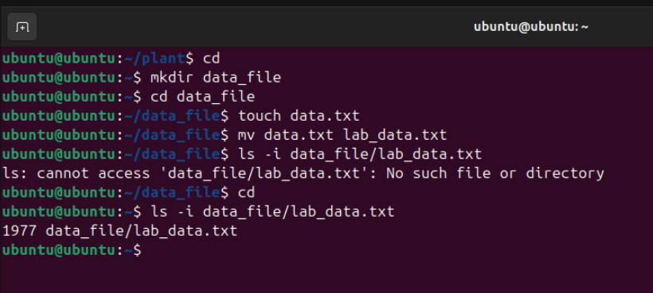

Task 4:
- Working with Directories, Files, and Permissions
- In your home directory, create a directory named Projects.
- Inside Projects, create two subdirectories: Linux and Python.
- In Linux, create a text file named commands.txt and write 5 basic Linux commands into it using nano.
- Copy commands.txt from Linux into the Python directory.
- Change the permissions of commands.txt inside the Python directory so only the owner can read and write it (no access for others).
- From your home directory, remove the entire Python directory (with its contents) in a single command.

Answer:
  - Create a directory named Projects: mkdir Projects
  - Inside Projects, create two subdirectories named Linux and Python: mkdir Projects/Linux Projects/Python
  - In the Linux directory, create a text file named commands.txt using nano and write 5 basic Linux commands in it: nano Projects/Linux/commands.txt
  - Copy commands.txt from the Linux directory to the Python directory: cp Projects/Linux/commands.txt Projects/Python/
  - Change the permissions of commands.txt inside the Python directory so only the owner can read and write it: chmod 600 Projects/Python/commands.txt
  - From the home directory, remove the entire Python directory along with its contents in a single command: rm -r Projects/Python
