CSC 320 Operating Systems LAB 2
SOLUTION
NAME: SAIM ZAFAR
ENROLLMENT: 01135241-045

Task:
  - Store the data of file1, file2, file3 in a file name Newfile containing nothing without overwritten
SOLUTION:
- Create a working directory:
mkdir oslab2
cd oslab2
- Create required files:
touch file1 file2 file3 Newfile
- Add data to files:
echo "This is file1" > file1
echo "This is file2" > file2
echo "This is file3" > file3
- Append data into newfile:
cat file1 file2 file3 >> newfile
- Display the contents of newfile:
cat Newfile

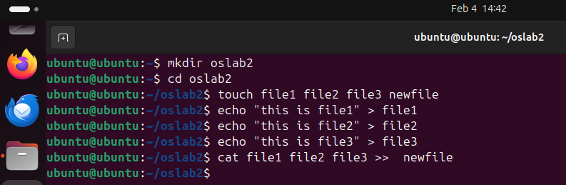
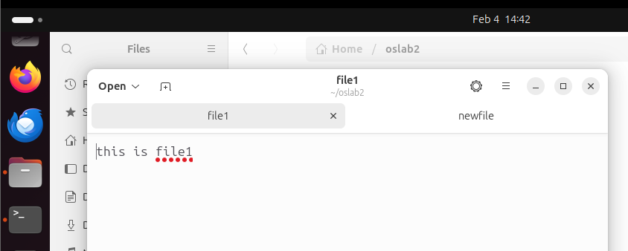
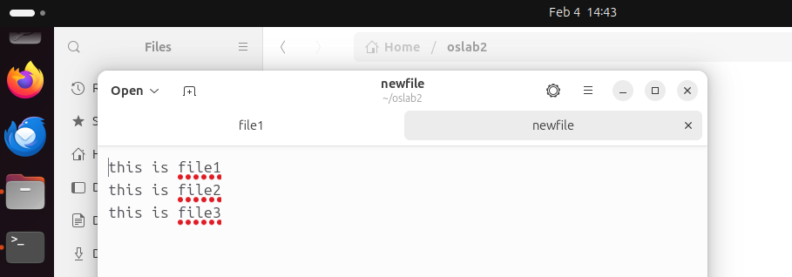
  - Echo Hello World in a file name newfile1
SOLUTION:
- Create the file newfile1:
touch newfile1
- Write “Hello World” into the file using echo:
echo "Hello World" > newfile1
- Display the contents of the file:
cat newfile1

  - Count the number of times your name is shown in a file name Newfile just created in part a of this task which is used as input for a file named redirection_Example
SOLUTION:
- Add name into newfile:
echo "saim zafar" >> newfile
echo "saim zafar" >> newfile
- Count the number of occurrences and redirect output:
grep -c "saim zafar" newfile > redirectionexample
- Display the output file:
cat redirectionexample
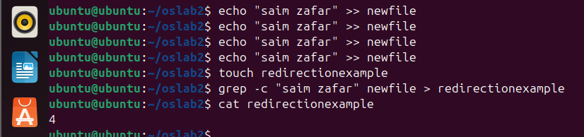
  - Find your name in file file1, file3 and file4 and put the valid output in output.txt and error messages in error.txt
SOLUTION:
- Create the required files:
touch file1 file3
file4 is not created on purpose to show error
- Add data into files:
echo "saim zafar is a student" > file1
echo "hello saim zafar" > file3
- Search the name and redirect outputs:
grep "saim zafar" file1 file3 file4 > output.txt 2> error.txt
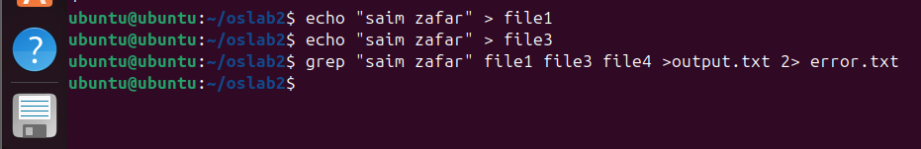
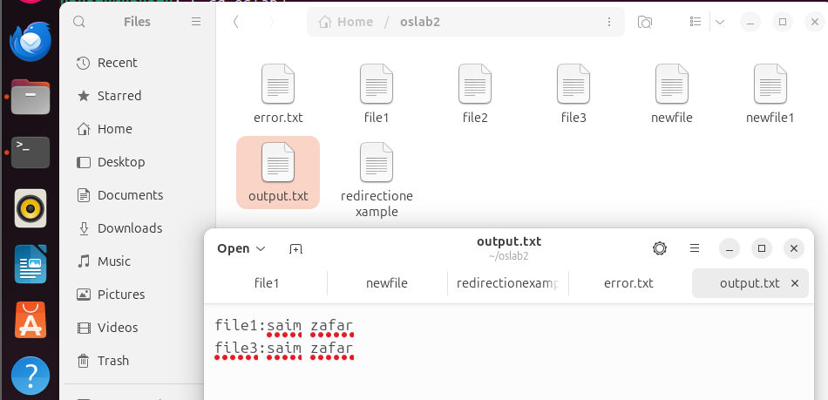
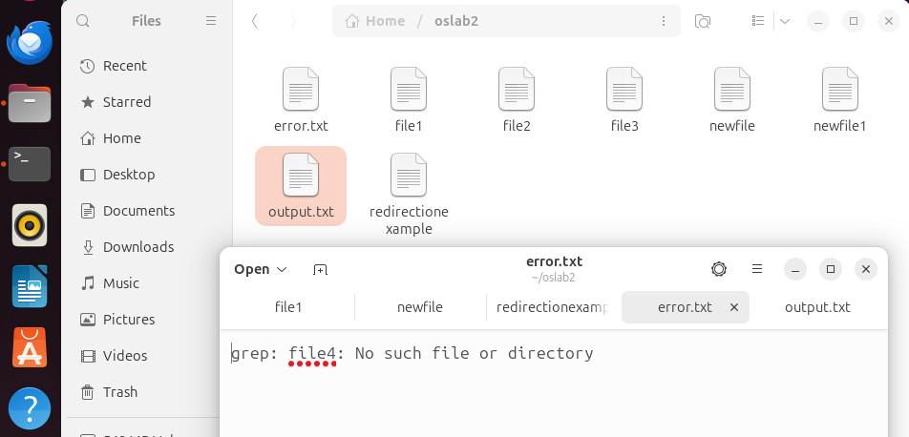

Task:
Create the following files:
task1, task2, work, giki2, linux1, hello, last.txt, f7.txt
Add the given content to last.txt and f7.txt.
last.txt:
Ubuntu1, ubuntu2, uubuntu3, world
f7.txt:
Pakistan, india123, atm, bank
SOLUTION:
- Create the required files:
touch task1 task2 work giki2 linux1 hello last.txt f7.txt
- Add content to last.txt:
echo "Ubuntu1, ubuntu2, uubuntu3, world" > last.txt
- Add content to f7.txt:
echo "Pakistan, india123, atm, bank" > f7.txt
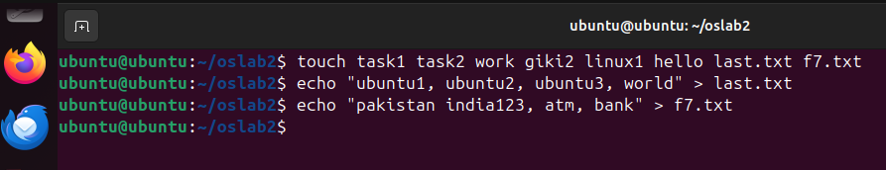

Task1:
- For file task1:
    - Set read, write and execute permissions for group
Remove read, write permissions for owner
SOLUTION:
- Set read, write, and execute permissions for group:
chmod g+rwx task1
- Remove read and write permissions for owner:
chmod u-rw task1
- Verify permissions:
ls -l task1
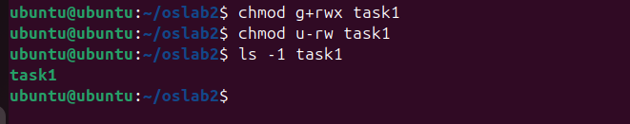
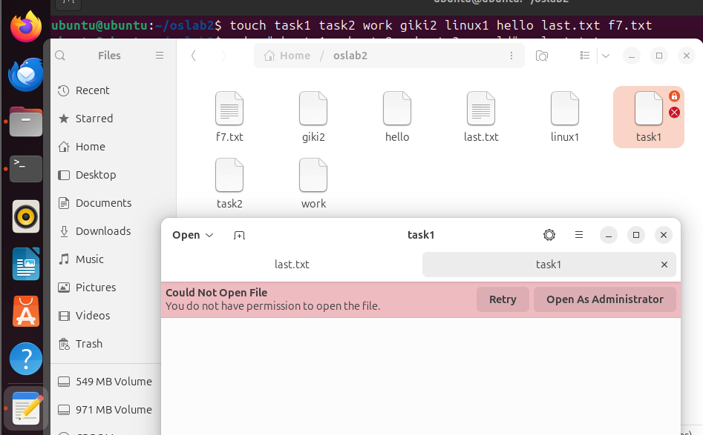

Task 2;
    - Allow write permissions for owner, execute permission for group and read permission for others
SOLUTION:
- Give write permission to owner:
chmod u+w task2
- Give execute permission to group:
chmod g+x task2
- Give read permission to others:
chmod o+r task2
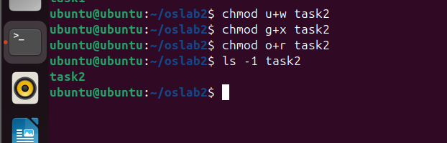

Task 3:
Find the files whose first five characters can be any but the last should be a number between (5-9)
SOLUTION:
- Create sample files:
touch abcde5 abcde7 abcde9 abcde3 hello10
- List files that match pattern:
ls ?????[5-9]
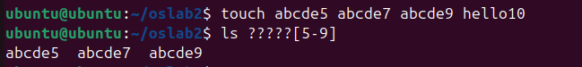

Task 4:
Find the files whose first and last characters should be between
(p – s) and anything between them
SOLUTION:
- Create sample files:
- List files that match the pattern:
ls [p-s]*[p-s]
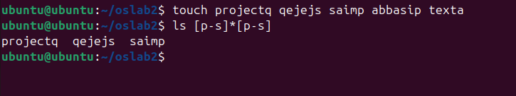

Task 5:
Try to copy the files with extension .c from Dir001 to Dir101 by keeping yourself in Dr01
SOLUTION:
- Create required directories:
mkdir Dir001 Dir101 Dr01
- Create sample .c files in Dir001:
touch Dir001/file1.c Dir001/file2.c Dir001/test.txt
- Stay in Dr01 and copy .c files:
cp ../Dir001/*.c ../Dir101/
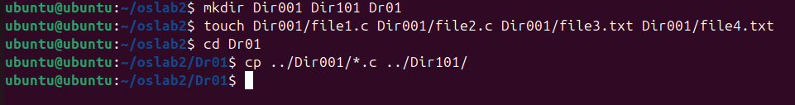
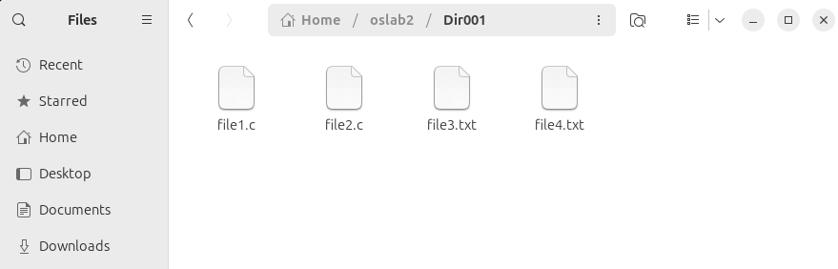

Task 6:
Try to remove .txt extension files from Dir001 keeping yourself in Dr00
SOLUTION:
- Create required directory:
mkdir Dr00
- Stay in Dr00 and remove .txt files:
rm ../Dir001/*.txt
- Verify remaining files:
ls ../Dir001
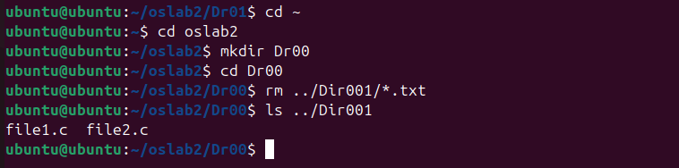

Task 7:
Try to move f7.c from Dir001 to Dir1 by keeping yourself in Dir102
SOLUTION:
