CS320 LAB 3 TASKS
Name: Saim Zafar
Enrollment: 01-135241-045
Description:
Files:
OS -> (ayesha, lab3, lab1, hello, Lab3 is in progress, I am
a student, 2024) (Hint: Each word with separated
commas is on new line )
file1 -> (Hello ayesha)
file2 -> (The only way to do great work is to love what
you do)
file3 -> (Be kind)
Task 1:
- Find the number of lines that start with either integers, capital or small
letters in the file OS
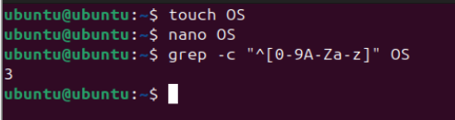
- Find the lines that contain spaces in the file OS
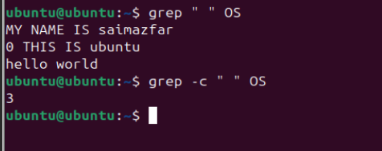

- Make a file name lab3 and put some information in it. Find all the lines that
start with vowels
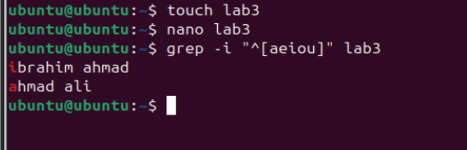
- Find all the lines not containing the word kind case insensitively
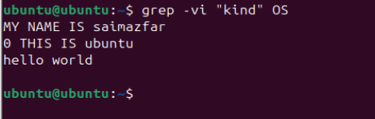
- Display 2 lines just before the statement “I am a student”
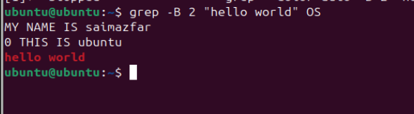
Task 2:
- Store the data of file1, file2, file3 in a file name Newfile containing nothing without overwritten
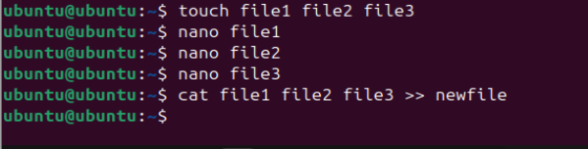
- Echo Hello World in a file name newfile1
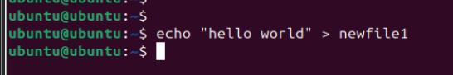
- Count the number of times your name is shown in a file name Newfile just
created in part a of this task which is used as input for a file named
redirection Example
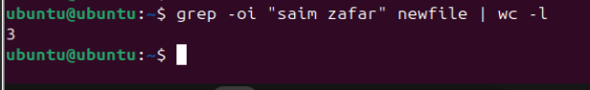
- Find your name in file file1, file3 and file4 and put the valid output
in output.txt and error messages in error.txt
Task 3:
Write and execute Linux shell commands to demonstrate the use of grep, piping (|), and input/output redirection.
Perform the following tasks:
- Create a text file named students.txt containing at least 5 student records (one record per line).
- Display the contents of the file using a file viewing command.
- Use the grep command to search for:
  - A specific word or name in the file
  - A pattern using case-insensitive search
- Use piping (|) to:
  - Count the number of lines that match a given pattern
  - Display line numbers for the matched lines
- Use output redirection to:
  - Save the result of a grep command into a file named output.txt
  - Append another search result to the same file
- Use input redirection to read data from students.txt and process it using a command-line utility
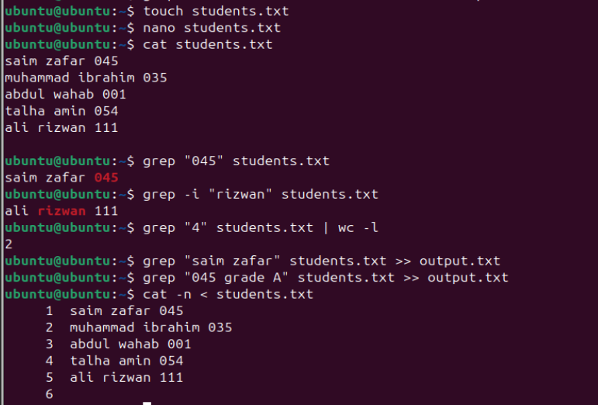
Instructions:
- Take Screenshot of every step which you type or enter the command and also take Screenshot of console output according to every question.
- Proper add the name and enrollment number and submit a report of lab tasks/journal.
- Follow the same practice for lab tasks every week.
- Late submissions will not be accepted.

