CS320 LAB 4 TASKS
Task 1:
Write a C code which asks from user to enter his/her name and age then it prints Hello, Name(Sana), your age.
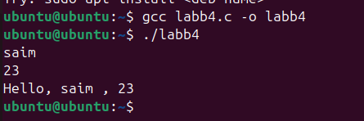
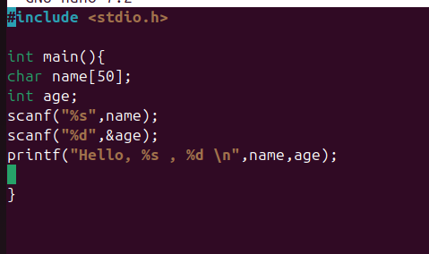
Task 2:
Write a code in C which asks from user to enter two numbers and then perform all the basic operations on them (+, -,*)
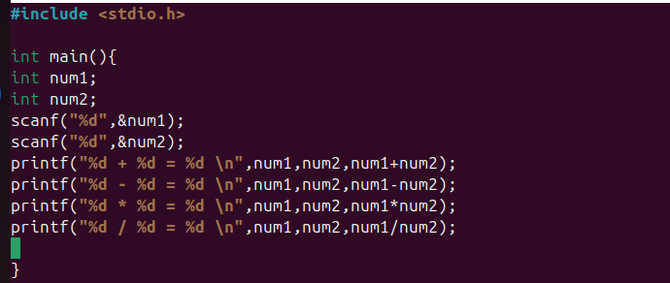
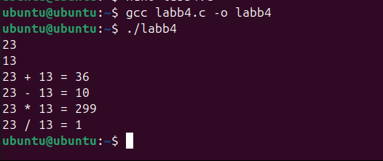
Task 3:
Create a C program named task3 that prompts the user to enter their GPA and the number of courses they are enrolled in, displaying these values with two decimal places using printf. Then, prompt the user to enter their name, allocate dynamic memory to store the entered name, and display it using printf
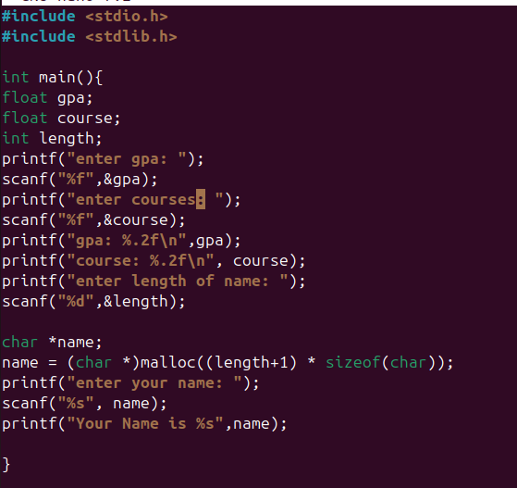
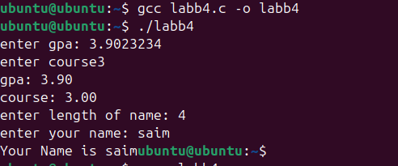
Task 4:
Write a code in C that declares a structure to store id, pages and price of a book. It inputs the records of five books from the user by asking every time to insert the data till the five books and display the record of most costly book. Clear the memory after your work
