System And Network Administration Lab
ITL 312

Lab Journal # 02


Submitted By:
NAME: | ENROLLMENT:
MUHAMMAD IBRAHIM | 01-135241-035
MANZER BIBI | 01-135241-026
ATEEQ UR REHMAN | 01-135241-011
MUHAMMAD TALHA AMIN | 01-135241-054
SAIM ZAFAR | 01-135241-045

Submitted To:
SIR RAJA SHUMAIL
Department of Computer Sciences

BAHRIA UNIVERSITY, ISLAMABAD

Task 1: Give answers to the following.
- Install ADDS? (Add Screenshots)
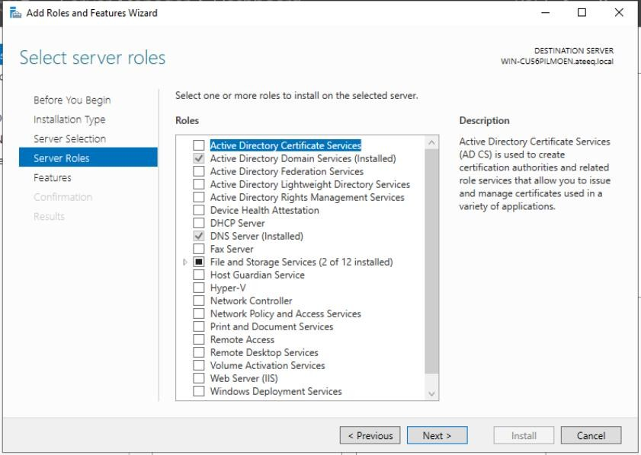

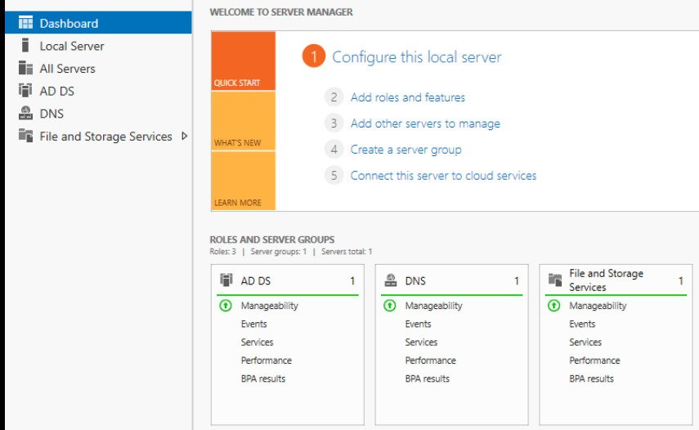

- What is the difference between Workgroup & Domain?

➢ Workgroup
A Workgroup is a peer-to-peer networking model where all computers are treated equally. There is no central server, and each computer maintains its own user accounts, passwords, and security settings.

Characteristics of Workgroup
- No centralized administration
- Each computer manages its own resources
- Users must have separate accounts on each computer
- Limited control over security policies
- Simple and low-cost setup
- Best suited for small networks (usually up to 10–15 computers)

Advantages
- Easy to install and configure
- No need for a dedicated server
- Minimal technical knowledge required

Disadvantages
- Difficult to manage as the network grows
- Weak security compared to domain networks
- No centralized backup or policy enforcement

➢ Domain
A Domain is a client-server network model where all computers are controlled by one or more
Domain Controllers. User accounts, permissions, and security policies are centrally managed.

Characteristics of Domain
- Centralized authentication and management
- One username and password can be used on any system in the domain
- Security policies are applied uniformly
- Supports thousands of computers and users
- Requires a dedicated server and skilled administrator

Advantages
- High level of security
- Easy management of users and resources
- Scalable and reliable for large organizations

Disadvantages
- Higher setup and maintenance cost
- Requires technical expertise
- Server failure can affect network access

Workgroup | Domain
Used in small networks (home or small office). | Used in large organizations.
No central control. Each computer manages its own users. | Centralized control using a server.
Users are stored locally on each PC. | Users are stored in Active Directory.
Less secure and harder to manage. | More secure and easier to manage centrally.
No dedicated server required. | Requires a Domain Controller.

3) Differentiate between ADC, RODC & CDC?
In an Active Directory environment, ADC, RODC, and CDC are different types of Domain Controllers used to manage users, authentication, and network resources. They differ mainly in role, security level, and usage scenario.

➢ CDC (Central Domain Controller)
A CDC (Central Domain Controller) is the primary and main domain controller in a network. It stores the master copy of the Active Directory database and performs all critical domain operations.

Key Features of CDC
- Acts as the main authority of the domain
- Stores complete Active Directory data
- Handles authentication, authorization, and policy enforcement
- Responsible for domain-wide changes
- Usually located at the head office

Advantages
- Full control over the domain
- High security and reliability
- Centralized management

Disadvantages
- Failure can affect the entire domain
- Requires strong security and backup measures

➢ ADC (Additional Domain Controller)
An ADC (Additional Domain Controller) is installed to support the CDC. It holds a replica copy of the Active Directory database and helps distribute network load.

Key Features of ADC
- Synchronizes data with the CDC
- Provides backup authentication services
- Reduces load on the CDC
- Improves performance and fault tolerance
- Can authenticate users if CDC is unavailable

Advantages
- Load balancing
- Increased reliability
- High availability of domain services

Disadvantages
- Still needs secure environment
- Depends on CDC for updates

➢ RODC (Read-Only Domain Controller)
A RODC (Read-Only Domain Controller) stores a read-only copy of Active Directory. It is mainly used in branch offices or remote locations where security is a concern.

Key Features of RODC
- Does not allow changes to Active Directory
- Prevents unauthorized modifications
- Limits credential storage
- Replicates changes only from CDC/ADC
- Ideal for low-security environments

Advantages
- High security
- Reduced risk if server is compromised
- Suitable for remote or branch offices

Disadvantages
- Cannot make directory changes
- Limited functionality compared to CDC and ADC

ADC | RODC | CDC
Additional Domain Controller | Read-Only Domain Controller | Child Domain Controller
Writable copy of Active Directory database. | Read-only copy of Active Directory database. | Controls a child domain under a parent domain.
Used for backup and load balancing. | Used in branch offices for security. | Used in large organizations with multiple domains.
Can make changes to AD. | Cannot make changes to AD. | Manages its own child domain structure.

4) What do you understand by the term Active Directory?

Active Directory
Active Directory (AD) is a directory service developed by Microsoft that is used to manage, organize, and secure network resources in a Windows domain environment. It provides a centralized system for managing users, computers, printers, applications, and security policies within an organization.

Definition
Active Directory is a central database that stores information about all network objects and allows administrators to control access, authentication, and authorization from a single location.

Key Functions of Active Directory
- Centralized User Management – Create, modify, and delete user accounts from one place
- Authentication & Authorization – Verifies user identity and controls access to resources
- Security Policy Management – Enforces password rules, login restrictions, and Group Policies
- Resource Management – Manages shared files, folders, printers, and applications
- Single Sign-On (SSO) – Users log in once and can access multiple network resources

Components of Active Directory
- Domain Controller Server that hosts Active Directory and authenticates users
- Domain A logical group of computers, users, and devices
- Organizational Units (OUs) Containers used to organize objects
- Group Policy Rules applied to users and computers to maintain security and consistency

Advantages of Active Directory
- Simplifies network administration
- Improves security through centralized control
- Scalable for small to large organizations
- Reduces administrative workload

Uses of Active Directory
- Corporate offices
- Educational institutions
- Government organizations
- Large enterprise networks

5) What is Active Directory Domain Controller?

Active Directory Domain Controller
An Active Directory Domain Controller (DC) is a server that runs Active Directory Domain Services (AD DS) and is responsible for authenticating users, authorizing access, and managing security policies in a Windows domain network.
It stores the Active Directory database, which contains information about users, computers, groups, and other network objects, and allows administrators to centrally manage the entire domain.

Functions of a Domain Controller
- Authenticates users and computers during login
- Controls access to network resources
- Stores and manages the Active Directory database
- Applies Group Policy settings
- Replicates directory data with other domain controllers

