SNA LAB

Lab Journal 1



NAME: | ENROLLMENT:
MUHAMMAD IBRAHIM | 01-135241-035
ABDUL WAHAB | 01-135241-001
ATEEQ UR REHMAN | 01-135241-011
MUHAMMAD TALHA AMIN | 01-135241-054
SAIM ZAFAR | 01-135241-045

Department of Computer Science
BAHRIA UNIVERSITY, ISLAMABAD

Tasks: Give answers to the following.
- Install Windows Server 2019 or 2016 (Add Screenshots)
- Install windows 10 pro or enterprise edition
- Why do we use Windows Server?
- Differentiate between Windows and Windows Server?
- What are the available editions of Windows server?

- Install Windows Server 2019 or 2016 (Add Screenshots)

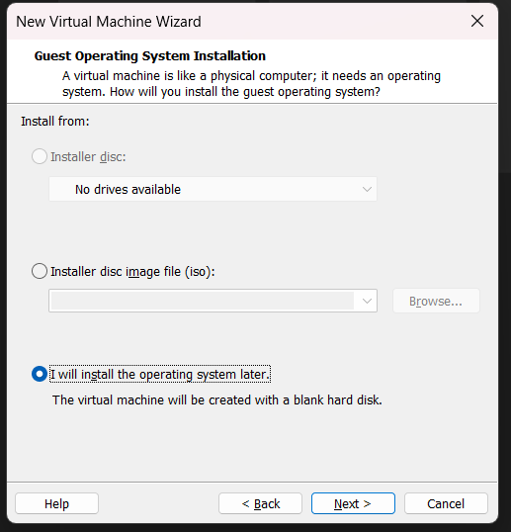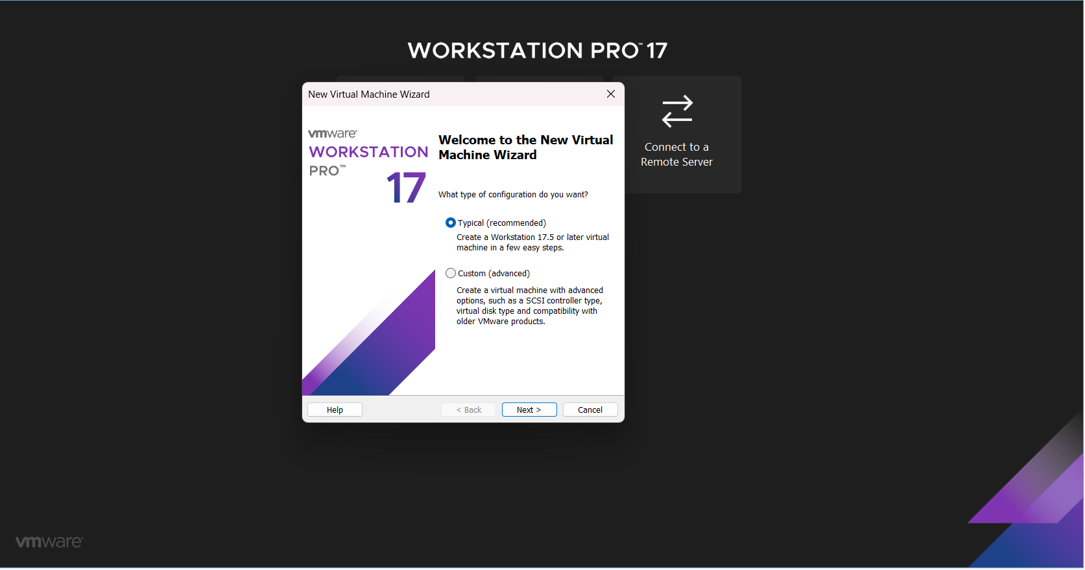

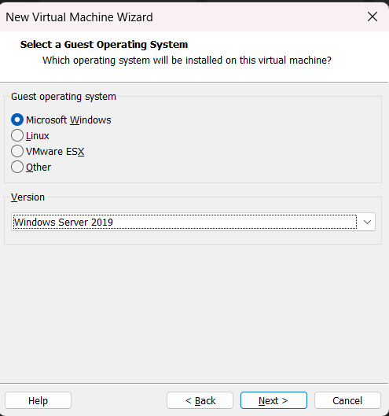
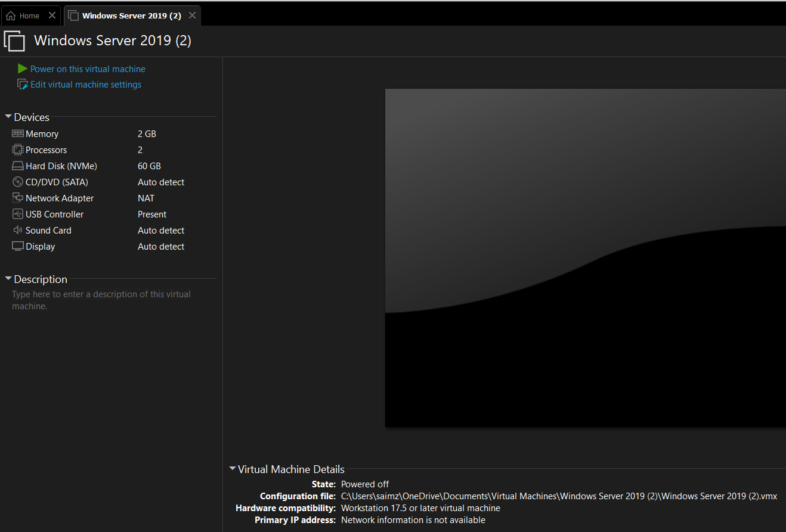
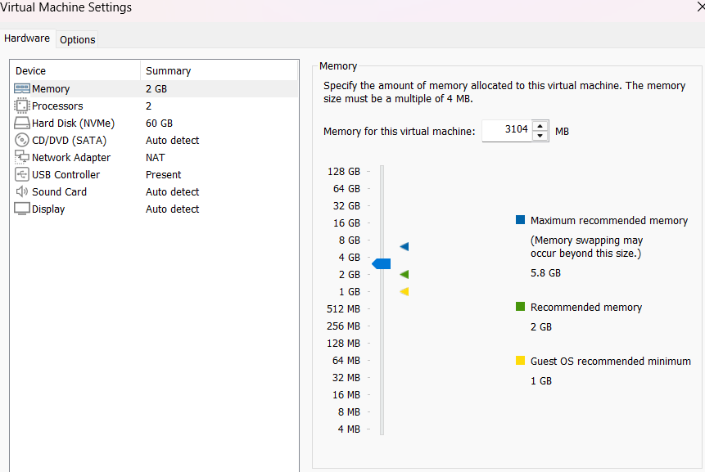
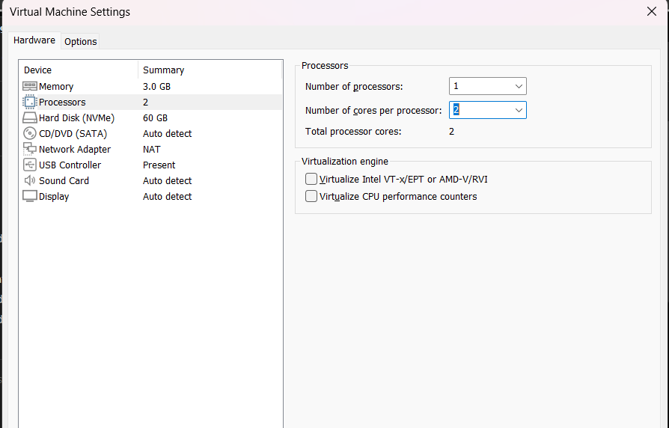
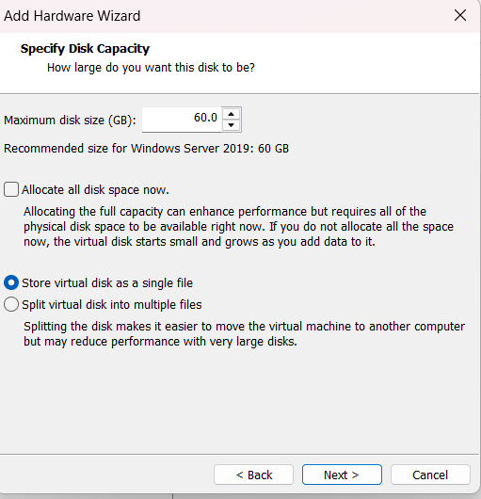
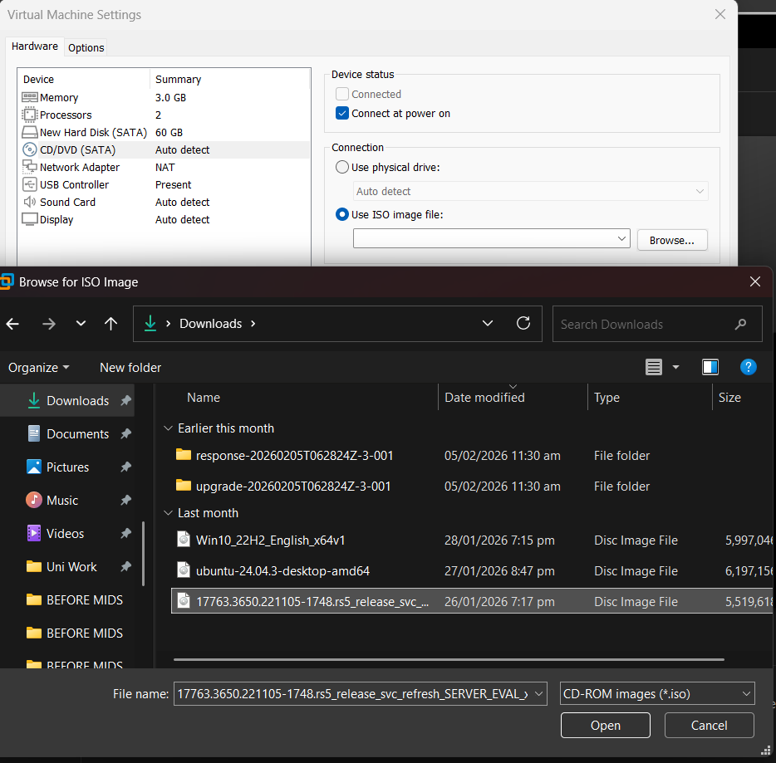

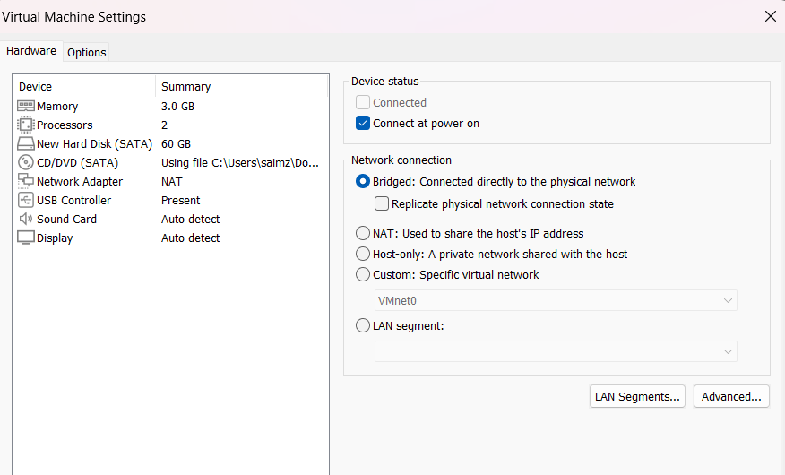
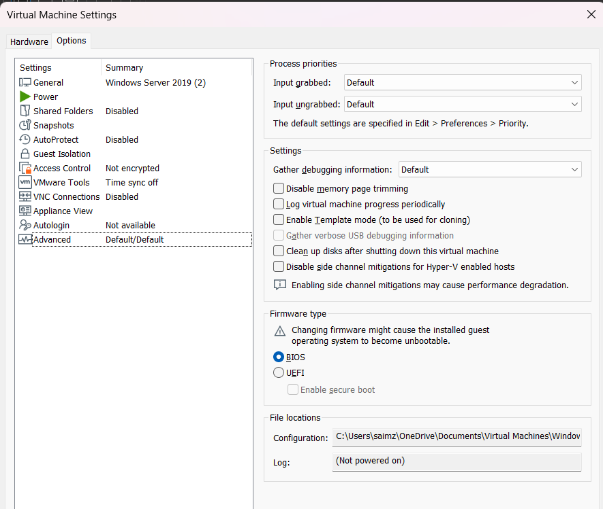

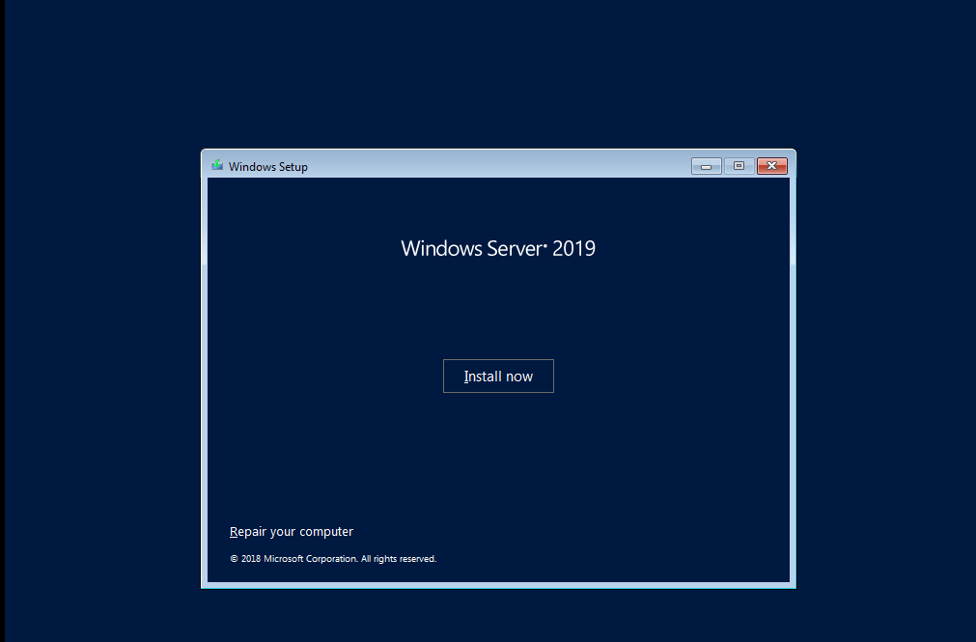
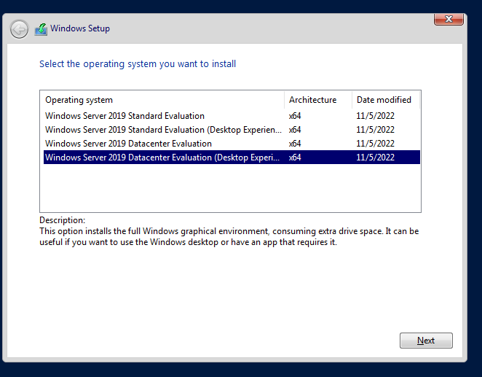
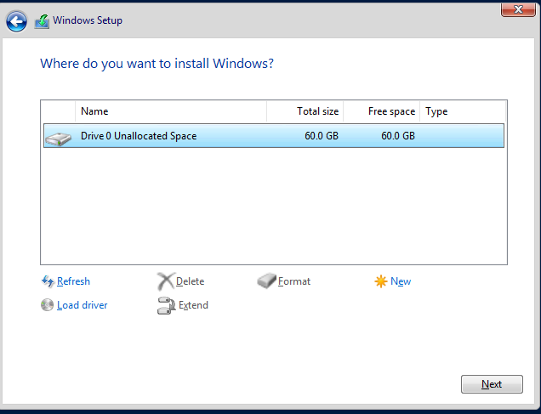
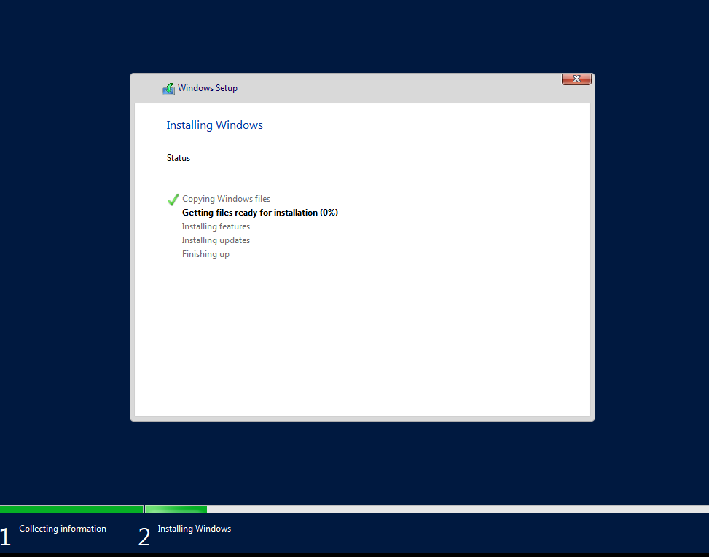
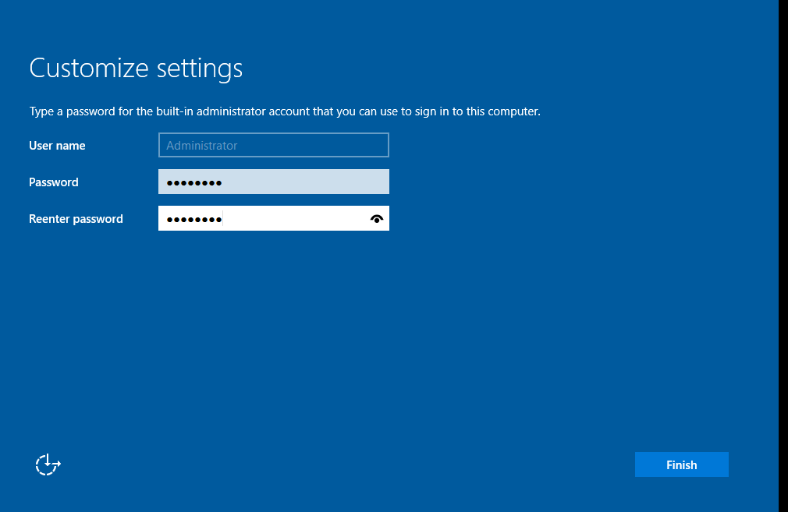
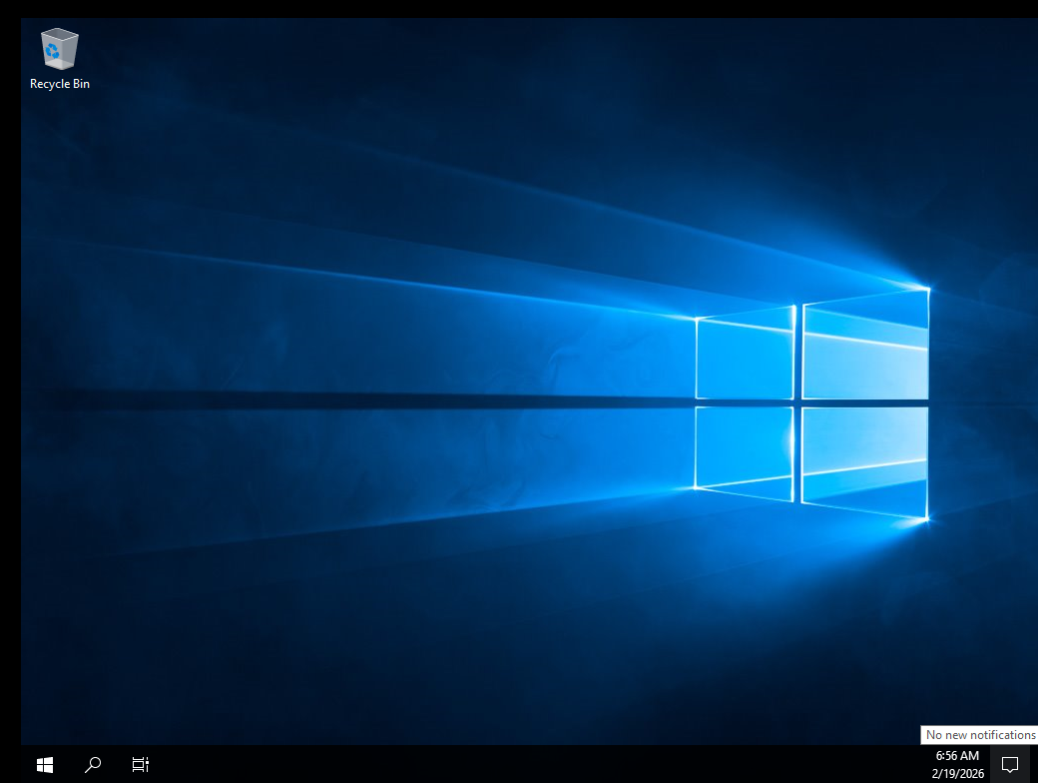

- Install windows 10 pro or enterprise edition

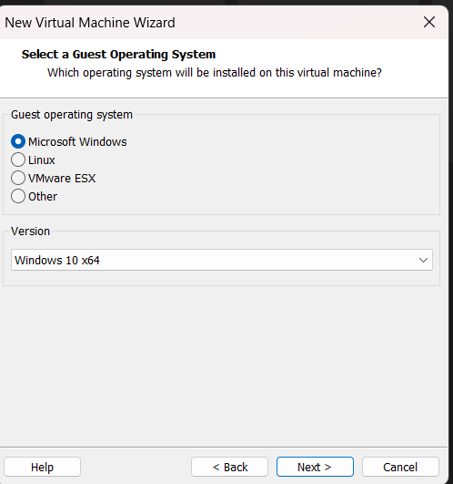
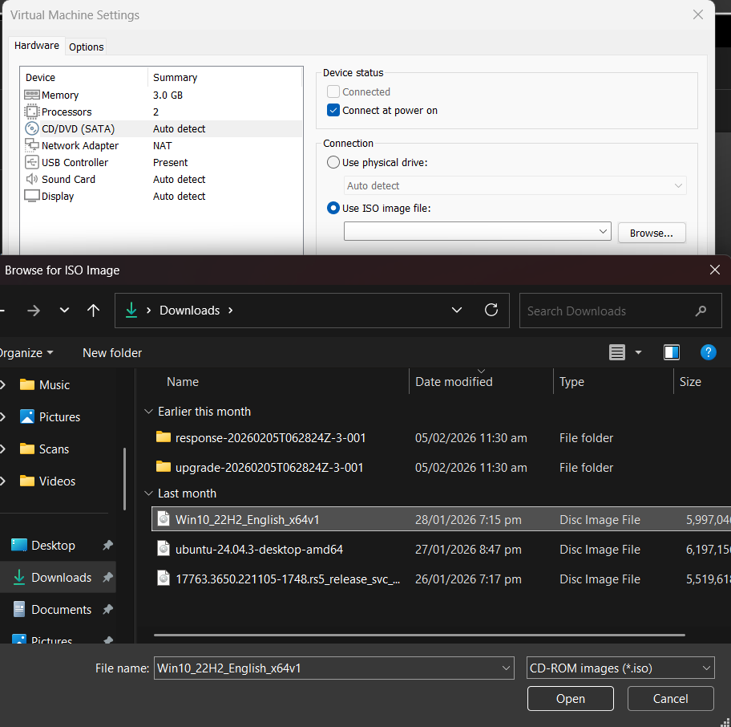
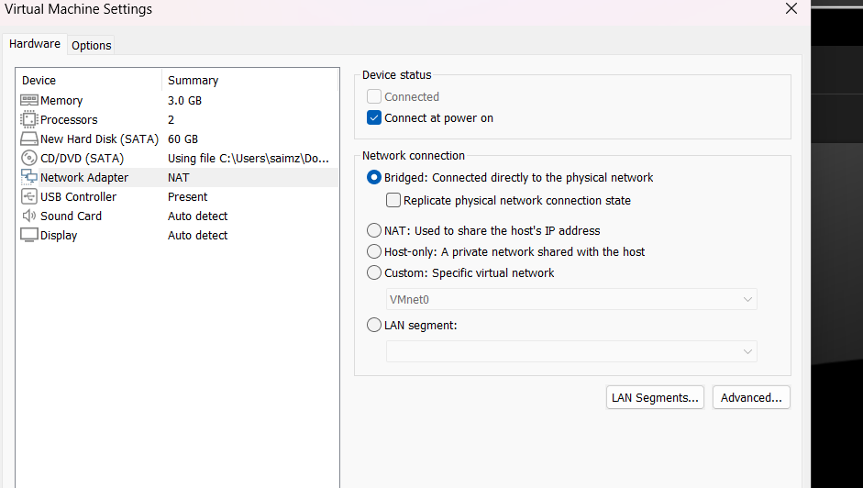
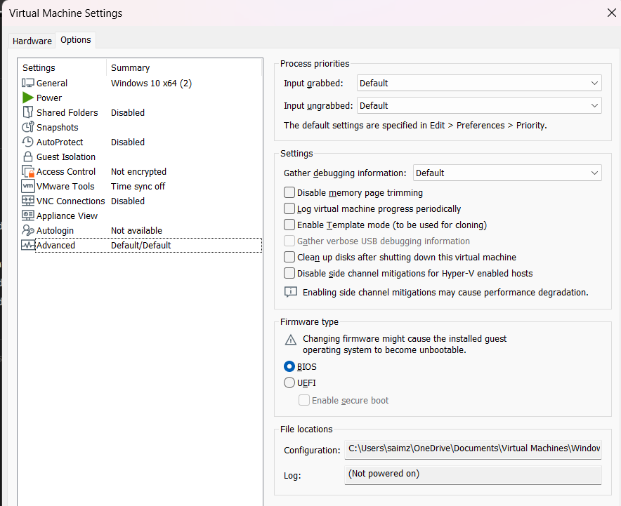
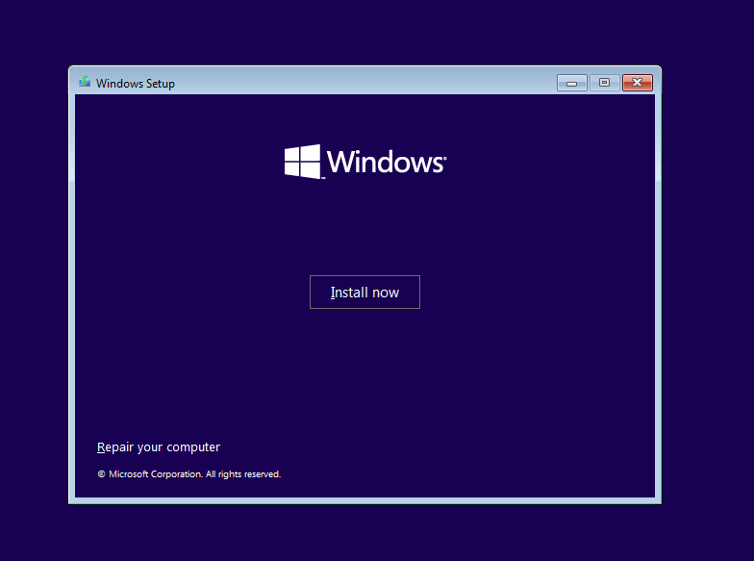
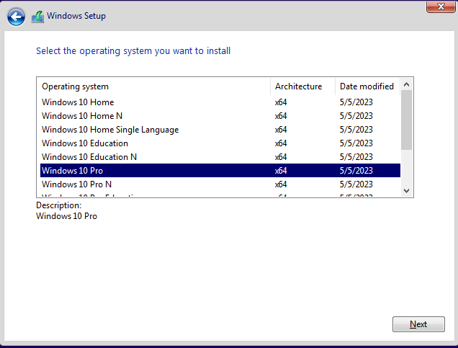
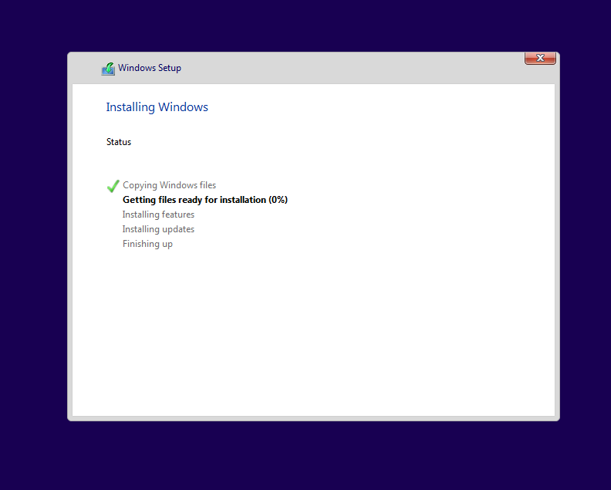
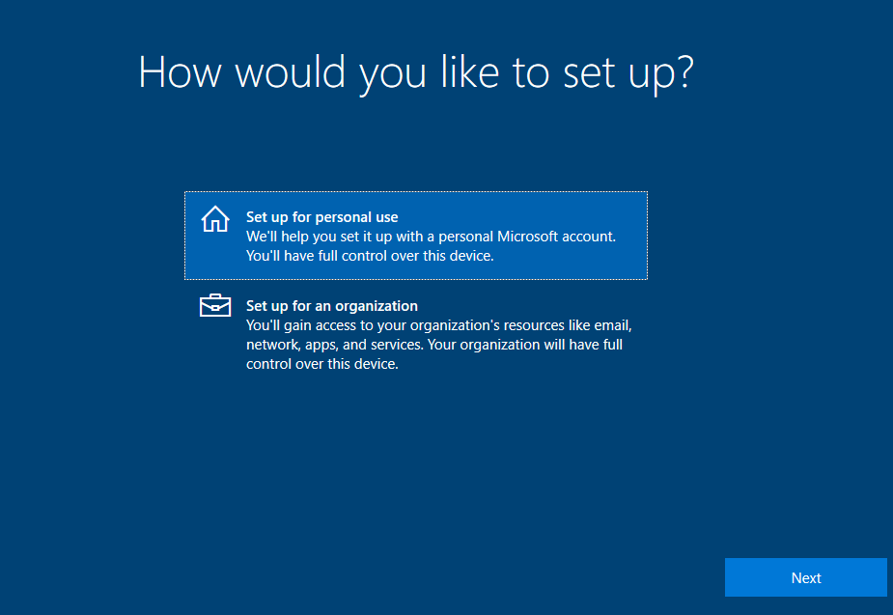
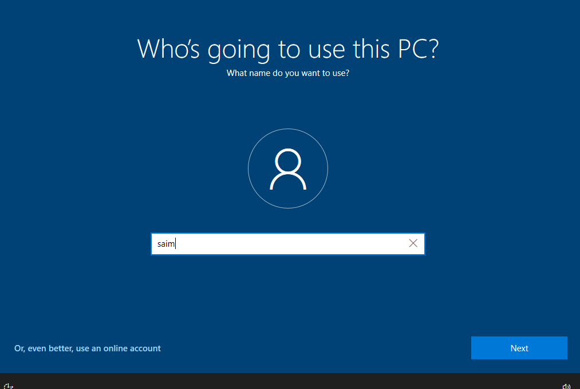
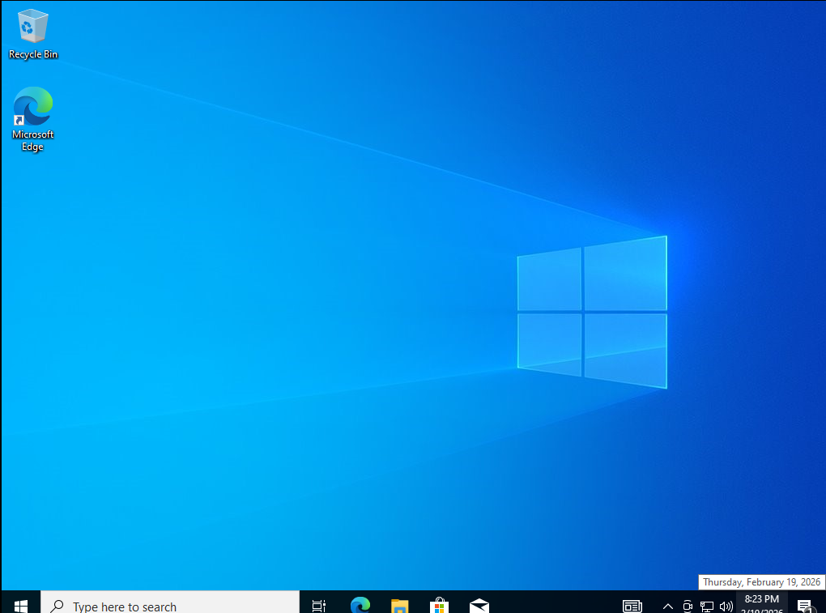

- Why do we use Windows Server?
Windows Server is used to manage, control, and provide services to computers and users in a network environment. It is mainly used in organizations, companies, schools, and enterprises where centralized management is required.
Unlike normal Windows, Windows Server is designed to handle multiple users, manage security, store data and control network resources.
Main Reasons We Use Windows Server
1. Centralized User Management
With Windows Server, we can use Active Directory to create and manage users and groups from one central location.
This allows administrators to control login access, permissions and security policies easily.
Example: In a company, instead of creating accounts on every computer we create user accounts once on the server.
2. Domain Management
Windows Server allows us to create a domain. All client computers can join this domain and be controlled centrally.
Example: A school can connect all lab computers to one domain and manage them from the server.
3. DNS and Network Services
Windows Server provides important network services like:
- DNS (Domain Name System)
- DHCP (Dynamic Host Configuration Protocol)
- File Services
These services help computers communicate properly in a network.
Example: DNS allows a client to resolve saim.local into an IP address.
4. Security and Access Control
Windows Server provides advanced security features such as:
- Group Policy
- User permissions
- Authentication control
Administrators can control who can access files, printers and applications.
5. File and Resource Sharing
It allows centralized file storage and sharing. Users can access shared folders securely from anywhere in the domain.
Example: Company employees can access shared documents stored on the server.
6. Scalability and Reliability
Windows Server is designed to handle:
- Large number of users
- Multiple client machines
- High workloads
It is more stable and powerful compared to regular Windows OS.

- Differentiate between Windows and Windows Server?
Windows and Windows Server are operating systems developed by Microsoft, but they are designed for different environments and purposes. Windows is mainly used for personal and client-side computing while Windows Server is designed to manage networks, users and services.
1. Purpose and Usage
Windows:
Windows is designed for individual users. It is mainly used for personal tasks like web browsing, gaming, office work, multimedia and general computing. It focuses on user-friendly interface and daily productivity.
Windows Server:
Windows Server is designed for enterprise environments. It is used to manage networks, control multiple users, host applications, manage storage and provide centralized services such as authentication and file sharing. It is built for stability and continuous operation in organizations.
2. Network Role
Windows:
In a network environment Windows usually acts as a client. It connects to a server to access shared files, printers and domain services. It does not normally control other computers.
Windows Server:
Windows Server acts as a server. It manages client machines in a domain. It can function as a Domain Controller, DNS server, DHCP server, file server or application server. It provides services to multiple client systems.
3. User and Resource Management
Windows:
User management is local. Accounts are created on that specific computer and permissions apply only to that machine. It does not provide centralized control over multiple computers.
Windows Server:
Provides centralized user and group management using Active Directory. Administrators can create users, groups and organizational units and apply policies across the entire network. This makes management more organized and secure.
Example: In a company, instead of creating accounts on 50 computers individually, accounts are created once on the server.
4. Features and Services
Windows:
Includes features for personal use such as:
- Microsoft Store
- Cortana
- Gaming features
- Media tools
- Basic file sharing
It does not include enterprise server roles by default.
Windows Server:
Includes advanced server roles such as:
- Active Directory Domain Services (ADDS)
- DNS Server
- DHCP Server
- File and Storage Services
- Group Policy Management
These features allow it to manage a complete enterprise network.
5. Security and Policy Control
Windows:
Provides basic security features such as Windows Defender, firewall and local user permissions. Security is mainly focused on protecting a single device.
Windows Server:
Provides advanced security management across the network. Through Group Policy administrators can enforce password policies, software restrictions, desktop settings and access controls on all client machines in the domain. This makes Windows Server much more powerful for enterprise-level security.

- What are the available editions of Windows server?

Editions of Windows Server 2019
The available editions of Windows Server 2019 include Standard and Datacenter editions. Each edition can be installed either in Server Core mode (without graphical user interface) or in Desktop Experience mode (with graphical user interface). The main difference between them lies in virtualization support, advanced features and management interface.
1. Windows Server 2019 Standard Evaluation
Windows Server 2019 Standard edition is designed for small to medium-sized organizations. It provides essential server functionalities such as domain services, file services, DNS, DHCP and basic virtualization. This edition supports up to two virtual machines under proper licensing. It is suitable for organizations that require basic server roles without advanced data center features.

2. Windows Server 2019 Standard Evaluation (Desktop Experience)
This edition includes all the features of the Standard edition but provides a full graphical user interface. The Desktop Experience makes installation, configuration and management easier compared to the Server Core installation. It is commonly preferred when administrators require a visual interface for managing server roles and services.
3. Windows Server 2019 Datacenter Evaluation
The Datacenter edition includes all the features of the Standard edition but is designed for large enterprises and highly virtualized environments. It supports unlimited virtual machines and provides advanced features such as software-defined networking, storage replication and shielded virtual machines. This edition is suitable for organizations that require high scalability and advanced infrastructure capabilities.
4. Windows Server 2019 Datacenter Evaluation (Desktop Experience)
This edition provides all the advanced features of the Datacenter edition along with a full graphical user interface. It supports unlimited virtualization and advanced data center features while allowing easier configuration and management through a GUI.
Why Datacenter (Desktop Experience) Is Commonly Selected
The Datacenter edition with Desktop Experience is commonly selected when full server features and unlimited virtualization are required along with a graphical interface for easier administration. It allows administrators to configure services such as Active Directory, DNS and other server roles efficiently while also supporting advanced enterprise-level functionalities. One of its major advantages is that it allows the creation of unlimited virtual machines on a properly licensed server making it ideal for highly virtualized environments and large-scale infrastructures.

