# SECTION A

## **Goal**: We’ll be using GitHub to Clone the VM Server to your machine. Later, we’ll push our projects to GitHub for instructor access.

# STEP 1 – INSTALL Git, Virtual box, and vagrant

## INSTALLATION INTRUCTIONS

### Prerequisite Installations on local machine (Windows)

Download and install Git (<https://git-scm.com/downloads> )

Download and install Virtual Box (<https://www.virtualbox.org/> )

Download and install Vagrant (<https://www.vagrantup.com/> )

You must have all three installed before moving on to Step 2.

**Note**: In addition to these, be sure you have a text editor such as Notepad++ for writing your code. Any text editor you prefer is fine!

# STEP 2 – ACCESS GITHUB

### Getting Started – Please follow each step carefully—don’t rush!

1. Access the GitHub Classroom assignment link created by your Instructor via the following link:

**https://classroom.github.com/a/9jKIyM5L**

1. Register an account on GitHub or login if you have an account (<https://github.com/join/>)

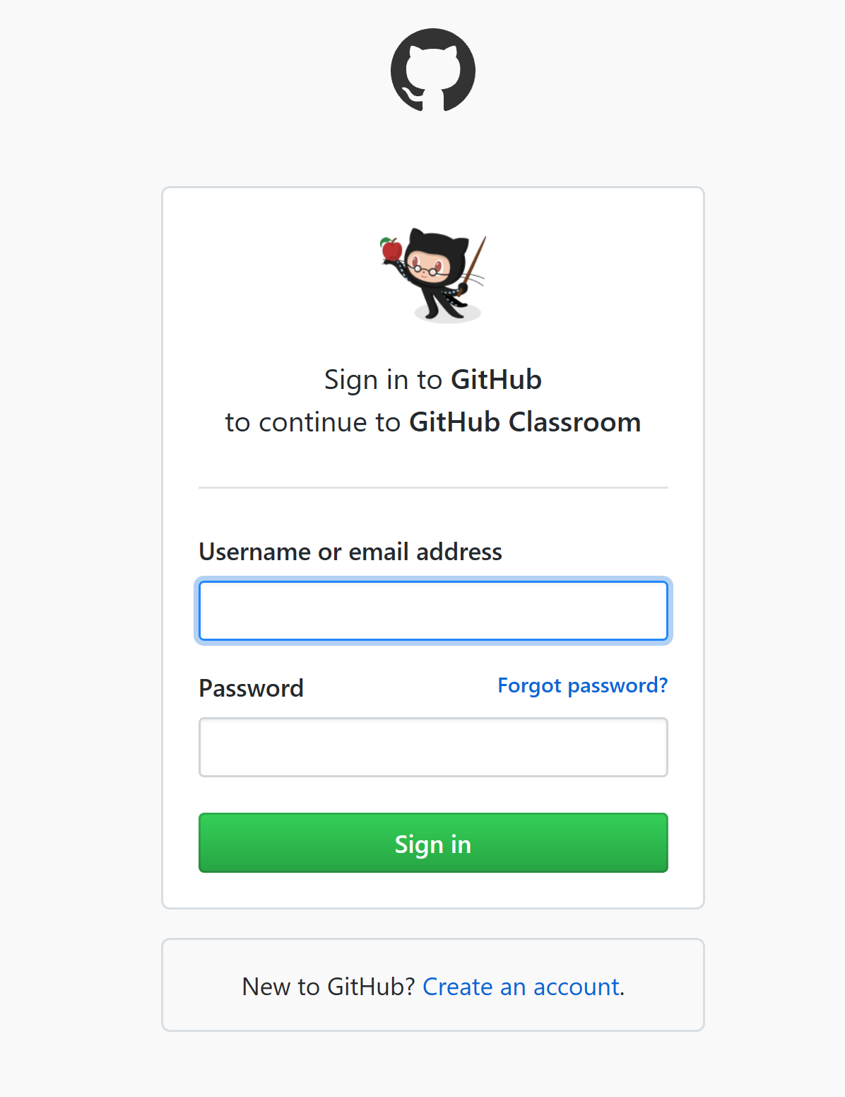

1. After creating your account, authorize GitHub Classroom as shown in the screenshot below

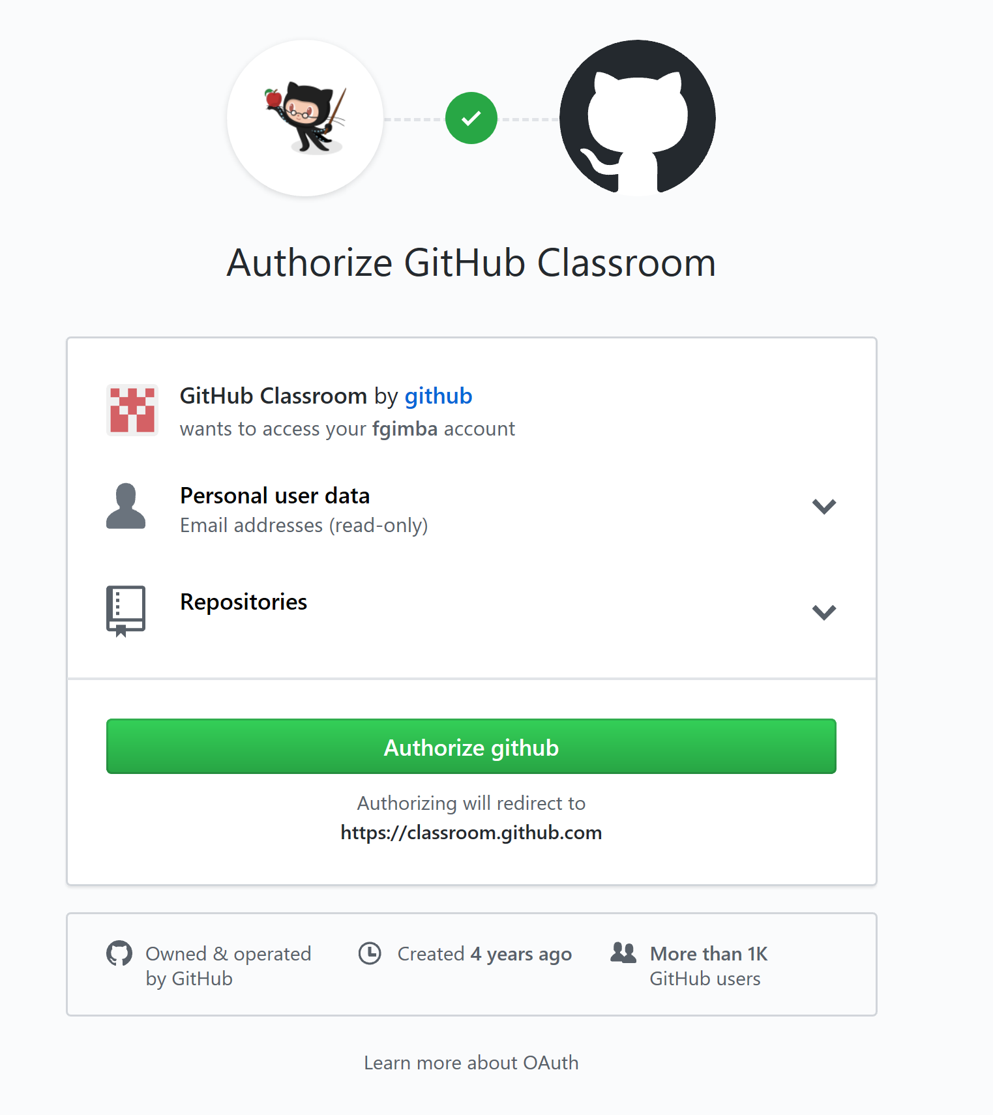

1. Accept the assignment

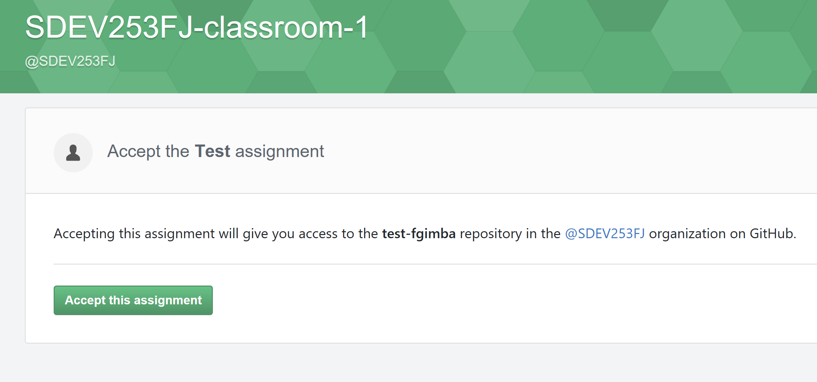

1. Wait for the your repository to be created

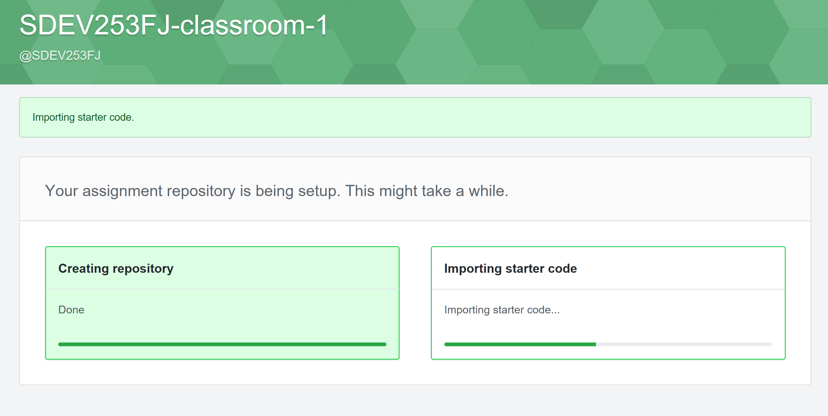

1. Access your assignment link

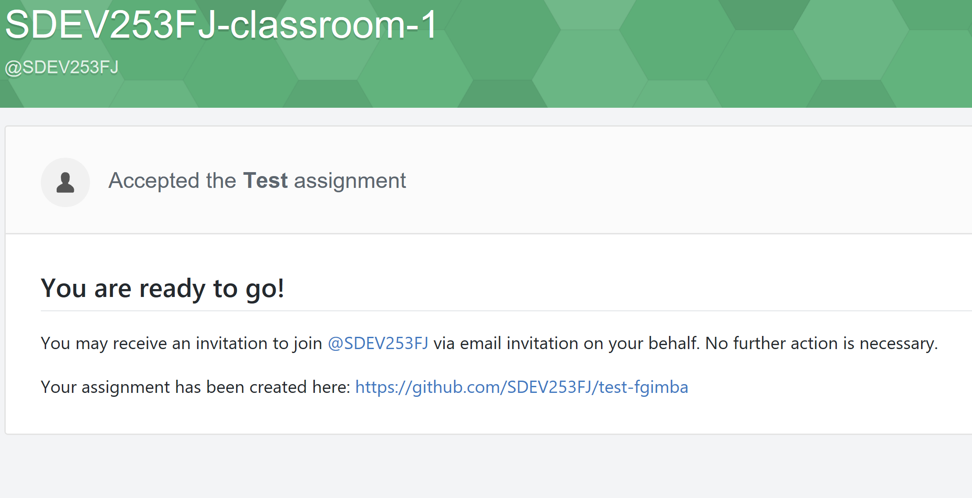

1. Retrieve your folder name at the end of the link as shown below—WRITE IT DOWN or you can copy this to notepad so you’ll have access to it in a few steps down (or you can use the clipboard manager—we’ll be copying something else in a few steps so you will overwrite this one if you do a simple copy).

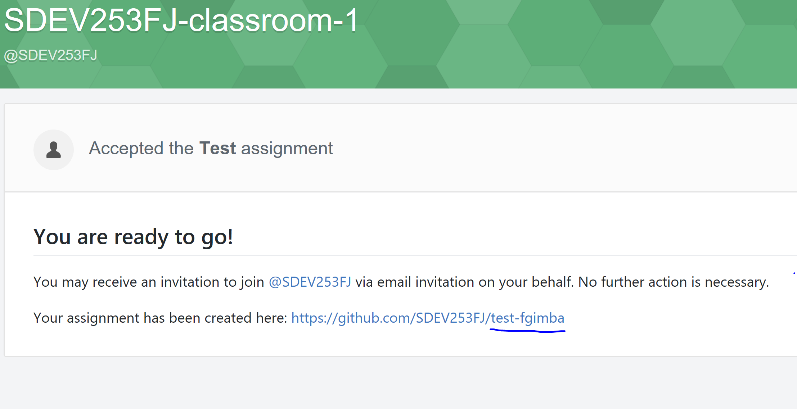

1. Go to your assignment repository
2. Click on the **Clone** or **Download** button and copy the clone address as shown in the screenshot below

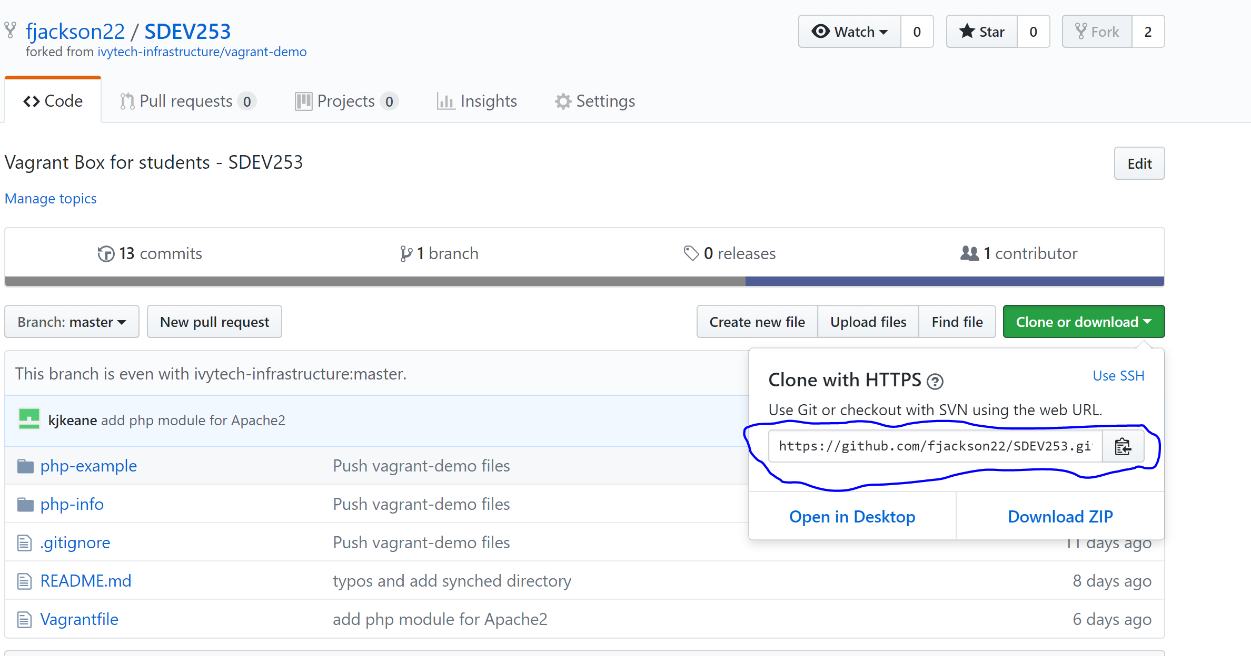

1. Open Git Bash from you search or apps menu (Windows 10)

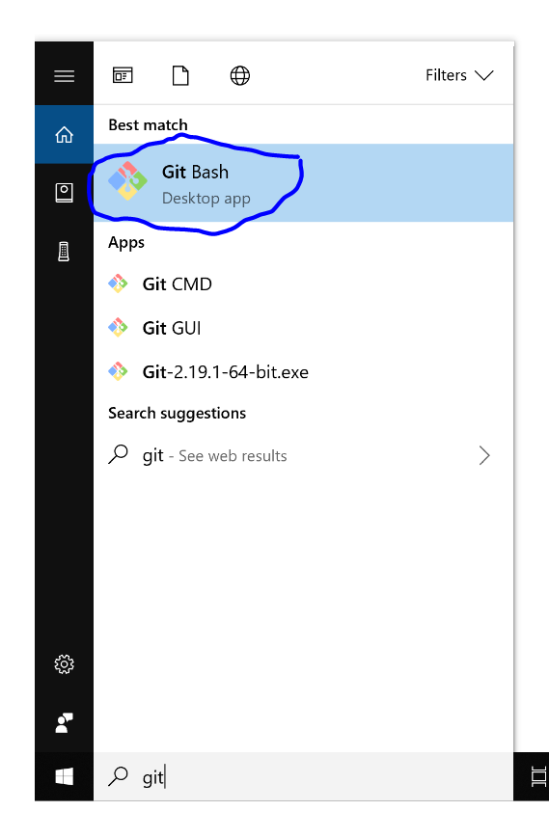

1. Go to your working directory by typing the command below.

Note: For the purpose of this documentation, the folder Projects was created as a working directory in the windows Documents folder (if you want to follow this example and place your virtual machine (vm) in the folder below, you will need to create the Documents and Projects folders. You can do this using file explorer or whatever method you prefer.) Be mindful of where you place your vm, you will be returning to this directory often.

Type ***cd Desktop/Documents/Projects***

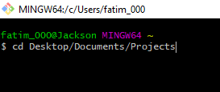

1. Your should see something similar to what you see below:

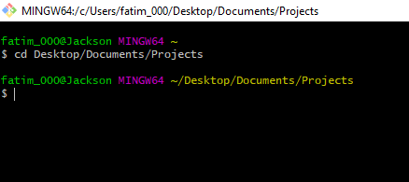

1. Clone the copied repository from step 9 above by typing the script below; this is where you paste the clone that you copied (instead of typing “copied repository address from step 9”, paste the address from step 9; yours will not match the one listed below).

***git clone “copied repository address from step 9”***  as shown below

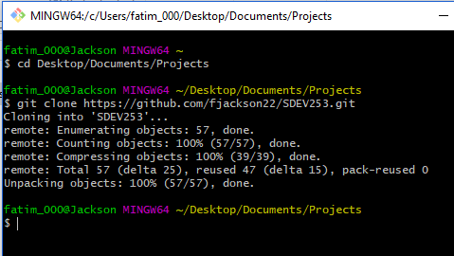

1. Go to the main master folder of the cloned directory. Use the name you wrote down from step 7 (if you pasted this into notepad you can copy it from there)

***cd “Folder name copied from step 7”***

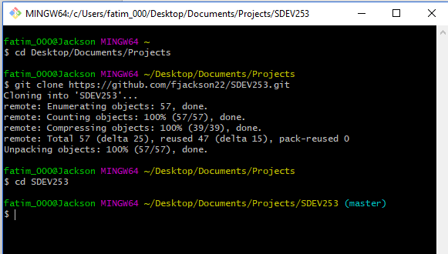

1. Start the virtual machine locally by typing **vagrant up** as shown below (you will most likely have many more steps than the one listed below, I had a few pages of commands that were executed to set up the vm. It looks this vm was already built and the user was just bringing it up.)

***vagrant up***

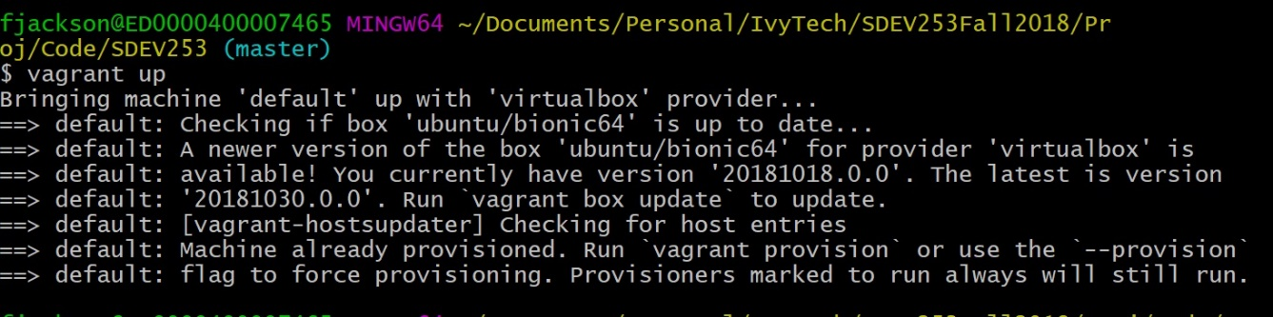

**TROUBLESHOOTING TIP: If it does not appear to be bringing vagrant up or you get some error messages, check your system settings to see if virtualization is enabled. Some computers (even newer models) may have virtualization disabled and you may need to enable this through the BIOS – to do so, check with your manufacturer on how to access the BIOS to enable virtualization.**

1. Update your username and email (**email used to sign up for a GitHub account in step 8 above**) as shown below to ensure that updated work is pushed to your repository.

NB: You will need to complete this step to be able to push code to GitHub

$ git config --global user.name "Fatima Jackson"
$ git config --global user.email "username@ivytech.edu"

1. In case of any mistakes during installation or afterwards. The installation steps (STEPS 1 and 2) can be repeated again after running the command below and deleting the master folder created. In the case of this specific example, the master folder is the folder name copied from step 7 on your local machine’s working directory.

***vagrant destroy***

**NOTE: The Installation steps in SECTION A only need to be completed once (if it works).**

**To start your virtual server for future sessions, you’ll need to bring vagrant up by following the steps outlined in SECTION D.**

To close the git bash window at any time, simply type ***exit***

## **SECTION B**

### Custom Work (Testing your setup)

All projects will run from the root site and can be accessed using the link below

<http://localhost:8080/>

Let’s run through an example to test your setup:

1. Go to the folder php-example
2. Create the file hello.php and type a simple hello word code as shown below (This can be created in notepad or another text editor and must be saved to the php-example folder.)

<?php
echo "Hello SDEV253!";
?>

1. Go to the link: <http://localhost:8080/php-example/hello.php>
2. Confirm that your code runs correctly (you should see the following – if so, skip the next step – Step 5 is only for troubleshooting.

## (In browser window) Hello SDEV253!

## NOTE: TROUBLESHOOTING STEP IF HAVING ISSUES

1. If you could not get step 4 to run it means your virtual machine (server) is not working, please check to see if these files are present in the directory your repository was cloned to. If they are not, you may need to issue the command **vagrant destroy** and complete the process again.

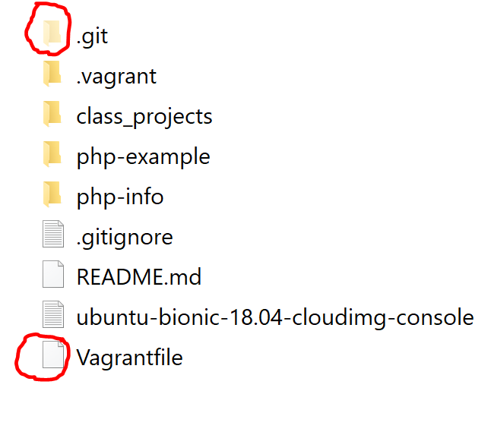

## **SECTION C**

### Submitting your assignment—Pushing to GitHub

1. It is recommended that all class assignments and projects be saved in the Class_Projects folder and pushed to github. You will then provide your instructor with your lab assignment or project path for each assignment in the modules.

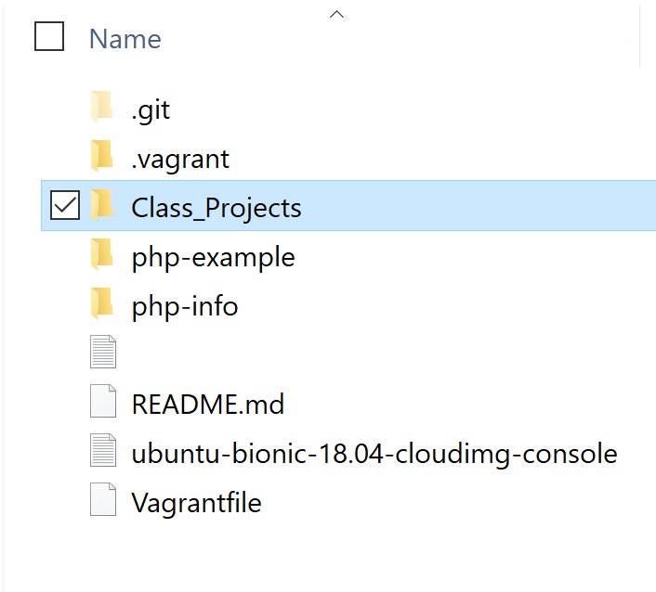

1. To push to Github, complete the following steps below:
2. Type the command below to add all changed files



1. Type the command below to commit and provide a text to document the specific commit. See example below



1. Type the command below to push the code to the origin. See example below where the origin is called “master” which is the default.



1. Visit the link below to review additional information and documentation on how to push code on GitHub.

<https://help.github.com/articles/adding-a-file-to-a-repository-using-the-command-line/>

## **SECTION D**

## NOTE: **AFTER INSTALLATION** IS COMPLETE, YOU NEED TO DO THE FOLLOWING STEPS TO ACCESS THE (VM) SERVER EACH TIME

To run projects or applications, these four steps below should be completed

1. Go to working directory
2. *cd your_assignment_folder_directory*
3. *vagrant up*
4. All projects will run from the root site and can be accessed using the link below

<http://localhost:8080/>