- Created mono repo in git. (food-delivery-app)
- Cloned that repo in local machine
- In this cloned repo folder, created folders as show in screenshot below
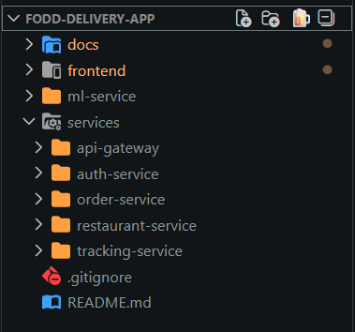
- Now created frontend app using command “npm create vite@latest frontend -- --template react-ts”
- Install tailwind css and initialize
  - npm install tailwindcss @tailwindcss/vite
  - vite.config.js: import { defineConfig } from 'vite' import tailwindcss from '@tailwindcss/vite' export default defineConfig({ plugins: [ tailwindcss(), ], })
  - @import "tailwindcss"; in src/index.css
  - Run server using npm run dev and validate tailwind css
- Installed react router npm install react-router-dom
- Install framer motion: npm install framer-motion
- Install and shadcn/ui for vite
  - tsconfig.json { "files": [], "references": [ { "path": "./tsconfig.app.json" }, { "path": "./tsconfig.node.json" } ], "compilerOptions": { "baseUrl": ".", "paths": { "@/*": ["./src/*"] } } }
  - tsconfig.app.json { "compilerOptions": { // ... "baseUrl": ".", "paths": { "@/*": [ "./src/*" ] } // ... } }
  - npm install -D @types/node
  - vite.config.ts import path from "path" import tailwindcss from "@tailwindcss/vite" import react from "@vitejs/plugin-react" import { defineConfig } from "vite" // https://vite.dev/config/ export default defineConfig({ plugins: [react(), tailwindcss()], resolve: { alias: { "@": path.resolve(__dirname, "./src"), }, }, })
  - npx shadcn@latest init (asked color: choose Zinc)
  - npx shadcn@latest add button input card navigation-menu (to install components: created components under src/components/ui)
- created folder structure for frontend
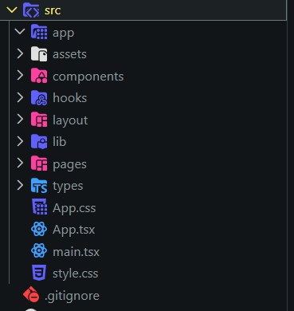
- created pages: Home, Search, Orders, Profile
- Created layouts: AppShell, BottomNav
- Install lucide icons for react npm install lucide-react
- Created home page with framer motion and created AppShell, BottomNav
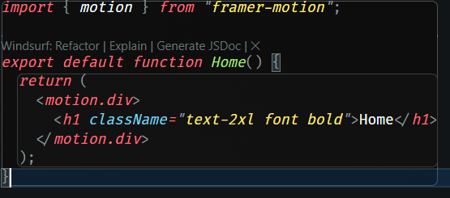
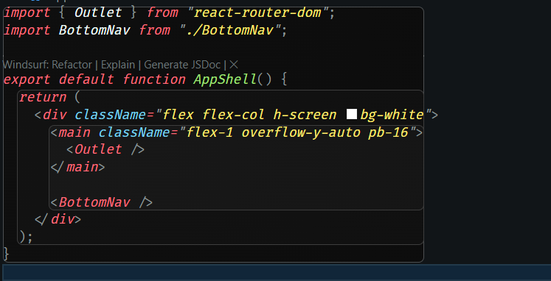
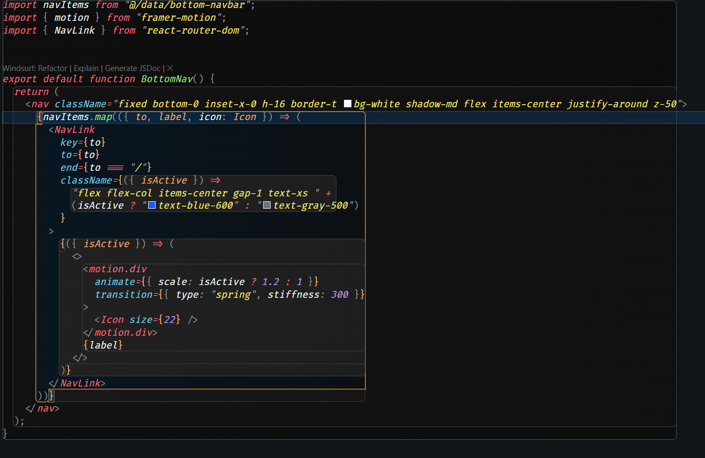
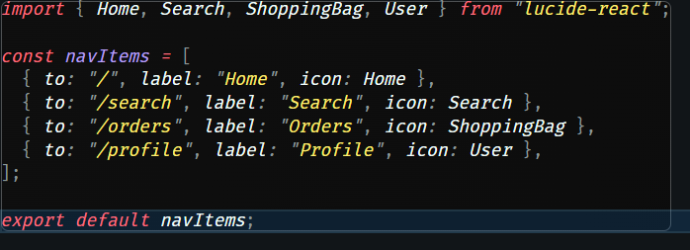
- Created router using createBrowserRouter
- Configure vite.config.ts
- PWA Setup:
  - npm install vite-plugin-pwa --save-dev
  - add manifest and others in vite.config.ts
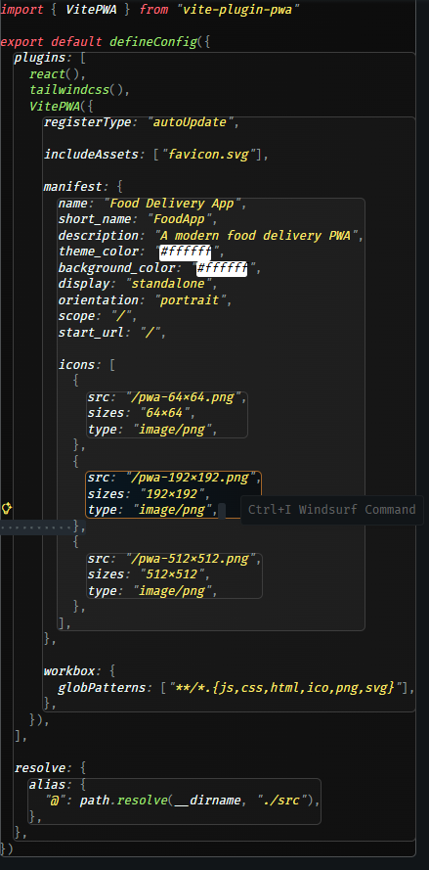
  - add pwa icons under public folder
  - make offline.html in public folder
  - Inject service worker registration
    - Add import { registerSW } from "virtual:pwa-register"; in main.tsx
    - Add registers() before createRoot
  - Restart dev server
  - Need to add devOptions: { enabled: true} under vitepwa()
  - Restart server and check chrome-devtools-application-manifest

