Abstract
The rapid growth of digital technologies has transformed the global retail landscape, leading to widespread adoption of e-commerce platforms. This project presents the design and development of a comprehensive e-commerce website aimed at providing users with a seamless online shopping experience. The system incorporates essential modules such as product catalog management, user authentication, shopping cart functionality, order processing, secure payments, and customer feedback. A robust relational database is implemented using PostgreSQL to ensure data integrity, efficient transactions, and scalable storage. Key database entities include users, products, categories, inventory, carts, orders, payments, reviews, and addresses, each linked through carefully designed foreign key relationships. The system ensures reliability through constraints, automated timestamps, and cascaded operations. This project demonstrates the integration of a well-structured backend with a user-friendly interface to deliver a complete and efficient e-commerce solution.

Introduction
E-commerce has emerged as a dominant mode of conducting business in the modern world, offering customers the convenience of browsing, selecting, and purchasing products from anywhere at any time. With increasing internet penetration and advancements in secure online transaction systems, the demand for dynamic and scalable e-commerce platforms has grown significantly.
This project focuses on developing a full-featured e-commerce website designed to handle real-world operational requirements such as user registration, product browsing, inventory tracking, and order management. To support these functionalities, a comprehensive PostgreSQL database schema has been created. It includes tables to manage users, product categories, inventories, carts, orders, payments, and reviews, ensuring that each component of the e-commerce ecosystem is efficiently handled.
The backend architecture emphasizes data integrity through relational constraints, cascading actions, unique fields, and validation rules. Features such as order tracking, payment processing, and customer reviews enhance the user experience, while modular design ensures scalability and maintainability. Overall, this project aims to deliver a robust, secure, and user-centric e-commerce application suitable for small to mid-scale businesses.

Objective
The primary objective of this project is to design and develop a fully functional, scalable, and user-friendly e-commerce website that enables seamless online shopping. The system aims to provide customers with an efficient platform for browsing products, managing shopping carts, placing orders, making payments, and providing feedback.
Technical objectives include:
- To build a robust backend powered by PostgreSQL with well-structured tables, relationships, and constraints for maintaining data integrity.
- To implement secure user authentication and role-based access.
- To ensure smooth product management, inventory tracking, and order processing workflows.
- To integrate secure and reliable payment mechanisms.
- To offer an intuitive user interface that improves customer engagement and satisfaction.
- To ensure scalability, so the system can handle increasing products, users, and transactions.

Problem Statement
With the rapid digital transformation of the retail industry, consumers expect fast, reliable, and accessible online shopping platforms. Many small and medium-sized businesses struggle to establish a functional e-commerce presence due to the complexity of managing products, inventories, orders, and payments efficiently.
Traditional manual processes often lead to:
- Inefficient inventory management
- Limited accessibility for customers
- Delays in order processing
- Lack of centralized data storage
- Difficulty tracking user activities, reviews, and purchases
- Poor customer experience due to outdated or unstructured systems
This project addresses these challenges by developing an integrated e-commerce solution supported by a robust backend database. The system ensures efficient data management, smooth user interactions, automated workflows, and secure handling of orders and payments. By providing a centralized and scalable digital platform, the project aims to eliminate operational inefficiencies and enhance the overall shopping experience for users.

Review of Previous Works
E-commerce systems have evolved significantly over the years, driven by advancements in web technologies, database management, and user experience design. Early e-commerce platforms were primarily static websites that offered limited functionalities such as product listing and basic shopping carts. These systems lacked strong database structures, resulting in poor inventory tracking, inefficient order processing, and minimal personalization.
Several modern e-commerce solutions—such as Shopify, WooCommerce, Magento, and custom MERN/MEAN stack systems—provide advanced features like real-time inventory updates, secure payment gateways, user reviews, and automated order management. These platforms implement robust relational or NoSQL databases to handle large-scale data and maintain integrity through well-defined schema designs.
However, despite their strengths, many existing systems are either:
- Too complex for small businesses
- Too costly to maintain
- Not customizable at the database or backend level
- Not optimized for specific workflows or academic understanding
- Overloaded with unnecessary features for small-scale deployments
Previous research also highlights that the effectiveness of an e-commerce solution depends heavily on:
- A structured and normalized database schema
- Efficient backend logic for orders, payments, and inventory
- Seamless integration between user interface and database
- Secure handling of sensitive data like user credentials and transactions
These insights highlight the need for a lightweight, scalable, and customizable e-commerce platform that balances simplicity with essential functionality.

Dataset Details
The dataset used in this e-commerce system consists of multiple interrelated tables stored in a PostgreSQL relational database. Each table represents a core entity in the system such as users, products, orders, payments, and reviews. The database is designed to ensure data consistency, reduce redundancy through normalization, and maintain integrity using foreign keys and constraints. The dataset is organized into the following major components:

1.Users Dataset
Table:users
Description:Stores user account information.
Key Fields:
- id – Unique identifier
- full_name, email, phone
- password_hash – Securely stored password
- role – user/admin
- created_at
Use: Authentication, authorization, profile management.
2.Product Categories Dataset
Table:categories
Description: Contains all product category information.
Key Fields:
- id
- name – Unique category title
- description
- Use: Organizing products into hierarchical groups.

3.Products Dataset
Table:products
Description: Stores all product-related data.
Key Fields:
- id
- name, description
- price
- image_url
- category_id — Foreign key
- created_at, updated_at
Use: Product listing, browsing, and order placement.

4.Product Inventory Dataset
Table:product_inventory
Description: Tracks available stock for each product.
Key Fields:
- id
- product_id — Foreign key
- quantity
Use: Real-time inventory management and stock validation.

5.Cart Dataset
Table:cart
Description: Represents an active or temporary shopping cart for each user.
Key Fields:
- id
- user_id
- created_at
Use: Manages user cart sessions.

6.Cart Items Dataset
Table:cart_items
Description: Stores the individual products in each cart.
Key Fields:
- id
- cart_id — Foreign key
- product_id
- quantity
Use: Tracks quantities of each item added to the cart.

7.Addresses Dataset
Table:addresses
Description: Contains delivery address information for users.
Key Fields:
- id
- user_id
- address_line1, address_line2
- city, state, pincode, country
- phone
- is_default
Use: Shipping and checkout operations.

8.Orders Dataset
Table:orders
Description: Represents finalized customer orders.
Key Fields:
- id
- user_id
- address_id
- total_amount
- status (pending/confirmed/shipped/delivered)
- payment_status
- created_at
Use: Core order tracking and management.

9.Order Items Dataset
Table:order_items
Description: Stores detailed breakdown of each product within an order.
Key Fields:
- id
- order_id — Foreign key
- product_id
- quantity
- price_at_purchase
Use: Invoice generation, revenue calculation, analytics.

10.Payments Dataset
Table:payments
Description: Logs all payment transactions.
Key Fields:
- id
- order_id
- amount
- method (UPI, card, COD, etc.)
- status (initiated/paid/failed/refunded)
- transaction_id
- created_at
Use: Payment verification and financial record keeping.

11.Reviews Dataset
Table:reviews
Description: Stores user ratings and comments for purchased products.
Key Fields:
- id
- product_id
- user_id
- rating (1–5)
- comment
- created_at
Use: Customer feedback, product ranking, improving recommendations.

12. Notifications Dataset
Table:notifications
Description: Stores alerts sent to users regarding products, categories, or system updates.
Key Fields:
- id SERIAL PRIMARY KEY
- user_id INT REFERENCES users(id) ON DELETE CASCADE
- product_id INT REFERENCES products(id) ON DELETE CASCADE
- category_id INT REFERENCES categories(id) ON DELETE CASCADE
- type VARCHAR(30) NOT NULL(stock, price_drop, offer)
- message TEXT
- is_read BOOLEAN DEFAULT FALSE
- is_sent BOOLEAN DEFAULT FALSE
- channel VARCHAR(20) DEFAULT 'email'
- created_at TIMESTAMP DEFAULT NOW()
- expires_at TIMESTAMP
Use: Sending user alerts, tracking notification status, managing communication channels

13. Promo Codes Dataset
Table:promo_codes
Description: Stores discount codes applicable to user purchases.
Key Fields:
- id SERIAL PRIMARY KEY
- code VARCHAR(50) UNIQUE NOT NULL
- discount_type VARCHAR(20) DEFAULT 'percentage'(percentage / fixed)
- discount_value NUMERIC(10,2) NOT NULL
- min_order_amount NUMERIC(10,2) DEFAULT 0
- max_discount NUMERIC(10,2)
- is_active BOOLEAN DEFAULT TRUE
- start_date TIMESTAMP DEFAULT NOW()
- end_date TIMESTAMP
- created_at TIMESTAMP DEFAULT NOW()
Use: Applying discounts, managing promotional campaigns, controlling offer validity

Dataset Integrity & Constraints
- Foreign keys ensure relational consistency.
- Unique constraints on emails, categories.
- Check constraints ensure valid ratings.
- Cascading deletes prevent orphaned records.
- Default timestamps track record history.

Data Flow Diagram
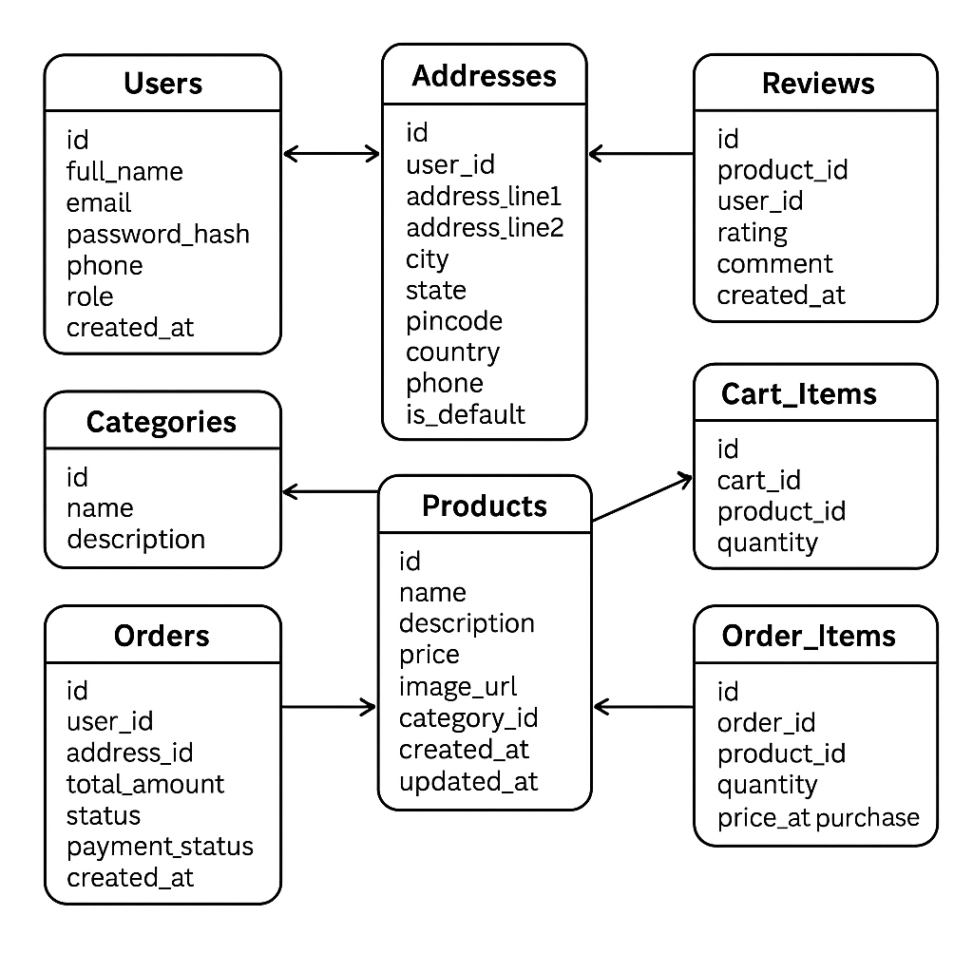
fig.1

Entity-Relationship diagram
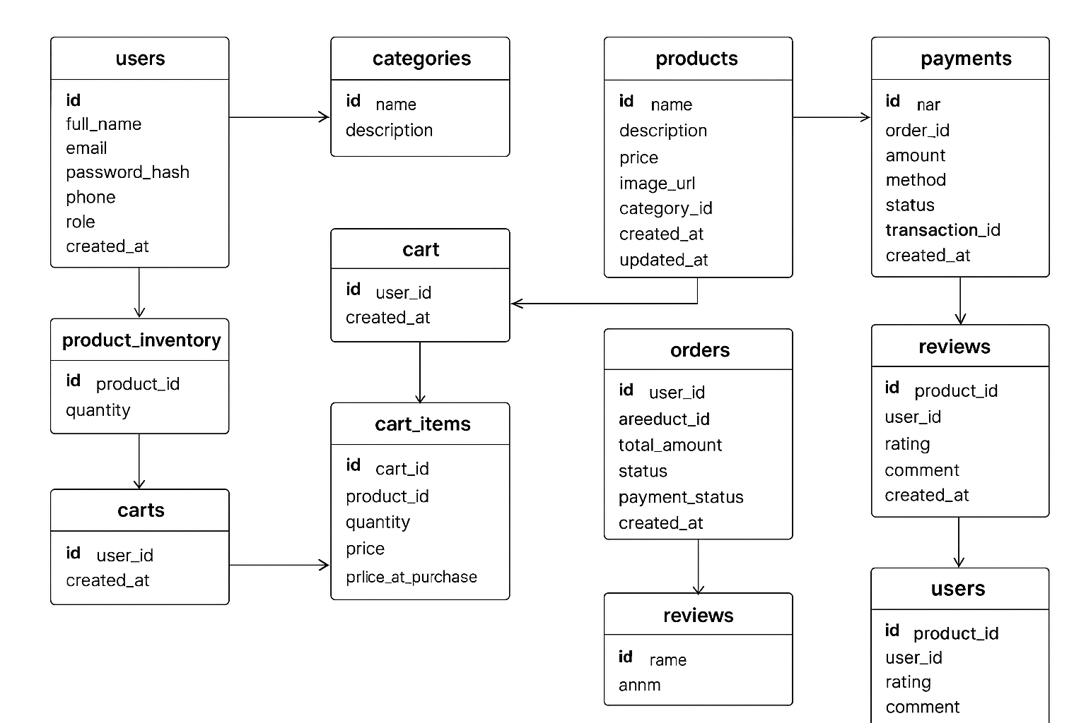
fig.2

Screenshot of Project Details

1.Homepage
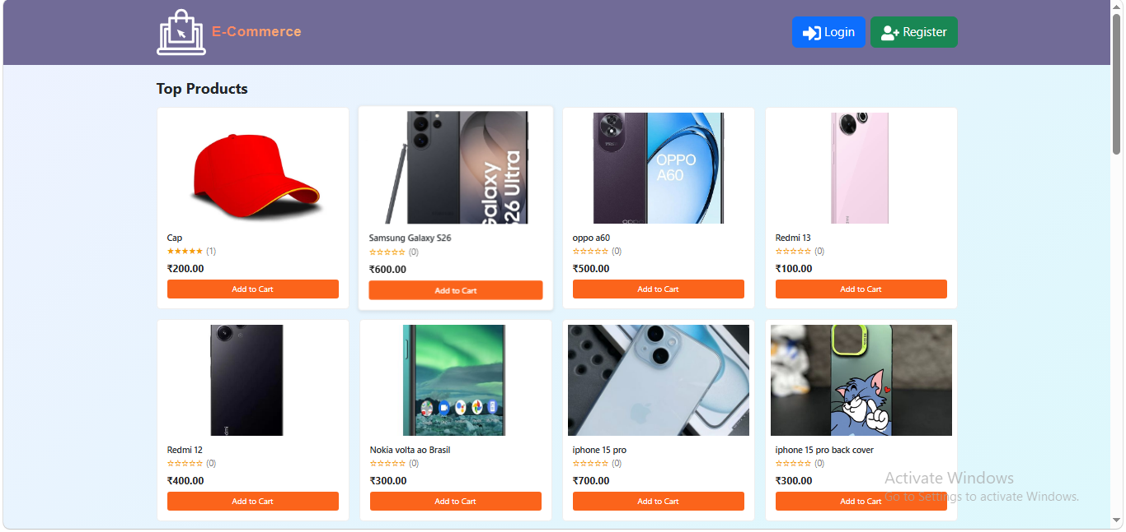
fig.3(homepage)
2.Registration Page
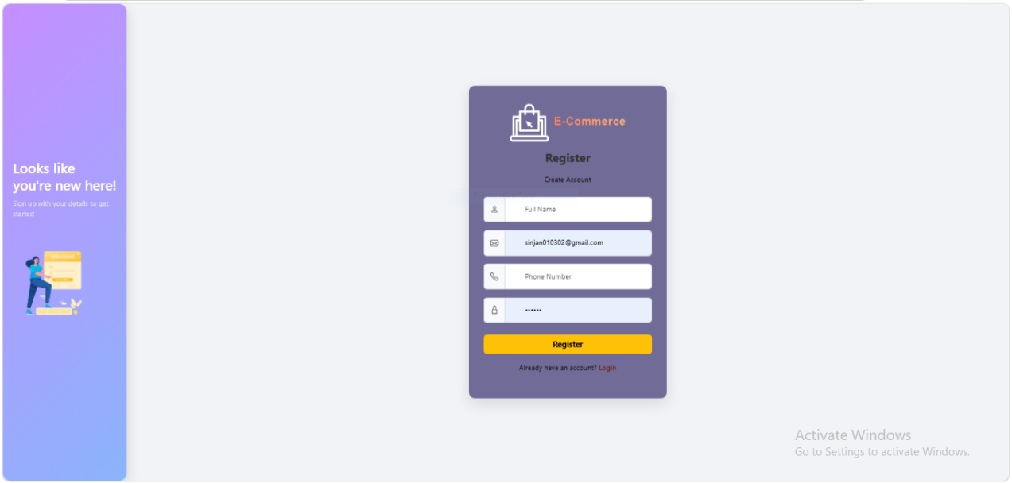
fig.4(registrationPage)

3.Login Page
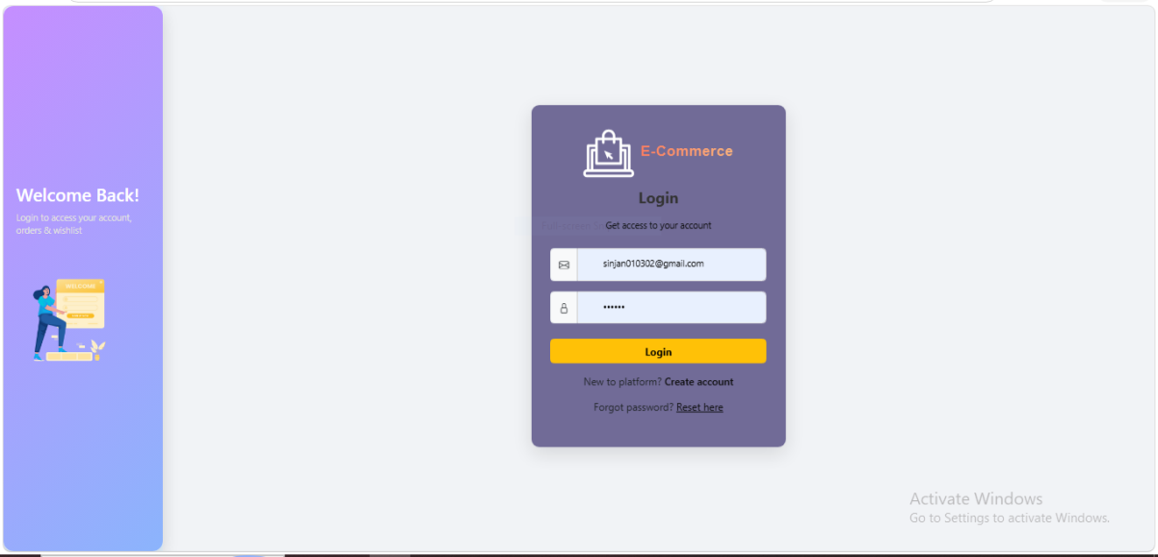
fig.5(loginPage)

Admin Dashboard

1.Dashboard
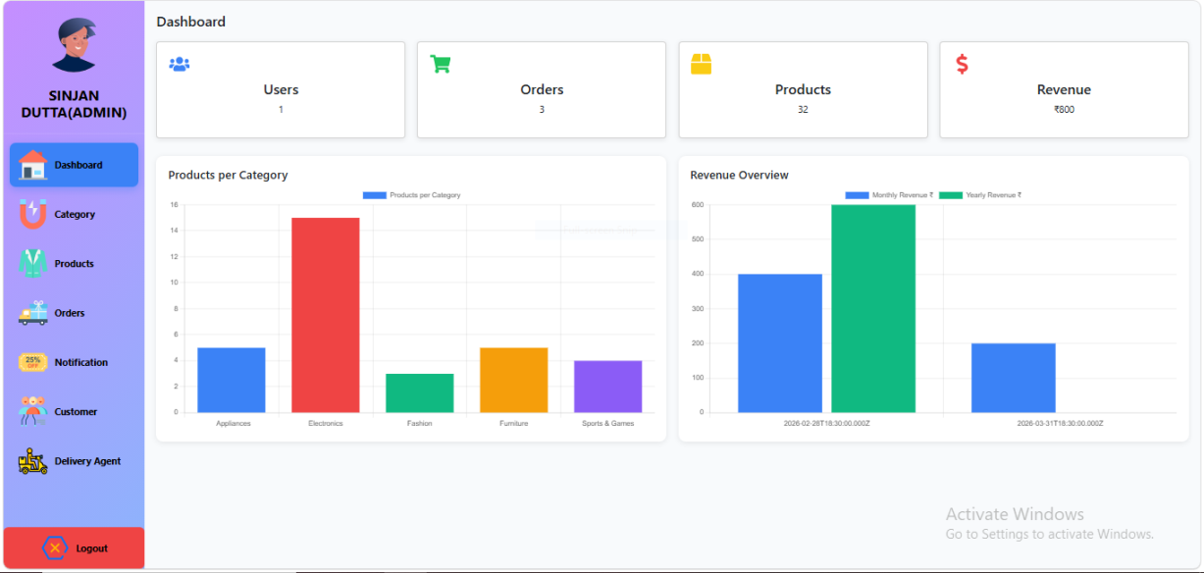
fig.6(adminDashboardPage)

2.Categories Page
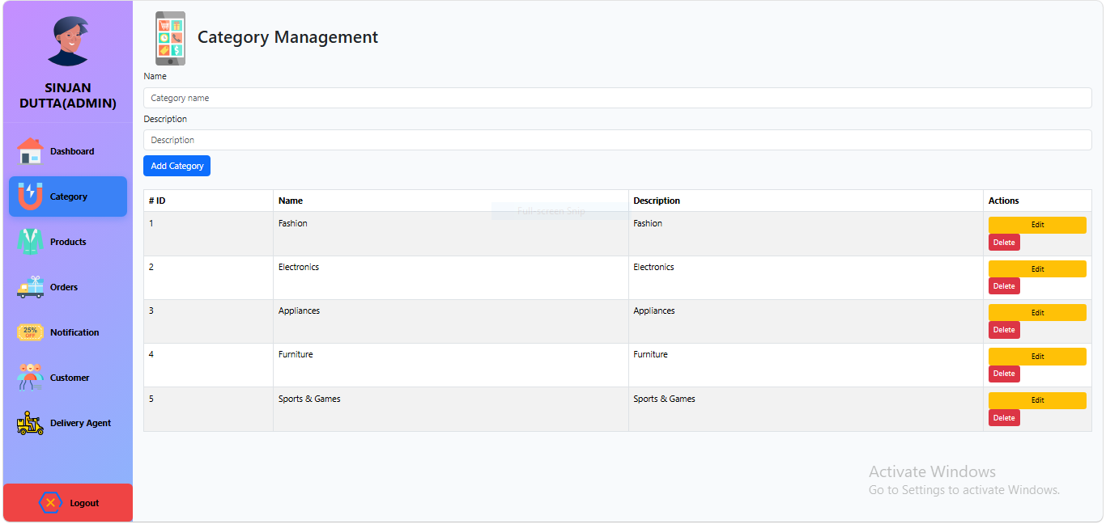
fig.7(lcategoriesPage)

3.Product Page
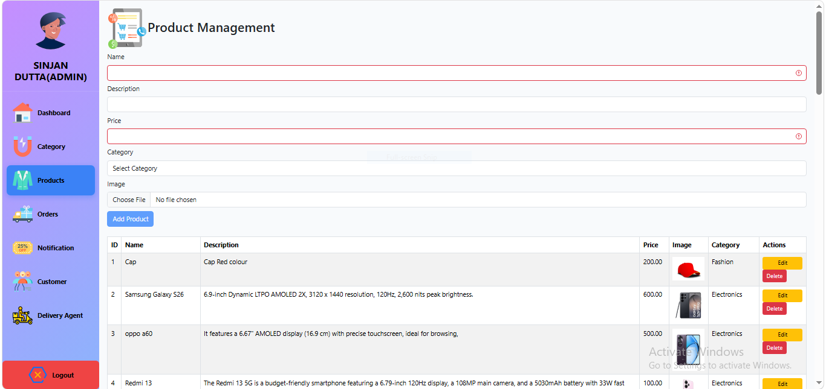
fig.8(lproductPage)

4.Total Order List Page
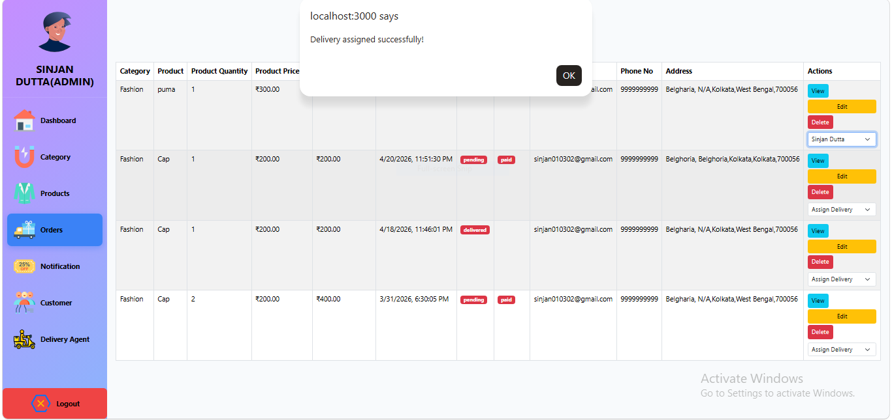
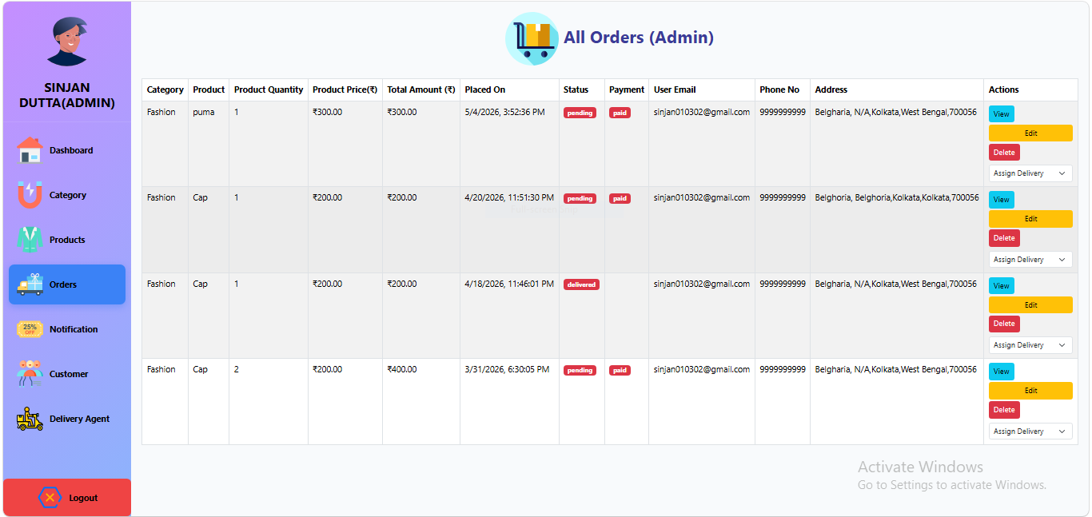
fig.9(ltotalorderPage)

5.Total Notification List Page
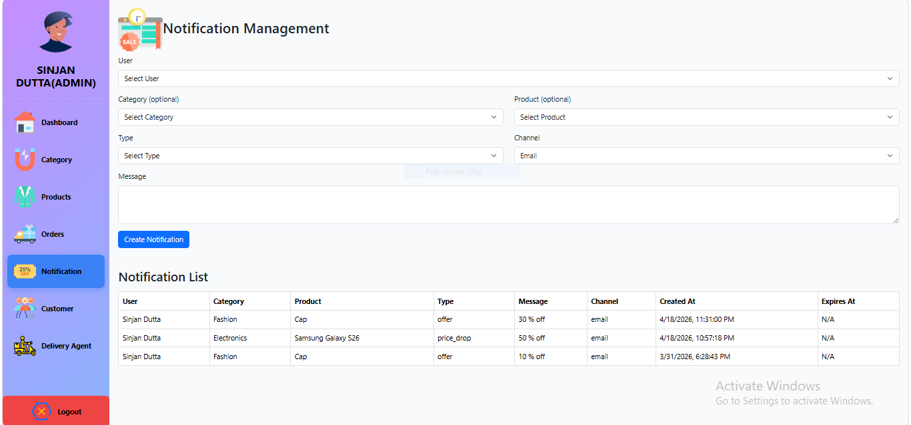
fig.10(Notification Page)

6.Customer List Page
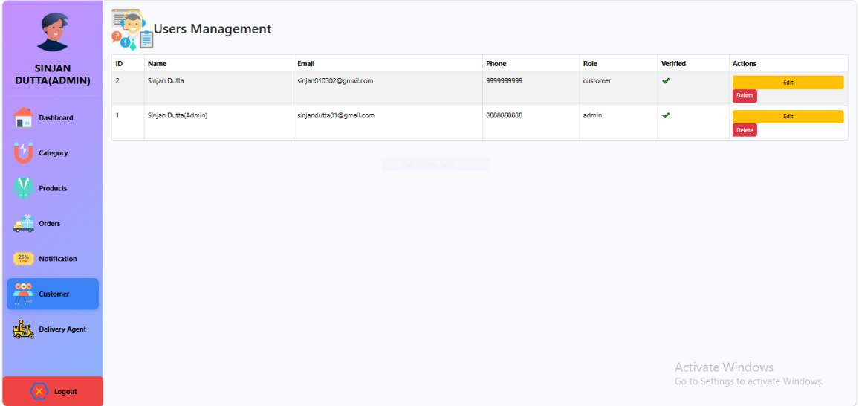
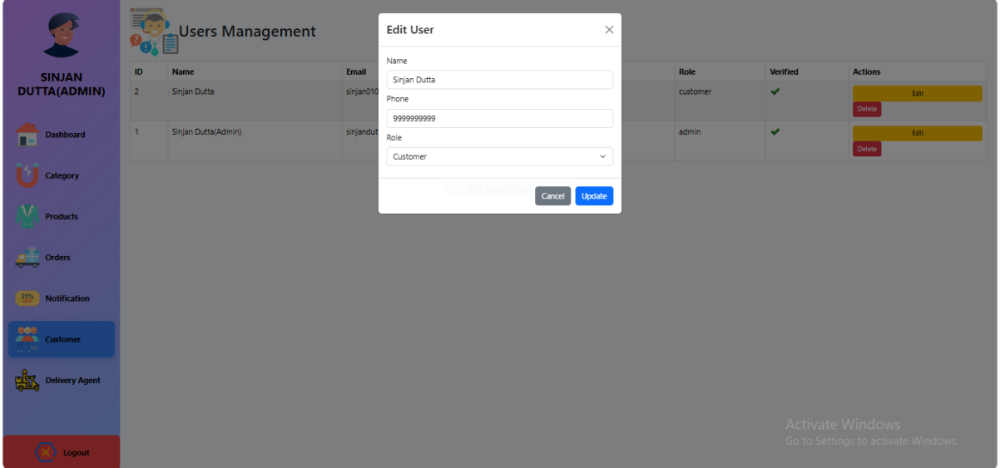
fig.11(Customer Page)

7.Delivery List Page
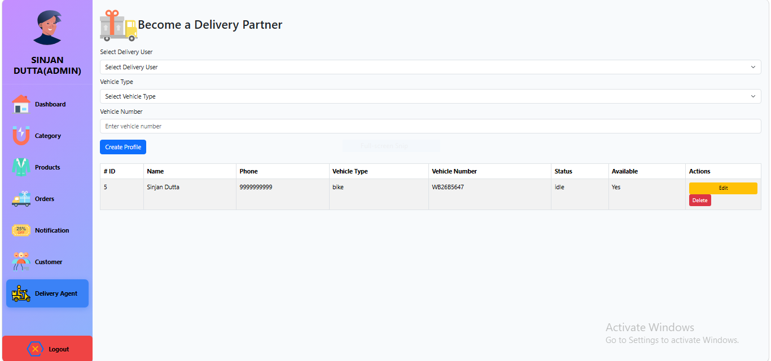
fig.12(DelivaryPage)

User Pages
1. Home Page
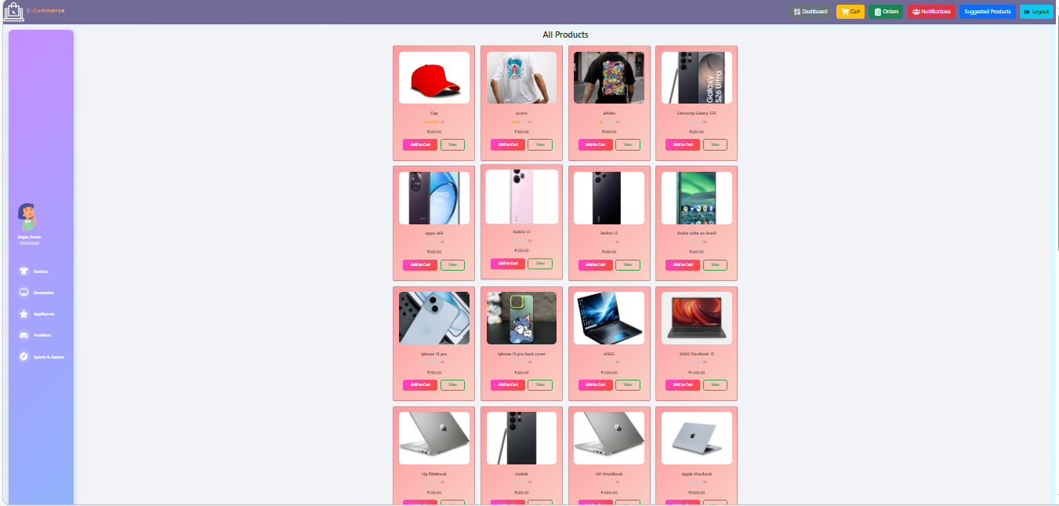
fig.13(userDashboardPage)
2. Home Page
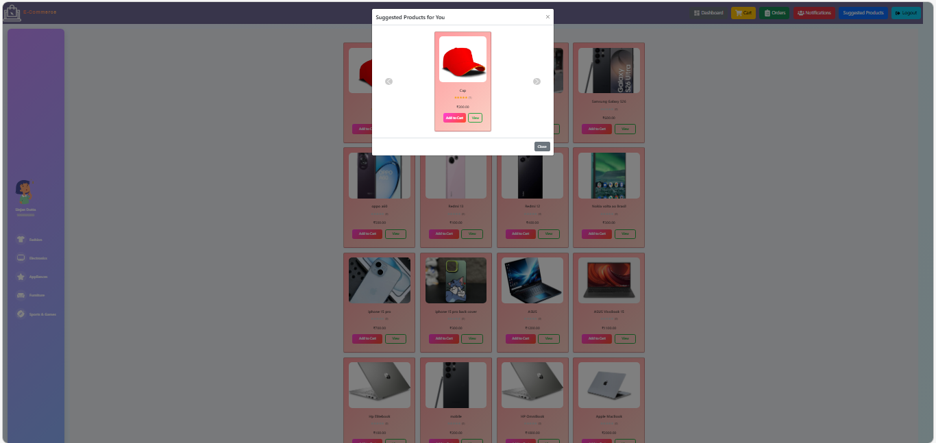
Fig-14(Suggested Page)

3. Add To Cart
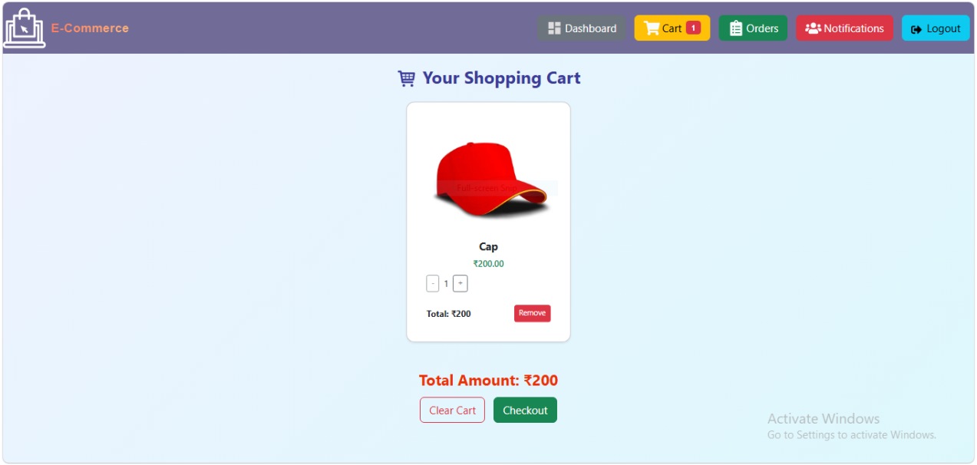
fig.15(userCartPage)

4. CheckOut Page
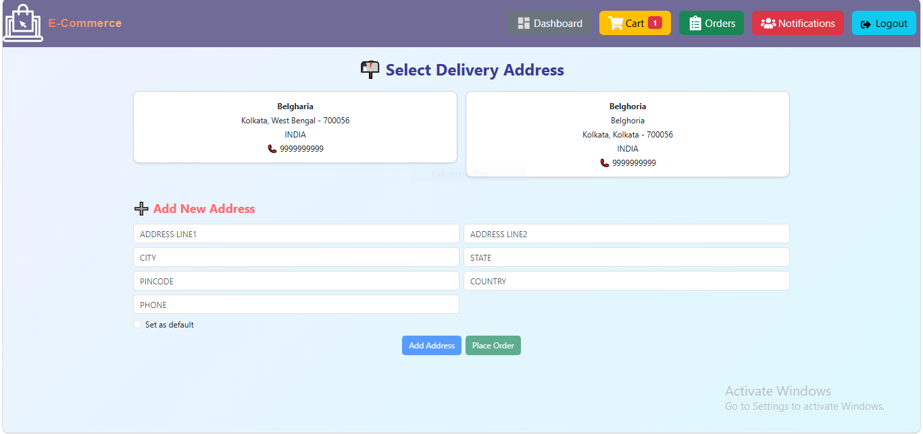
fig.16(checkoutPage)

5. Order summary Page
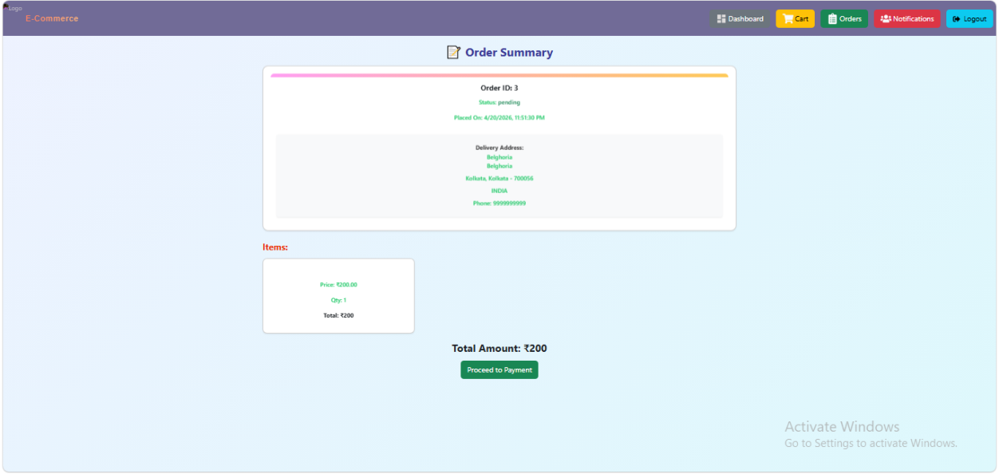
fig.17(ordersummaryPage)
6. Payment Page
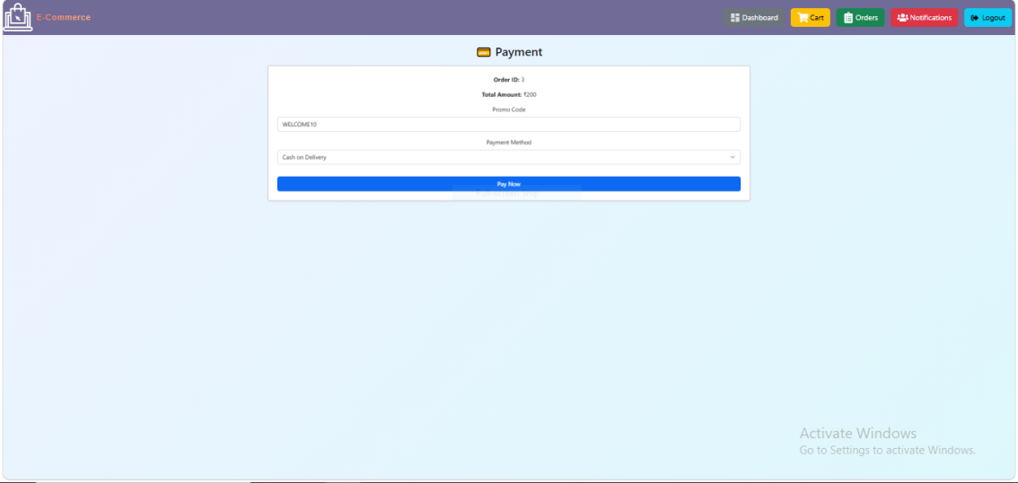
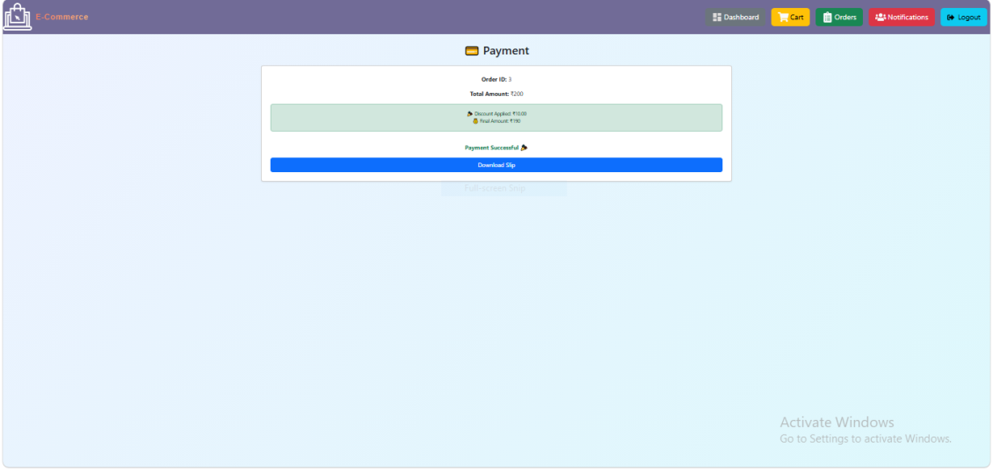
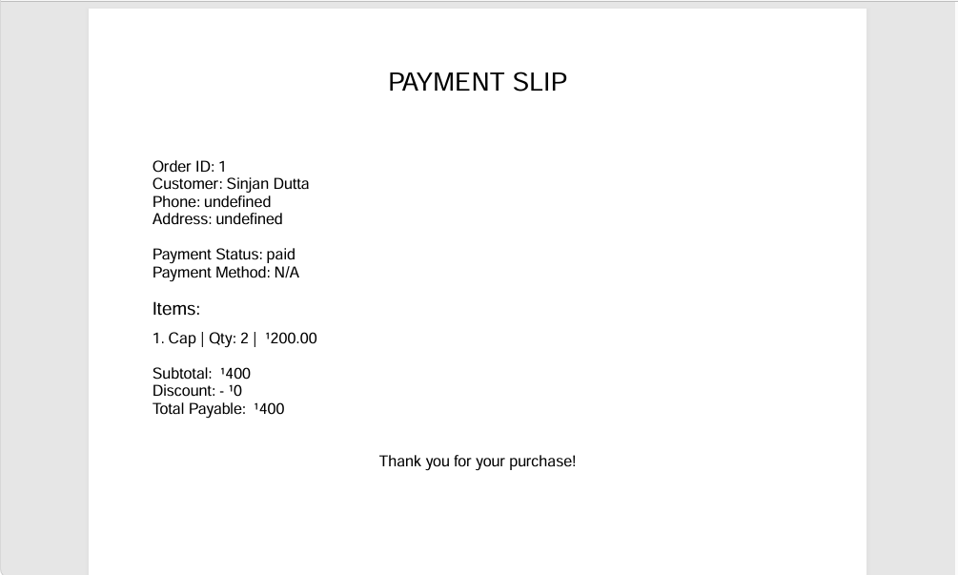
fig.18(paymentPage)

7. User Order List Page
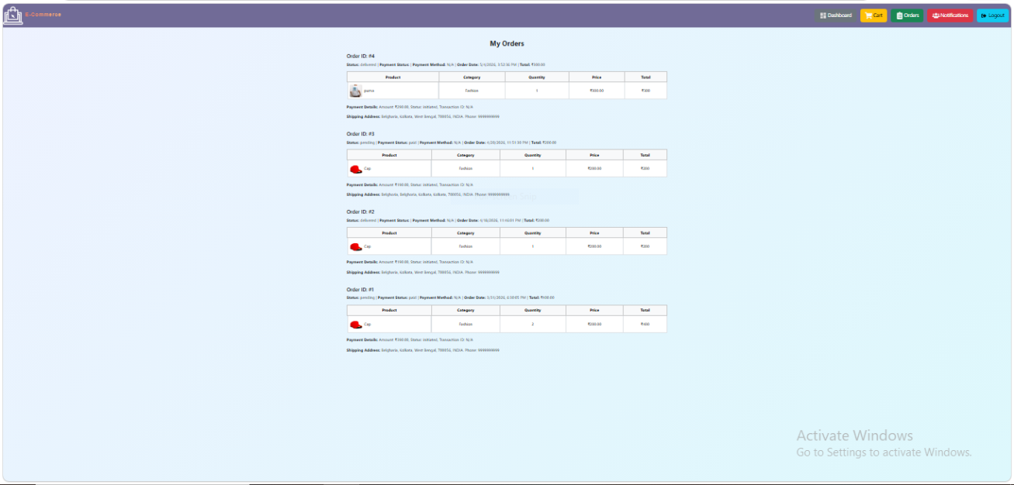
fig.19(orderslistPage)

8. User Notification List Page
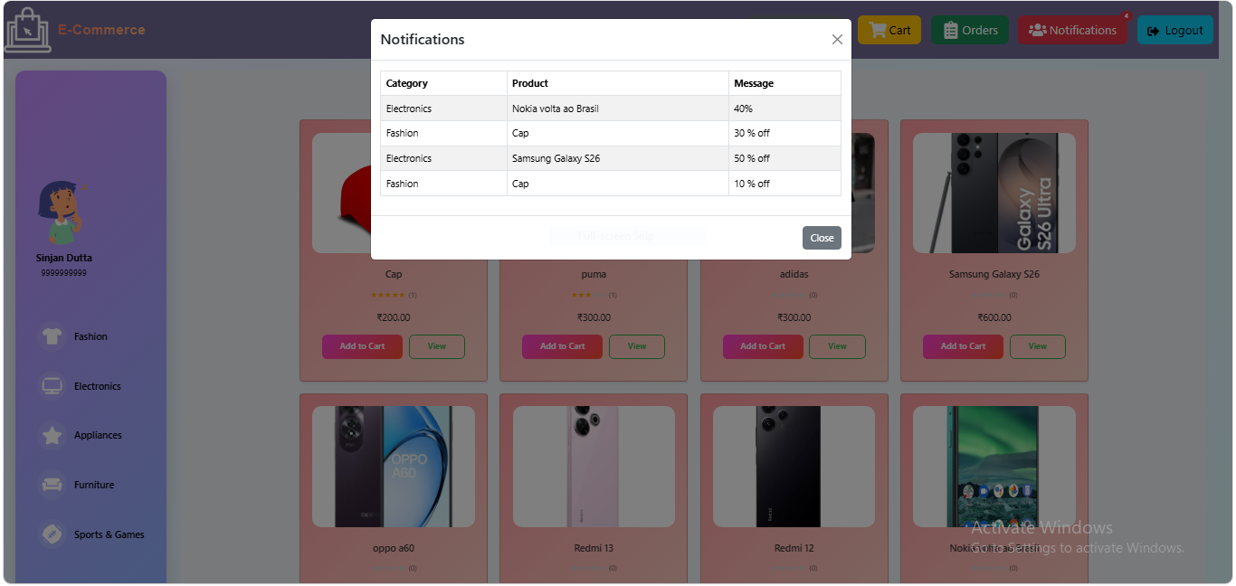
fig.20(NotificationlistPage)

9. User Review List Page

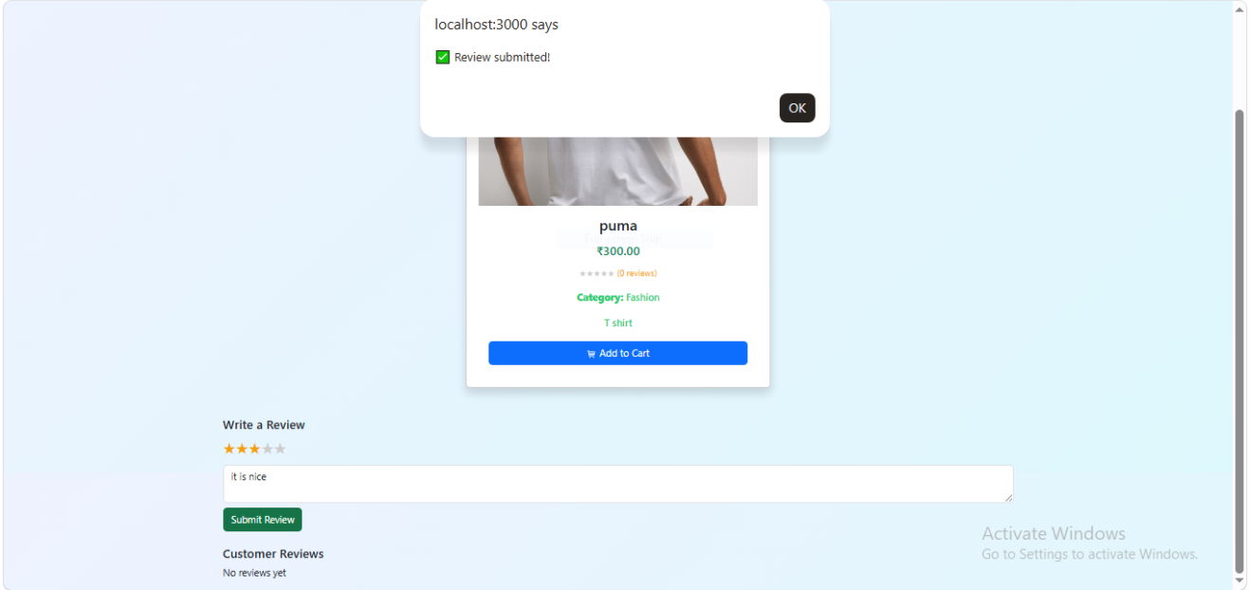
fig.21(ReviewtPage)

.

Delivery Pages
1. Delivery Page
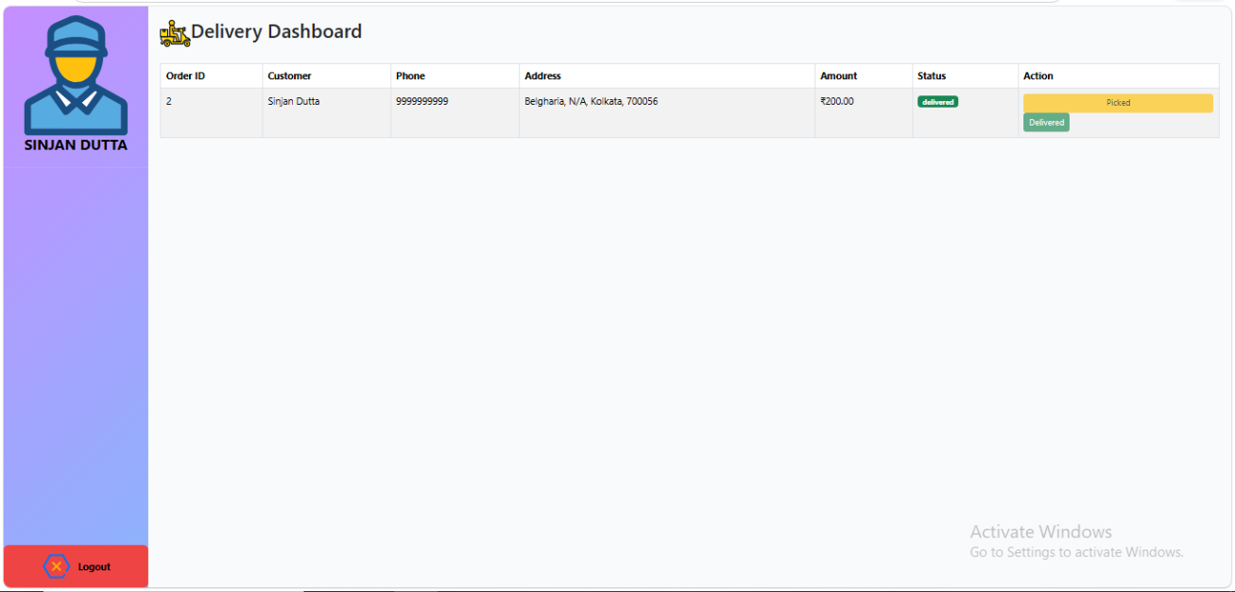
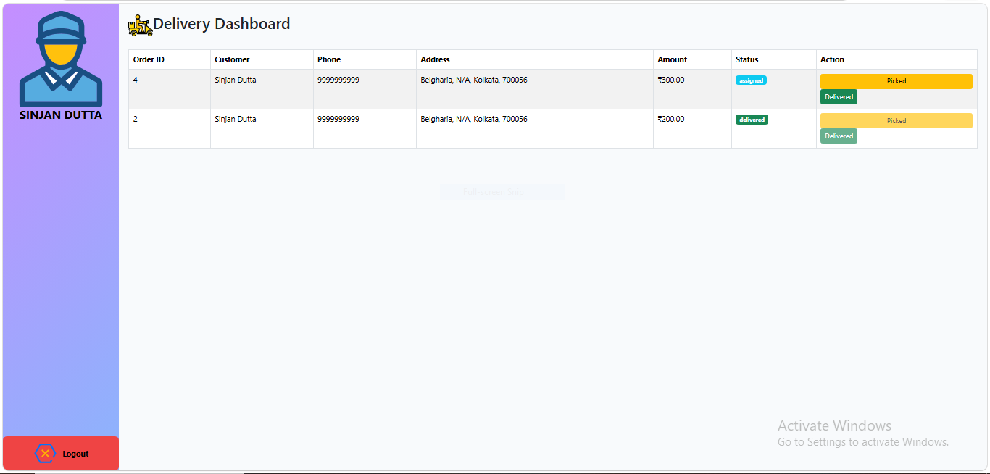
fig.22(NotificationlistPage)

Discussion
The development of the e-commerce platform demonstrates how a structured relational database and modular backend architecture can together create a scalable, reliable, and user-friendly system. The implementation of PostgreSQL with well-defined tables and relationships contributed significantly to maintaining data integrity and ensuring smooth operations across modules such as product management, cart functionality, order processing, and payment tracking.
One of the major strengths of the system lies in the clear separation of concerns. By dividing the database into multiple entities—users, products, categories, orders, inventory, payments, and reviews—the platform ensures a clean and maintainable structure. This modularity allows easy modification or extension of system features without affecting the entire architecture. For example, the inventory and cart modules operate independently yet remain fully synchronized through foreign key constraints and backend logic.
The integration of review and rating functionality further enhances the customer experience by allowing users to provide feedback, improving trust and product evaluation. Payment workflows, although simple, demonstrate the essential principles of handling transaction records, ensuring transparency and traceability.
The database-driven design allows the system to scale effectively. As more users, products, and orders are added, the relational structure ensures that operations remain efficient. Proper indexing and normalization minimize redundancy and improve query performance. Additionally, cascading delete/update rules prevent orphaned records and ensure consistent state even after complex operations such as deleting users or products.

Results
Based on implementation and testing, the following results were observed:

Functional Performance
- All core e-commerce features—user registration, product browsing, cart management, order placement, and reviews—functioned as expected.
- Orders were processed correctly, with order items and total amounts calculated accurately.
- Inventory levels updated automatically after order placement, ensuring real-time stock accuracy.

System Reliability
- Foreign key constraints prevented invalid data entry and maintained relational consistency.
- Cascading rules ensured that no orphaned cart items, order items, or payment records remained after deletions.
- Default timestamps and status fields improved tracking of order lifecycles.

User Experience
- Users could browse products efficiently and view detailed descriptions and categories.
- The cart system responded smoothly to addition, deletion, and quantity updates.
- Order confirmation and payment information provided clear and complete feedback to users.

Data Integrity & Security
- Unique constraints on email and category name prevented duplicates.
- Rating validation ensured proper user-generated input.
- Secure hashing of passwords protected account data.

Scalability & Extensibility
- The modular schema allows expansion to include:
  - Discount codes
  - Admin dashboards
  - Product variants (size, color)
  - Advanced payment integrations
  - AI-based recommendations

Summary of Discussion
The results demonstrate that the implemented e-commerce system successfully addresses the core challenges of online shopping platforms: data consistency, inventory accuracy, smooth order management, and user engagement. The relational design provides a strong foundation for future enhancements while maintaining high maintainability and performance.

Future Scope
The developed e-commerce platform provides a strong foundational architecture and can be expanded in numerous ways to improve functionality, user experience, performance, and scalability. The following future enhancements are recommended:

Advanced Product Recommendation System
- Implement AI/ML-based recommendation engines using user behavior, purchase history, and product similarity.
- Introduce personalized suggestions such as “Recommended for You,” “Trending Products,” or “Frequently Bought Together.”

Enhanced Search Functionality
- Add full-text search using tools like PostgreSQL FTS, Elasticsearch, or Meilisearch.
- Implement intelligent filters and sorting options based on price, rating, category, and availability.

Admin Analytics Dashboard
- Provide graphical dashboards for tracking sales, revenue trends, inventory status, and customer activity.
- Integrate reporting tools for monthly/annual business insights.

Integration with Real Payment Gateways
- Connect the system with secure live payment systems such as Razorpay, Stripe, or PayPal.
- Add refund handling, payment retries, and payment settlement reports.

Product Variants and Attributes
- Extend database to support product variations (size, color, weight).
- Allow dynamic attribute creation for different product types.

Multi-Vendor Marketplace
- Allow multiple sellers to list and manage their products.
- Add seller dashboards, commissions, payouts, and performance tracking.

Mobile Application Development
- Develop Android/iOS mobile apps using React Native or Flutter.
- Provide push notifications for offers, order updates, and delivery status.

Real-Time Inventory & Order Tracking
- Integrate APIs for real-time stock updates.
- Add live order tracking with delivery partner integrations.

Enhanced Security Measures
- Implement two-factor authentication (2FA).
- Add role-based permissions for admins, sellers, and staff.
- Use JWT with refresh tokens for secure API authentication.

Social Commerce Features
- Enable login via Google, Facebook, and other social platforms.
- Allow users to share wishlists, carts, and product links with others.

Chatbot and Customer Support Integration
- Integrate AI-based chatbots for customer assistance.
- Add live chat support and automated query resolution.

Loyalty Programs &Gamification
- Introduce reward points, referral bonuses, coupons, and memberships.
- Add gamified features to increase customer retention.

Cloud Deployment & Auto-Scaling
- Deploy backend and database to cloud platforms like AWS, Azure, or GCP.
- Enable auto-scaling to handle high traffic during peak seasons.

Summary
The e-commerce system has significant potential for expansion. With the integration of emerging technologies such as AI, real-time tracking, mobile apps, and advanced analytics, the platform can evolve into a fully scalable and commercially competitive solution suitable for modern online retail environments.

Conclusion
The development of the e-commerce platform demonstrates the effectiveness of combining a well-structured relational database with a modular backend architecture to create a reliable, scalable, and user-friendly online shopping system. The project successfully fulfills its objective of providing essential e-commerce functionalities, including product browsing, inventory management, cart operations, order processing, payment tracking, and customer reviews.
The use of PostgreSQL as the database backbone ensured data consistency, integrity, and efficient handling of complex relationships between entities such as users, products, orders, and payments. Through constraints, foreign keys, and normalization, the system maintained a high level of accuracy and reliability across all operations. Additionally, the integration of timestamps, validation checks, and cascading actions further strengthened the robustness of the data model.
The platform’s modular design supports future scalability, allowing additional features—such as advanced search, recommendation systems, mobile applications, and analytics dashboards—to be integrated with minimal architectural changes. Testing results confirm that the system performs effectively under typical use cases and provides a smooth and intuitive experience for end-users.
Overall, this project serves as a solid foundation for a fully functional e-commerce system and offers considerable potential for enhancement. It demonstrates how thoughtful database design and backend logic can work together to solve real-world challenges in digital retail, making the platform suitable for academic learning as well as practical implementation in small to medium-scale businesses.

References
- Connolly, T., &Begg, C. (2015). Database Systems: A Practical Approach to Design, Implementation, and Management (6th ed.). Pearson Education.
- Elmasri, R., &Navathe, S. B. (2016). Fundamentals of Database Systems (7th ed.). Pearson.
- Date, C. J. (2004). An Introduction to Database Systems (8th ed.). Addison Wesley.
- Postgresql.org. (2024). PostgreSQL Documentation. Retrieved from
https://www.postgresql.org/docs/
- Ullman, J. D., &Widom, J. (2008). A First Course in Database Systems (3rd ed.). Pearson.
- Laudon, K. C., &Traver, C. G. (2021). E-commerce: Business, Technology, Society (16th ed.). Pearson.
- Welling, L., & Thomson, L. (2008). Web Database Applications with PHP and MySQL. O’Reilly Media.
- Mozilla Developer Network. (2024). MDN Web Docs. Retrieved from
https://developer.mozilla.org/
- Shopify Engineering. (2023). E-commerce Architecture Best Practices. Shopify Technical Blog.
- Stripe, Inc. (2024). Online Payments Integration Guide. Retrieved from
https://stripe.com/docs
- React Documentation. (2024). React Official Documentation. Retrieved from
https://react.dev/
- Node.js Foundation. (2024). Node.js Documentation. Retrieved from
https://nodejs.org/en/docs/
- REST API Tutorial. (2024). RESTful API Design Guidelines. Retrieved from
https://restfulapi.net/
- ISO/IEC. (2011). ISO/IEC 9126: Software Engineering — Product Quality.

