CONTENTS

Part I – General Description
- Introduction..............................................................................................................................
- Objective..................................................................................................................................
- Description...............................................................................................................................
- Advantages...............................................................................................................................
- System Architecture..................................................................................................................
- Related Works...........................................................................................................................

Part II – High Level Software Design Details
- Software Requirements............................................................................................................
- Technologies Employed...........................................................................................................
- Use Cases.................................................................................................................................
- Class Modelling........................................................................................................................
- Dynamic Modelling..................................................................................................................
- Functional Modelling................................................................................................................
- Design Considerations and Re-use............................................................................................

PART III – Low Level Design
- Gstreamer Pipeline Architecture...............................................................................................
- Description of Gstreamer elements employed..........................................................................
- Portability Issues with Windows...............................................................................................
- The Next Step............................................................................................................................

APPENDIX
- Screenshots...............................................................................................................................
- Detailed alerts specification.....................................................................................................

7. SOFTWARE REQUIREMENTS

- The application will be named as ‘CLASSICO’ (CLASsroom Sharing by Interactive COnferencing).
- Single Application with different modes of operation to support the following (with the increasing order of complexity):

  - At rural schools for receiving only (one way video conferencing)

  - At urban schools for transmission only (one way video conferencing)

  - At rural school for two-way video conferencing

  - At urban school for two-way video conferencing

- Application should be to handle multiple video sources.

- Application should be able to handle multiple audio sources.

- Application should be able to translate AV content to IP and vice versa ; Application should support be able to send and receive audio/video content over the IP network

- Interactivity Support:
  - Application at rural school should support ‘interfering/attention-seeking’ (for rural students/teacher to ask a question) the urban class (application running at the urban school).
  - Application at Urban school should support identify and process of ‘attention-seeking’ and correspondingly provide notifications.
  - 6a & 6b VICE-VERSA

- Strong error handling – Connection failures, streaming problems.

- Recording of video in urban school for quality and training purposes

8. Technologies Employed

The application is designed to be deployed under a linux environment. The computers at either end are powered by Intel Atom processors and therefore we have quite a restricted amount of processing power available for us to exploit.
The following is a list of API and frameworks that shall be used in CLASSICO
- Python 2.7.1
- Farsight – 1
- Gstreamer 0.10
- GTK 2.x – for the user interface
- Gobject and Glib
- Glade for GTK2

Each of the above are described briefly below.

Python

Python is a fast, powerful, dynamic and easy to use language that can be used for programming in multiple paradigms. The philosophy here is to code less and achieve more from it. It is an interpreted language and can be easily deployed on many popular machine architectures and supports a variety of operating systems.
Some of the key features of python as stated in the official website are given below:

- strong introspection capabilities
- very clear, readable syntax
- intuitive object orientation
- natural expression of procedural code
- full modularity, supporting hierarchical packages
- exception-based error handling
- very high level dynamic data types
- extensive standard libraries and third party modules for virtually every task
- extensions and modules easily written in C, C++ (or Java for Jython, or .NET languages for IronPython)
- embeddable within applications as a scripting interface

The availability of python extensions for all the other API being used in the project makes it an even better candidate programming language for such an application. Moreover, python is implemented under an open source license and that makes it freely distributable even for commercial use. Also we have a large no of people working at building more and more modules so that the developers can concentrate more on the logic and stop worrying about things like allocation strategies or memory leaks or null pointers and garbage collection.
The easy to use factor makes existing code and modules easy to understand, modify, reuse and extend in order to suit our requirements.

Python 2.7.1 is the minimum requirement for CLASSICO.
It can be obtained from the official website download page:
http://www.python.org/download/

Gstreamer

Gstreamer is a framework for creating multimedia applications.
It lies at the heart of every linux distribution to satisfy the audio/video streaming and playback needs. The fundamental design comes
from the video pipeline at Oregon Graduate Institute, as well as some ideas from DirectShow (which is a similar technology used by Microsoft Corp.)

The idea of pipeline architecture makes an application easy to create using gstreamer. It is not restricted to just audio and video. In general it can handle any kind of data flow. The internal gstreamer pipeline implementation is efficient enough to cause very little overhead above what the actual filters and other algorithms introduce.
It has support for a variety of audio/video formats. This can be extended by adding more and more plugins. The entire framework is based on plugins and these plugins provide the various codecs and filters and other functionality that may be required in the course of building a full fleged application. Its main advantages are that the pluggable components can be
mixed and matched into arbitrary pipelines so that it’s possible to write a full-fledged video or audio
editing application.
Gstreamer plugins may be of the following types
- sources: for audio and video (involves protocol plugins)
- parsers, encoders, decoders, muxers, demuxers, metadata
- streaming plugins
- sinks: for audio and video
- filters mixers, effects, etc
The following is an overview of the gstreamer architecture:

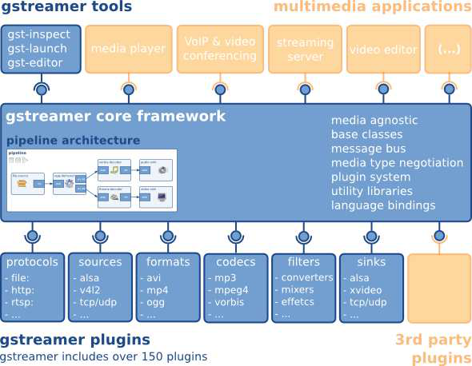

There are four sets of plugins apart from the gstreamer core package
• gst-plugins-base: an essential exemplary set of elements

• gst-plugins-good: a set of good-quality plug-ins under LGPL

• gst-plugins-ugly: a set of good-quality plug-ins that might pose distribution problems

• gst-plugins-bad: a set of plug-ins that need more quality
.

Some of the terminologies that we need to know before we start to explain any gstreamer application are discussed.
- Elements: The element is the most important and the foundation class for all objects that are used in gstreamer. It encapsulates a specific functionality of the pipeline. It can be anything. Everything we can think of in gstreamer is an element. All plugins – sources, sinks, filters, etc are elements. Even a pipeline is an element. If needed one can create his or her own element. (plugin). The name of the class is GstElement. In python it will be gst.Element.
Elements can be in three states:
  - GST_STATE_PLAYING: Playing state
  - GST_STATE_PAUSED: Paused state
  - GST_STATE_NULL: Stopped
Every gstreamer element has a clock and a bus. The states control the clock and the bus is for sending and receiving messages.
- Pads: A pad can be considered as a port or a jack (for audio/video, etc). Now there are two types of pads. Source pads and Sink pads. As explained in gstreamer manual we can understand pads with an analogy.
Consider, for example, a home theater system consisting of an amplifier, a DVD player, and a (silent) video projector.
Linking the DVD player to the amplifier is allowed because both devices have audio jacks, and linking
the projector to the DVD player is allowed because both devices have compatible video jacks. Links between the projector and the amplifier may not be made because the projector and amplifier have different types of jacks. Pads in GStreamer serve the same purpose as the jacks in the home theater system.

Now we understand that data in gstreamer always flows in one direction only. That is to say one pipeline can only function in one direction. Obviously pads must then have restricted directionality.
Elements send out data to source pads.
Elements accept data from sink pads.
Data types are negotiated using a specialised feature called GstCaps

- Bins and pipelines: A collection of elements is a bin. Hence bins are containers for elements. Since bins themselves are also sub-classed from GstElement we may therefore use a bin once created as if it were an element. The state of elements inside a bin can then be controlled by changing the state of the bins themselves.
A pipeline is a top-level bin. We can set the pipeline to PLAYING state and therefore we can start the data flow. Similarly we can set it to PAUSED state to pause the entire functionality, etc

- Communication There are various ways we can interact with the elements that are in a bin. The diagram summarises the same
  - Buffers
  - Events
  - Messages
  - Queries
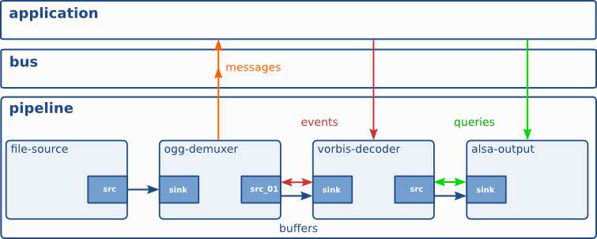
That's all we need to know.
You can obtain gstreamer and the python bindings of gstreamer (PyGst) from
http://gstreamer.freedesktop.org/download/

Farsight

The Farstream (formerly Farsight) project is an effort to create a framework to deal with all known audio/video conferencing protocols. On one side it offers a generic API that makes it possible to write plugins for different streaming protocols, on the other side it offers an API for clients to use those plugins.
The main target clients for Farstream are Instant Messaging applications. These applications should be able to use Farstream for all their Audio/Video conferencing needs without having to worry about any of the lower level streaming and NAT traversal issues.
Farstream constitute the first implementation of the Jingle XMPP protocol.
Farstream uses GStreamer for all it's media streaming needs. A large part of the project is to provide the required elements and improvements to GStreamer in order to deal with streaming protocols such as RTP.
Farstream is written in C/Glib and uses GObjects extensively. Python bindings are available for Farstream.
The Farsight core library has the following classes
- FsParticipant — A participant in a conference
- FsSession — A session in a conference
- FsStream — A stream in a session in a conference
- FsCandidate — Structure describing a transport candidate.
- FsCodec — Structure representing a media codec

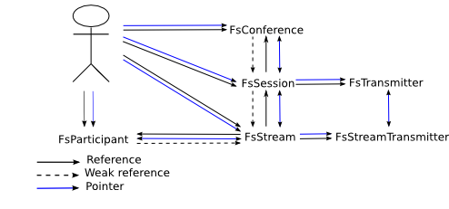
Architecture of Farsight API

The above classes are abstract so they need to be extended. They have been extended to make gstreamer plugins as mentioned above
The plugins that we are using in CLASSICO are

- FsRtpConference — Farsight RTP Conference Gstreamer Elements
- FsRtpParticipant — An RTP participant in a FsRtpConference
- FsRtpSession — An RTP session in a FsRtpConference
- FsRtpStream — An RTP stream in a FsRtpSession in a FsRtpConference

Transmitters
In the previous diagram, we can see transmitter, they abstract the network layer. Different transmitter could be multicast UDP, unicast UDP, ICE UDP, HTTP tunnelling, etc. The transmitter is selected by the client when it creates the Stream (so different stream could use different transmitters).
The Transmitter we use in this application is FsRawUdpTransmitter
This information and more can be found at
http://www.freedesktop.org/wiki/Software/Farstream/Design

GTK +
This is the default User Interface API that is used in Gnome Desktop Environment and also the Unity Desktop
It is completely based on the Glib type system and uses Gobjects extensively to achieve object oriented workflow and relationships between the various UI elements
The UI elements like any other linux UI framework are supposed to be fit inside specialised elements called containers or layouts. The layout manager shall manipulate and resize the widgets as and when the top level windows get resized.
GTK (GIMP Toolkit) is a library for creating graphical user interfaces. It is licensed using the LGPL license, so you can develop open software, free software, or even commercial non-free software using GTK without having to spend anything for licenses or royalties.

It’s called the GIMP toolkit because it was originally written for developing the GNU Image Manipulation Program (GIMP), but GTK has now been used in a
large number of software projects, including the GNU Network Object Model
Environment (GNOME) project. GTK is built on top of GDK (GIMP Drawing
Kit) which is basically a wrapper around the low-level functions for accessing
the underlying windowing functions (Xlib in the case of the X windows system),
and gdk-pixbuf, a library for client-side image manipulation.

GTK uses the Pango library for internationalized text out-put.

PyGtk
PyGTK 2.0 is a set of Python modules which provide a Python interface to GTK+ 2.X. Throughout the rest of this document PyGTK refers to the 2.X version of PyGTK and GTK and GTK+ refer to the 2.X version of GTK+. The primary web site for PyGTK is www.pygtk.org. The primary author of PyGTK is James Henstridge.
It provides a very simple and powerful binding of gtk+ to python. With PyGtk it is possible to code entire UI, or even load an xml file (either libglade format or GtkBuilder format) and automatically construct the interfaces as well as connect the signal handlers to the relevant callbacks.
These python bindings hide the intricacy involved with allocation, destruction and extensions of Gobjects. The python's dynamic typing allows us to do away with the useless type cast macros that would have been employed had the program been written in a traditional language like C.
However there is support only for GTK 2 in PyGtk as of now. Hence we cannot make use of the enhancements provided by GTK +- 3.0.

GOBJECT and GLIB
There has been a need to make a type system that would be interoperable across platforms and across languages making it simpler for the developers to reuse code written in other language. One such system is the Glib type system.
The Glib type system defines platform independent types and their specification in terms of size of the atom and the purpose. Also Glib has been implemented in a variety of languages and is increasingly becoming popular these days
Some of the example Glib types are:
guint → an implementation of an unsigned interactive
gulong → unsigned long
gboolean → TRUE or FALSE (takes up one bit)
gpointer → a platform independent pointer implementation
etc
We also have macros and functions that convert among these types and also from native types to Glib types.

Gobject is a platform independent object implementation.
We can therefore emulate classes and objects and members and inheritance even in a non object oriented language like C.
Also we have traditional ways of creating “class” members dynamically and referring to them.
Refcounts are maintained and garbage collection is performed when a refcount falls to zero for any object.
However the disadvantage is that we need to have a lot of boilerplate code in order to implement a simple class in Gobject. Fortunately this is curbed when using an implementation of Gobjects under python. (ie PyGObject)

9. USE CASES

The application deals with one to one video conferencing between two schools, a rural school and an urban school.
Obviously there would now be two applications, one that runs on the urban side and behaves as a server listening for connection on a specified port. The other runs as the client-side in the rural school.

The use cases are shown and discussed below.

URBAN SIDE

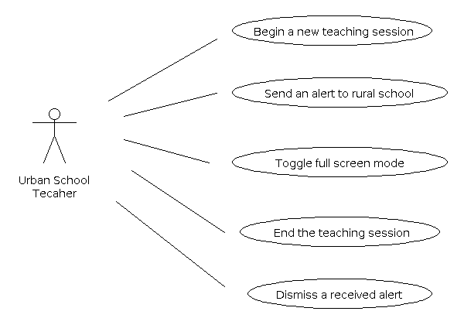

Use cases description:
- Begin a new teaching session:
The teacher at the urban side is ready to begin a teaching session or a lecture. He/She starts the application and specifies the port number the application should listen on.
- Send an alert to rural school:
The teacher may wish to grab the attention of the teacher at the rural side so that a relevant action my be taken or a student may be brought to attention, etc. There are 4 different kinds of alerts that may be sent from the urban side to the rural school. This is achieved by the urban teacher pressing one of the four numbered buttons in the send alert area of the user interface. The details of the alerts have been presented in the appendix II.
- Toggle full screen mode
This option is available only after the remote rural school has connected and the urban side application is displaying the remote video in the designated position of the User Interface. The urban teacher may wish to maximize the remote video to full screen for better viewing. Once in full screen mode, a floating controller window is provided to send alerts, etc. It has a Back button to restore the video to windowed mode. The urban teacher hits this when he wishes to restore the video to the user interface widget.
- End the session
The teacher may end the session by clicking on the end call button when he/she is done with the class. The rural side is presented with a dialog box that says “Disconnected from server.”
- Dismiss a received alert
Just like alerts may be sent, similarly the urban application receives alerts from the rural side and shows a notification on the user interface. This is in the form of a button whose label becomes bold typeface when a particular alert is received. The appropriate button (that was highlighted) must be clicked in order to acknowledge that the teacher has seen the alert and therefore enables further alerts to be received and displayed in a similar manner. Once the button is clicked the label of the button is restored to its original state.

RURAL SIDE

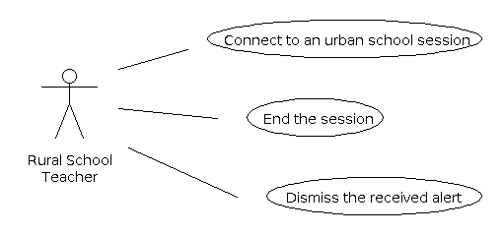

Use case description:

- Connect to an urban school
The rural school wishes to connect to a classroom session going on in a remote urban school. The user at the rural school must select an IP Address from the list of IP Address given that represents an urban school he wishes to connect to. Then a port number is specified which matches the port number the urban school is listening on. The rural teacher then clicks on “Connect” to begin the call. In case the details specified are incorrect a dialog box showing failure to connect is displayed and the user can enter the details once again.
- End the session
The rural school may wish to end the session and not participate in the video conference. It can do so by clicking the “End Call” button which automatically ends the app lication on both sides.
- Dismiss the received alert
This is similar to the “Dismiss received alert” use case of the URBAN side, described above. The alerts are dismissed by clicking on the appropriate highlighted button representing the alert that has been received.

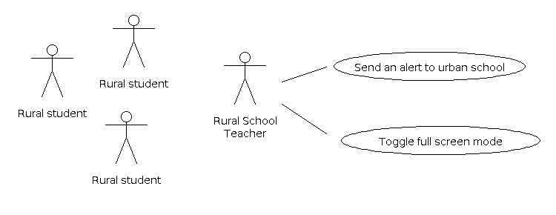

Use Case Description:

- Send an alert to the urban school
If the need arises for the rural side to notify the urban teacher of some discrepancy or seek the attention of the urban side or respond to some query, etc. then the rural teacher clicks on the appropriate button to the send the alert message. The list of possible alert messages have been summarised in Appendix II.
- Toggle full screen mode
This use case is exactly same as the Toggle full screen mode use case in the Urban side. This option is available only after the remote rural school has connected and the urban side application is displaying the remote video in the designated position of the User Interface. The urban teacher may wish to maximize the remote video to full screen for better viewing. Once in full screen mode, a floating controller window is provided to send alerts, etc. It has a Back button to restore the video to windowed mode. The urban teacher hits this when he wishes to restore the video to the user interface widget.

10. CLASS MODELLING

Based on the use cases and the low level architecture of the API used. The following classes have been used in the application
Since the paradigm is not purely object oriented the global variables, flags and functions have been described first and then followed by the classes. Finally we display a class diagram that shows the class members and relationships among the classes
Module: urban.py
Global Scope:
Modules:
sys: System related functions
os: OS modules and calls
pwd: Unix Password database

gtk.glade: libglade for loading glade ui files
gtk: pygtk
gobject: pygobject

pygst or gst: Python gstreamer bindings
farsight: Python Farsight bingings

Variables:
AUDIO, VIDEO: flags for specifying whether AUDIO/VIDEO enabled.
TRANSMITTER: The farsight transmitter to use (rawudp)
mycname: My connection name
gladefile: The path to the Glade UI XML file
RUNNING STATUS: whether the gstreamer pipeline is playing or not.
RECORDING_FLAG: specifies whether the urban side is recording the local video or not (for quality and training purposes only)

Methods:
make_video_sink: Make a bin with a video sink in it, that will be displayed on xid.

Classes:
- FsUIPipeline: “Object to wrap the Gstreamer Pipeline in entirety.” This class wraps over the entire gstreamer pipeline that is the application itself. The entire application's functional component is the gstreamer pipeline. This class shall handle the pipeline and all the synchronous and asynchronous messages that are sent on the pipeline's GstBus. It also handles the dynamic construction and asynchronous linking of the various bins that are a part of the pipeline.
- FsUISource: "An abstract generic class for media sources." This class encapsulates a media source which may be audio source or video source depending on which of its subclasses are instantiated. Hence it has to be an abstract class. The method to make the actual source bin shall not be implemented here. However the adding of this bin to the pipeline and the linking shall be handled here. Also queues are added at the source pads of tees, to avoid the tee from blocking. The destruction of the bin is handled here though.
- FsUIVideoSource: “A Video Source”. This class inherits all the properties from FsUISource and provides an implementation of the method that makes the source bin. Here it makes a video source bin that reads from the camera device. The appropriate settings for the video mode of the analog camcorders are also done here.
- FsUIAudioSource: "An audio source." This is similar to the FsUIVideoSource class described above. It also inherits from FsUISource This class creates an audio source to listen from the soundcard the default audio source as specified in the sound settings.
- FsUISession: "This is one session (audio or video depending on the source)." This is the place where the FsSession bin is created and assigned the available codecs and bad codecs are disabled. This is added to the pipeline and respective callbacks for dynamically linking are connected.
- FsUIStream: "One participant in one session" The audio video streaming is handled here. It wraps over the FsStream element of the Farsight API. The sending of codecs and negotiating the remote codecs are also taken care of.

